**Manual**

**Steps to run the files:**

1. To calculate the number of particles and size of macro particles-

To run matlab file:

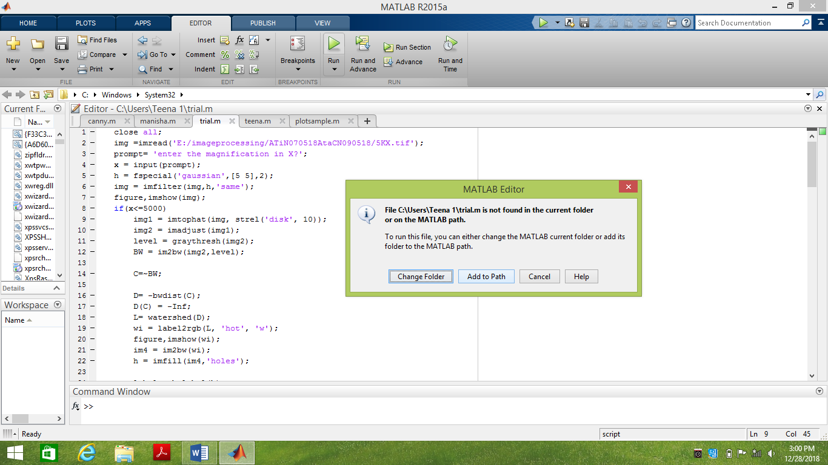

img =imread('E:/imageprocessing/ATiN070518AtaCN090518/5KX.tif');

* Inside the imread() function insert the directory of the image.
* Click on run button then MATLAB Editor will open and click on Add to path.
* Enter the magnification in command window then code will run.

1. To Find the quality of coated surface apply machine learning

* Install JetBrains pycharm in your system.
* To run pycharm file (.py file)
* Right click to run the file.

