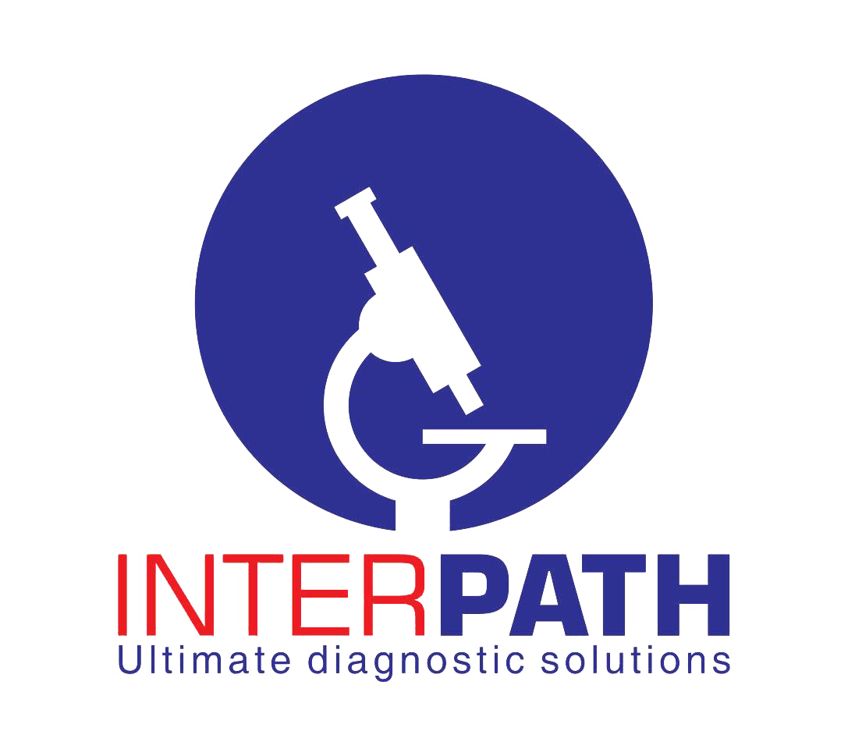

Interpath Results: Data Deletion Request
Last updated: 27 September 2026
Interpath Results accounts are issued or recognised through Interpath Medical Laboratories' laboratory systems. The app does not currently allow members of the public to create a new account directly.
You may request deactivation of your app access and deletion of eligible app-related personal information by contacting:
Email: [insert monitored privacy email address]
Telephone: [insert telephone number]
Privacy/Data Protection Officer: [insert name or title]
Use the subject line Interpath Results Data Deletion Request and provide only:
1. your full name;
2. your account type (patient, doctor/clinic or employee);
3. the username or account identifier associated with the request;
4. a telephone number or email address at which Interpath can contact you; and
5. whether you are requesting account-access deactivation, deletion of eligible app data, correction of information, or withdrawal from WhatsApp notifications.
Do not email your password, laboratory results or other unnecessary medical information.

What happens next
1. Interpath will acknowledge the request and may ask for reasonable proof of identity and authority.
2. Interpath will review which information can be deleted and which must be retained for healthcare, laboratory, legal, security or audit purposes.
3. Interpath will deactivate access and delete or de-identify eligible app-related information within the period required by applicable law.
4. Interpath will confirm completion or explain any information that must be retained and the reason for retention.
Deleting the mobile app does not itself delete laboratory records held by Interpath. Core laboratory reports and required clinical records may need to be retained under applicable healthcare and legal obligations. Expired secure sharing links, application session data and other information that no longer needs to be retained will be deleted, de-identified or allowed to expire according to Interpath's retention schedule.
For more information, read the Interpath Results Privacy Policy ([insert public privacy-policy URL]).

