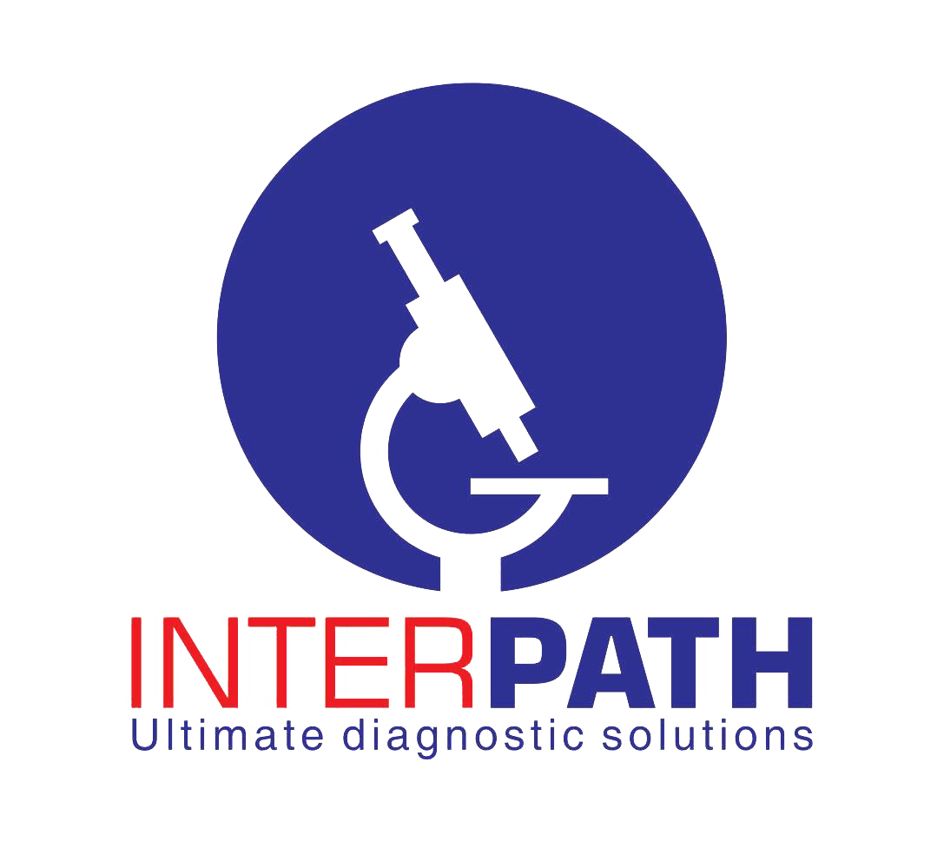

Privacy Policy for Interpath Results
Effective date: 27 September 2026
Last updated: 27 September 2026
Interpath Medical Laboratories [insert full registered legal name] ("Interpath", "we", "us" or "our") respects your privacy and is committed to protecting personal information, including sensitive health information.
This Privacy Policy explains how we collect, use, disclose, retain and protect information when you use the Interpath Results mobile application, progressive web application, website and related result-notification services (collectively, the "Services").
Interpath is the data controller for the processing described in this Policy, except where we process information on behalf of another healthcare provider under a separate agreement.

1. Who may use the Services
The Services are intended for authorised patients, doctors, clinics, hospitals and Interpath employees. User accounts are issued or recognised through Interpath's laboratory information systems. The Services do not currently allow members of the public to create an account directly in the app.
Users must only access information they are authorised to view. Doctors, clinics, hospitals and employees must protect their login details and comply with applicable professional confidentiality duties.

2. Information we process
Depending on your role and the features you use, we may process the following categories of information.

Account and identity information
- Username, user or employee identifier, account role and display name.
- Authentication credentials submitted to verify your identity. We do not intentionally store your password in the Interpath Results application database.
- Session and security tokens used to keep you signed in securely.

Patient and laboratory information
- Patient name, patient or laboratory identifiers, visit/reference number and visit date.
- Clinic, doctor, hospital, collection point or branch information.
- Requested tests, report status, laboratory results, result PDFs and related report information.
- Information required to produce or retrieve certificates and laboratory reports.
Laboratory and health information is sensitive personal information. We process it only to provide laboratory and healthcare-related services, to authorised users, and as otherwise permitted or required by applicable law.

Contact and communication information
- Authorised doctor, clinic or hospital telephone numbers and email addresses.
- WhatsApp recipient name and number, message identifier, delivery state, timestamp and provider error information.
- Communications and support requests you send to us.
WhatsApp result notifications are restricted to verified doctor, clinic or hospital recipients. We do not use the result-sharing feature to send walk-in patient results directly to patient telephone numbers. A notification contains a laboratory visit/reference number and a time-limited secure result link; it is not intended to contain the underlying laboratory values.

Technical, security and usage information
- IP address, browser or device type, operating system and user agent.
- Login, result-view, report-download, sharing and administrative audit events.
- Dates, times, status information, error information and security events.
We do not currently use third-party advertising SDKs, sell behavioural profiles or use the Services for cross-app advertising tracking.

3. How we collect information
We collect information:
- directly from users when they sign in, make a request or contact us;
- from Interpath's laboratory information system and authorised clinical records;
- from authorised doctors, clinics, hospitals and Interpath personnel;
- automatically when the Services communicate with our servers; and
- from service providers, including WhatsApp delivery-status webhooks, where necessary to operate requested features.

4. Why we use information
We process information to:
- authenticate users and maintain secure sessions;
- display and deliver laboratory reports to authorised users;
- generate, download and securely share report PDFs;
- notify verified doctors, clinics or hospitals that a report is available;
- track whether a requested WhatsApp notification was accepted, sent, delivered, read or failed;
- manage branches, visits, reports, certificates and sample-collection workflows;
- provide support and respond to enquiries;
- prevent unauthorised access, fraud, misuse and security incidents;
- maintain clinical, operational and security audit trails;
- comply with healthcare, data-protection, record-keeping and other legal obligations; and
- establish, exercise or defend legal rights.
Where applicable, our processing is based on the provision and management of healthcare services, performance of our obligations to users and healthcare providers, compliance with law, protection of vital interests, our legitimate interests in securing and administering the Services, and consent where consent is legally required. Consent may be withdrawn for future processing where processing depends on consent, subject to legal and clinical record-retention obligations.

5. WhatsApp notifications
When an authorised employee approves a WhatsApp notification, we send the verified recipient's telephone number, recipient or clinic name, laboratory visit/reference number, secure report link and necessary message-delivery information to Meta Platforms through the official WhatsApp Business Platform.
Meta processes this information under its own terms and privacy notices. Recipients should understand that WhatsApp communications are handled through Meta's infrastructure and may be processed outside Zimbabwe.
Recipients may opt out of WhatsApp result notifications by contacting Interpath using the details below. Opting out of WhatsApp notifications does not prevent Interpath from retaining laboratory records where required for healthcare or legal purposes.

6. When we disclose information
We may disclose information only where reasonably necessary to:
- the patient, authorised representative or authorised healthcare professional;
- authorised Interpath staff and contracted personnel who require access for their duties;
- the doctor, clinic or hospital associated with the relevant laboratory visit;
- our laboratory information-system, hosting, database, security, communications and technical-support providers;
- Meta Platforms and WhatsApp when an authorised user requests a WhatsApp notification;
- Apple and Google as necessary to distribute, secure and operate the mobile applications;
- an email or sharing application selected by the user when the user intentionally invokes that feature;
- regulators, courts, law-enforcement bodies or other parties where disclosure is legally required; or
- professional advisers, insurers, auditors or a successor organisation, subject to appropriate confidentiality safeguards.
Service providers must process information only for authorised purposes and are expected to apply protections consistent with this Policy and applicable law. We do not sell personal information.

7. International transfers
Some technology providers may process or store information outside Zimbabwe. Where personal information is transferred across borders, we take reasonable steps to use appropriate contractual, organisational and technical safeguards and to comply with applicable restrictions on cross-border transfers.

8. Retention and deletion
We retain information only for as long as it is reasonably required for the purposes described in this Policy and to meet healthcare, legal, regulatory, security and audit obligations.
- Secure report-sharing links are designed to expire after 24 hours.
- Mobile session information remains on the device until logout, session expiry, app-data removal or uninstall, subject to operating-system behaviour.
- The web application does not intentionally retain complete laboratory results permanently in browser storage.
- WhatsApp delivery records and security/audit logs are retained according to Interpath's approved clinical, security and legal retention schedule.
- Core laboratory records are retained according to applicable medical-record and laboratory obligations and may not be erasable merely because the app is uninstalled.
- Information no longer required is securely deleted, de-identified or anonymised, subject to backup cycles and legal preservation requirements.
Before publishing this Policy, Interpath must insert its approved retention period for application audit and WhatsApp delivery records here: [INSERT APPROVED RETENTION PERIOD].

9. Security
We use reasonable administrative, technical and physical safeguards designed to protect personal information. These include encrypted network connections, role-based access controls, secure session handling, expiring share links, access logging, recipient validation and restricted employee functionality.
No electronic system can be guaranteed to be completely secure. Users must protect their credentials, keep devices secured and promptly report suspected unauthorised access.

10. Your privacy rights and choices
Subject to applicable law and appropriate identity verification, you may request:
- confirmation of whether we process your personal information;
- access to personal information held about you;
- correction of inaccurate or incomplete information;
- deletion of information that we are not legally or clinically required to retain;
- restriction of or objection to certain processing;
- withdrawal of consent where processing is based on consent; and
- information about relevant recipients or cross-border processing.
Some requests may be limited where information must be retained to provide healthcare, preserve the integrity of a laboratory record, protect another person's rights, maintain required audit trails or comply with law. We will explain any applicable limitation.
The app does not currently provide public self-registration. To deactivate app access or request deletion of eligible app-related information, follow the instructions on our Data Deletion page or contact us using the details below.
You may also complain to the Postal and Telecommunications Regulatory Authority of Zimbabwe (POTRAZ), the Data Protection Authority, where applicable.

11. Children's information
The Services are not directed to children for independent use. Laboratory records may relate to a person under 18 when healthcare services are requested by a parent, guardian, authorised healthcare professional or as otherwise permitted by law. We apply the same safeguards to children's health information and require appropriate authority for access.

12. Third-party links and services
The Services may open WhatsApp, an email client, a browser, a PDF viewer or another external service at the user's request. Those services operate under their own privacy policies. Interpath is not responsible for the independent privacy practices of third-party services, although we assess providers used to operate core features and seek appropriate safeguards.

13. Changes to this Policy
We may update this Policy when our Services, providers or legal obligations change. We will publish the updated version with a revised "Last updated" date and provide additional notice where required. Material changes will apply prospectively unless law requires otherwise.

14. Contact us
For privacy questions, rights requests, consent withdrawal, WhatsApp opt-out requests or complaints, contact:
Interpath Medical Laboratories [insert full registered legal name]
Privacy/Data Protection Officer: [insert name or title]
Email: [insert monitored privacy email address]
Telephone: [insert telephone number]
Physical address: [insert registered physical address, Zimbabwe]
Website: [insert official website URL]
Data Deletion page: [insert public data-deletion URL]
To protect patients, we may request reasonable proof of identity and authority before fulfilling a privacy request. Do not send laboratory results, passwords or unnecessary medical details by ordinary email.

