GADE5121 – Game Development – Planning Document

Tinashe Muneri – ST104368060

Group Members

Gift Zowa

Tinashe Muneri

Contents

List Of Components 2

Start Up Interface – by Gift Zowa 2

Player Turn Interface – by Tinashe Muneri 3

Forms (GUI) 4

Start Up Interface – by Gift 4

Player Turn Interface – by Tinashe 5

User Input 6

Start Up Interface 6

Player Turn Interface 6

Generated Output 7

Start Up Interface 7

Player Turn Interface 7

Why output is generated. 7

Start Up Interface 7

Player Turn Interface 8

Overall, Logic & Rules 8

High Level Logic 8

Rules 9

GitHub Links 9

# List Of Components

## Start Up Interface – by Gift Zowa

Component Type – Component Name

* Form – Form 2
* Group Box – groupBox2
* Group Box – groupBox3
* Button - startbtn
* GroupBox - groupBox3
* Label - label7
* GroupBox - groupBox2
* Button - savebtn2
* GroupBox - groupBox5
* PictureBox - pictureBox8
* PictureBox - pictureBox7
* PictureBox - pictureBox6
* PictureBox - pictureBox5
* RadioButton - earthDrag2
* RadioButton - windDrag2
* RadioButton - iceDrag2
* RadioButton - fireDrag2
* Label - label6
* Label - label4
* TextBox - dragon2
* TextBox - player2
* Label - label2
* GroupBox - groupBox1
* Button - savebtn1
* GroupBox - groupBox4
* PictureBox - pictureBox2
* PictureBox - pictureBox4
* PictureBox - pictureBox3
* PictureBox - pictureBox1
* RadioButton - earthDrag1
* RadioButton - windDrag1
* RadioButton - iceDrag1
* RadioButton - fireDrag1
* Label - label5
* Label - label3
* TextBox - dragon1
* TextBox - player1
* Label - label1

## Player Turn Interface – by Tinashe Muneri

Component Type – Component Name

* PictureBox - pcBoxPlayerDragon
* Label - lblPlayerHitPoints
* Button - btnAttack
* Button - btnSpecialAttck
* Button - btnBlock
* TextBox - txtBoxBattleLog
* PictureBox - pcBoxOppDragon
* Label - lblOppDragonNameAndType
* Label - lblOppDragonHP
* GroupBox - grpBoxOppDetails
* GroupBox - grpBoxPlayerDetails
* GroupBox - grpBoxBattleLog

# Forms (GUI)

## Start Up Interface – by Gift

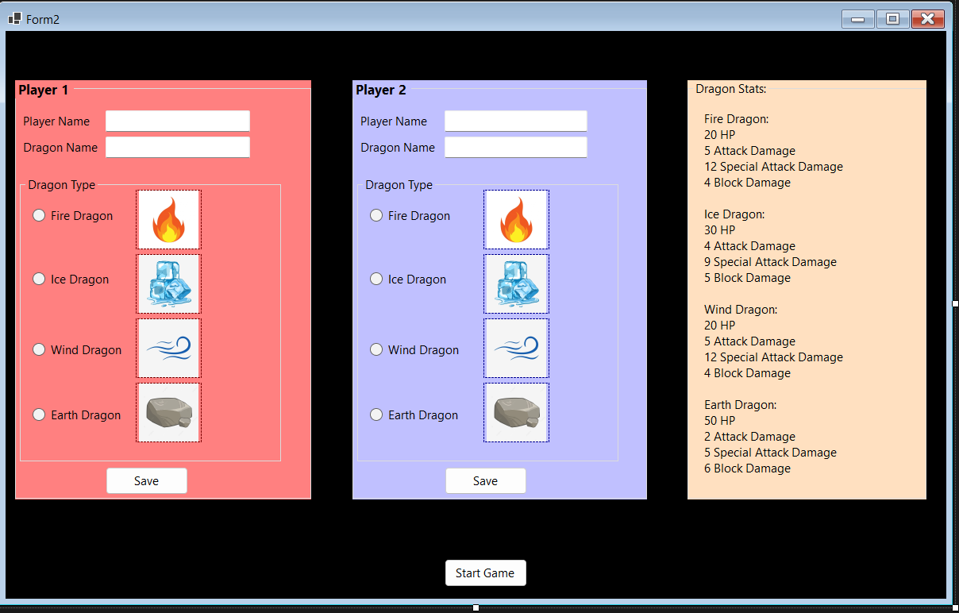

* This is the Start Up Interface/Page/Form. This is a Graphic User Interface (GUI) that is used to welcome players to the game and allows them to input their name and name of dragon using textboxes and choose a dragon type of their choice using radio buttons.
* Two group boxes are used to house and store the fields and components which players will use to input their details. A second group box nested within the first one is used to hold the radio buttons allowing players to select their dragon type with adjacent picture boxes holding images corresponding to the respective dragon type.
* Once they have completed this they may click the “Save” button to save their preferences before beginning the game.
* The third group box is used to house all the dragon stats.
* The page also displays the stats of each dragon type so players can get an idea of the advantages and disadvantages of each dragon before selecting one. The advantages being either higher HP and block value or relatively higher attack and special attack damage points.
* Once players have completed their selections and inputs, they may press the “Start game” button to proceed to the Player Turn interface where the game begins.

## Player Turn Interface – by Tinashe

* This is the Player Turn Interface; this page is used to play the game and allow players to interact with each other.
* The title on the top of the form displays the name of the game (Dragon Dungeon Duels) as well which player’s turn it is.
* The form consists of 3 group boxes. Group box 1 – grpBoxPlayerDetails, contains 5 components. These components display the first players saved preferences, namely: dragon’s name and type of choice as well a an image of their dragon (Picture Box - pcBoxPlayerDragon ), the dragons remaining HP (Label - lblPlayerHitPoints ), and their options of play: Attack(Button - btnAttack), Special Attack(Button – btnSpecialAttack ), and Block (Button - btnBlock)
* The second group box (Group Box - grpBoxOppDetails), displays the second player’s/opponent’s details, being: their name, dragons name and type (Label - lblOppDragonNameAndType) and their dragons remaining HP (Label - lblOppDragonHP)
* The third and final group box (Group Box - grpBoxBattleLog) holds the games Battle log (Text Box - txtBoxBattleLog) which is a multiline text box that updates after every turn. The battle log displayers which players turn it was/is as well as what actions they took and what effect it may have had on the opponents dragon, be it: attacking, special attacking or blocking.

# User Input

## Start Up Interface

* Name – String Input using a Text Box: Players must enter their name on the Start Page, this way they can identify their turn by reading the title on the top of the window.
* Dragon’s name – String Input using a Text Box: Players must enter their dragon’s name.
* Type of Dragon – Input using Radio Buttons: players must select one of the radio button options to choose their type of dragon between Fire, Ice, Earth, and Wind.
* Save – Input to confirm data has been entered using a Button: Once players have input all the above-mentioned fields, they must click the save button to save their data.
* Start Game – Input to begin the game using a Button: After players saved their data, they must click the Start Game button to move to the Player Turn Interface.

## Player Turn Interface

On this screen the player has a choice of their different inputs to engage with the game.

* Attack – Button, this allows the player to attack the opponents dragon and deal the respective amount of damage points according to their dragons stats.

OR

* Special Attack – Button, this input option is for a player to deal a larger amount of damage then their normal attack however leaving them helpless in the next turn.

OR

* Block – button, the block feature will allow players to negate a certain number of attack points from the opponents attack on the next turn.

# Generated Output

## Start Up Interface

* Error Message 1 – A short and simple error message will be displayed should the player forget to enter their username before clicking save.
* Error Message 2 - A short and simple error message will be displayed should the player forget to enter their dragon’s name before clicking save.
* Error Message 3 - A short and simple error message will be displayed to notify the player to select a dragon type on the radio buttons should the player forget to their dragon type before clicking save.
* Error Message 4 – And lastly an error message will be displayed should the player not click save before clicking the Start Game button.

## Player Turn Interface

* Player’s Dragon’s remaining health/hit points – A textbox on the Player Turn Interface will display the players dragon’s remaining HP.
* Opponent’s Dragon’s remaining health/hit points - A textbox on the Player Turn Interface will display the opponent’s dragon’s remaining HP.
* Battle Log – The battle log generates string output stored in a textbox that cannot be edited by the user. It will display a summary of the previous turn’s events. Such as “Lupe’s Turn: Tundra attacked Boulder and dealt 4 damage. Boulder has 46 remaining HP.”. The battle log will update after every turn.
* Winner Prompt – Once one of the player’s dragon has reached 0 HP a small notification will display the name of the winning player and the name of their dragon.

# Why output is generated.

## Start Up Interface

* Error messages, the error messages are to ensure users do not proceed without entering the required data and inputs.

## Player Turn Interface

* Player’s and Opponent’s Dragon HP, this output is generated and updated in order to keep the player’s informed and aware of the current state of their dragon, this can help players decide whether to block when low on HP or attack when the opponent’s dragon is low on health.
* Battle Log output is generated to keep players updated on what happened on the previous turn and can guide them in making their next decision on their turn. For example, if the battle log informs a player that their opponent blocked on their turn then it may encourage them to perform a special attack in order to deal enough damage to overcome the opponents block.
* Winner’s announcement is an important output to generate because it informs players when the game is over and who won.

# Overall, Logic & Rules

## High Level Logic

* Setup – The setup phase of the game takes place on the Start Up page where players must input the name and dragon’s and type then proceed to save and start the game.
* Step 1 – The games begin when the first Player (Player 1) takes their turn by choosing one of the three action options (Attack which deals damage to the opponents dragon, Special Attack which deals a larger amount of damage to the opponents dragon or Block which negates a certain amount of damage from the opponents attack if not all of it depending of the block value and the attacking value from the opposing dragon).
* Step 2 – Once Player 1 takes their turn the battle log will be updated, and it will then be Player 2’s turn next.
* Step 3 - Player 2 takes their turn by choosing one of the three action options (Attack, Special Attack or Block).
* Step 4 – The battle log is updated with Player 2’s turn and then the game returns to Player 1’s turn to play.
* Step 5 – Steps 1 – 4 repeat until one of the player’s dragon’s HP reaches 0 and thus winning the other player the game.

## Rules

* Dragon Dungeon Duels is a turned based two player battle game where players have a choice of selection amongst 4 different element-themed dragons. Each dragon has unique stats defining their 3 actions, Attacks, Special Attacks and Blocking.
* Attacks will deal a certain amount of damage to the opposing dragon according to the respective dragon’s stats.
* Special attacks deal a larger amount of damage to the opponent’s dragon than the normal Attack however, it has a draw back of leaving the dragon unable to attack or defend on the next turn.
* Blocking allows a player to reduce or entirely eliminate the amount of damage they take from the opponent’s next attack. Block only last 1 turn and do not carry over even if the opponent does not attack on their turn. The amount of damage negated will the opponents attack damage minus the block value. If the block value is higher than the opponents attack damage value no damage will b taken. However, in the case the opponents attack damage is the greater value the remainder of the damage minus the block value will be dealt to the blocking dragon.
* Once a player has chosen one of the actions to play the game’s turn switches to the next player.
* The game will switch turns until one of the players dragon HP reaches 0 or less and the game will display the winning player.

# GitHub Links

Gifts Repository:

<https://github.com/ClownBeatz/Game-Dev-Project-1.git>

Tinashe’s Repository:

<https://github.com/TinasheM18/Game_Development_PoE_Project.git>