Example Document
Simple docname

List Example:
- Engine
  - Foo ooFPlop
  - Bar raB
  - Baz zaB
- Gearbox
- Chassis

Table Example:

Name | Surname | Position | Cars | Reserved
Paul | Viberg | Engineer |  | 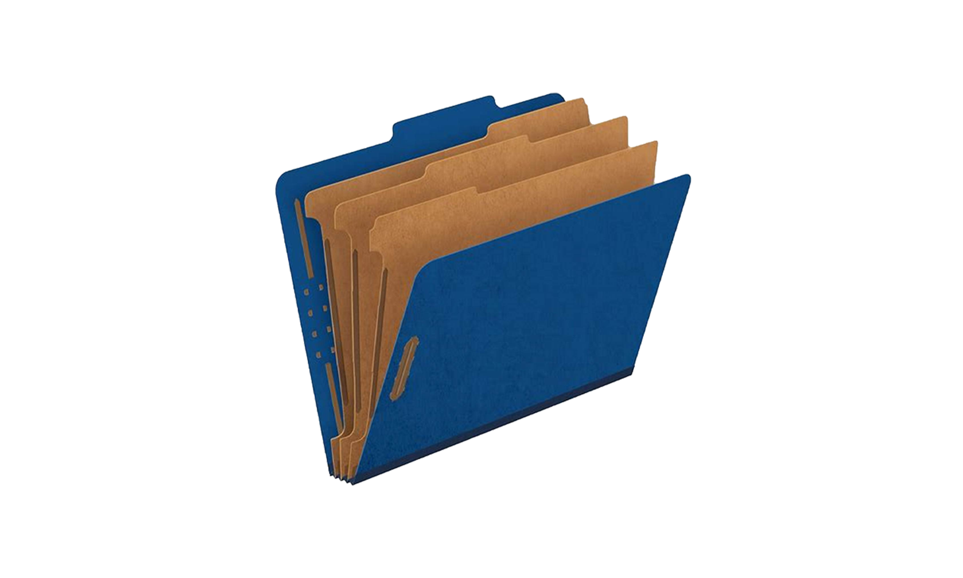
Alex | Houser | CEO & Founder | - Mercedes-Benz C-Class S205  - Lexus LX 570

Another text block:
Passport NE0323 4456673
(enter text)

Repeated content:
Hello world!

Paul | Viberg | Engineer
Alex | Houser | CEO & Founder | - Mercedes-Benz C-Class S205  - Lexus LX 570

Hi, word!!
Hello world!

Nathan | Anceaux | Music artist | - Peugeot 508
Louis | Houplain | Music artist | - Range Rover Velar  - Lada Vesta SW Sport

Hi, word!!

This method adds a new paragraph for each text element. Works the same way as when you press enter
This method adds a newline. Works the same way as when you press SHIFT+enter
line 1
line 2
line 3

Image replace test:

