A Time Budgeting Technological Intervention for Minimizing Problematic Social Media Use in College Students

Tinashe M. Tapera & Ohida Binte Amin

A Time Budgeting Technological Intervention for Minimizing Problematic Social Media Use in College Students

# Introduction

Young adults account for the majority of social media users. Recent data shows that 84% of U.S. adults aged 18 to 29 report frequently using any kind of social media, and the COVID-19 pandemic has made social media use ubiquitous for many (Auxier & Anderson, 2021). This is particularly important for college students who have had to adjust to remote or hybrid learning, and are required to engage with instructors and peers on social media. Unfortunately, the rise of social media has brought with it a prevalence of *problematic social media use* (PSMU). Problematic social media use can be defined in multiple ways, such as addiction (the inability to cease the behavior regardless of known negative impacts), dependency (an inability to achieve goals without the behavior), compulsive use, excessive use, and disordered use (Huang, 2022). A recent meta-analytic study confirms that problematic social media use can have negative effects on both physical and mental health(Huang, 2022). The study found that problematic social media use was negatively correlated with indicators of well-being, while being positively correlated with anxiety, depression, and distress. Importantly, findings were robust across multiple countries.

In considering these challenges, it is important to also acknowledge the technology-based environment that students now find themselves in due to the pandemic. Zhao and Zhuo (2021) raised worrying evidence of the link between the COVID-19 pandemic and addictive social media use, while Barbosa-Camacho et al. (2022) showed that COVID-19 had a significant negative influence on students’ mental well-being as it pertains to the classroom, in the domains of anxiety, depression, and self-perception. An international report by UNESCO reports that over 50% of students felt overwhelmed by the pandemic and how it would affect their schoolwork, and the data suggests that vulnerable students (such as those in low or underserved SES categories) are statistically more likely to fall behind in class as the pandemic continues (Meinck, Fraillon, & Strietholt, 2022). Likewise, Jiang (2022) found that students who endorsed being concerned that their academic performance had been affected by the pandemic, tended to have higher levels of base anxiety, and these same students tended to report higher levels of PSMU.

Further findings from Jiang (2021), however, also provide evidence that the link between mental well-being, the pandemic, and social media, is multifaceted. This particular study found that while the relationship between student anxiety and their social media use was not significant in their sample, the moderating effect of students’ perceived fatalism — the belief that one’s health is not self-determined — was significant, suggesting that the outcome of decreased mental well-being was strongly tied to students’ perceptions about their sense of autonomy and control over their own health. This is supported by a reviews by Haddad et al. (2021) and Alshare, Moqbel, and Merhi (2022) who concluded that COVID-19 acts as a moderator between social media use (problematic or not) and mental health.

Given the prevalence of social media, the increased stress of the ongoing pandemic, and the deleterious effects of problematic social media use, our group aims to use behavior change theories to inform the implementation of a fictional technological intervention for college students exhibiting problematic social media use. We aim to implement a novel mobile application to help users mindfully budget their time on social media. Significantly for this paper, we leverage behavior change theories relevant to health *beliefs at the intrapersonal level* to inform the design and implementation of our proposed intervention.

## Relevant Behavior Change Theories

At the intrapersonal or individual level, health behavior change theories primarily address constructs within the individual that influence behavior, such as beliefs about self and the world around them, intrinsic and extrinsic motivations, perceived skills, previous experiences, and acquired knowledge (Glanz, Rimer, & Viswanath, 2015). There are a handful of currently prevalent individual-level theories, but for this paper we’ve elected to narrow our focus to the Transtheoretical Model for Stages of Change (TTM), and the Health Belief Model (HBM). TTM conceptualizes behavior change as a sequence of stages that unfolds over time as individuals progress through different beliefs about their health (Prochaska & Diclemente, 2005). There are five discrete stages of change in this model – precontemplation, contemplation, preparation, action, and maintenance (see Figure 1). TTM has seen widespread adoption and success in a variety of different fields and scenarios, and is highly adaptable.

Relatedly, the Health Belief Model (HBM) suggests that an individual’s perceptions most strongly predict their health-related actions or behaviors (Rosenstock, 1974). The model is based on six interrelated constructs: perceived susceptibility, perceived severity, perceived benefits, perceived barriers to action, self-efficacy, and cues to action (see Figure 2). HBM is one of the oldest models of behavior change that is still used widely to this day.

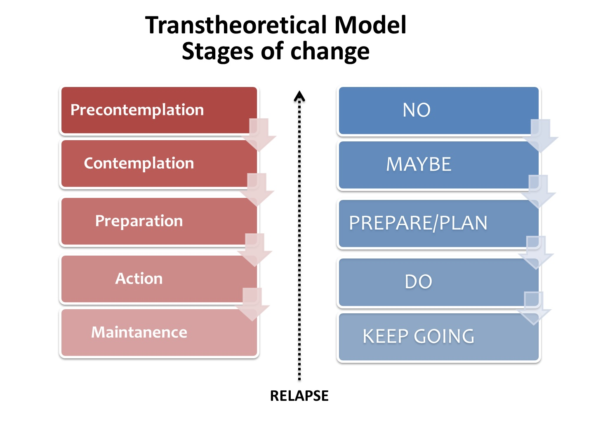

*Figure* *1.*  Visual Schematic of the Transtheoretical Model for Stages of Change. Source: [Wikipedia](https://en.wikipedia.org/wiki/Transtheoretical_model)

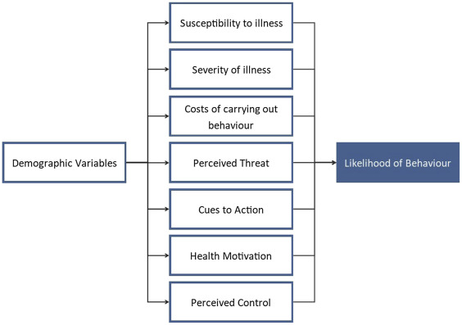

*Figure* *2.*  Visual Schematic of the Transtheoretical Model for Stages of Change. Source: [Wikipedia](https://en.wikipedia.org/wiki/Transtheoretical_model)

While both TTM and HBM have had notable popularity in health interventions in various scenarios that may include social media as an environment or intervention delivery medium (Al-Sabbagh et al., 2022; Al-Tahitah, Al-Sharafi, & Abdulrab, 2021; Frith & Loprinzi, 2017; *JMIR Public Health and Surveillance - Use of Health Belief Model for COVID-19 Social Media Content to Examine Public Perceptions of Physical Distancing*, n.d.; Sardi et al., 2019; Zareban et al., 2022), there are no published studies demonstrating the use of either TTM or HBM in a problematic social media use *intervention*. That being said, there is existing literature to support the potential for success of a well-planned intervention for problematic social media use. One study implemented cognitive reconstruction, a primary goal of cognitive behavioral therapy, to significantly reduce social media addiction amongst an experimental cohort of 21 students, compared to the control group (Hou, Xiong, Jiang, Song, & Wang, 2019). On the other hand, a separate study found that simply instructing participants with social media addiction to abstain from social media for 7 days resulted in 59% of participants relapsing, and most experiencing severe withdrawal symptoms (Stieger & Lewetz, 2018).

## Applied Behavior Change Mechanisms

To develop the intervention, we apply the selected models to the individual with PSMU as summarized in Figure 3 and Figure 4. As Figure 3 illustrates, the aim of TTM is to categorize an individual along the axes of stages based on their attitudes and beliefs about a behavior change, and use our understanding of that stage to inform how to encourage a shift in perception towards the next stage. As a thought experiment, consider a student exhibiting PSMU in need of a behavior change, but does not intend to take any action in the near future — the individual is not aware that excessive social media use may yield the negative effects described in the introduction. This student would be classified into the precontemplation stage. In the contemplation stage, the student may recognize their behavior as problematic, but may still feel ambivalent toward a change in behavior. In the preparation stage, the student may be ready to confront barriers to taking necessary action. In the action stage, the student is actively modifying their behavior, for example by consuming less social media. Lastly, in the maintenance phase, the student’s social media habits no longer constitute PSMU and this behavior is maintained in the long term.

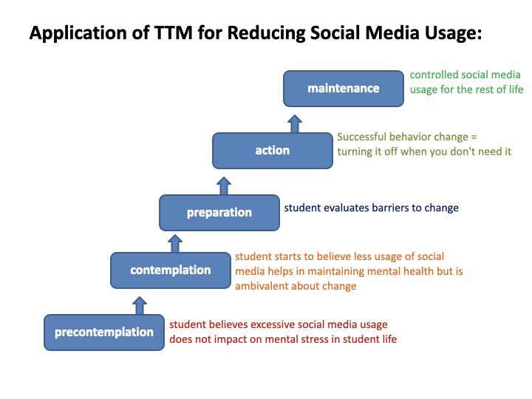

*Figure* *3.*  Application of the TransTheoretical Model for Stages of Change to students with problematic social media use.

We believe that an appropriate technological intervention may best be implemented for students in the preparation stage, so we employ HBM to carefully examine health belief factors that an intervention at this stage must address. As Figure 4 illustrates, perceptions about susceptibility and seriousness contribute to a student’s perceived threat of PSMU, which we estimate is *moderate*. A number of benefits of managing PSMU (culminating in improved well-being) conflict with various perceived constraints (such as the temptation of habit and ubiquity of social media), while modifying external factors also influence an individual’s beliefs. This, taken into account with various environmental cues (such as mobile notifications) all constitute our hypothetical student’s beliefs about their PSMU at the preparation stage of change. We believe the average student in this scenario has a moderate likelihood of taking action on their behavior.

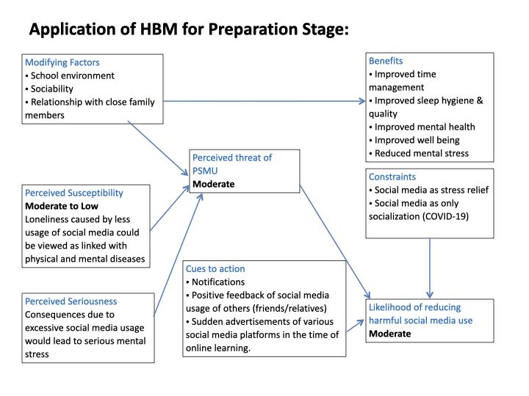

*Figure* *4.*  Application of the Health Belief Model to the Preparation stage of TTM in students ready to confront their problematic social media use.

# Methods

## Population

We propose our intervention for undergraduate college students who exhibit problematic social media use. Ideally, a cohort of participants would be of legal adult age and racially-, ethnically-, and gender-diverse, as systematic reviews and meta-analyses have established such universality of PSMU. Participants would be required to have a smartphone (OS agnostic) that they use comfortably and regularly for interacting with the social media apps of their choice. Social media apps may include, but are not limited to, Facebook, Instagram, Snapchat, TikTok, Reddit, Whatsapp, Telegram, and many others.

We don’t foresee any exclusion criteria; participants would initially attend a consent and intake session where they would complete the Bergen Social Media Addiction Scale (Duradoni, Innocenti, & Guazzini, 2020) and the Social Media Disorder Scale (van den Eijnden, Lemmens, & Valkenburg, 2016) to collect baseline data on participants’ relationships with their social media. Further, participants would also be asked to complete the Beck Depression Inventory, the Patient Health Questionnaire, and Generalized Anxiety Disorder scale, to gather data on participants’ baseline mood and anxiety scores (Shevlin et al., 2022). Participants will participate in the intervention for at least 1 month, after which they will return to the lab to retake the above battery of surveys.

## Technological Intervention

Our group proposes to implement a mobile application that will allow participants to budget the amount of time they spend on social media per week, and reflect on their experience after each significant interaction on social media. Our hypothesis is that PSMU can be minimized by changing the individual’s perceptions about their use of social media. The app’s goals, therefore, are to empower the user to:

1. **Be in control of their own limitations.** We hypothesize from our HBM model that the strongest components affecting the likelihood of change are constraints from the *need* for a social media presence (Figure 4). This autonomy addresses these constraints directly by enabling the user to be mindful of the value of their own time.
2. **Be mindful about their mood.** We also hypothesize from the HBM model that the benefits to mental health are not salient enough for students exhibiting PSMU (Figure 4). By providing reflections on their mood, we expect that users will develop greater mindfulness about their relationship with social media, and how that relationship affects their mood.

To address goal 1, the app can set varying levels of “strictness” for encouraging users *not* to open the app. In order of strictness:

* Displaying a count-up timer of how much time has been spent on social media that week;
* Displaying a count-down timer of how much time is left;
* Banner notifications while using social media when a large amount of their budget has been used (“you have used half your budget for the week”; “you have 1 hour remaining in your budget”);
* Adding an interruption screen upon opening the social media app, to give users a salient decision point (“Are you sure you want to open Facebook?”);
* Hiding the app from the homescreen (ensuring the app is not easily accessible);

To address goal 2, the app will implement short Ecological Momentary Assessments (EMA) at the end of each significant social media session (app is running and open in the foreground for longer than 2 minutes). The EMAs will be used both to allow the user to briefly reflect on their mood and relationship with social media, and to provide the app with data that will inform where to set the strictness of the intervention going forward. EMA questions could include (with addressed goals in parentheses), “How much time do you believe you spent on social media today?” (goal 1); “Do you feel your time was well spent?” (goal 1); “Is there anything you would have preferred to do with your time today?” (goal 1); “Rate your mood right now” (goal 2).

With the responses to these questions, the app can use this data to aid the user in maintaining their desired budget by adjusting the strictness of intervention, if necessary.

### User Story.

1. User joins the study, completes intake materials, and installs the intervention app on their phone.
2. User sets a budget for social media use, in hours.
3. User opens a social media app.
4. In the background, the intervention app tracks use of social media against the budgeted time.
5. User closes the social media app.
6. The intervention app prompts the user to fill out a short EMA survey.
7. The app evaluates EMA responses and, if necessary, changes the strictness of the intervention.

## Assessment of Results

The app will evaluate EMA responses continuously, and adjust strictness of the intervention according by considering changes in both mood and perceptions since the last complete survey. See Figure 5 for an illustration. When participant mood has decreased since their last survey, or their perception about how much time they have spent on social media has decreased, the app will implement a stricter intervention. Exact decision points for how much mood has to decrease, or how much their positive self-perception has to decrease, in order for an intervention change to take effect should be determined by psychometric internal validity, which is outside the scope of this proposal.

of relationship with social media.

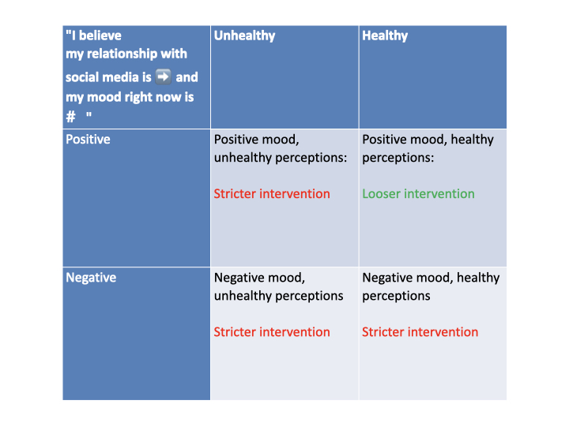

*Figure* *5.*  (ref:confapp-caption)

After the course of the intervention, participants will have ideally completed both a pre- and post-intervention battery of psychometric measures of mood, anxiety, depression, and social media addiction questionnaires. Appropriate statistical testing (such as ANOVA) can be used to assess the effectiveness of this intervention.

# Conclusion

Problematic social media use is a rising and prevalent problem affecting people now more than ever due to our increased engagement in online spaces as we grapple with the ongoing pandemic. This problem is affecting students especially, and it is estimated to get worse. This paper outlined a proposed technological intervention, backed by two sound health behavior change theories. The Transtheoretical Model categorizes students along a sequence of stages towards behavior change, and the Health Belief Model is used to further analyze student attitudes about PSMU at the “preparation to change” stage. In this paper, we developed a proposal for a mobile application aimed at minimizing PSMU in students by 1) helping them budget their time spent on social media, and 2) providing them with EMAs that allow them to reflect on their perceptions about social media use and how it affects their health. These two features work together to specifically address tangible constructs identified in our HBM analysis.

# References

Al-Sabbagh, M. Q., Al-Ani, A., Mafrachi, B., Siyam, A., Isleem, U., Massad, F. I., … Abufaraj, M. (2022). Predictors of adherence with home quarantine during COVID-19 crisis: The case of health belief model. *Psychology, Health & Medicine*, *27*(1), 215–227. <https://doi.org/10.1080/13548506.2021.1871770>

Alshare, K. A., Moqbel, M., & Merhi, M. I. (2022). The double-edged sword of social media usage during the COVID-19 pandemic: Demographical and cultural analyses. *Journal of Enterprise Information Management*, *ahead-of-print*(ahead-of-print). <https://doi.org/10.1108/JEIM-07-2021-0292>

Al-Tahitah, A. N., Al-Sharafi, M. A., & Abdulrab, M. (2021). How COVID-19 Pandemic Is Accelerating the Transformation of Higher Education Institutes: A Health Belief Model View. In I. Arpaci, M. Al-Emran, M. A. Al-Sharafi, & G. Marques (Eds.), *Emerging Technologies During the Era of COVID-19 Pandemic* (pp. 333–347). Cham: Springer International Publishing. <https://doi.org/10.1007/978-3-030-67716-9_21>

Auxier, B., & Anderson, M. (2021). Social Media Use in 2021.

Barbosa-Camacho, F. J., Romero-Limón, O. M., Ibarrola-Peña, J. C., Almanza-Mena, Y. L., Pintor-Belmontes, K. J., Sánchez-López, V. A., … González-Ojeda, A. (2022). Depression, anxiety, and academic performance in COVID-19: A cross-sectional study. *BMC Psychiatry*, *22*(1), 443. <https://doi.org/10.1186/s12888-022-04062-3>

Duradoni, M., Innocenti, F., & Guazzini, A. (2020). Well-Being and Social Media: A Systematic Review of Bergen Addiction Scales. *Future Internet*, *12*(2), 24. <https://doi.org/10.3390/fi12020024>

Frith, E., & Loprinzi, P. (2017). Can Facebook Reduce Perceived Anxiety Among College Students? Randomized Controlled Exercise Trial Using the Transtheoretical Model of Behavior Change. *JMIR Mental Health*, *4*(4), e8086. <https://doi.org/10.2196/mental.8086>

Glanz, K., Rimer, B. K., & Viswanath, K. (Eds.). (2015). *Health behavior: Theory, research, and practice* (Fifth edition). San Francisco, CA: Jossey-Bass.

Haddad, J. M., Macenski, C., Mosier-Mills, A., Hibara, A., Kester, K., Schneider, M., … Liu, C. H. (2021). The Impact of Social Media on College Mental Health During the COVID-19 Pandemic: A Multinational Review of the Existing Literature. *Current Psychiatry Reports*, *23*(11), 70. <https://doi.org/10.1007/s11920-021-01288-y>

Hou, Y., Xiong, D., Jiang, T., Song, L., & Wang, Q. (2019). Social media addiction: Its impact, mediation, and intervention. *Cyberpsychology: Journal of Psychosocial Research on Cyberspace*, *13*(1). <https://doi.org/10.5817/CP2019-1-4>

Huang, C. (2022). A meta-analysis of the problematic social media use and mental health. *International Journal of Social Psychiatry*, *68*(1), 12–33. <https://doi.org/10.1177/0020764020978434>

Jiang, Y. (2021). Problematic Social Media Usage and Anxiety Among University Students During the COVID-19 Pandemic: The Mediating Role of Psychological Capital and the Moderating Role of Academic Burnout. *Frontiers in Psychology*, *12*.

*JMIR Public Health and Surveillance - Use of Health Belief Model for COVID-19 Social Media Content to Examine Public Perceptions of Physical Distancing: Model Development and Case Study*. (n.d.). https://publichealth.jmir.org/2020/3/e20493/.

Meinck, S., Fraillon, J., & Strietholt, R. (2022). The Impact of the COVID-19 Pandemic on Education: International Evidence from the Responses to Educational Disruption Survey (REDS). In *International Association for the Evaluation of Educational Achievement*. International Association for the Evaluation of Educational Achievement.

Ngien, A., & Jiang, S. (2022). The Effect of Social Media on Stress among Young Adults during COVID-19 Pandemic: Taking into Account Fatalism and Social Media Exhaustion. *Health Communication*, *37*(10), 1337–1344. <https://doi.org/10.1080/10410236.2021.1888438>

Prochaska, J. O., & Diclemente, C. C. (2005). The Transtheoretical Approach. In J. C. Norcross & M. R. Goldfried (Eds.), *Handbook of Psychotherapy Integration* (p. 0). Oxford University Press. <https://doi.org/10.1093/med:psych/9780195165791.003.0007>

Rosenstock, I. M. (1974). The Health Belief Model and Preventive Health Behavior. *Health Education Monographs*, *2*(4), 354–386.

Sardi, L., Kharbouch, M., Rachad, T., Idri, A., de Gea, J. M. C., & Fernández-Alemán, J. L. (2019). Blood4Life: A Mobile Solution to Recruit and Retain Blood Donors Through Gamification and Trans-Theoretical Model. In Á. Rocha, H. Adeli, L. P. Reis, & S. Costanzo (Eds.), *New Knowledge in Information Systems and Technologies* (pp. 3–12). Cham: Springer International Publishing. <https://doi.org/10.1007/978-3-030-16187-3_1>

Shevlin, M., Butter, S., McBride, O., Murphy, J., Gibson-Miller, J., Hartman, T. K., … Bentall, R. P. (2022). Measurement invariance of the Patient Health Questionnaire (PHQ-9) and Generalized Anxiety Disorder scale (GAD-7) across four European countries during the COVID-19 pandemic. *BMC Psychiatry*, *22*(1), 154. <https://doi.org/10.1186/s12888-022-03787-5>

Stieger, S., & Lewetz, D. (2018). A Week Without Using Social Media: Results from an Ecological Momentary Intervention Study Using Smartphones. *Cyberpsychology, Behavior, and Social Networking*, *21*(10), 618–624. <https://doi.org/10.1089/cyber.2018.0070>

van den Eijnden, R. J. J. M., Lemmens, J. S., & Valkenburg, P. M. (2016). The Social Media Disorder Scale. *Computers in Human Behavior*, *61*, 478–487. <https://doi.org/10.1016/j.chb.2016.03.038>

Zareban, I., Rahmani, A., Allahqoli, L., Ghanei Gheshlagh, R., Hashemian, M., Khayyati, F., … Nemat, B. (2022). Effect of Education Based on Trans-Theoretical Model in Social Media on Students with Gingivitis; a Randomized Controlled Trial. *Health Education and Health Promotion*, *10*(1), 1–7.

Zhao, N., & Zhou, G. (2021). COVID-19 Stress and Addictive Social Media Use (SMU): Mediating Role of Active Use and Social Media Flow. *Frontiers in Psychiatry*, *12*.