Introductory Certificate Competencies

*Revised from BYU-Pathway Worldwide* [*Certificates and Degrees Program List*](https://www.byupathway.org/degrees/program-list)

# Overview

The following lists were compiled to make it easier for you to copy skills (or competencies) that you gained during your certificate and paste them under the certificate listed in your résumé.

Instructions:

1. Find your certificate below, with competencies listed below the title.
2. Pick 4 to 6 competencies from the list under your certificate, that you want most on your résumé and are most relevant to the job you might apply for.
3. Copy the list and paste it under the certificate in your résumé. Here are some quick tips to paste the new text in and preserve the proper font settings and formatting, with bullets in two columns:
   1. Highlight and copy the bullet(s) you wish to put in your résumé.  
      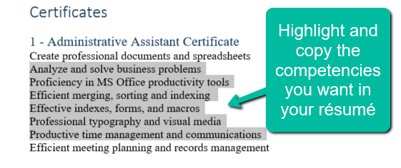
   2. Open your résumé and highlight the bullets you are to replace.   
      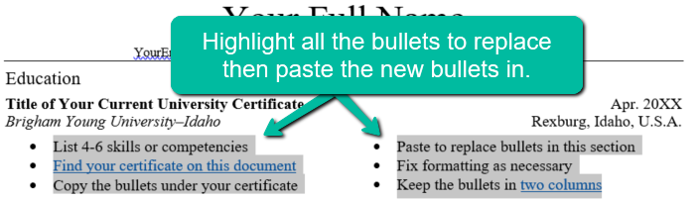
   3. Paste the new list. Before clicking anything else, **open the small ‘Paste Options’ window**, *toward the bottom right of the area you just pasted*, and choose ‘Keep Text Only’.   
      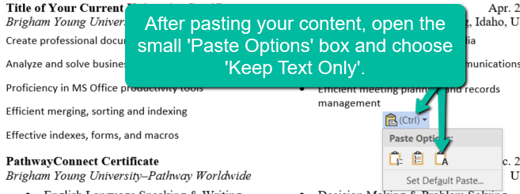
   4. The formatting and font of your résumé should be preserved. If not, fix the font size and type and be sure the formatting is corrected, so the bullets are in [two columns](https://support.microsoft.com/en-us/office/add-columns-to-a-word-document-319f3705-bc28-9da2-0ec5-eea2343274aa).  
      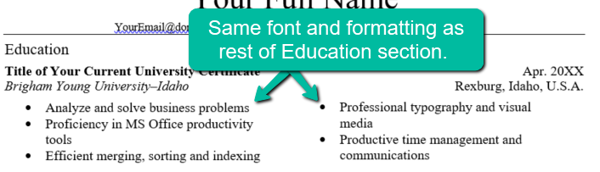

# Certificates

## 1 - Administrative Assistant Certificate

Create professional documents and spreadsheets

Analyze and solve business problems

Proficiency in MS Office productivity tools

Efficient merging, sorting and indexing

Effective indexes, forms, and macros

Professional typography and visual media

Productive time management and communications

Efficient meeting planning and records management

## 2 - Agribusiness Certificate

Create business plans

Understand global agribusiness impacts

Understand small enterprises

Increase profitability of organizations

Analyze international value chain

Construct budgets and financial statements

Perform feasibility analyses to mitigate risk

Perform financial transaction analysis

## 3 - Auto Service Technology Certificate

Understand operation of systems and components

Apply logical processes

Diagnose mechanical and electrical faults

Use correct procedures for repair and maintenance

Show proficiency with professional certification

Demonstrate professionalism and integrity

## 4 - Basic Accounting Certificate

Create basic accounting statements

Analyze budgeting tools

Produce useful QuickBook reports

Provide data for financial decision making

Build advanced professional spreadsheets

Report production decisions in market economy

## 5 - Commercial Fundamentals Certificate

Manage accounting cycle and cash flow

Design and launch social media campaigns

Create advanced professional spreadsheets

Increase sales through persuasive selling skills

Find, ask questions, highlight benefits

Overcome objections, negotiate and close, service

## 6 - Community Health Planning and Implementation Certificate

Differentiate diseases of the human body

Plan health programs

Apply health education and promotion principles

Organize data using Microsoft Office products

Communicate health information

Demonstrate professionalism and integrity

## 7 - Computer Programming Certificate

Learn and apply new technology and techniques

Use Python, HTML/CSS, Java, and JavaScript

Convert software requirement into code

Understand principles of programming and design

Apply strong design and problem-solving skills

Strong communication and interpersonal skills

## 8 - Computer Support Certificate

Identify and describe function of key hardware

Design and configure basic corporate network

Identify hardware and devices to connect systems

Identify and configure key security policies

Troubleshoot basic networking and system issues

Create advanced professional spreadsheets

Provide tools to visualize and solve problems

Share vision and articulate complex idea

## 9 - Construction Field Supervision Certificate

Utilize construction documents

Understand drawings and specifications

Create and use construction budgets

Manage people, time and equipment

Use Critical Path Method for productivity

Plan and carry out work in a safe manner

## 10 - Entrepreneurship Certificate

Improve sales through persuasive selling skills

Find, ask questions, highlight benefits

Overcome objections, negotiate and close, service

Manage accounting cycle and cash flow

Create advanced professional spreadsheets

Build proposals for small business ventures

## 11 - Family History Research Certificate

Define genealogical research problem

Develop plans to solve basic research problem

Gather information from documents

Analyze evidence and reach conclusions

Record conclusions in various formats

Teach and promote family history to others

## 12 - Hospitality and Tourism Management Certificate

Improve accommodation operations

Understand metrics and software applications

Increase customer service

Team-building skills, leadership and coaching

Develop and enhance food services

Plan menus, purchase, storage, sanitation and safety

Marketing

Strong communication and interpersonal skills

## 13 - Marriage, Family and Human Relations Certificate

Describe basic principles and theories

Apply basic principles to healthy marriages

Relate theories to family functioning

Understand religious and secular research

Strong communication and interpersonal skills

Demonstrate professionalism and integrity

## 14 - Social Media Marketing Certificate

Create and manage content

Advertise and market

Develop content for social media

Produce, engage with, and build brand loyalty

Improve effectiveness of content and campaigns

Use analytical and research tools

## 15 - TEFL Certificate (Teaching English as a Foreign Language)

Teach English as a foreign language

Apply essential theory

Practice basic principles of TEFL

Utilize best practices for effective instruction

Apply principles and framework for learning

Demonstrate professionalism and integrity

## 16 - Web Frontend Certificate

Web design, HTML, CSS, and JavaScript

Develop web pages that are semantic and valid

Use HTML5 markup language

Design web pages with valid CSS level 3

Avoid HTML presentational markup

Provide appropriate, usable and findable content

Develop content for both humans and machines

Proficient with current web design principles