How to use the PIC18F45K22 version

General
KirbyPIC runs natively on a PIC18F45K22 microprocessor, it needs 32Kb of program memory, 1.5Kb of RAM and an 8MHz of cycle speed. It needs a GLCD Ampire 128x64 connected to pins RB0-RB5 and RD0-RD7 for its graphics display. It also requires there to be 4 buttons connected to the pins RA0, RA2, RA3 and RA5 for gameplay interaction.

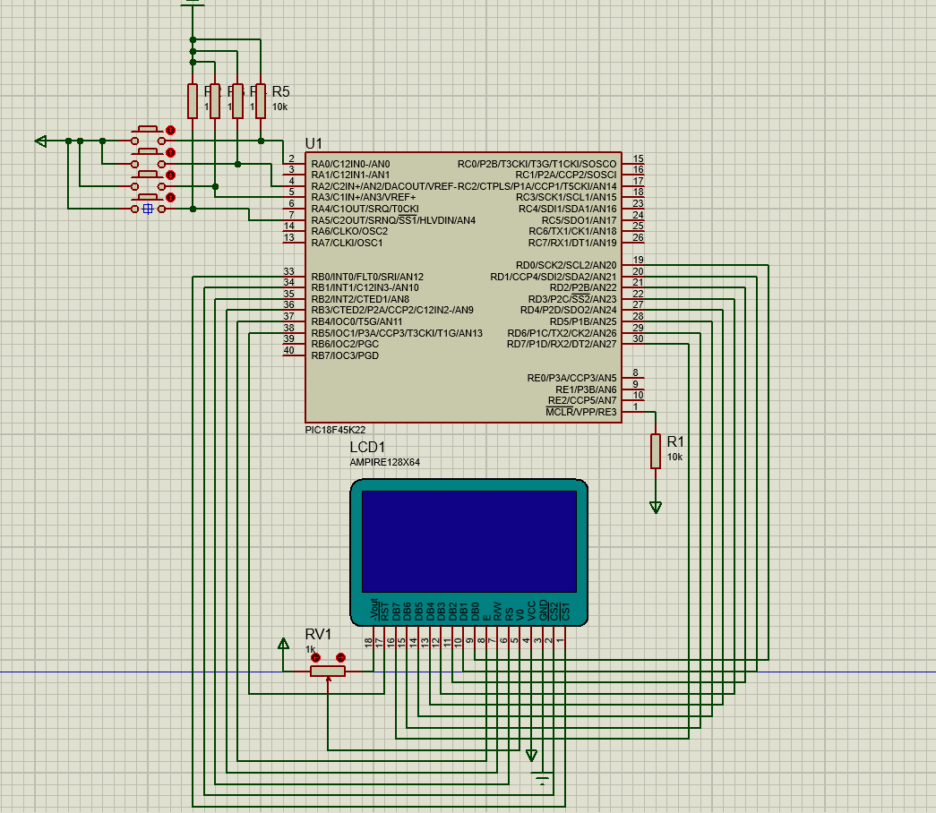
This is a mock-up of how my system is connected, once the program is loaded in and the PIC is running, the game will automatically start.
Simulation
The easier way to try the program is using a PCB/Circuit simulator that can emulate the PIC hardware. The most recommended is the one I used (which is also the one seen in the screenshot), a version of Proteus, must include the previously mentioned components.

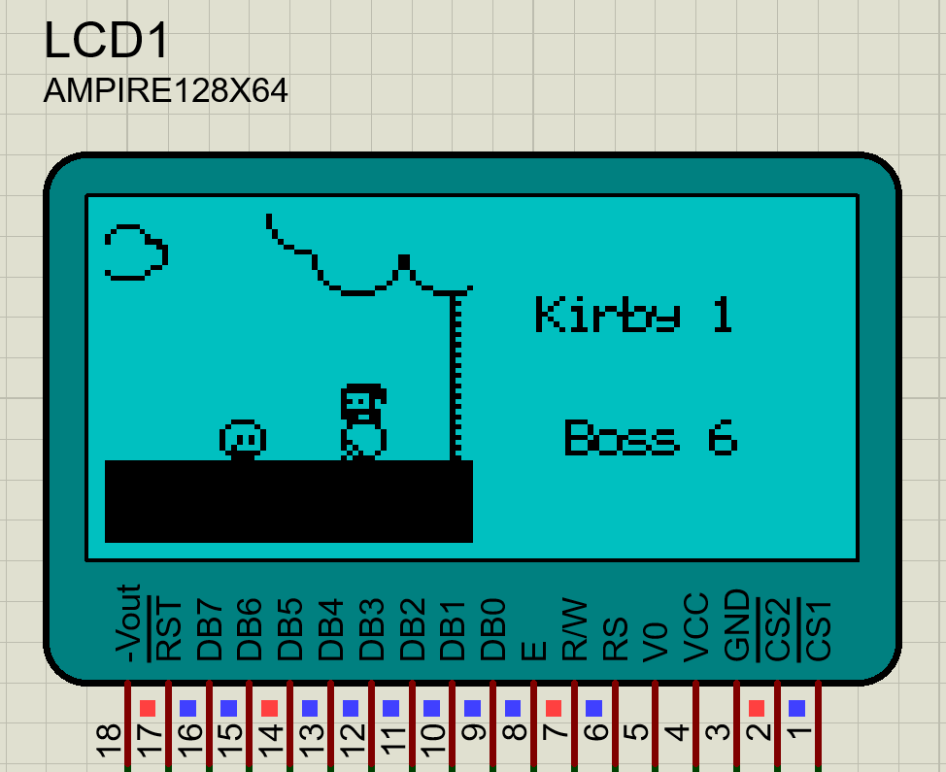

Hardware
The harder way is creating the setup physically. There are two ways, making it from zero or using a pre-made board like the MIKROE-2005. Creating it with the original components is way cheaper but also requires some technical know-how. Either way, once it’s working, you’ll only have to load the program into the PIC with MikroProg or an analogue.

