Deployment Design
One Cloud Run service runs the FastAPI backend and serves the built React files. It uses Cloud SQL for PostgreSQL for data, Secret Manager for the Gemini API key, and Artifact Registry for the container image. The service runs exactly one instance, always on, because summaries run in a background thread inside the app. The estimated cost is about $55 to $85 a month.

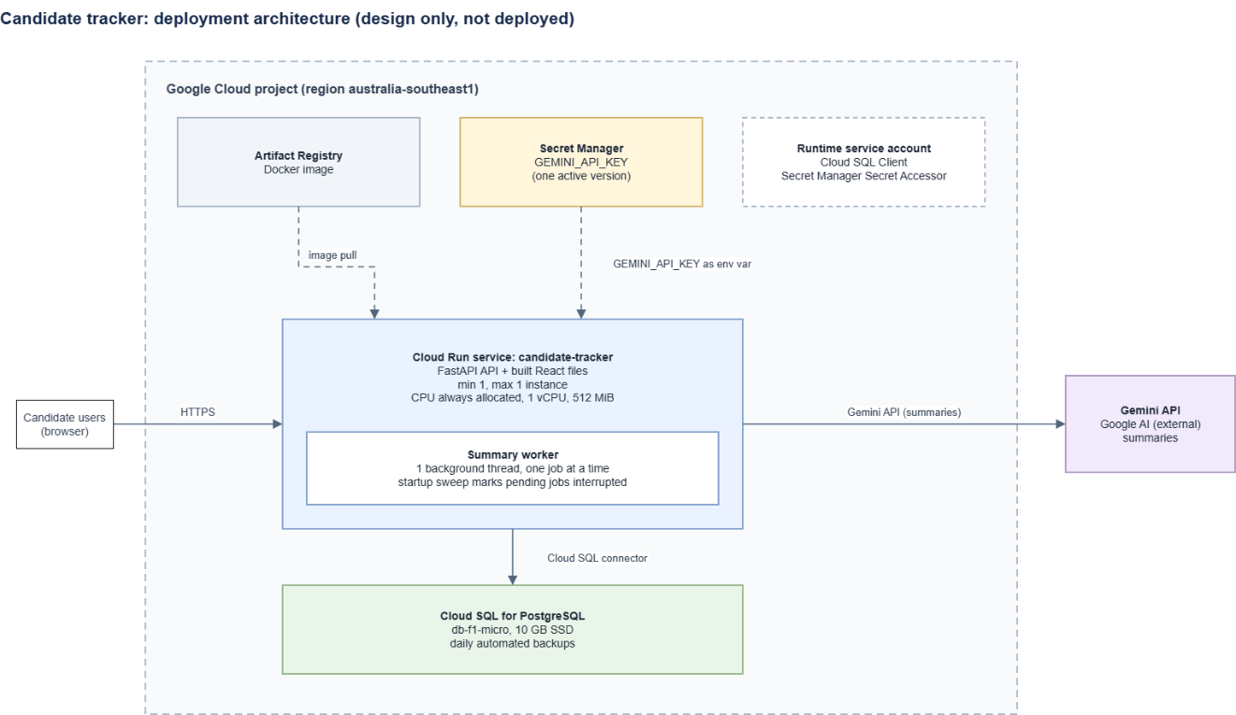
1.0 Architecture

2.0 Cost (per month estimation)
Item | Estimate
Cloud Run, always on | $45 to $55
Cloud SQL | $10 to $20
Secret Manager and Artifact Registry | under $1
Gemini API (about $0.002 per summary) | $0 to $5
Total | about $55 to $85

3.0 Code changes required
The app currently uses SQLite. To use PostgreSQL on Cloud SQL, it needs a configurable database URL, the psycopg driver, seed commands that support both databases and duplicate checks using unique constraint names instead of SQLite error messages. A Dockerfile is also needed to package the app for Cloud Run, with the server listening on the port provided through $PORT.

4.0 Scaling limit
Only one instance can run. Summaries run inside the app, and on startup the app marks every pending job as interrupted, so a second instance would break jobs that are running. Always-on CPU keeps the background worker running between requests. The next step is to move the worker to Cloud Run Jobs or Cloud Tasks.

5.0 Security and data
The key stays in Secret Manager. Candidate data is personal, so use a project with billing enabled, and check Gemini’s terms before loading real data. There is no sign-in yet, so add it before real use.

6.0 Deployment outline
Enable the APIs, create the Artifact Registry repository, build and push the image, create the Cloud SQL instance and the secret, run the migrations, deploy the Cloud Run service with the settings above, check /health and one summary, and roll back by redeploying the previous revision.

