SPECCHIO V3 Developer Guide

# Overview

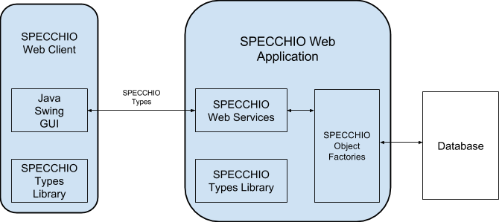

SPECCHIO V3 consists of three Java components:

* the SPECCHIO Types Library, which defines a set of Java classes representing spectra, metadata, instruments, and other entities used in the SPECCHIO system;
* the SPECCHIO Web Application, which implements a set of RESTful services through which clients can access and manipulate spectral data stored in a central database; and
* the SPECCHIO Web Client, a Java Swing GUI application that allows users to interact with the SPECCHIO Web Application.

SPECCHIO V3 was developed using Java 1.6, GlassFish 3.1.2.2 and MySQL 5.1.x. SPECCHIO V3 is expected to work with later versions of the same software, but may not work with earlier versions.

# Building SPECCHIO

## Obtaining Source Code

SPECCHIO’s source code is available from <https://github.com/IntersectAustralia/dc10>. Access to this repository requires git.

To create a local copy of the source code, execute

git clone <https://github.com/IntersectAustralia/dc10.git>

on the command line. Refer to git’s documentation for further details on obtaining updates from master repository and transmitting new code to the master repository.

The repository contains several directories as follows:

* conf contains the database definitions
* doc contains the user, administrator and developer guides in Microsoft Word format
* pkg contains the installable software and publishable documentation
* src contains the source code for the SPECCHIO application
  + src/types contains the SPECCHIO types library
  + src/webapp contains the SPECCHIO web application
  + src/client contains the SPECCHIO client
* web contains the web site used for user acceptance testing (no longer maintained)

## Building with Eclipse

Each of the src/types, src/webapp and src/client sub-directories of the source code repository contain an Eclipse project for developing that part of the application. These can be imported into an Eclipse workspace using the “Import…” option of the Project Explorer’s context menu.

1. In the “Import” dialogue, expand the “Git” node and select “Projects from Git”. Press the “Next” button.
2. Select the “Local”, then press “Next”.
3. Use the “Add…” button to add your local repository. Select it, then press “Next”.
4. Select “Import existing projects”, then press “Next”.
5. The projects should be added to the Project Explorer.

## Building with Ant

Each of the src/types, src/webapp and src/client sub-directories of the source code repository contain an Ant build file (build.xml).

* Execute ant dist in each sub-directory to build each component. Note that the types library must be built first, since the other two components depend on it.
* Execute ant package in the web application and client sub-directories to build the distributable files and copy them into the pkg directory. Packaging the client software requires version 5.0 or later of IzPack to be installed. See <http://izpack.org> for further information on this software.

There is also a top-level build file in the src directory that can be used to build all of the components with one invocation of ant dist in this directory. Building the package from this directory did not work at the time of writing.