SPECCHIO system GUI design

The current GUI design is one of the major parts of the project that has to be completed. The main aspect of this change comes from the current lack of usability for the end user, the design was created for use by the main program creator and thus many aspects are unique to the point of obscurity, this is not to say that the design is bad but more so that the general look and feel of the program is disjointed in certain aspects.

When carrying out this GUI update the main document that will be taken into account is the tutorial document given from both the website and from downloaded versions of the SPECCHIO system. The version of the SPECCHIO system that will be worked upon is the 3.1 release. This implementation runs java 7 linked to a MySQL database and is deployed on glassfish 3.1.2.2.

The current implementation of the GUI is as below. This implementation pops up this window and then all of the menu bars pop open a new window which causes a massive overlap in the design. The initial concept that will be work upon is taking the current window and implementing as much of the menu items into the blank space.

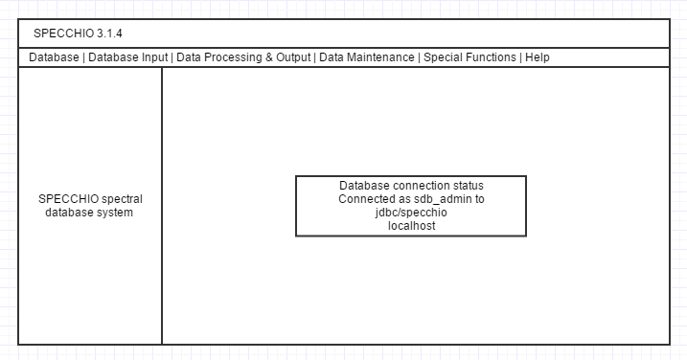The initial window runs at a frame of 700x350, this will be changed to a full screen resolution. Once this change has been made this will allow for the white space which is currently the specchio database system and database connection status parts of the current implementation to be used for processing instead of opening new frames.

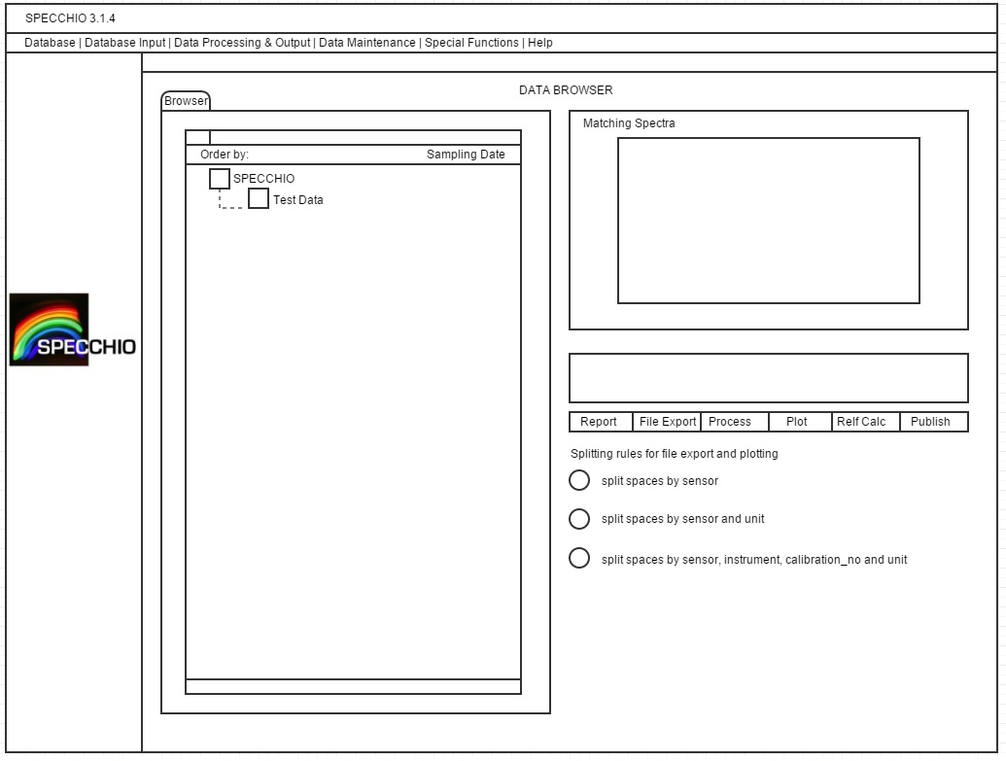This mock to the left will be a general mock-up of how the system will look in the data browser this is to give an idea of the shape of the windows.

Within the program the main thing that will remain untouched are the file explorer windows as it is common practice in operating systems to have a new window open when choosing files.

I choose Scneiderman’s 8 golden rules as the bases of GUI design and following some more closely than others. I will strive for consistency more than anything throughout which is the main problem I find the current system it is very disjointed in its approach and information may slip by in a small pop up that may have gone unnoticed.

[8 Golden Rules](http://faculty.washington.edu/jtenenbg/courses/360/f04/sessions/schneidermanGoldenRules.html)