AI Workshop

Animal Sound classification

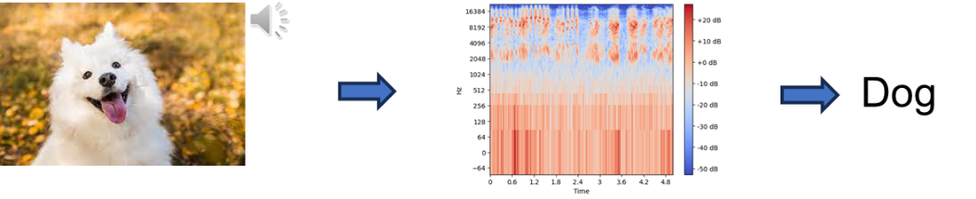

In this project, you need to create an classification model to perform audio classification. The input raw data is audio data in .wav format, and the output is the categories. ESC50 dataset is utilized to train and evaluate the model performance. However, the additional data is allowed to train the model.

We encourage everyone demonstrate your own creativity to improve the model performance. For example, data preprocessing technique, model architecture, training tricks and so on.

**Evaluation rule**

**Total score = 25**

|  |  |  |
| --- | --- | --- |
| **Code** | 5 | To get the full 5 points, you should hand in the reproducible code in .py or ipynb format.  The code must be easily implemented by the TA. |
| **Accuracy** | 5 | Score given in order.  The top 1/3 🡪 1 point  The middle 1/3 🡪 3 points  The last 1/3 🡪 5 points |
| **Report** | 15 | A clear PPT not exceeding 10 pages to show everything valuable in your code. |