

CSCU9YW
(Report)

[2410516]
Table of Contents
1. Outline of Problem 3
1.1 Description and Assumptions 3
1.2 Solution with screenshots of test cases 3
1.2.1 Empty composer name text field 3
1.2.2 Integer entered in composer name text field 4
1.2.3 Searching by finding specific characters in composer name 4
1.2.4 Finding track by composer name 5
1.2.5 Empty disc number field 5
1.2.6 Disc number entered in disc text field 6
1.2.7 Negative integer in disc number text field 6
1.2.8 String entered in disc number text field 7
1.2.9 Special character error handling in text fields 7
1.2.10 SOAP Monitor request and response example 7
2. Project completion 10
2.1 Completed implementation 10
2.2 Incomplete implementation and special cases 10
References 11
Appendices 12
Appendix 1: Services.wsdl file 12
Appendix 2: MusicService.java file 14
Appendix 3: Client.java file 17

Outline of Problem

Description and Assumptions
The objective of retrieving music tracks from a database, is achieved using a SOAP (Simple Object Access Protocol) based web service that connects to the database and retrieves music tracks based on composer names and disc numbers. The client created connects to the web service whenever the user pressed the “check” buttons on the client window.
With the creation of the WSDL (Web Services Description Language) file, Axis2’s[1] WSDL2JAVA tool[2] is used to convert the WSDL service file into Java – creating outline client code and outline server code to be used in Java code. The complex types that are created, are mapped to Java classes and then used within the web service as object classes.
No major assumptions are made throughout the development.

1.2 Solution with screenshots of test cases
In this sub-section, a series of screenshots will be shown, along with explanations of different test case scenarios. In the end an example of the request and response models will be shown too.

1.2.1 Empty composer name text field
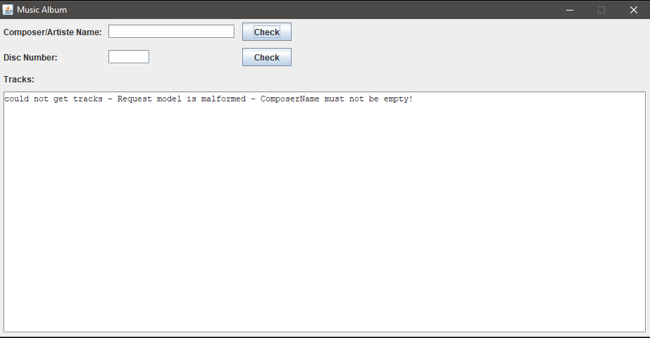
As shown in the image above: When the composer text field is left empty, and the corresponding check button is pressed, an error is outputted by the server to say that the “ComposerName” should not be empty.

1.2.2 Integer entered in composer name text field
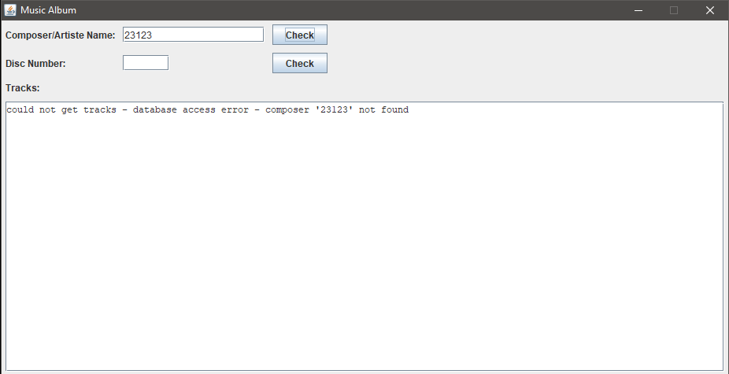
As shown in the image above: When the composer text field is an integer only, the web service still searches for a composer that may have a number in their name as part of their known artist name. In the case above, no composer is found with the specific number and therefore, a not found error is displayed in the client window.

1.2.3 Searching by finding specific characters in composer name
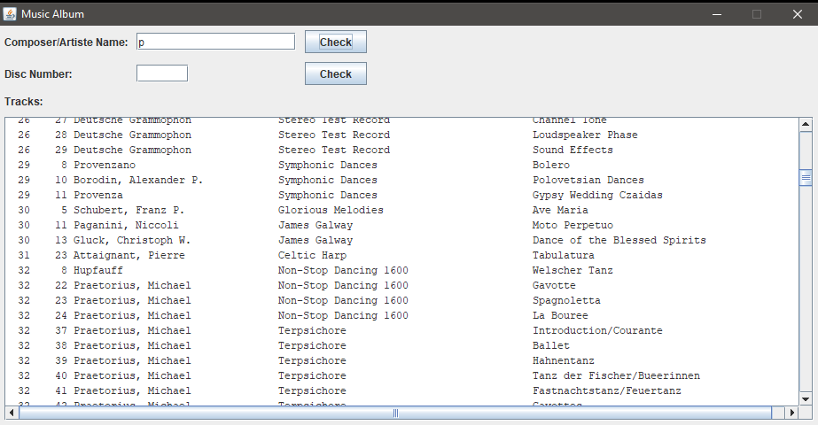
As shown in the image above: The web service searches for composer names that contain the letter “p” in their composer name. In other cases, if a full word was inputted then it would do the same with the word and look for composer names with the word in their name. In this case, the letter “p” returns many results.

1.2.4 Finding track by composer name
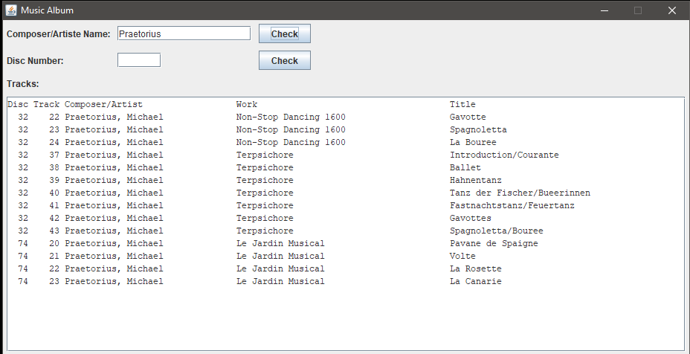
As shown in the image above: Searching for the composer name “Praetorius”, it returns all tracks that contain the string “Praetorius” in their composer name.

1.2.5 Empty disc number field
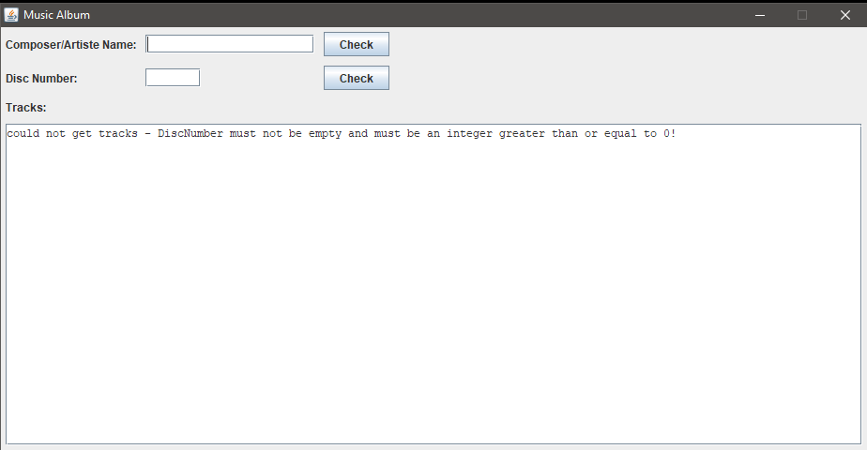
As shown in the image above: When the disc number text field is left blank, an error is displayed to tell the web service user to enter an integer greater than or equal to zero.

1.2.6 Disc number entered in disc text field
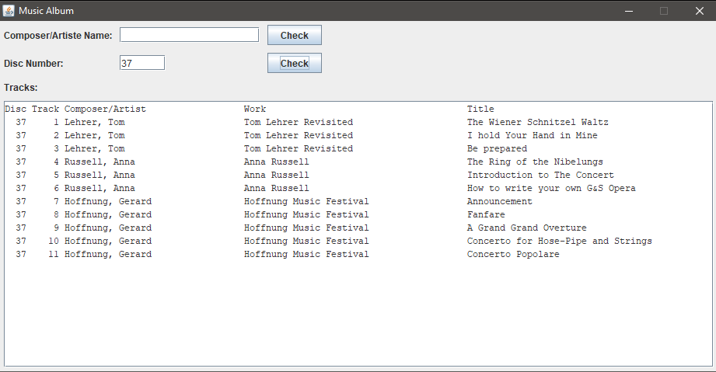
As shown in the image above: The disc number entered is “37” and therefore returns all the tracks within the disc number “37”.

1.2.7 Negative integer in disc number text field
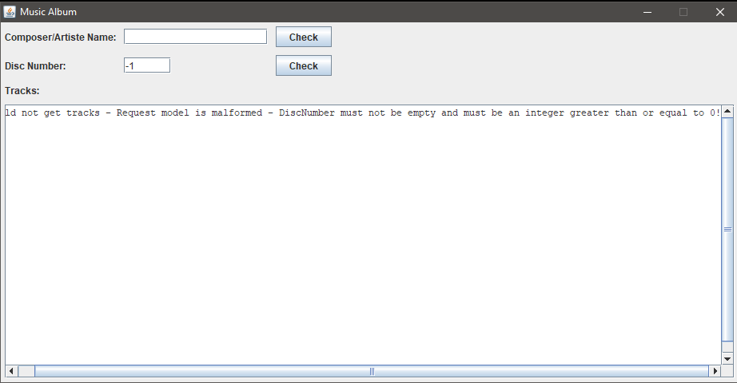
As shown in the image above: The integer being less than zero, returns an error to say that the request model is malformed, with appropriate explanation of what the request model should contain.

1.2.8 String entered in disc number text field
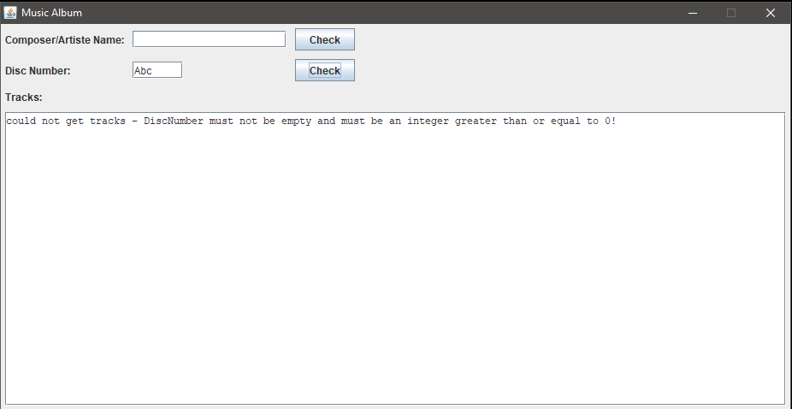
As shown in the image above: The disc number should be an integer greater than or equal to zero. In the case above, a string is inputted and therefore the web service user is warned to use an appropriate integer.

1.2.9 Special character error handling in text fields
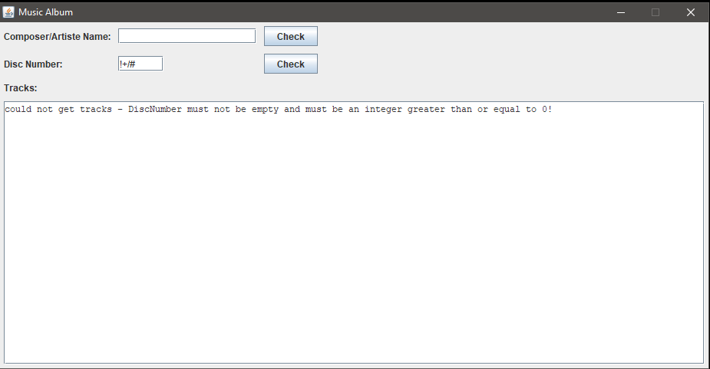
As shown in the image above: Some web services will throw exceptions due to special characters being entered, the text fields and sent along with the requests. Both the composer and disc text fields will handle special characters by asking the web service user to use appropriate values.

1.2.10 SOAP Monitor request and response example

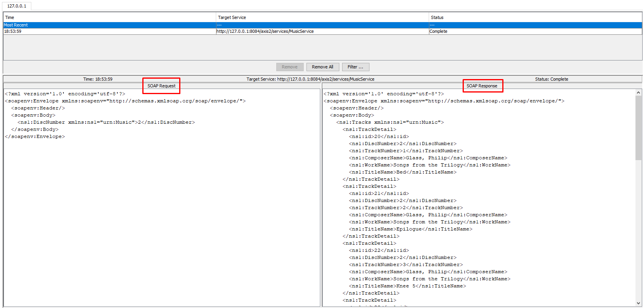

We can see in the above two images the request and response results shown in the Axis 2 SOAP Monitor [3]. This shows what the user has sent to the web service as a request, and what the web service has responded with, a response with the appropriate complex types.

2. Project completion

2.1 Completed implementation
All requirements were tackled and implemented fully – therefore, all functionality from the assignment sheet have been completed and added to the web service. In addition to the functionality, test cases have been thought of and explained in the screenshots in the previous chapter. The test cases were created before developing the web service and allowed strenuous manual-testing of the project in the end.
Implementation includes:
- SOAP web service using Document/Literal.
- GetByComposerName operation.
- GetByDiscNumber operation.
- Client implementation to allow testing of the web service.
- Documentation of functions and operations within the different parts of code.
- Implementation of SOAP faults, exceptions to be thrown upon issues within the web service and client requests and results. This displays correctly within the client and shows feedback if no music results are found.
- SOAP Monitor testing to ensure correct requests and responses.
- Refactored the code so that the composer name is searched for by looking for composer names that ‘contain’ a certain value, and that the disc number is searched for with an exact match. This has been changed as the supplied code was searching for disc numbers but returning results from other disc numbers too, rather than exact matches. See MusicService.java code in Appendix 2 for more details, clearly commented too.

2.2 Incomplete implementation and special cases
There are no incomplete implementation and no special cases to be considered.

References
[1] (2018/11/16). Apache Axis2 – Apache Axis2/Java - Next Generation Web Services. Available: https://axis.apache.org/axis2/java/core/.
[2] (2018/11/16). Apache Axis2 – Apache Axis2 User's Guide- Creating Clients. Available: http://axis.apache.org/axis2/java/core/docs/userguide-creatingclients.html.
[3] (2018/11/16). Apache Axis2 – The SOAP Monitor Module. Available: https://axis.apache.org/axis2/java/core/docs/soapmonitor-module.html.

Appendices

Appendix 1: Services.wsdl file
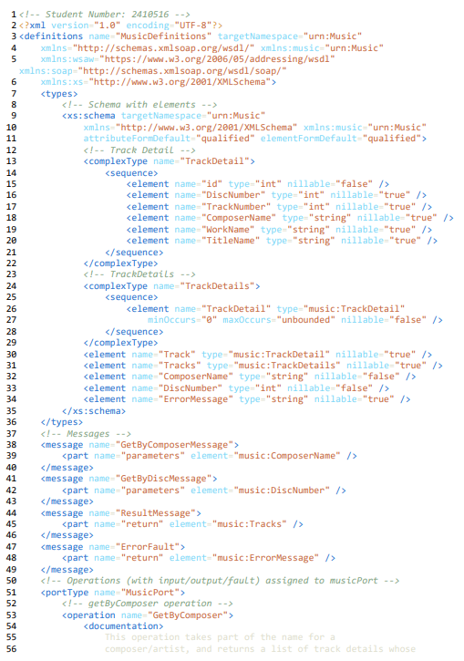
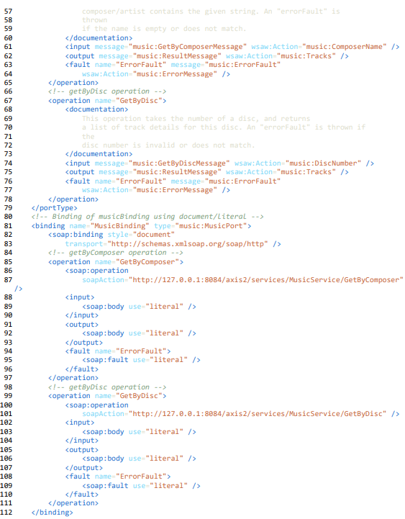
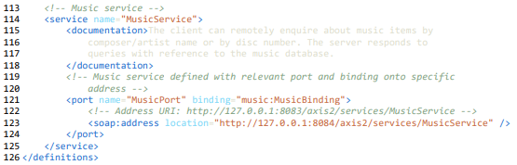

Appendix 2: MusicService.java file
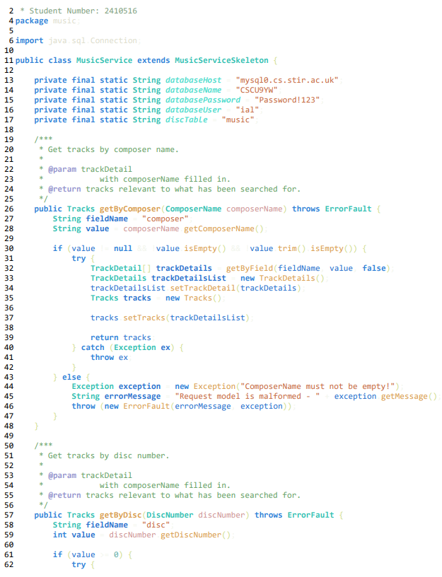
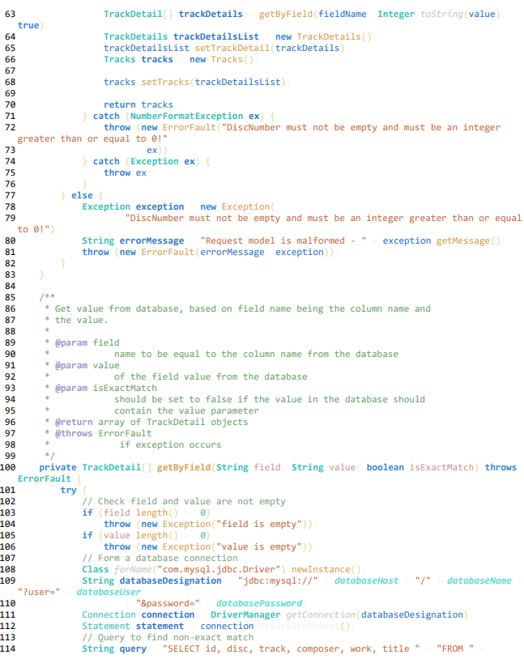
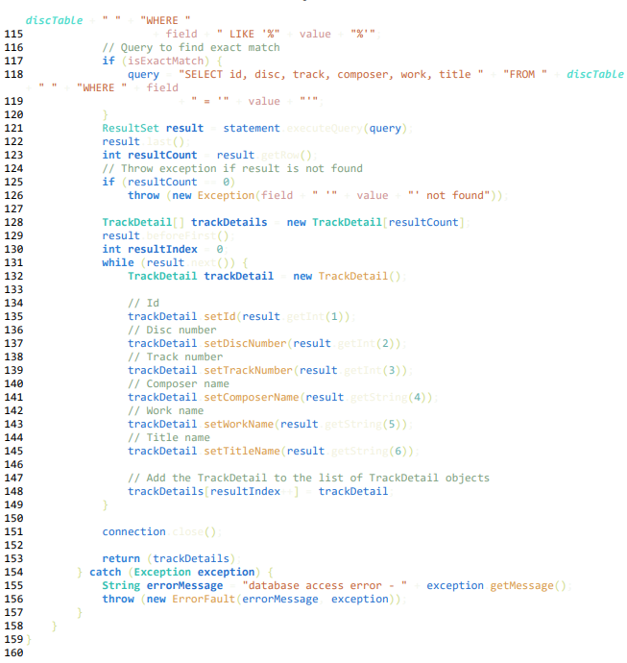

Appendix 3: Client.java file
