**Lumé: Intelligent Matchmaking and Emotion-Aware Dating App Powered by AI**

By

Choo Ting Feng



FACULTY OF COMPUTING AND

INFORMATION TECHNOLOGY

TUNKU ABDUL RAHMAN UNIVERSITY OF MANAGEMENT AND TECHNOLOGY

KUALA LUMPUR

ACADEMIC YEAR

**2024/25**

**Lumé: Intelligent Matchmaking and Emotion-Aware Dating App Powered by AI**

By

Choo Ting Feng

Supervisor: Nur Shidah Binti Ahmad Sharawardi

A project report submitted to the

Faculty of Computing and Information Technology

in partial fulfillment of the requirement for the

Bachelor of Software Engineering (Honours)

Choose an item.

Faculty of Computing and Information Technology

Tunku Abdul Rahman University of Management and Technology

Kuala Lumpur

**Copyright by Tunku Abdul Rahman University of Management and Technology.**

All rights reserved. No part of this project documentation may be reproduced, stored in retrieval system, or transmitted in any form or by any means without prior permission of Tunku Abdul Rahman University of Management and Technology

**Declaration**

The project submitted herewith is a result of my own efforts in totality and in every aspect of the project works. All information that has been obtained from other sources had been fully acknowledged. I understand that any plagiarism, cheating or collusion or any sorts constitutes a breach of TAR University rules and regulations and would be subjected to disciplinary actions.

Feng

__________________________

Choo Ting Feng

Bachelor of Software Engineering (Honours) in Software Engineering

ID: 24PMR00544

**Abstract**

This project proposes *Lumé: Intelligent Matchmaking and Emotion-Aware Dating App Powered by AI*, a web-based platform designed to transform the online dating experience through intelligent matching, emotional awareness, and enhanced safety. Existing dating platforms often rely on superficial matching mechanisms and suffer from poor user trust, limited emotional depth in interactions, and frequent incidents of harassment. In Malaysia, where over 40% of young adults have engaged with such platforms, these limitations highlight the urgent need for an improved solution. Lumé addresses these challenges by integrating K-Means clustering to recommend users based on deeper compatibility, and real-time sentiment analysis to interpret conversational tone, enhancing both connection quality and user experience. Toxic chat filters powered by the Perspective API and manual photo moderation are employed to maintain safety and authenticity within the platform.  
  
The project is developed using an Agile incremental methodology, with two-week sprints allowing for iterative design, development, and refinement. The technology stack includes Angular for frontend development, .NET Core Web API for backend operations, and SQL Server for secure data storage. Cloud deployment is handled via Microsoft Azure, ensuring scalability and accessibility. Sentiment and toxicity detection models are integrated via external APIs, while clustering logic is implemented locally using ML.NET. Testing involves unit, integration, and usability assessments, focusing on system functionality, emotional tone accuracy, engagement responsiveness, and overall user satisfaction.  
  
The results are expected to demonstrate Lumé’s strength in fostering safe, emotionally attuned, and authentic connections compared to traditional platforms. Limitations may include challenges in accurately interpreting user sentiment and reliance on third-party APIs for moderation. Nevertheless, Lumé serves as a proof of concept that AI can enhance online dating by offering not only smarter matches but also a more respectful and human-centered communication space. Future plans include expanding to mobile platforms and refining AI models through user feedback and real-world usage data.

**Table of Contents**

**3 Methodology and Requirement Analysis 2**

3.1 Introduction 2

3.2 Requirements Gathering Techniques 3

3.2.1 Questionnaire 3

3.2.1.1 Section 1: Demographic Information 5

3.2.1.2 Section 2: Dating App Usage and Preferences 8

3.2.1.3 Section 3: Intelligent Matchmaking 11

3.2.1.4 Section 4: Emotion-Aware Features 13

3.2.1.5 Section 5: Safety and Privacy 15

3.3 Requirement Analysis 21

3.3.1 Overall Use Case Diagram 21

3.3.1.1 Account Management Module (AM) 22

3.3.1.2 Administration Module (AD) 27

3.3.1.3 User Management Module (UM) 33

3.3.1.4 Likes Feature Module (LF) 39

3.3.1.5 Messaging Feature Module (MF) 43

3.3.2 Activity Diagram 47

3.3.2.1 Account Management Module 47

3.3.2.2 Administration Module 51

3.3.2.3 User Management Module 54

3.3.2.4 Likes Feature Module 58

3.3.2.5 Messaging Feature Module 60

3.4 Functional and Non-Functional Requirement 63

3.4.1 Functional Requirement 63

3.4.1.1 Account Management Module 63

3.4.1.2 Administration Module 63

3.4.1.5 Users Management Module 64

3.4.1.3 Likes Features Module 64

3.4.1.4 Messaging Features Module 64

3.4.2 Non-Functional Requirements 65

3.4.2.1 Usability 65

3.4.2.2 Availability 65

3.4.2.3 Maintainability 66

3.4.2.4 Security 66

3.4.2.5 Additional System-Wide Requirements 66

3.5 Chapter Summary and Evaluation 68

**References 69**

Chapter 3

**Methodology and Requirements Analysis**

## 

# 3 Methodology and Requirement Analysis

## 3.1 Introduction

In this chapter, we dive into the heart of Lumé’s creation process, exploring the two key fact-gathering methods that fueled the development of this AI-powered dating app. To understand the diverse needs of our future users, we launched a comprehensive questionnaire, reaching out through email and social media to connect with people across different ages, genders, and walks of life. This wasn’t just about collecting basic data—it was about uncovering how potential users view AI as a matchmaker and companion in their quest for connection.

To deepen our understanding, we sat down with a relationship expert for an insightful interview, tapping into their expertise on the emotional and psychological layers of modern romance. Together, these approaches revealed critical insights into what users crave from an online dating experience, guiding the design of Lumé’s standout features like AI-enhanced communication and emotionally intelligent matchmaking.

Moving forward, this chapter will bring Lumé’s vision into focus through UML diagrams. Use case diagrams will paint a picture of how users will interact with our AI-driven tools, paired with detailed descriptions and activity diagrams that map out the seamless flow of tasks within the app. We’ll also unpack the functional and non-functional requirements that define Lumé’s capabilities, ensuring it delivers both performance and a user experience that feels personal and intuitive. By weaving in requirement traceability, we’ll connect every user insight to the features that bring Lumé to life, offering a clear roadmap from discovery to implementation.

## 

## 3.2 Requirements Gathering Techniques

### 3.2.1 Questionnaire

A questionnaire, commonly known as a survey, is a research tool comprising a series of questions aimed at collecting data on respondents’ attitudes, behaviors, and preferences. For the Lumé dating app, the Lumé User Survey was designed to gather insights into users’ needs and expectations, particularly for an AI-driven dating platform targeting the youth generation.

The survey was conducted using Google Forms, a convenient and accessible tool for data collection. I shared the survey through my social media platforms, targeting individuals around my age—22 years old—to understand their perspectives on dating apps. At this age, many of us face similar challenges, such as limited social circles, making it critical to explore how AI features like intelligent matchmaking and emotion-aware communication can address these issues. A total of 47 responses were collected, offering valuable feedback on dating app preferences and experiences.

The survey included questions on demographics, dating app usage, and opinions about Lumé’s unique AI features, such as analyzing chat tones or suggesting replies based on emotions. This data will guide the app’s development, ensuring it meets the needs of users, especially in Malaysia and Southeast Asia, by prioritizing features that resonate with this demographic.

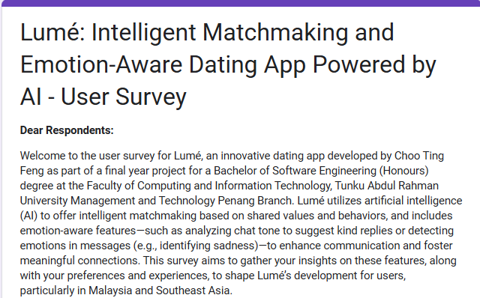

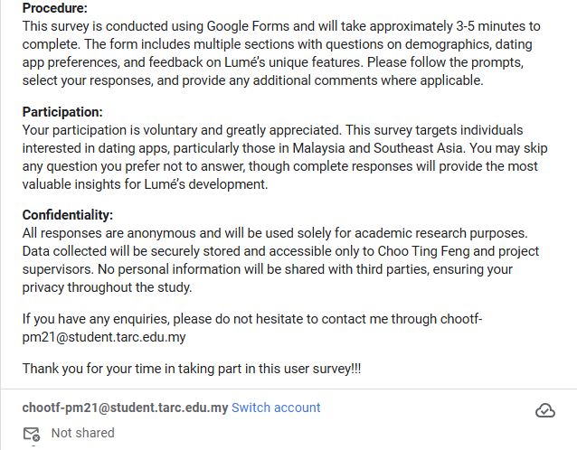

Figure 3.1: Title and description of Lumé’s user survey

The description for the Lumé User Survey welcomes respondents to provide feedback on an innovative dating app developed by Choo Ting Feng as part of a final-year project, highlighting its AI-powered features like intelligent matchmaking and emotion-aware communication. Conducted via Google Forms, the survey takes 3-5 minutes and includes sections on demographics, preferences, and feedback to shape Lumé’s development, targeting users in Malaysia and Southeast Asia.

No sign-in is required to answer the form, reinforcing the confidentiality statement that Lumé prioritizes user privacy. This approach ensures that respondents can share their true opinions without worrying about identity leaks, as all responses are anonymous and used solely for academic research. By respecting privacy even at this Methodology and Requirement Analysis —evidenced by secure data storage accessible only to Choo Ting Feng and supervisors—this method maximizes the collection of valuable, authentic feedback, aligning with Lumé’s commitment to user trust.

### 3.2.1.1 Section 1: Demographic Information

This section helps us understand our potential user base for the Lumé dating app, ensuring we capture a diverse range of perspectives to shape its AI-driven features. By collecting basic information about age, gender, relationship status, and location, we can tailor the app’s intelligent matchmaking and emotion-aware communication tools to meet the needs of users, particularly the youth generation in Southeast Asia.

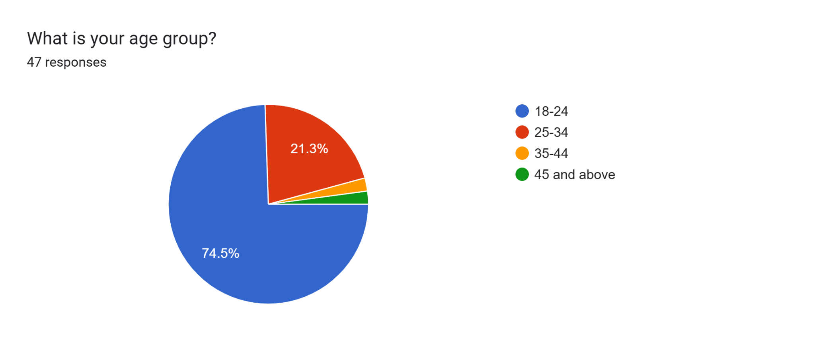

Figure 3.2: Age Distribution

The majority of participants, accounting for 74.5%, fall within the 18-24 age group. This significant representation aligns with the survey’s focus on the youth generation, particularly around the developer’s age of 22, where individuals often face challenges with limited social circles and can benefit from Lume’s AI-driven features like emotion-aware communication. The 25-34 age group follows with 21.3%, comprising young professionals who might value the app’s intelligent matchmaking for efficient dating opportunities. Meanwhile, the 35-44 and 45+ age groups each contribute a mere 2.1%, indicating minimal participation from mid-career and older adults, possibly due to the survey’s targeted reach. These findings underscore Lume’s strong appeal to younger users, providing a clear direction to prioritize features that cater to their specific needs and preferences as the app continues to develop.

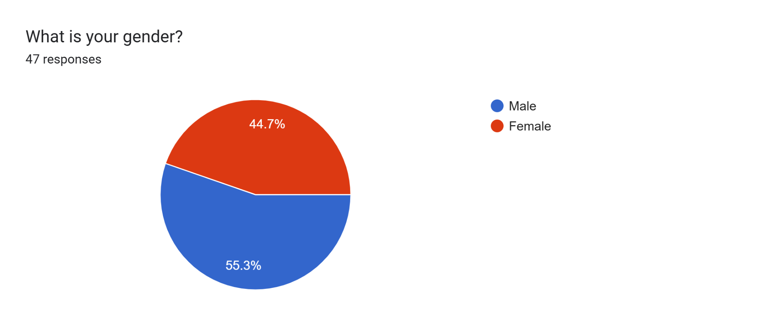

Figure 3.3: Gender Distribution

The chart shows that 55.3% of respondents identified as Male, while 44.7% identified as Female. This nearly balanced gender distribution suggests a broad appeal among young users. The slight majority of male respondents may indicate a slightly higher engagement from this group, possibly due to their interest in exploring AI-enhanced dating tools to address challenges like limited social circles. For Lumé’s development, this balance provides an opportunity to design features that cater to both genders equally, such as emotion-aware chat analysis that adapts to diverse communication styles.

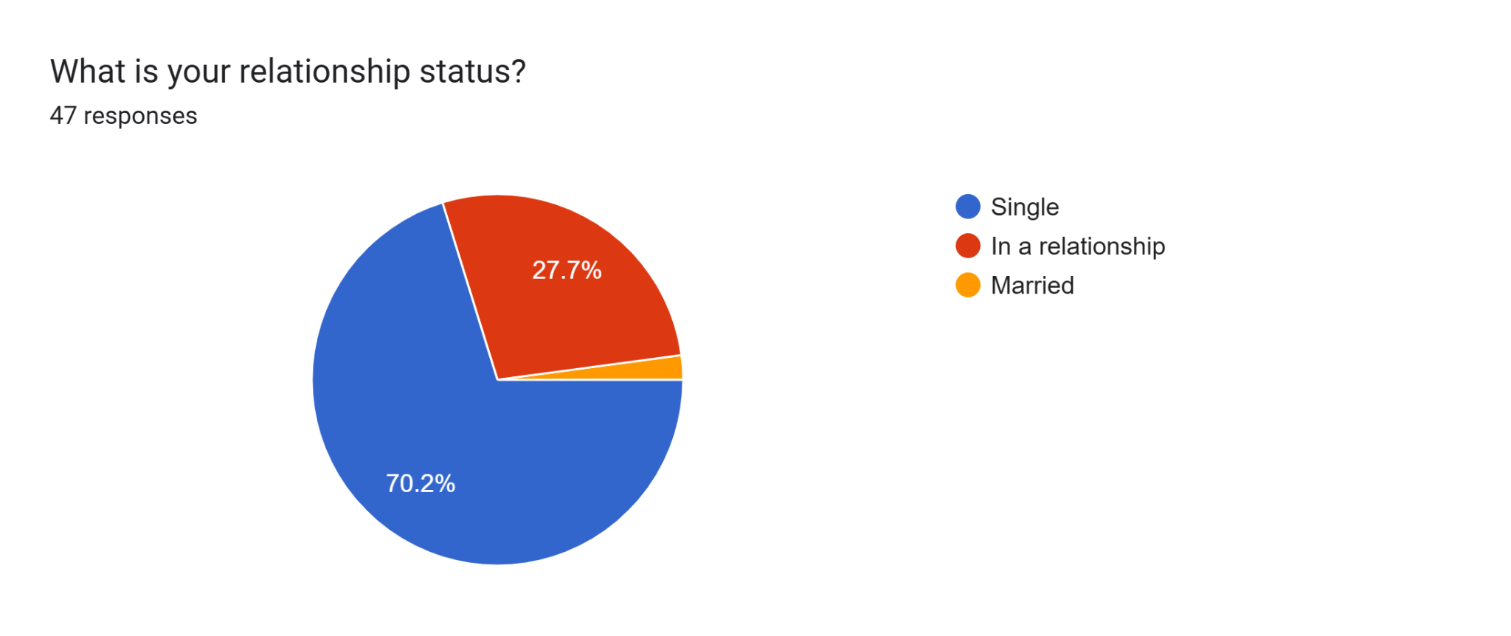

Figure 3.4: Relationship Status Distribution

The chart reveals that 70.2% of respondents are Single, indicating a strong potential user base for a dating app. The 27.7% who are In a relationship suggest a smaller but notable group that might provide insights into maintaining connections, possibly influencing emotion-aware communication features. Only 2.1% are Married, reflecting minimal participation from this group, likely due to the survey’s youth-centric reach. This distribution underscores Lumé’s primary appeal to single individuals, guiding the app’s development to prioritize features that enhance matchmaking and relationship-building for this demographic in the Southeast Asian market.

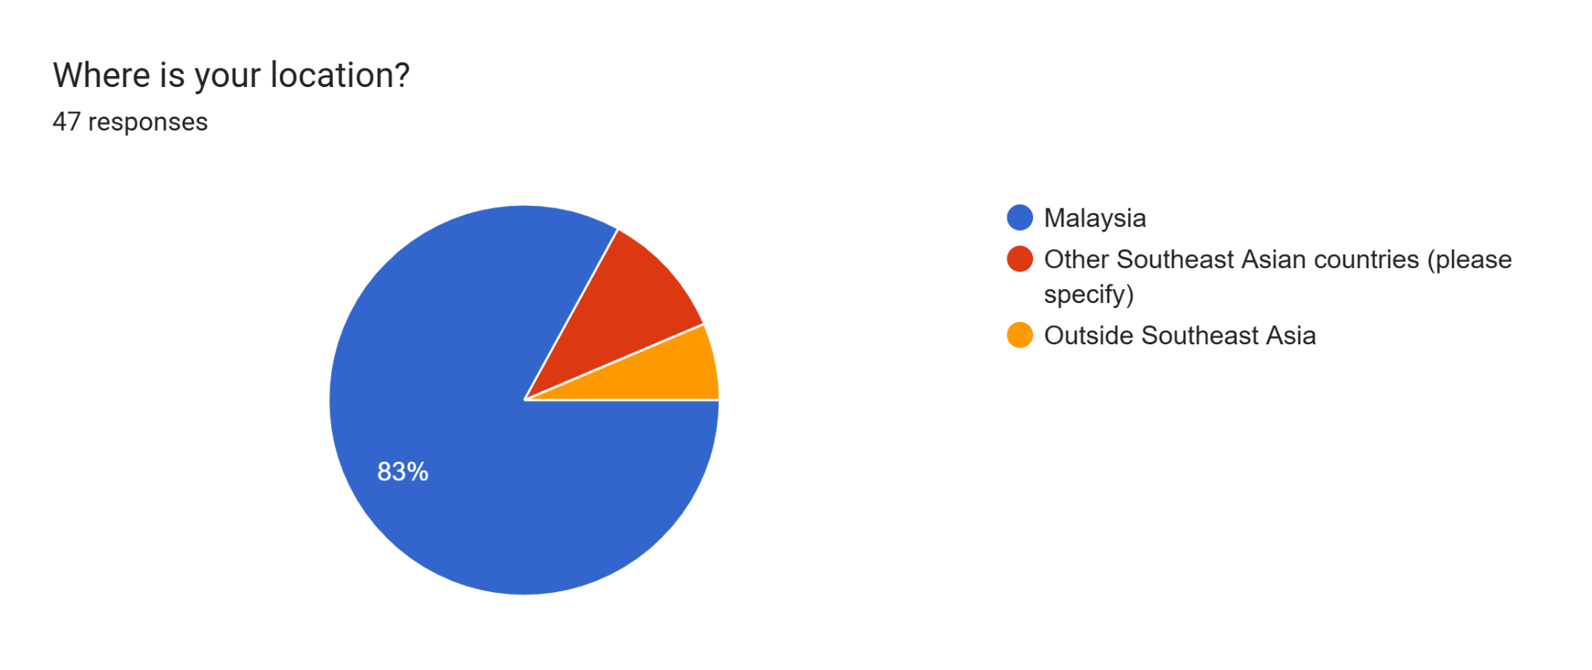

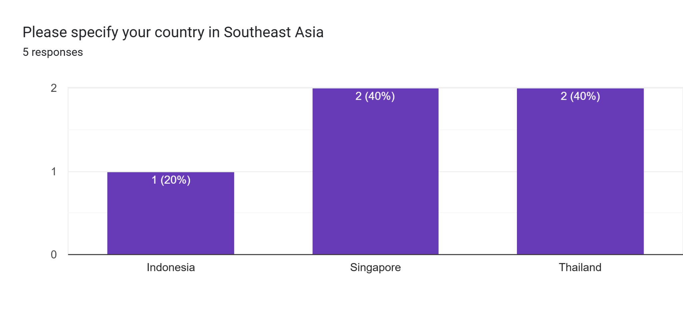

Figure 3.5: Location Distribution

The pie chart shows that 83% of respondents are from Malaysia, reflecting the survey’s primary focus on this country. Other Southeast Asian countries (please specify) account for 10.6%, with a follow-up bar chart detailing 5 responses: 2 (40%) from Singapore, 2 (40%) from Thailand, and 1 (20%) from Indonesia. Only 6.4% of respondents are from Outside Southeast Asia. This strong representation from Malaysia, combined with modest participation from other Southeast Asian nations, confirms the app’s regional relevance. For Lumé’s development, this data suggests prioritizing features that cater to Malaysian users while considering adaptations for broader Southeast Asian preferences, enhancing its appeal across the targeted market.

### 3.2.1.2 Section 2: Dating App Usage and Preferences

This section of the Lumé User Survey explores your experiences and preferences with dating apps, aiming to understand current usage habits and identify areas for improvement. It prioritizes gathering insights into the challenges users face and the features they value, helping Lumé tailor its offerings to better meet the needs of the Southeast Asian youth market.

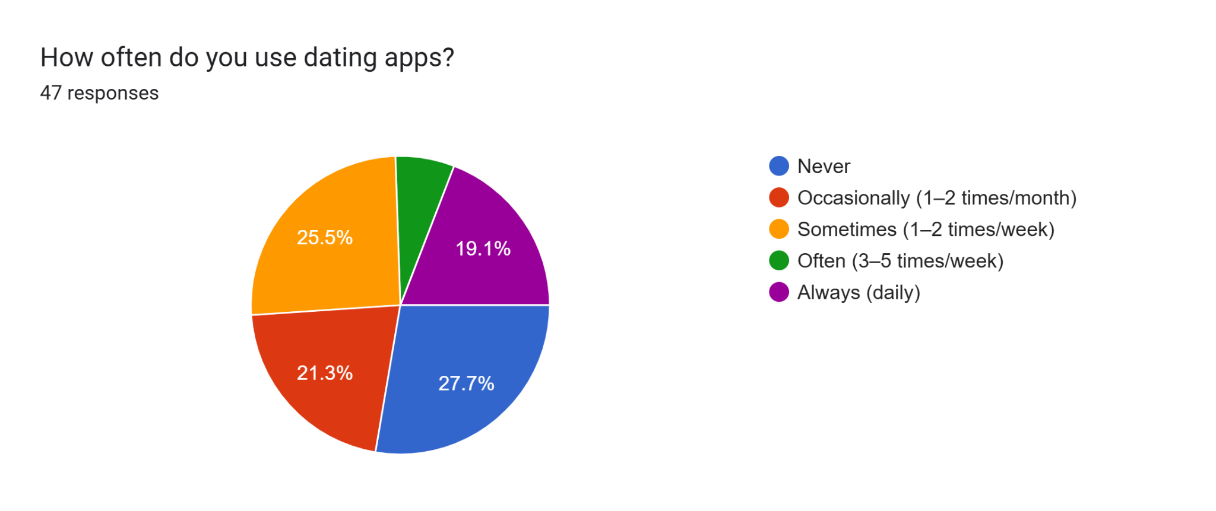

Figure 3.6: Frequency of Dating App Usage

The pie chart indicates that 27.7% of respondents Never use dating apps, suggesting a segment that may need encouragement to adopt such platforms. Occasionally (1-2 times/month) and Sometimes (1-2 times/week) usage each account for 21.3% and 25.5%, respectively, reflecting moderate interest. Often (3-5 times/week) and Always (daily) usage are reported by 19.1% and 6.4%, respectively, indicating a smaller but dedicated user base. Together, the total of Occasionally, Sometimes, Often, and Always (21.3% + 25.5% + 19.1% + 6.4% = 72.3%) demonstrates that the majority of respondents have used dating apps before, contrasting with the 27.7% who never have. This distribution highlights a significant opportunity for Lumé to attract and retain users, particularly by enhancing features like emotion-aware communication to boost engagement among occasional and non-users in the Southeast Asian market.

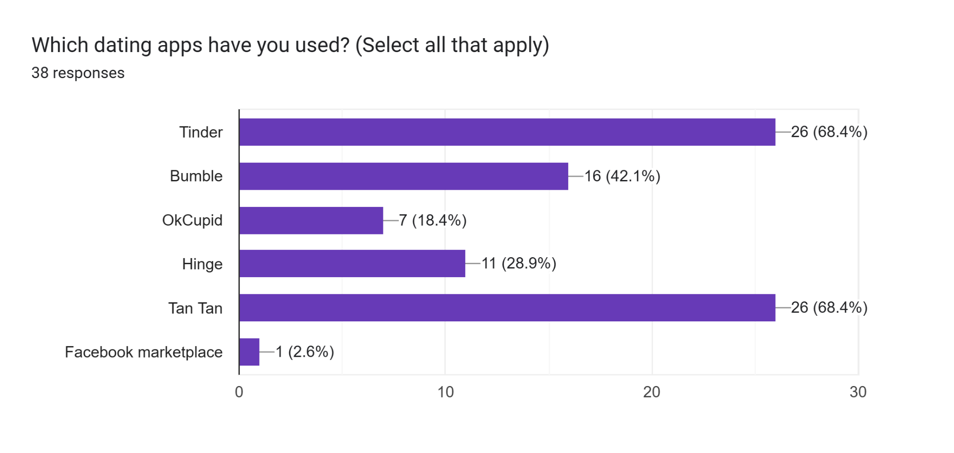

Figure 3.7: Dating Apps Used

The bar chart shows that Tinder and TanTan are the most used apps, each with 26 responses (68.4%), indicating strong familiarity with these platforms. Hinge follows with 11 responses (28.9%), while Bumble has 16 responses (42.1%). OkCupid has 7 responses (18.4%), and Facebook Marketplace has the least usage with 1 response (2.6%). However, Facebook Marketplace can be ignored as a relevant data point, as it is not a dating site but was likely entered under the "Others" option, where respondents may have mistaken it for Facebook Dating, which was intended as an option. This suggests the single response may reflect confusion rather than actual usage. This distribution highlights a preference for widely recognized apps like Tinder and TanTan, suggesting Lumé should focus on matching or enhancing their appeal with unique AI features, such as emotion-aware communication, to attract users in the Southeast Asian market. Additionally, Lumé can study from Tinder and TanTan, which have the highest percentage, to understand successful user engagement strategies and adapt their effective elements, like user-friendly interfaces or robust matchmaking algorithms, to strengthen its own development.

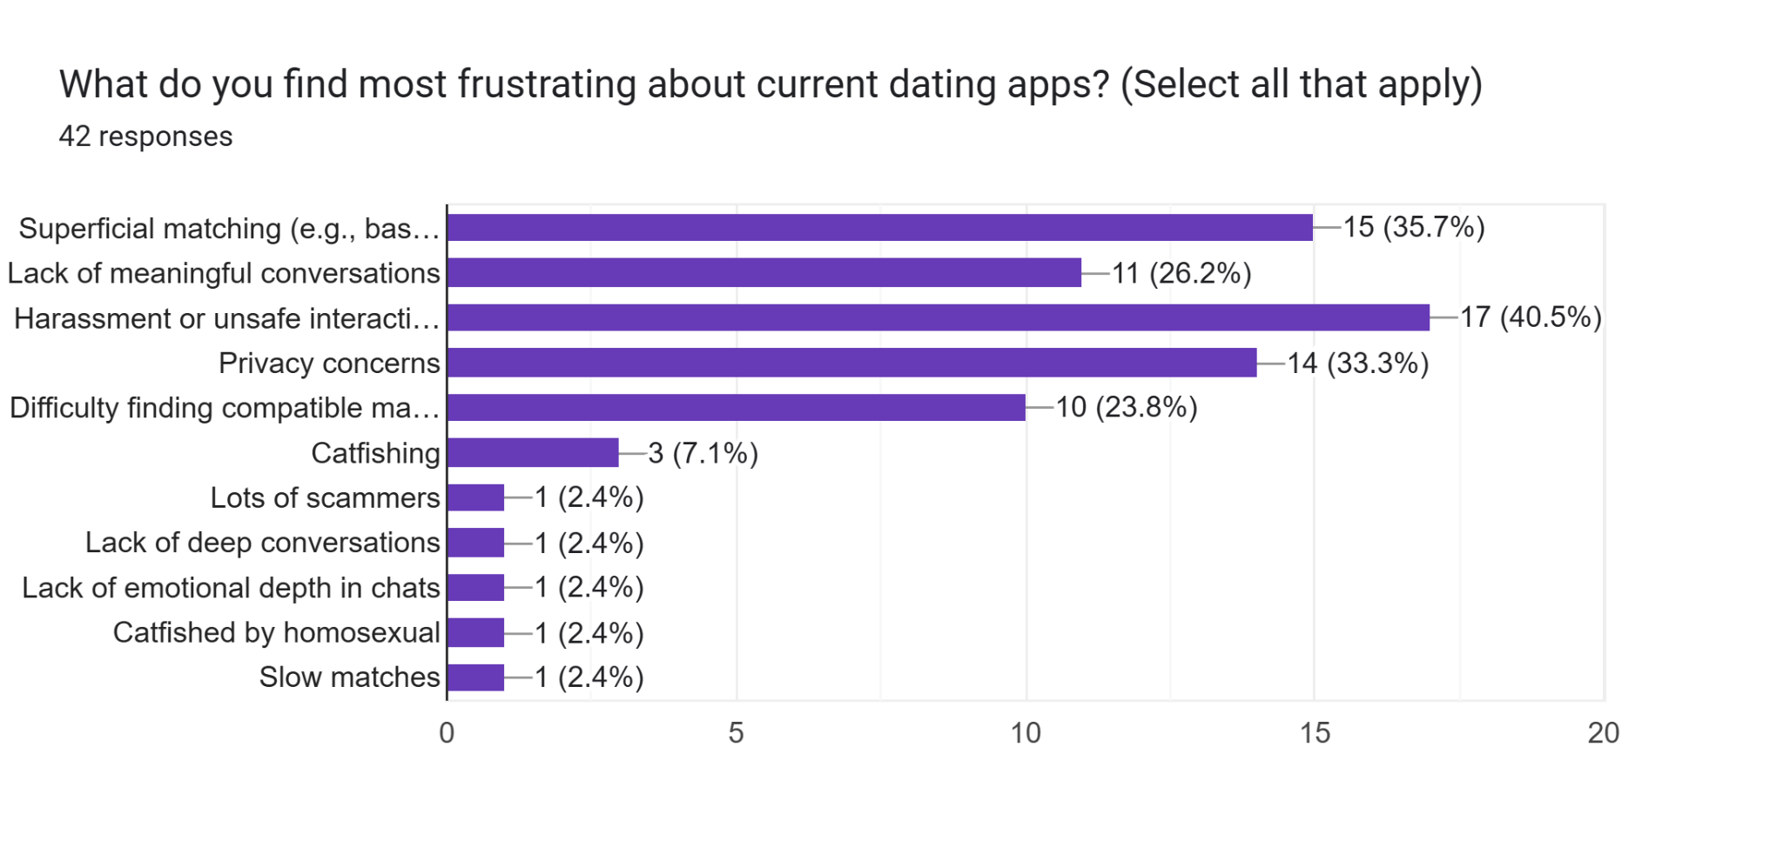

Figure 3.8: Most Frustrating Aspects of Current Dating Apps

The bar chart reveals that Harassment or unsafe interactions topped the list with 17 responses (40.5%), indicating a significant concern for user safety. Privacy concerns followed with 14 responses (33.3%), highlighting the importance of secure data handling. Superficial matching (e.g., based on looks) and Lack of meaningful conversations each had 15 (35.7%) and 11 (26.2%) responses, respectively, pointing to dissatisfaction with current matchmaking quality. Difficulty finding compatible matches was noted by 10 respondents (23.8%), while Catfishing, Lack of deep conversations, Lack of emotional depth in chats, Catfished by homosexual, and Slow matches each received 1-3 responses (1.2%-7.1%), suggesting lesser but still relevant issues. These findings suggest Lumé should prioritize enhancing safety features, privacy measures, and deeper matchmaking algorithms to address the most pressing frustrations in the Southeast Asian market.

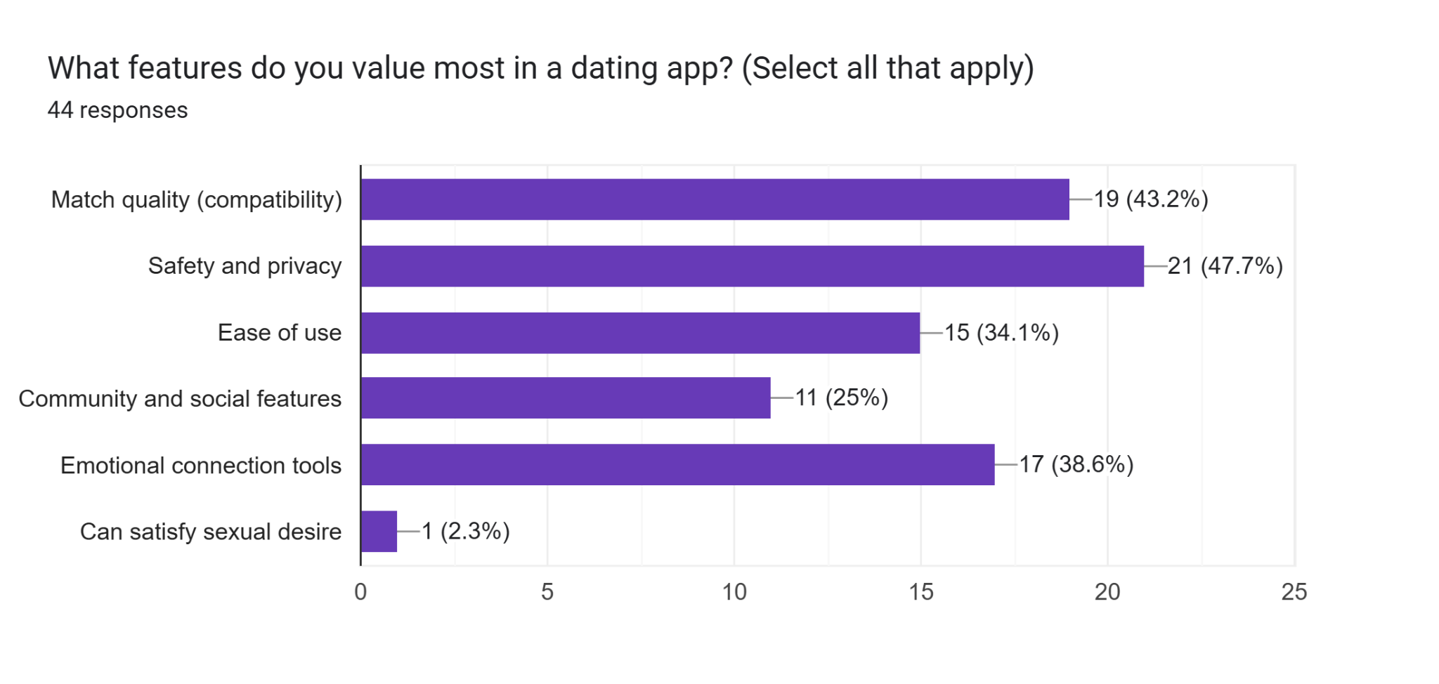

Figure 3.9: Most Valued Features in a Dating App

The bar chart shows that Safety and privacy is the most valued feature, with 21 responses (47.7%), underscoring the importance of secure user experiences. Match quality (compatibility) follows closely with 19 responses (43.2%), highlighting a demand for effective matchmaking. Emotional connection tools received 17 responses (38.6%), suggesting interest in deeper interaction features. Ease of use was noted by 15 respondents (34.1%), indicating a preference for user-friendly design, while Community and social features had 11 responses (25%). Can satisfy sexual desire was the least valued, with only 1 response (2.3%). These findings suggest Lumé should prioritize safety, privacy, and compatibility features, leveraging its AI capabilities to enhance user trust and connection in the Southeast Asian market.

### 

### 3.2.1.3 Section 3: Intelligent Matchmaking

This section focuses on your preferences for matchmaking features, seeking to determine the importance of compatibility beyond superficial traits. It prioritizes understanding user interest in deeper matching criteria, guiding Lumé to enhance its AI-driven intelligent matchmaking technology to align with user expectations.

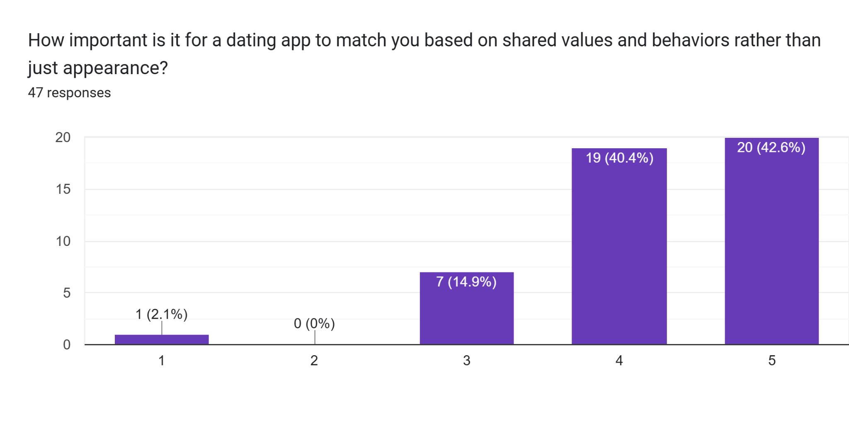

Figure 3.10: Importance of Matching Based on Shared Values and Behaviors

The bar chart shows a strong preference for value- and behavior-based matching, with 19 respondents (40.4%) rating it a 4 and 20 (42.6%) rating it a 5 on a scale of 1 to 5 (1 not important at all, 5 being very important). This totals 82.9% of respondents valuing it highly (4 or 5). Only 7 respondents (14.9%) rated it a 3, while 1 (2.1%) rated it a 1, and none rated it a 2. This overwhelming support indicates that users prioritize meaningful compatibility over superficial traits, suggesting Lumé should enhance its AI algorithms to focus on shared values and behaviors to meet the needs of the Southeast Asian market.

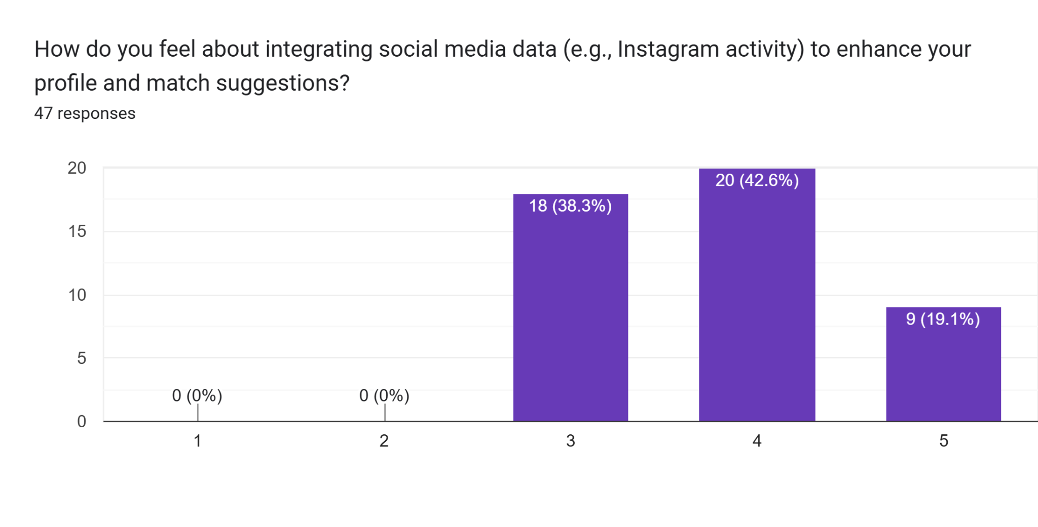

Figure 3.11: Opinion on Integrating Social Media Data for Profile and Match Suggestions

The bar chart shows a positive reception, with 20 respondents (42.6%) rating it a 4 and 18 (38.3%) rating it a 5 on a scale of 1 to 5 (1 being not comfortable at all, 5 being very comfortable), totaling 81.9% in favor (4 or 5). Nine respondents (19.1%) rated it a 3, while no one rated it 1 or 2 (0% each). This strong support suggests that users are open to using social media data to enhance their profiles and matches, indicating Lumé should consider integrating such features to improve personalization and compatibility in the Southeast Asian market, while ensuring robust privacy measures.

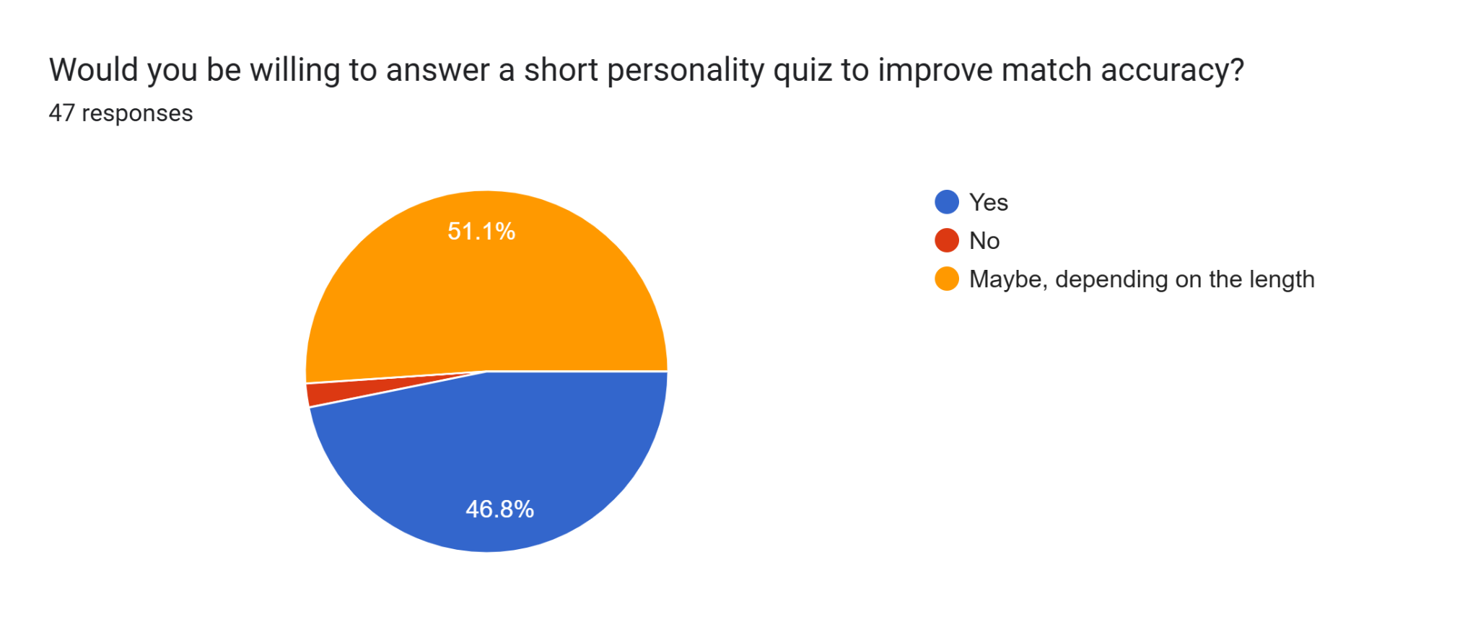

Figure 3.12: Willingness to Answer a Personality Quiz for Match Accuracy

The pie chart shows that 51.1% of respondents selected “Maybe, depending on the length”, indicating a majority are willing to participate. A close 46.8% chose “Yes”, suggesting conditional acceptance based on quiz duration. Only 2.1% selected “No”, reflecting minimal outright resistance. This distribution highlights strong user interest in improving match accuracy through personality quizzes, with Lumé potentially increasing participation by keeping the quiz concise and user-friendly to address the "Maybe" group’s concerns in the Southeast Asian market.

### 3.2.1.4 Section 4: Emotion-Aware Features

This section of the Lumé User Survey delves into your interest in emotion-aware technologies, a cornerstone of the Lumé dating app’s core technology. Lumé utilizes sentiment analysis with a custom-trained algorithm to analyze conversation text, enabling features like intelligent reply suggestions and emotional insights to enhance user interactions. The results across this section overwhelmingly show positive responses, indicating strong user support for this innovative approach.

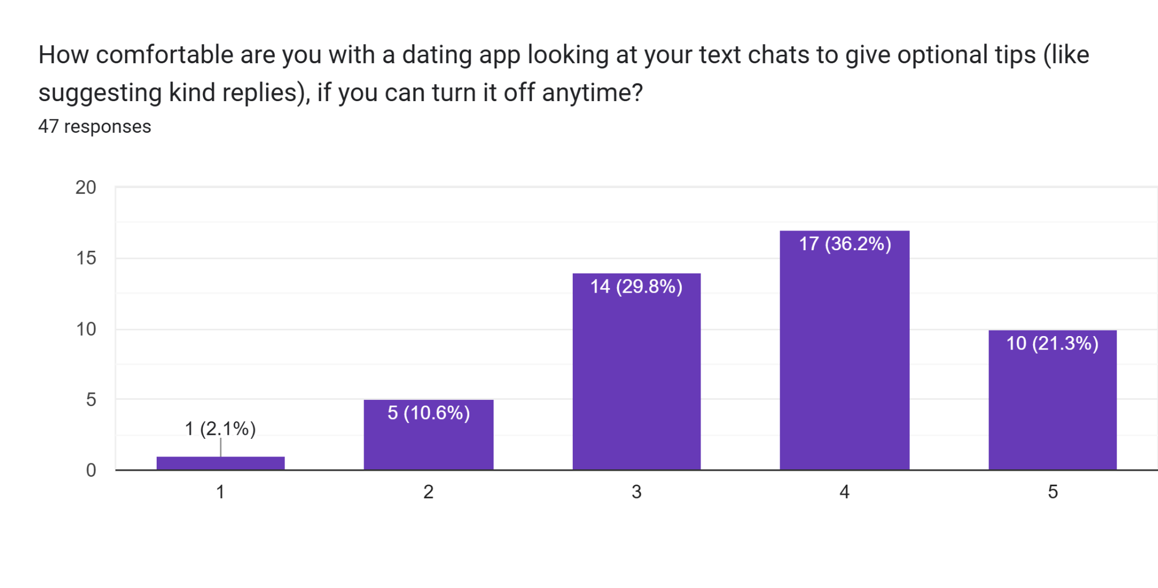

Figure 3.13: Comfort Level with Dating App Analyzing Text Chats for Optional Tips

The bar chart shows a generally positive response, with 17 respondents (36.2%) rating their comfort level a 4 and 14 (29.8%) rating it a 5 on a scale of 1 to 5 (1 being not comfortable at all, 5 being very comfortable), totaling 66% in favor (4 or 5). Ten respondents (21.3%) rated it a 3, indicating neutrality, while 5 (10.6%) rated it a 2 and 1 (2.1%) rated it a 1, reflecting minor discomfort. The option to turn off the feature likely boosts acceptance, suggesting Lumé should implement this core functionality with clear user control to enhance trust and engagement in the Southeast Asian market.

Forms response chart. Question title: How often do you think you’d use a feature that gives you ideas for replies based on how your match feels?
. Number of responses: 47 responses.

Figure 3.14: Frequency of Using a Feature for Reply Ideas Based on Match Feelings

The pie chart shows that 40.4% of respondents would use the feature Sometimes, indicating moderate interest. Often follows with 21.3%, suggesting a notable group would rely on it regularly. Rarely and Always each account for 17%, reflecting a balanced minority, while Never has the smallest share at 4.3%. This distribution suggests a strong potential for adoption, with Lumé benefiting from promoting the feature’s utility for enhancing emotional connections, particularly among the Sometimes and Often users in the Southeast Asian market.

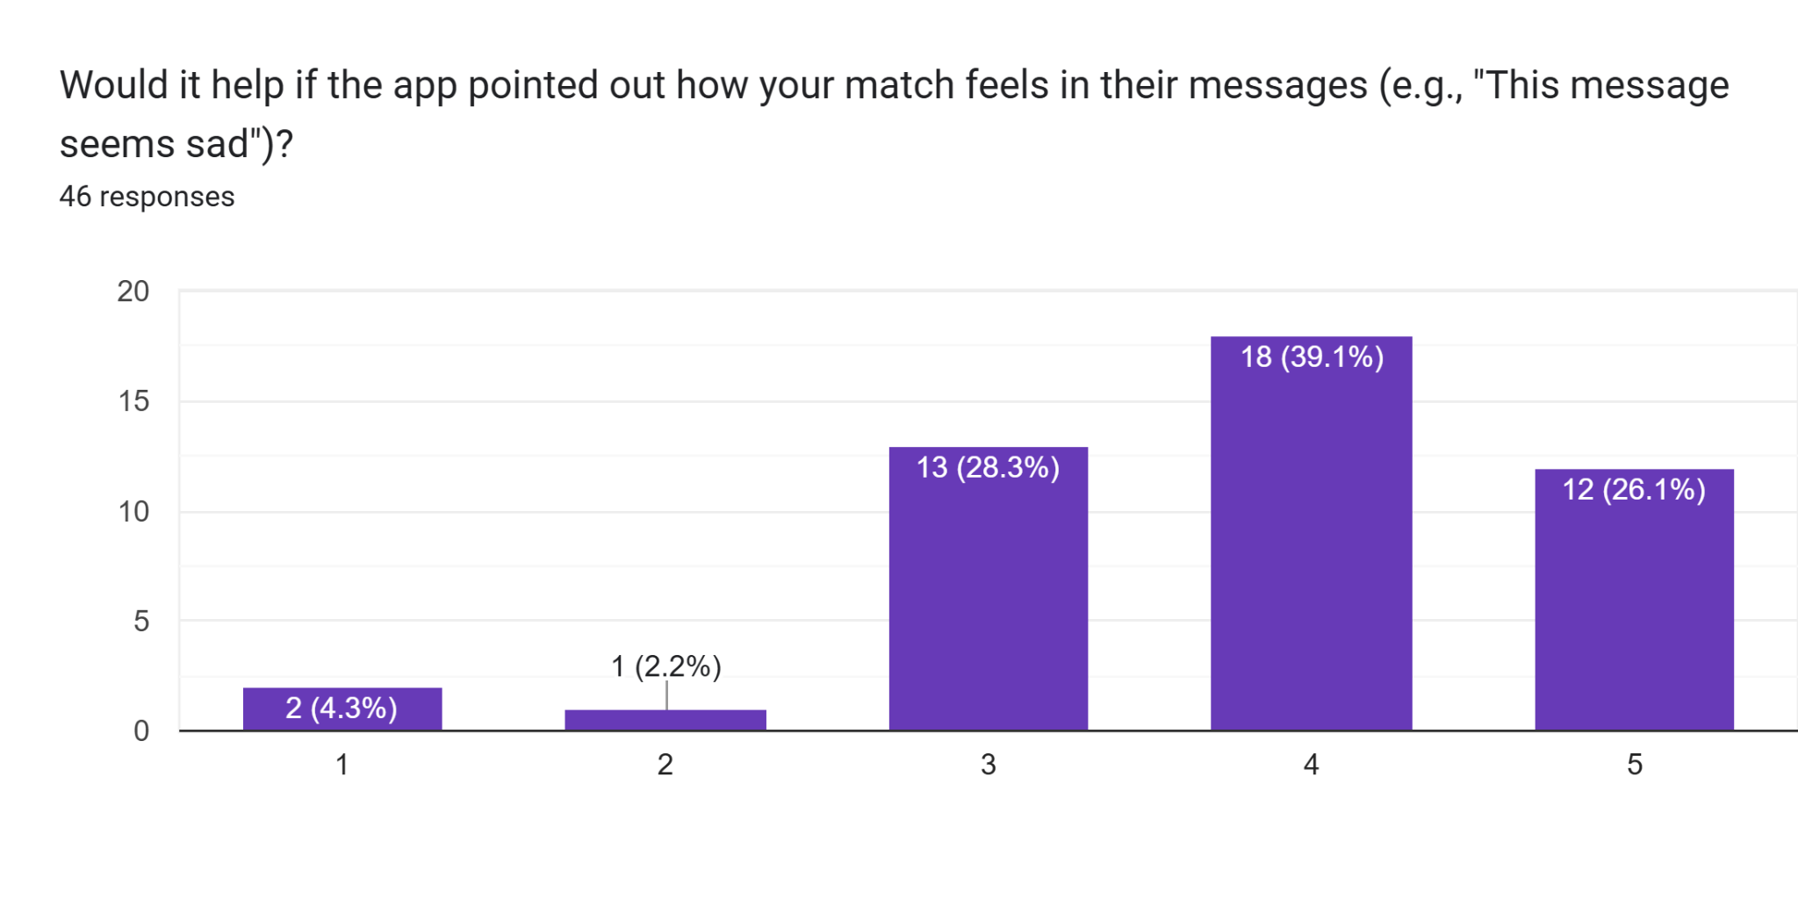

Figure 3.15: Helpfulness of App Indicating Match’s Feelings in Messages

The bar chart shows a positive response, with 18 respondents (39.1%) rating it a 4 and 12 (26.1%) rating it a 5 on a scale of 1 to 5 (1 being not helpful at all, 5 being most very helpfull), totaling 65.2% in favor (4 or 5). Thirteen respondents (28.3%) rated it a 3, indicating neutrality, while 2 (4.3%) rated it a 1 and 1 (2.2%) rated it a 2, reflecting minimal opposition. This suggests that users find value in real-time emotional insights, encouraging Lumé to refine this feature to enhance user interactions in the Southeast Asian market.

### 3.2.1.5 Section 5: Safety and Privacy

This section addresses your concerns about safety and privacy, aiming to assess the level of trust and security users require. It prioritizes identifying key safety and privacy issues, enabling Lumé to implement robust measures to ensure a secure and trustworthy platform for its users in the Southeast Asian market.

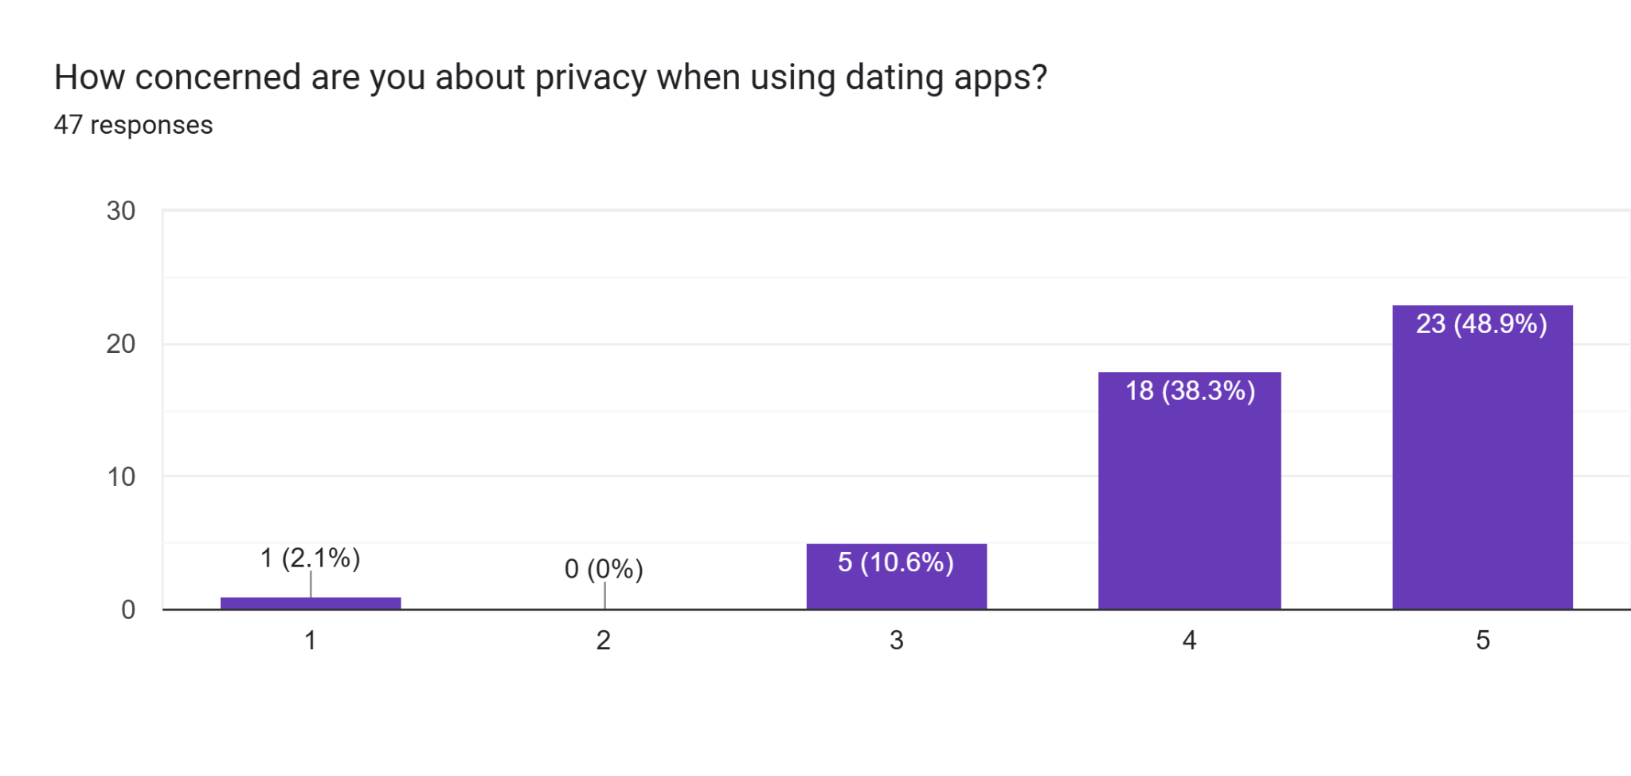

Figure 3.16: Privacy Concern Levels Among Dating App Users

The bar chart shows a strong response, with 23 respondents (48.9%) rating their concern a 5 and 18 (38.3%) rating it a 4 on a scale of 1 to 5 (1 being not concerned at all, 5 being very concerned), totaling 87.2% with high concern (4 or 5), reflecting a significant worry about privacy likely due to data breaches or identity risks. A moderate 5 respondents (10.6%) rated it a 3, indicating neutrality possibly from mixed experiences, while only 1 (2.1%) rated it a 1 and none (0%) a 2, showing minimal disregard. This significant majority highlights a deep-seated worry among users, likely driven by past experiences or awareness of privacy breaches, data misuse, or lack of control over personal information on dating platforms. For the Lumé dating app, this strong concern underscores the need to implement stringent privacy protections, such as end-to-end encryption, clear data usage policies, and optional features that allow users to limit data sharing. Addressing this could enhance user trust and adoption, particularly among the youth demographic in Southeast Asia where the survey was targeted.

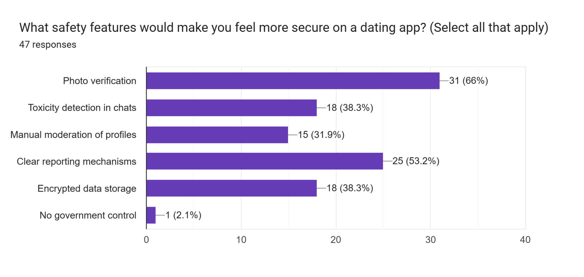

Figure 3.17: Preferred Safety Features for Dating Apps

The bar chart shows a strong response, with 31 respondents (66%) selecting photo verification, 25 (53.2%) choosing clear reporting mechanisms, and 18 (38.3%) each for toxicity detection in chats and encrypted data storage, indicating these are the most valued safety features on a scale where all that apply were selected from 47 responses. A moderate 15 respondents (31.9%) opted for manual moderation of profiles, showing moderate interest, while only 1 (2.1%) selected no government control, reflecting minimal support. This suggests Lumé should prioritize photo verification and clear reporting mechanisms to enhance user security, addressing the high privacy concerns identified earlier, particularly among the Southeast Asian youth market.

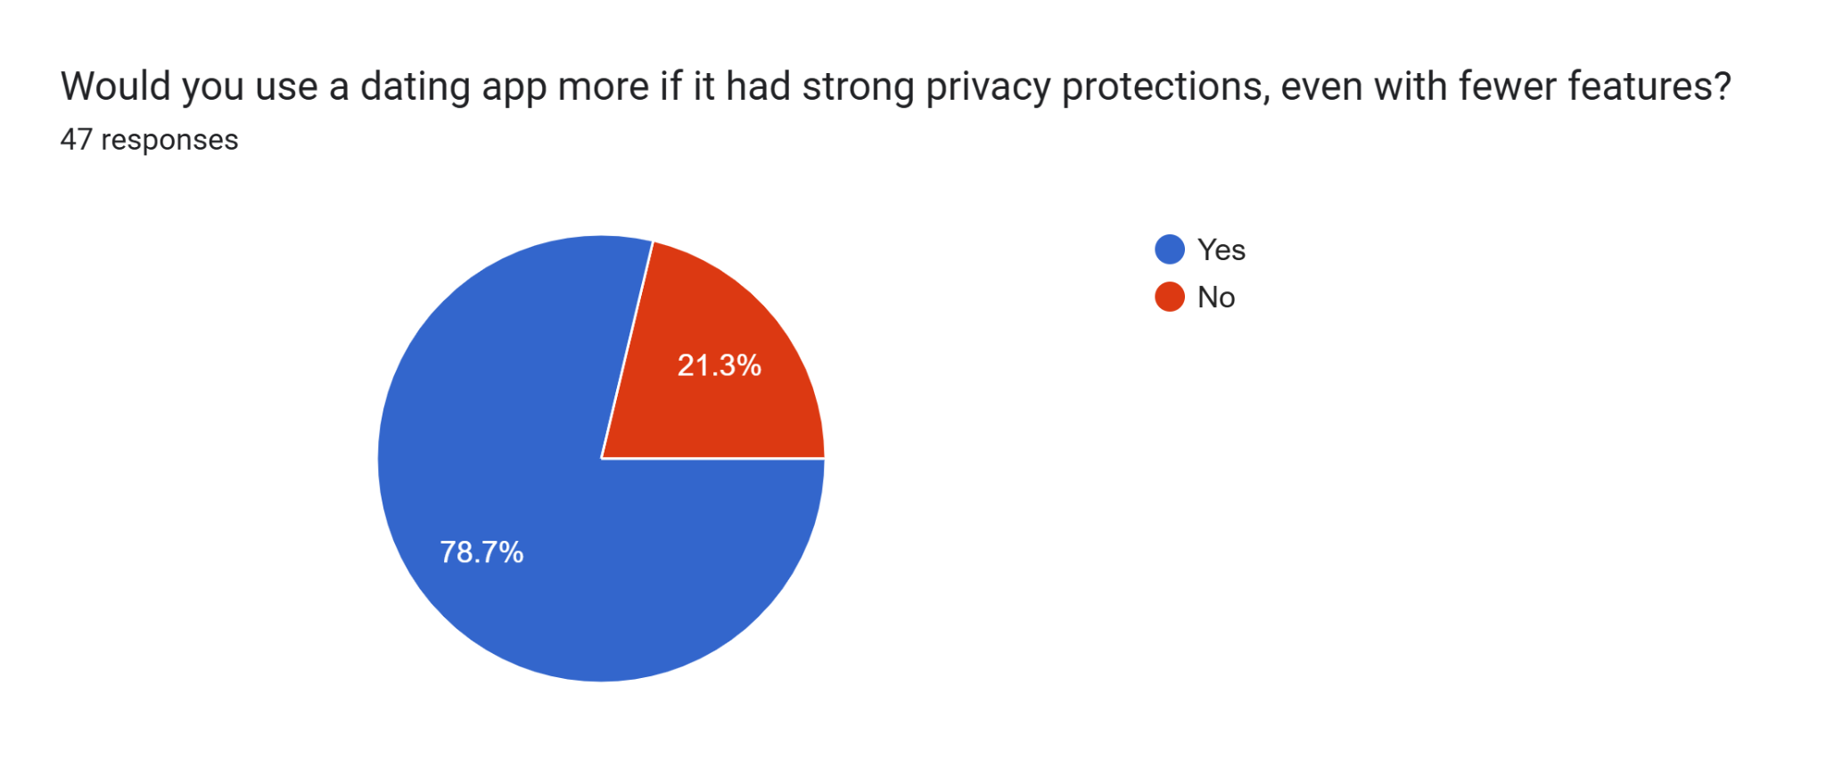

Figure 3.18: Willingness to Use Dating App with Strong Privacy Protections and Fewer Features

The pie chart shows a strong response, with 37 respondents (78.7%) selecting Yes and 10 (21.3%) selecting No from 47 responses, indicating a clear preference for strong privacy protections even at the cost of fewer features. This overwhelming majority suggests that users prioritize security over functionality, likely influenced by the high privacy concerns (87.2% rated 4 or 5 in Figure 3.16). This implies Lumé should focus on robust privacy measures, such as encryption and data control, to boost adoption among the Southeast Asian youth market, potentially outweighing the appeal of additional features. Additionally, this acceptance of a streamlined app with strong privacy could support launching Lumé as a web-based dating app initially, given the current lack of budget for a mobile app, allowing development to start on a web platform and progress to a mobile app if users are satisfied with the experience.

**3.2.1.6 Section 6: Additional Feedback**

This Section provides an open-ended platform for respondents to share their real voice feedback, capturing unprompted insights and personal perspectives on the app’s development. This section encourages users to express additional thoughts, suggestions, or concerns beyond the structured questions, offering valuable qualitative data to refine Lumé’s AI-driven features and address specific needs of the Southeast Asian youth market.

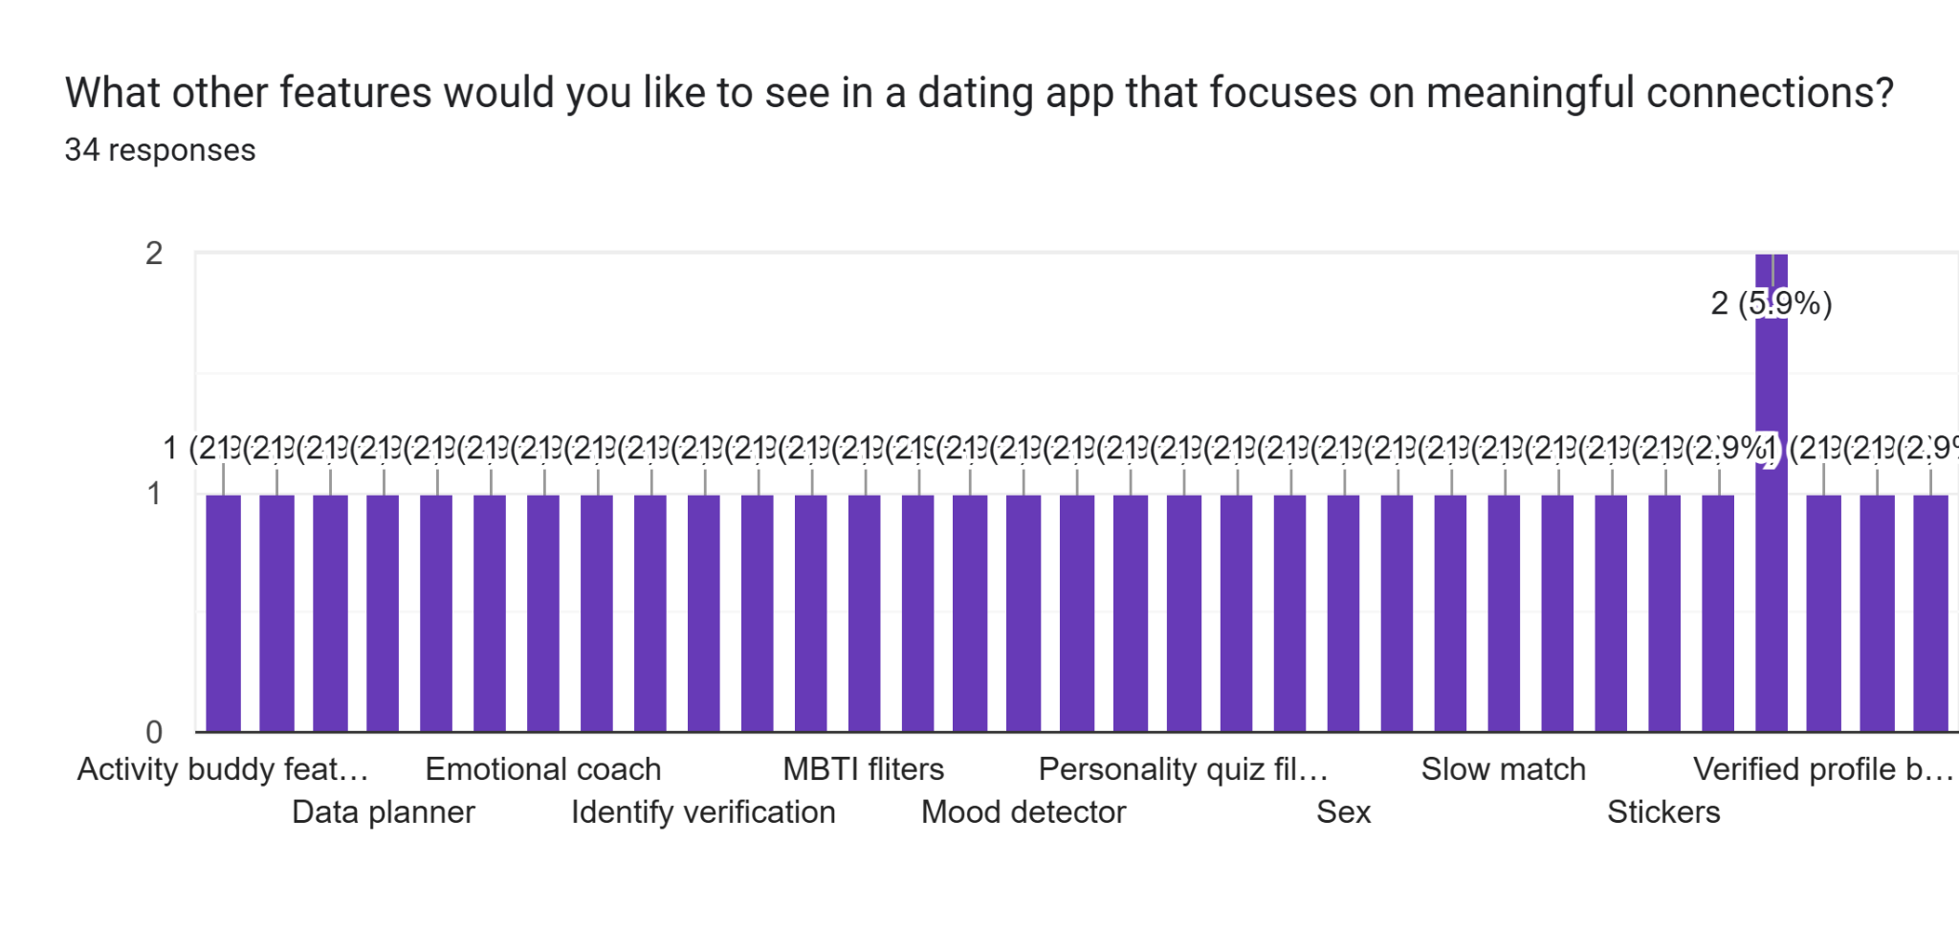

Figure 3.19: Desired Features for a Dating App Focusing on Meaningful Connections

The bar chart shows a varied response, with 2 respondents (5.9%) selecting verified profile badges and 1 respondent (2.9%) each for activity buddy features, data planner, emotional coach, MBTI filters, personality quiz filters, slow match, verified profile badges, and stickers from 34 responses, indicating low but diverse interest in additional features. The majority of features, including identity verification, mood detector, and others, also received 1 response (2.9%) each, reflecting a wide range of individual preferences with no dominant choice. This suggests Lumé could explore incorporating popular suggestions like verified profile badges to enhance authenticity and trust, aligning with the high privacy concerns (87.2% in Figure 3.16), while starting with a web-based platform to test these features among the Southeast Asian youth market before expanding to a mobile app if user satisfaction grows.

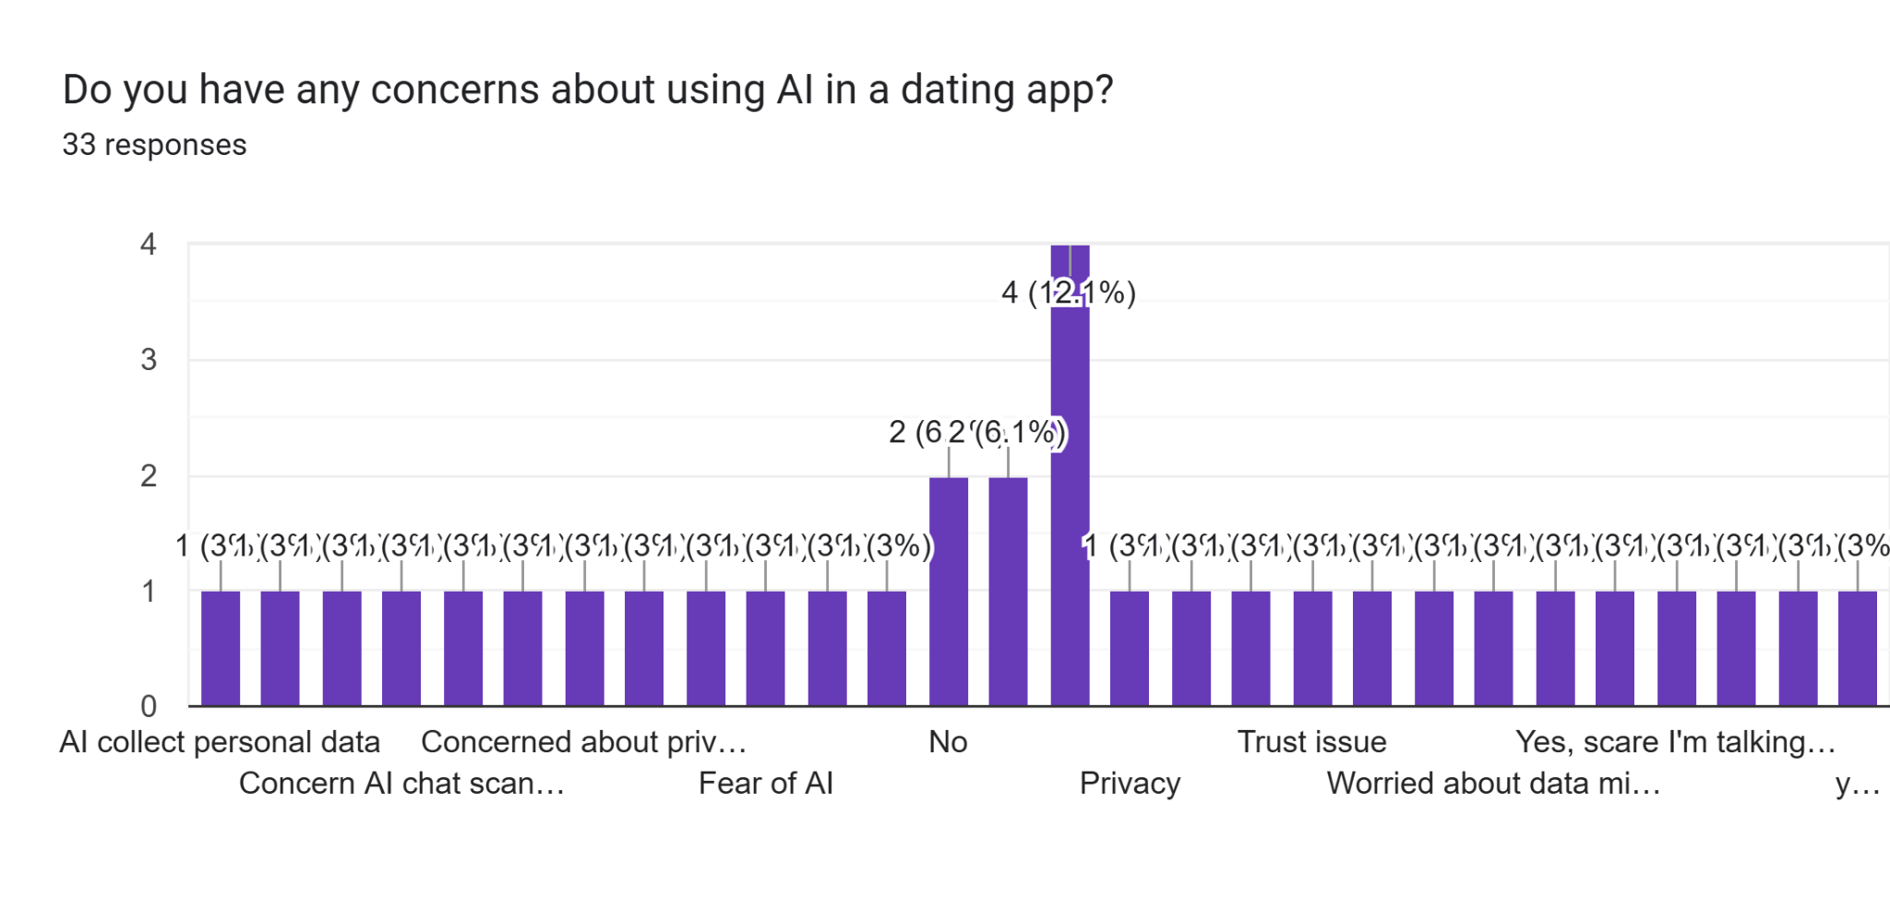

Figure 3.20: Concerns About Using AI in a Dating App

The bar chart shows a mixed response, with 2 respondents (6.1%, 6.1%) each selecting No and Privacy from 33 responses, indicating a moderate acceptance and a notable concern about privacy, respectively, on a scale where multiple concerns were noted. A significant 4 respondents (12.1%) chose Yes, scare I'm talking..., reflecting a specific fear of interacting with AI, while 1 respondent (3.0%) each selected AI collect personal data, Concern AI chat scan..., Fear of AI, and other concerns like Trust issue and Worried about data misuse, totaling a diverse set of worries with 3.0% each. This suggests Lumé should address privacy and trust issues, such as ensuring transparent data handling and clear communication about AI interactions, to alleviate concerns and build confidence among the Southeast Asian youth market, especially given the high privacy focus (87.2% in Figure 3.16).

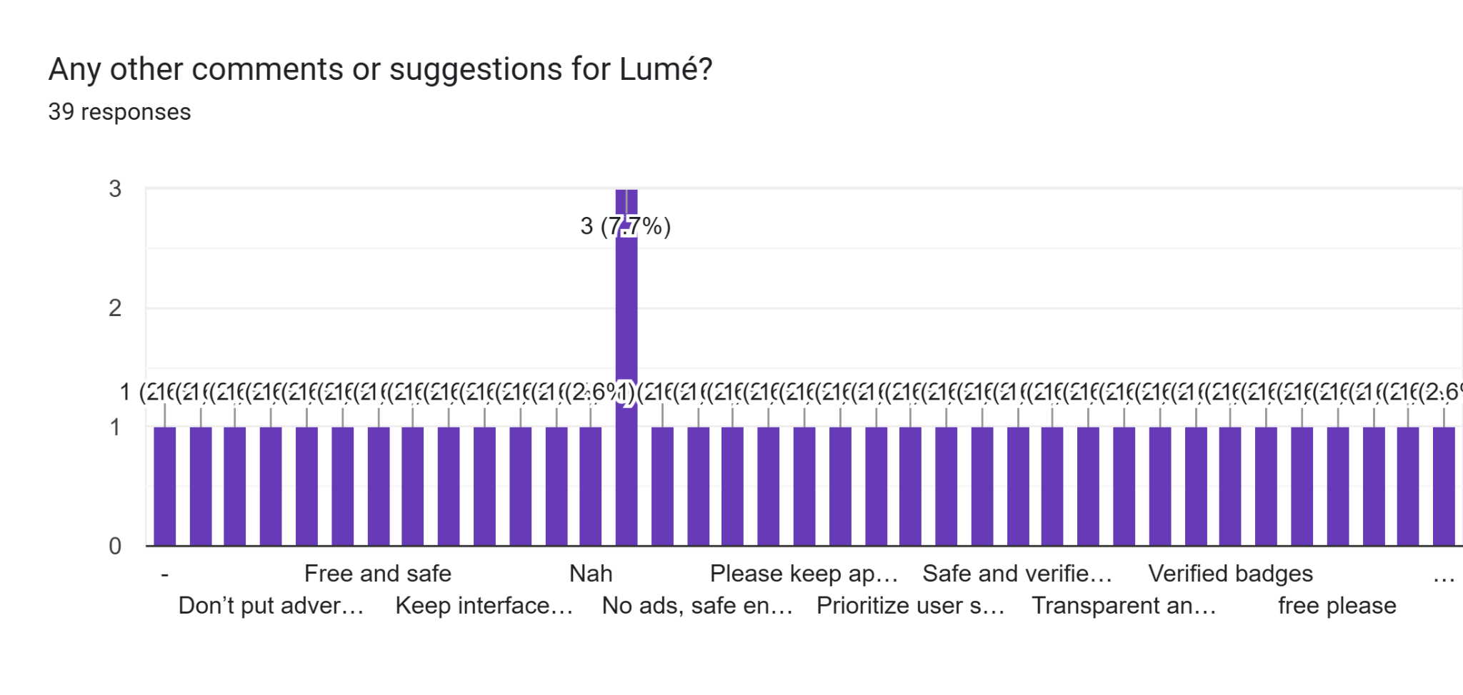

Figure 3.21: Additional Comments and Suggestions for Lumé

The bar chart shows a notable response, with 3 respondents (7.7%) selecting "Safe and verify..." and 1 respondent (2.6%) each for "Don't put advertisment", "Keep interface simple", "No ads, safe en...", "Prioritize user safety", "Transparent an...", "free please", "Free and safe", "Nah", "Please keep app...", "Verified badges", and other suggestions from 39 responses, indicating a range of preferences with a slight emphasis on safety and verification. The majority of comments, including "No ads", "Free and secure", and "Transparent policies", also received 1 response (2.6%) each, reflecting diverse user priorities with no single dominant suggestion. This suggests Lumé should focus on enhancing safety features, ensuring verification processes, and maintaining an ad-free, transparent platform to align with user expectations.

## 3.3 Requirement Analysis

### 3.3.1 Overall Use Case Diagram

[Clearer Overall Use Case](https://drive.google.com/file/d/1hukLGFi5vBMpEpjX9VxHdFDT_G2fB2qN/view?usp=sharing)

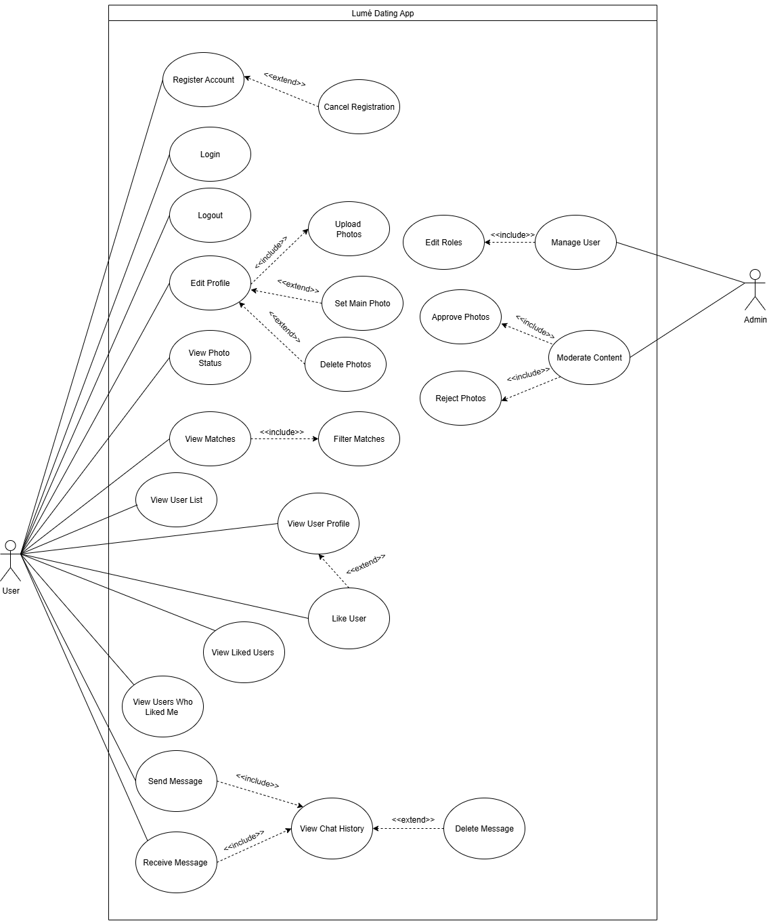

Figure 3.22: Overall Use Case Diagram for Lumé Dating App

### 3.3.1.1 Account Management Module (AM)

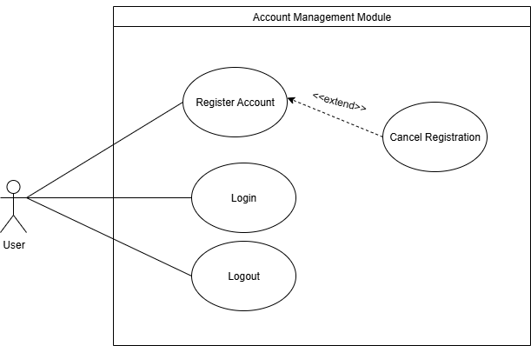

Figure 3.23: Use Case Diagram for Account Management Module (AM)

Table 3.1: Use Case Description for Account Management Module-Register Account (AM1-RA)

| Author | | | Choo Ting Feng | | |
| --- | --- | --- | --- | --- | --- |
| Use Case Name | | | Register Account (AM1-RA) | | |
| Actor | | | User | | |
| Description | | | This use case describes how users register their account with a unique username, password, and role assignment. | | |
| Priority | | | High | | |
| Pre-condition | | | The user account does not exist in the database. | | |
| Main Flow of Event | | | | | |
| Actor Action | | | | System Response | |
| 1. User click on Register button | | | | 1. Display registration page. | |
| 1. User inputs their username, password, and personal details (e.g., gender). | | | | 1. System validates the username and password format. 2. System checks if the username is associated with an existing account. 3. System assigns the selected role and stores user information in the database. 4. System prompts a successful message. 5. System directs user to home page. | |
| Alternative Flow of Event | | | | | |
| A1: 4. If the username or password format is incorrect, the system prompts an error message and asks the user to enter valid input, then redirects back to step 2.  A2: 5. If the username is already associated with an existing account, the system prompts an error message and asks the user to enter another username, then redirects back to step 2. | | | | | |
| Post-condition | | | User has successfully registered an account with a unique username, password, and assigned role. | | |

Table 3.2: Use Case Description for Account Management Module-Cancel Registration (AM2-CR)

| Author | | | Choo Ting Feng | | |
| --- | --- | --- | --- | --- | --- |
| Use Case Name | | | Cancel Registration (AM2-CR) | | |
| Actor | | | User | | |
| Description | | | This use case describes how a user can cancel the account registration process before completion. | | |
| Priority | | | Low | | |
| Pre-condition | | | The user has started the registration process but not submitted it. | | |
| Main Flow of Event | | | | | |
| Actor Action | | | | System Response | |
| 1. User is on the registration page. | | | | 1. System enables the cancel option. | |
| 1. User selects the cancel option. | | | | 1. System terminates the registration process. 2. System redirects the user to the login page or dashboard. | |
| Alternative Flow of Event | | | | | |
| A1: 3. If the user accidentally cancels, the system provides an option to resume registration, returning to step 1. | | | | | |
| Post-condition | | | The registration process is terminated, and no account is created. | | |

Table 3.3: Use Case Description for Account Management Module-Login (AM3-LI)

| Author | | | Choo Ting Feng | | |
| --- | --- | --- | --- | --- | --- |
| Use Case Name | | | Login (AM3-LI) | | |
| Actor | | | User | | |
| Description | | | This use case describes how an existing user logs into their account using their username and password. | | |
| Priority | | | High | | |
| Pre-condition | | | The user has an existing account in the database. | | |
| Main Flow of Event | | | | | |
| Actor Action | | | | System Response | |
| 1. User navigates to the login page. | | | | 1. Display login page. | |
| 1. User inputs their username and password. | | | | 1. System validates the username and password format. 2. System checks the credentials against the database. 3. System logs the user in and redirects to the home page. | |
| Alternative Flow of Event | | | | | |
| A1: 4. If the username or password format is incorrect, the system prompts an error message and asks the user to enter valid input, then redirects back to step 3.  A2: 5. If the credentials are incorrect, the system prompts an error message and asks the user to retry, then redirects back to step 3. | | | | | |
| Post-condition | | | User is successfully logged in and accesses the main dashboard. | | |

Table 3.4: Use Case Description for Account Management Module-Logout (AM4-LO)

| Author | | | Choo Ting Feng | | |
| --- | --- | --- | --- | --- | --- |
| Use Case Name | | | Logout (AM4-LO) | | |
| Actor | | | User | | |
| Description | | | This use case describes how a logged-in user securely ends their session. | | |
| Priority | | | Medium | | |
| Pre-condition | | | The user is logged in. | | |
| Main Flow of Event | | | | | |
| Actor Action | | | | System Response | |
| 1. User selects the logout option from the home page. | | | | 1. System terminates the user session. 2. System redirects the user to the login page or dashboard. | |
| Alternative Flow of Event | | | | | |
| A1: 2. If session termination fails, the system retries and notifies the user of success upon completion. | | | | | |
| Post-condition | | | The user is logged out and redirected to the login page or dashboard. | | |

### 3.3.1.2 Administration Module (AD)

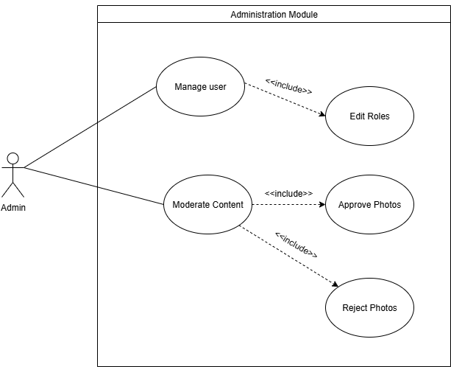

Figure 3.24: Use Case Diagram for Administration Module (AD)

Table 3.5: Use Case Description for Administration Module-Manage User (AD1-MU)

| Author | | | Choo Ting Feng | | |
| --- | --- | --- | --- | --- | --- |
| Use Case Name | | | Manage User (AD1-MU) | | |
| Actor | | | Admin | | |
| Description | | | This use case describes how an admin manages user accounts, including viewing a list of users with their roles and editing those roles. | | |
| Priority | | | High | | |
| Pre-condition | | | The admin is logged in with appropriate permissions. | | |
| Main Flow of Event | | | | | |
| Actor Action | | | | System Response | |
| 1. Admin navigates to the user management section. | | | | 1. System retrieves and displays a paginated list of users with their assigned roles, including usernames and current roles. 2. System shows a loading indicator if the list takes time to load. | |
| 1. Admin selects a user by clicking their name. | | | | 1. System opens a modal dialog with the user's current role and available role options. 2. System checks the admin's permission to edit roles. | |
| 1. Admin selects a new role and submits the change. | | | | 1. System updates the user role. 2. System refreshes the UI to reflect the change. 3. System displays a confirmation message and logs the action. | |
| Alternative Flow of Event | | | | | |
| A1: 5. If the modal fails to load, the system displays an error message and retries, returning to step 4.  A2: 9. If the role update fails, the system displays an error message and reopens the modal, returning to step 7. | | | | | |
| Post-condition | | | The user's role is successfully updated and reflected in the system. | | |

Table 3.6: Use Case Description for Administration Module-Edit Roles (AD2-ER)

| Author | | | Choo Ting Feng | | |
| --- | --- | --- | --- | --- | --- |
| Use Case Name | | | Edit Roles (AD2-ER) | | |
| Actor | | | Admin | | |
| Description | | | This use case describes how an admin modifies the roles of users, potentially enabling moderation capabilities, with detailed validation. | | |
| Priority | | | High | | |
| Pre-condition | | | The admin has accessed the user management section and selected a user. | | |
| Main Flow of Event | | | | | |
| Actor Action | | | | System Response | |
| 1. Admin opens the role edit modal for a user. | | | | 1. System displays the user's current role, available role options, and a role description tooltip. 2. System checks the admin's authority to assign the selected role. | |
| 1. Admin selects a new role (e.g., moderator) and clicks save. | | | | 1. System validates the role change. 2. System updates the user role. 3. System refreshes the UI and displays a success notification. | |
| Alternative Flow of Event | | | | | |
| A1: 5. If the role change is invalid, the system displays a warning and returns to step 4. | | | | | |
| Post-condition | | | This use case extends to Moderate Content when a moderator role is assigned. | | |

Table 3.7: Use Case Description for Administration Module-Moderate Content (AD3-MC)

| Author | | | Choo Ting Feng | | |
| --- | --- | --- | --- | --- | --- |
| Use Case Name | | | Moderate Content (AD3-MC) | | |
| Actor | | | Admin | | |
| Description | | | This use case describes how an admin reviews and moderates user-generated content, including photos, messages, and profiles, with detailed actions. | | |
| Priority | | | High | | |
| Pre-condition | | | The admin is logged in with moderator permissions. | | |
| Main Flow of Event | | | | | |
| Actor Action | | | | System Response | |
| 1. Admin navigates to the moderation section. | | | | 1. System displays a dashboard with options to view photos, messages, or profiles. 2. System shows a loading indicator if content takes time to load. | |
| 1. Admin selects to view photos. | | | | 1. System displays a list of flagged or reported photos. 2. Admin selects a photo to moderate. | |
| 1. Admin selects to view messages. | | | | 1. System displays a list of flagged or reported messages. 2. Admin selects a message to moderate. | |
| 1. Admin selects to view user profiles. | | | | 1. System displays a list of flagged profiles. 2. Admin selects a profile to moderate. 3. System allows the admin to flag, report, or take action and logs the action. | |
| Alternative Flow of Event | | | | | |
| A1: 5, 8, 11. If content retrieval fails, the system displays an error and asks the admin to retry, returning to step 4, 7, or 10 respectively. | | | | | |
| Post-condition | | | The admin has reviewed and moderated the selected content, with actions logged. | | |

Table 3.8: Use Case Description for Administration Module-Approve Photos (AD4-AP)

| Author | | | Choo Ting Feng | | |
| --- | --- | --- | --- | --- | --- |
| Use Case Name | | | Approve Photos (AD4-AP) | | |
| Actor | | | Admin | | |
| Description | | | This use case describes how an admin approves pending photos for user profiles with detailed review. | | |
| Priority | | | Medium | | |
| Pre-condition | | | The admin is logged in and has access to pending photo approvals. | | |
| Main Flow of Event | | | | | |
| Actor Action | | | | System Response | |
| 1. Admin navigates to the photo approval section. | | | | 1. System displays a list of photos pending approval with thumbnails and user details. 2. System updates the list as needed. | |
| 1. Admin selects a photo and clicks approve. | | | | 1. System checks the photo's status. 2. System updates the photo to approved. 3. System notifies the user and removes the photo from the pending list. 4. System logs the approval action. | |
| Alternative Flow of Event | | | | | |
| A1: 5. If the approval fails, the system displays an error and asks the admin to retry, returning to step 4. | | | | | |
| Post-condition | | | The selected photo is approved and visible on the user's profile. | | |

Table 3.9: Use Case Description for Administration Module-Reject Photos (AD5-RP)

| Author | | | Choo Ting Feng | | |
| --- | --- | --- | --- | --- | --- |
| Use Case Name | | | Reject Photos (AD5-RP) | | |
| Actor | | | Admin | | |
| Description | | | This use case describes how an admin rejects pending photos for user profiles with detailed feedback. | | |
| Priority | | | Medium | | |
| Pre-condition | | | The admin is logged in and has access to pending photo approvals. | | |
| Main Flow of Event | | | | | |
| Actor Action | | | | System Response | |
| 1. Admin navigates to the photo approval section. | | | | 1. System displays a list of photos pending approval with thumbnails and user details. 2. System updates the list as needed. | |
| 1. Admin selects a photo and clicks reject, optionally adding a reason. | | | | 1. System checks the photo's status. 2. System updates the photo to rejected. 3. System notifies the user with the rejection reason and removes the photo from the pending list. 4. System logs the rejection action. | |
| Alternative Flow of Event | | | | | |
| A1: 5. If the rejection fails, the system displays an error and asks the admin to retry, returning to step 4. | | | | | |
| Post-condition | | | The selected photo is rejected and removed from the pending list. | | |

### **3.3.1.**3User Management Module **(**UM**)**

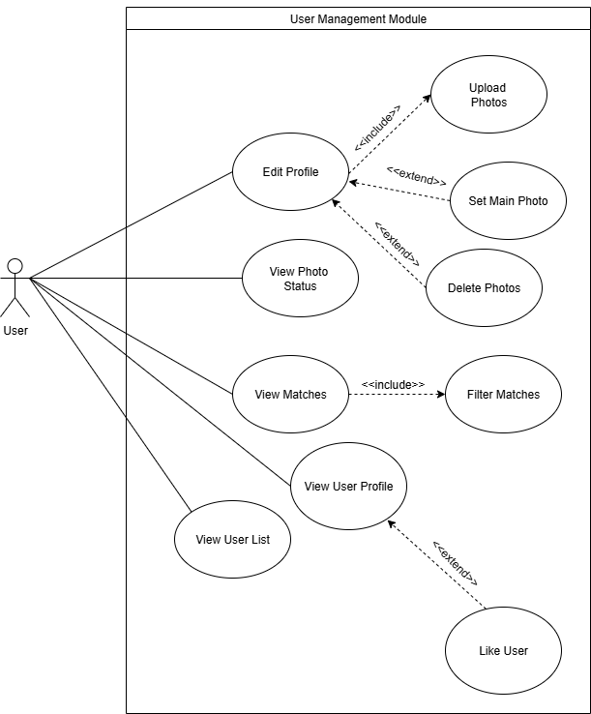

Figure 3.25: Use Case Diagram for User Management Module (UM)

Table 3.10: Use Case Description for User Management Module-Edit Profile (UM1-EP)

| Author | | | Choo Ting Feng | | |
| --- | --- | --- | --- | --- | --- |
| Use Case Name | | | Edit Profile (UM1-EP) | | |
| Actor | | | User | | |
| Description | | | This use case describes how a current user updates their personal details. | | |
| Priority | | | High | | |
| Pre-condition | | | The user is logged in and has an existing profile. | | |
| Main Flow of Event | | | | | |
| Actor Action | | | | System Response | |
| 1. User navigates to the profile edit section. | | | | 1. System shows the current profile details. | |
| 1. User updates description, looking for, interests, or location. | | | | 1. System checks the input. | |
| 1. User saves the changes. | | | | 1. System saves the updates to the profile. 2. System shows a success message. | |
| Alternative Flow of Event | | | | | |
| A1: 4. If the input is incorrect, the system shows an error message and asks the user to fix it, returning to step 3. | | | | | |
| Post-condition | | | The user’s personal details (description, looking for, interests, location) are updated. | | |

Table 3.11: Use Case Description for User Management Module-Upload Photos (UM2-UP)

| Author | | | Choo Ting Feng | | |
| --- | --- | --- | --- | --- | --- |
| Use Case Name | | | Upload Photos (UM2-UP) | | |
| Actor | | | User | | |
| Description | | | This use case describes how a current user adds photos to their profile, linking to setting a main photo, deleting photos, and viewing photo status. | | |
| Priority | | | High | | |
| Pre-condition | | | The user is logged in and is within the edit photos section. | | |
| Main Flow of Event | | | | | |
| Actor Action | | | | System Response | |
| 1. User selects the upload photos option. | | | | 1. System opens a file upload area. | |
| 1. User chooses a photo file and submits. | | | | 1. System checks the file. 2. System uploads the photo. 3. System shows the photo. 4. System saves the photo to the profile. 5. System offers to set as main, delete, or view status. | |
| 1. User selects an option (e.g., set main). | | | | 1. System processes the selected action (e.g., sets as main photo) and updates the profile. | |
| Alternative Flow of Event | | | | | |
| A1: 4. If the file check fails, the system shows an error message and allows re-selection, returning to step 3.  A2: 5. If the upload fails, the system shows an error message and prompts retry, returning to step 3.  A3: 10. If the action fails, the system shows an error message and returns to step 8. | | | | | |
| Post-condition | | | The photo is uploaded, and any selected action (set main, delete, or view status) is completed. | | |

Table 3.12: Use Case Description for User Management Module-View Matches (UM3-VM)

| Author | | | Choo Ting Feng | | |
| --- | --- | --- | --- | --- | --- |
| Use Case Name | | | View Matches (UM3-VM) | | |
| Actor | | | User | | |
| Description | | | This use case describes how a current user retrieves a paginated list of potential matches with filtering options. | | |
| Priority | | | High | | |
| Pre-condition | | | The user is logged in and has access to the matches section. | | |
| Main Flow of Event | | | | | |
| Actor Action | | | | System Response | |
| 1. User navigates to the matches section. | | | | 1. System shows a list of potential matches. | |
| 1. User applies a filter (e.g., gender). | | | | 1. System updates the list with the filter. 2. System shows the filtered results. | |
| 1. User navigates through pages. | | | | 1. System loads the next or previous page. | |
| Alternative Flow of Event | | | | | |
| A1: 4. If no matches are found, the system shows a message ("No matches found") and allows resetting the filter, returning to step 3.  A2: 7. If page loading fails, the system shows an error message and retries, returning to step 6. | | | | | |
| Post-condition | | | The user views a paginated, filtered list of potential matches. | | |

Table 3.13: Use Case Description for User Management Module-View User List (UM4-VUL)

| Author | | | Choo Ting Feng | | |
| --- | --- | --- | --- | --- | --- |
| Use Case Name | | | View User List (UM4-VUL) | | |
| Actor | | | User | | |
| Description | | | This use case describes how a current user retrieves a paginated list of users, distinct from matches. | | |
| Priority | | | Medium | | |
| Pre-condition | | | The user is logged in and has access to the user list section. | | |
| Main Flow of Event | | | | | |
| Actor Action | | | | System Response | |
| 1. User navigates to the user list section. | | | | 1. System shows a list of all users. | |
| 1. User navigates through pages. | | | | 1. System loads the next or previous page. | |
| Alternative Flow of Event | | | | | |
| A1: 2. If the list fails to load, the system shows an error message and retries, returning to step 1.  A2: 4. If page navigation fails, the system shows an error message and allows retry, returning to step 3. | | | | | |
| Post-condition | | | The user views a paginated list of all users. | | |

Table 3.14: Use Case Description for User Management Module-View User Profile (UM5-VUP)

| Author | | | Choo Ting Feng | | |
| --- | --- | --- | --- | --- | --- |
| Use Case Name | | | View User Profile (UM5-VUP) | | |
| Actor | | | User | | |
| Description | | | This use case describes how a current user retrieves detailed information about another user by username, with an optional action to like them. | | |
| Priority | | | High | | |
| Pre-condition | | | The user is logged in and a target user exists. | | |
| Main Flow of Event | | | | | |
| Actor Action | | | | System Response | |
| 1. User navigates to the user list. | | | | 1. System shows available usernames. | |
| 1. User selects a username to view. | | | | 1. System shows the user’s detailed profile (e.g., bio, photos). | |
| 1. User optionally chooses to like the user. | | | | 1. System processes the like request and updates the user’s like status (if implemented here). | |
| Alternative Flow of Event | | | | | |
| A1: 4. If the profile fails to load, the system shows an error message and returns to step 3.  A2: 6. If the like action fails, the system shows an error message and returns to step 5. | | | | | |
| Post-condition | | | The user has viewed the detailed profile, with an optional like action processed if selected. | | |

### 3.3.1.4 Likes Feature Module (LF)

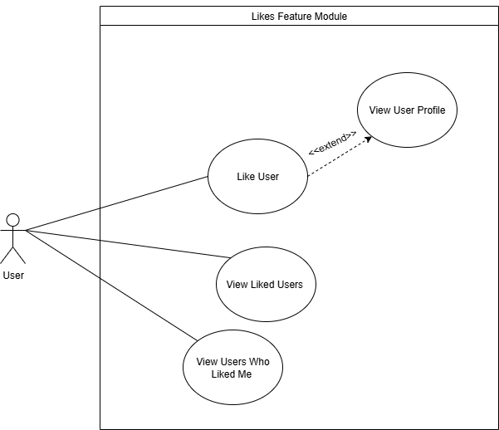

Figure 3.26: Use Case Diagram for Likes Feature Module (LF)

Table 3.15: Use Case Description for Likes Feature Module-Like User (LF1-LU)

| Author | | | Choo Ting Feng | | |
| --- | --- | --- | --- | --- | --- |
| Use Case Name | | | Like User (LF1-LU) | | |
| Actor | | | User | | |
| Description | | | This use case describes how a current user adds a like to another user, preventing self-likes or duplicate likes. | | |
| Priority | | | High | | |
| Pre-condition | | | The user is logged in and viewing another user’s profile. | | |
| Main Flow of Event | | | | | |
| Actor Action | | | | System Response | |
| 1. User navigates to another user’s profile. | | | | 1. System shows the profile with a like option. | |
| 1. User clicks the like button. | | | | 1. System checks if it’s a self-like or duplicate. 2. System adds the liked user list to LF2-VLU. | |
| Alternative Flow of Event | | | | | |
| A1: 4. If it’s a self-like or duplicate, the system shows an error message and returns to step 3.  A2: 5. If the like fails to save, the system shows an error message and allows retry, returning to step 3. | | | | | |
| Post-condition | | | The like is successfully added to the other user, or an error is handled. | | |

Table 3.16: Use Case Description for Likes Feature Module-View Liked Users (LF2-VLU)

| Author | | | Choo Ting Feng | | |
| --- | --- | --- | --- | --- | --- |
| Use Case Name | | | View Liked Users (LF2-VLU) | | |
| Actor | | | User | | |
| Description | | | This use case describes how a current user retrieves a paginated list of users they have liked. | | |
| Priority | | | Medium | | |
| Pre-condition | | | The user is logged in and has liked at least one user. | | |
| Main Flow of Event | | | | | |
| Actor Action | | | | System Response | |
| 1. User navigates to the liked users section. | | | | 1. System shows a paginated list of liked users. | |
| 1. User navigates through pages. | | | | 1. System loads the next or previous page. | |
| Alternative Flow of Event | | | | | |
| A1: 2. If no users are liked, the system shows a message ("No users liked") and returns to the main menu.  A2: 4. If page loading fails, the system shows an error message and allows retry, returning to step 3. | | | | | |
| Post-condition | | | The user views a paginated list of users they have liked. | | |

Table 3.17: Use Case Description for Likes Feature Module-View Users Who Liked Me (LF3-VULM)

| Author | | | Choo Ting Feng | | |
| --- | --- | --- | --- | --- | --- |
| Use Case Name | | | View Users Who Liked Me (LF3-VULM) | | |
| Actor | | | User | | |
| Description | | | This use case describes how a current user retrieves a paginated list of users who have liked them. | | |
| Priority | | | Medium | | |
| Pre-condition | | | The user is logged in and has been liked by at least one user. | | |
| Main Flow of Event | | | | | |
| Actor Action | | | | System Response | |
| 1. User navigates to the users who liked me section. | | | | 1. System shows a paginated list of users who liked them. | |
| 1. . User navigates through pages. | | | | 1. System loads the next or previous page. | |
| Alternative Flow of Event | | | | | |
| A1: 2. If no users have liked them, the system shows a message ("No users who liked you") and returns to the main menu.  A2: 4. If page loading fails, the system shows an error message and allows retry, returning to step 3. | | | | | |
| Post-condition | | | The user views a paginated list of users who have liked them. | | |

### 3.3.1.5 Messaging Feature Module (MF)

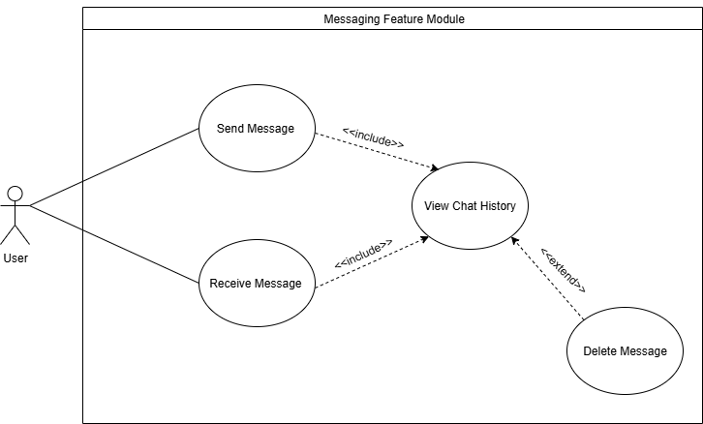

Figure 3.27: Use Case Diagram for Messaging Feature Module (MF)

Table 3.18: Use Case Description for Messaging Feature Module-Send Message (MF1-SM)

| Author | | | Choo Ting Feng | | |
| --- | --- | --- | --- | --- | --- |
| Use Case Name | | | Send Message (MF1-SM) | | |
| Actor | | | User | | |
| Description | | | This use case describes how a current user creates and sends a message to another user, preventing self-messaging. | | |
| Priority | | | High | | |
| Pre-condition | | | The user is logged in and has selected a recipient from their chat list or user profile. | | |
| Main Flow of Event | | | | | |
| Actor Action | | | | System Response | |
| 1. User navigates to the messaging section. | | | | 1. System shows the chat interface with the recipient. | |
| 1. User types a message and clicks send. | | | | 1. System checks if it’s a self-message. 2. System sends the message to the recipient. 3. System updates the chat history and shows the sent message. | |
| Alternative Flow of Event | | | | | |
| A1: 4. If it’s a self-message, the system shows an error message and returns to step 3.  A2: 5. If sending fails, the system shows an error message and allows retry, returning to step 3. | | | | | |
| Post-condition | | | The message is successfully sent to the recipient and displayed in the chat history. | | |

### 

Table 3.19: Use Case Description for Messaging Feature Module-Receive Message (MF2-RM)

| Author | | | Choo Ting Feng | | |
| --- | --- | --- | --- | --- | --- |
| Use Case Name | | | Receive Message (MF2-RM) | | |
| Actor | | | User | | |
| Description | | | This use case describes how a current user creates and sends a message to another user, preventing self-messaging. | | |
| Priority | | | Medium | | |
| Pre-condition | | | The user is logged in and has an active messaging session. | | |
| Main Flow of Event | | | | | |
| Actor Action | | | | System Response | |
| 1. User is in the messaging section or background. | | | | 1. System receives a new message from another user. | |
| 1. User opens the chat or gets a notification. | | | | 1. System shows the new message in the chat history. 2. System marks the message as read if viewed. | |
| Alternative Flow of Event | | | | | |
| A1: 4. If the message fails to display, the system shows an error message and retries, returning to step 2. | | | | | |
| Post-condition | | | The received message is displayed in the user’s chat history. | | |

### 

Table 3.20: Use Case Description for Messaging Feature Module-Delete Message (MF3-DM)

| Author | | | Choo Ting Feng | | |
| --- | --- | --- | --- | --- | --- |
| Use Case Name | | | Delete Message (MF3-DM) | | |
| Actor | | | User | | |
| Description | | | This use case describes how a current user deletes a message with authorization, using soft delete logic. | | |
| Priority | | | Medium | | |
| Pre-condition | | | The user is logged in and viewing a chat history containing the message to delete. | | |
| Main Flow of Event | | | | | |
| Actor Action | | | | System Response | |
| 1. User navigates to the chat history. | | | | 1. System shows the list of messages. | |
| 1. User selects a message and clicks delete. | | | | 1. System asks for confirmation. 2. User confirms deletion. 3. System marks the message as deleted in the database. 4. System updates the chat history to hide the deleted message. | |
| Alternative Flow of Event | | | | | |
| A1: 4. If the user cancels, the system returns to step 3.  A2: 6. If deletion fails, the system shows an error message and returns to step 3. | | | | | |
| Post-condition | | | The selected message is marked as deleted and hidden from the chat history. | | |

### 3.3.2 Activity Diagram

### 3.3.2.1 Account Management Module

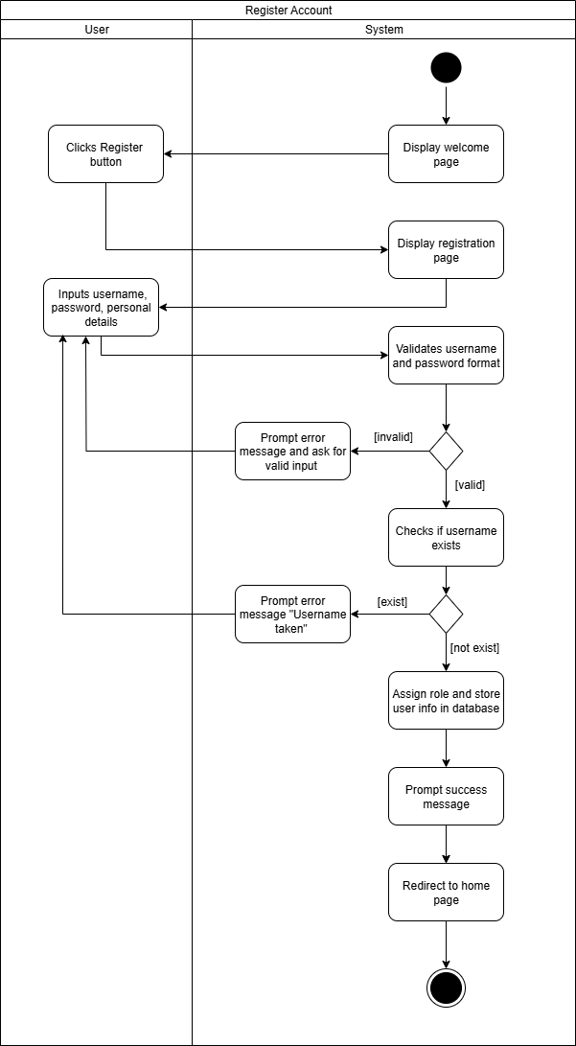

Figure 3.29: Activity Diagram for Register Account

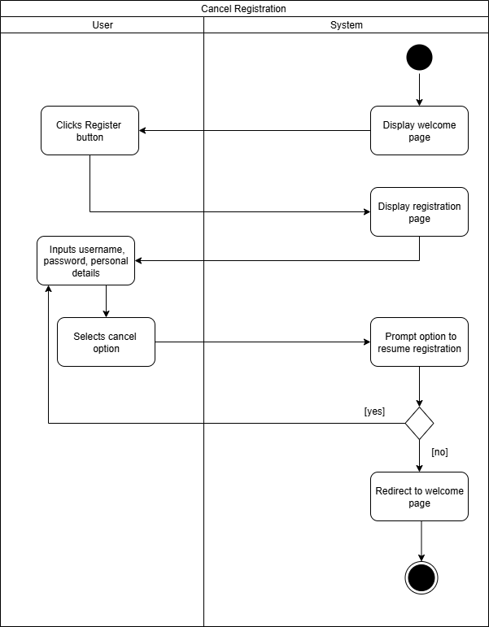

Figure 3.29: Activity Diagram for Cancel Registration

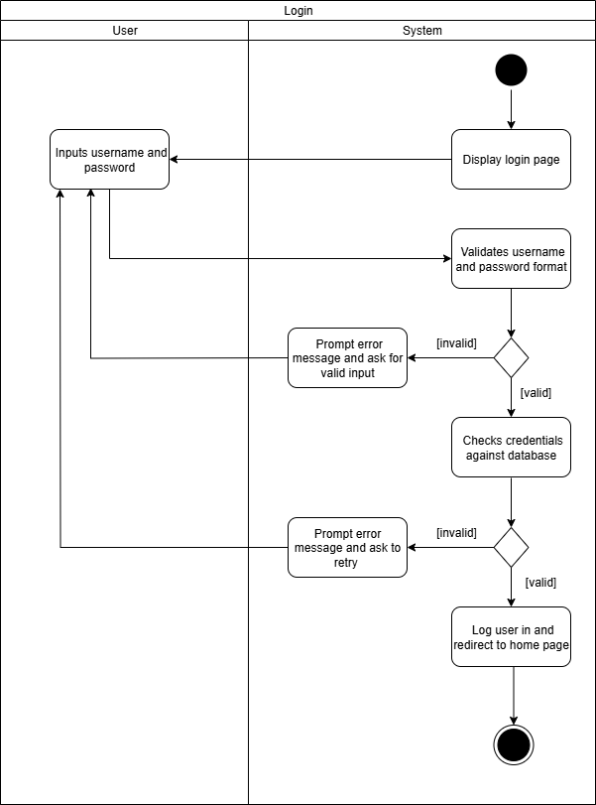

Figure 3.29: Activity Diagram for Login

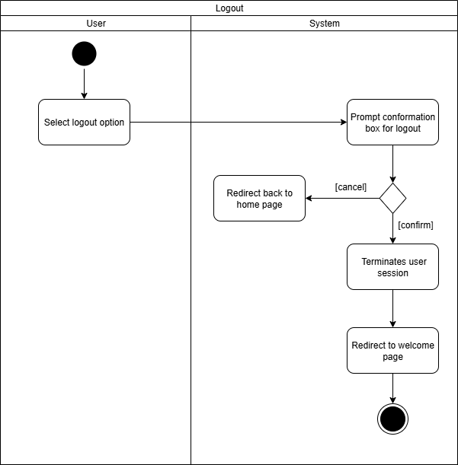  
Figure 3.29: Activity Diagram for Logout

### 3.3.2.2 Administration Module

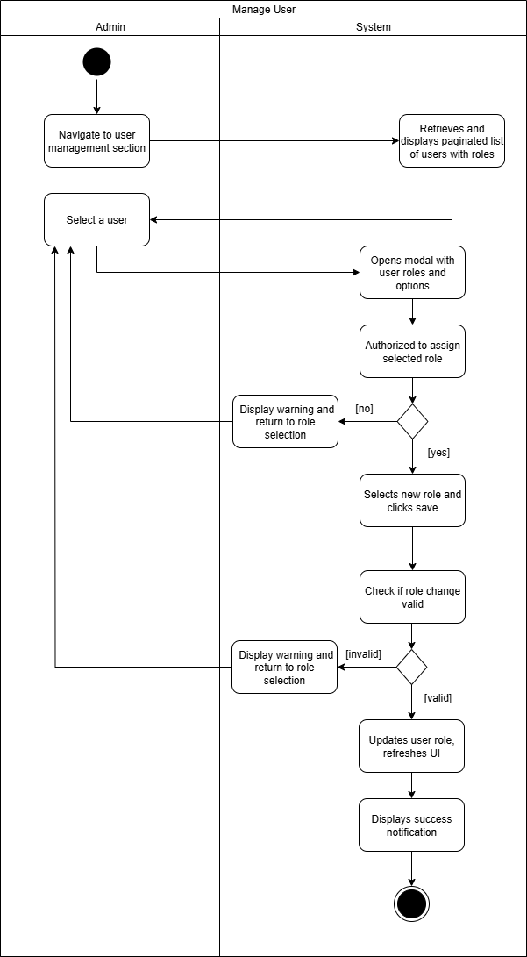

Figure 3.29: Activity Diagram for Edit Roles

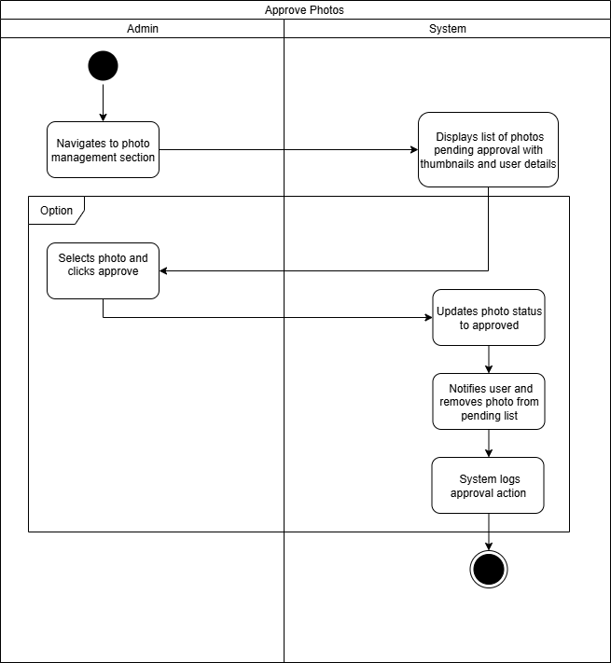

Figure 3.29: Activity Diagram for Approve Photos

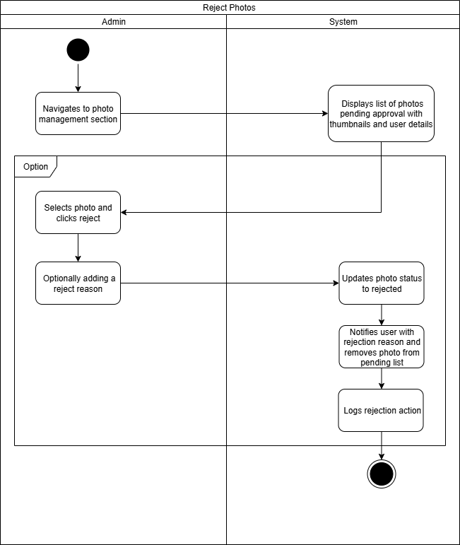

Figure 3.29: Activity Diagram for Reject Photos

### **3.3.2.3 User Management Module**

### 

Figure 3.29: Activity Diagram for Edit Profile

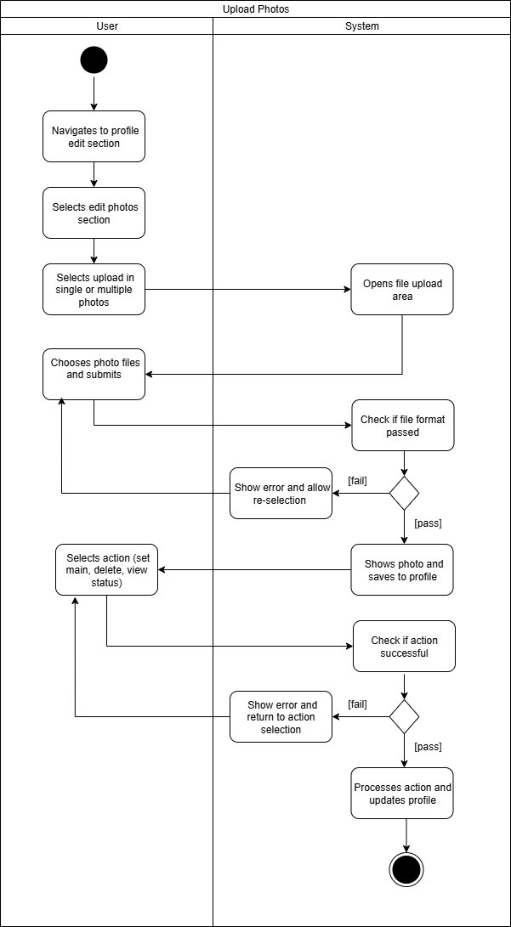

Figure 3.29: Activity Diagram for Upload Photos

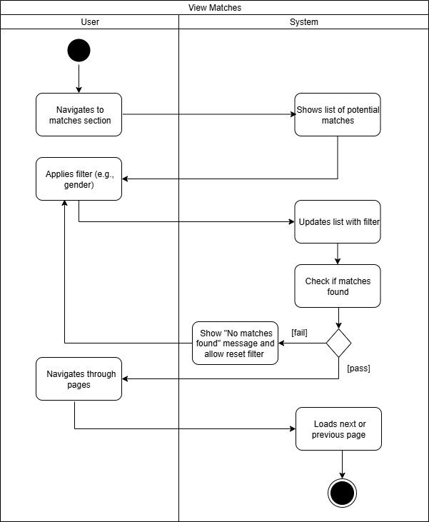

Figure 3.29: Activity Diagram for View Matches

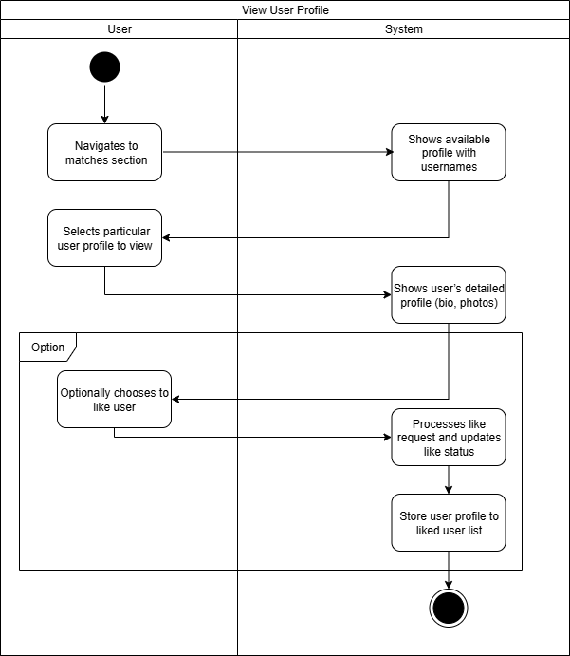

Figure 3.29: Activity Diagram for View User Profile

### 3.3.2.4 Likes Feature Module

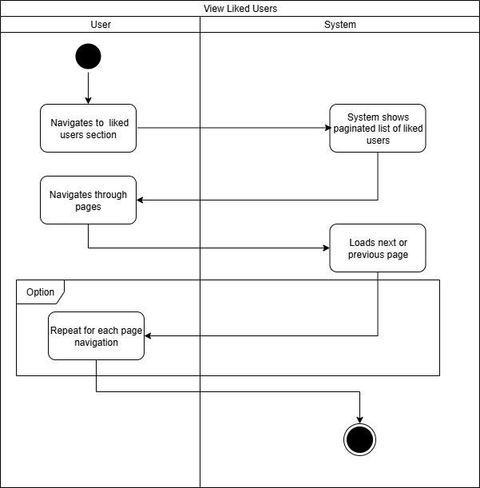

Figure 3.29: Activity Diagram for View Liked User

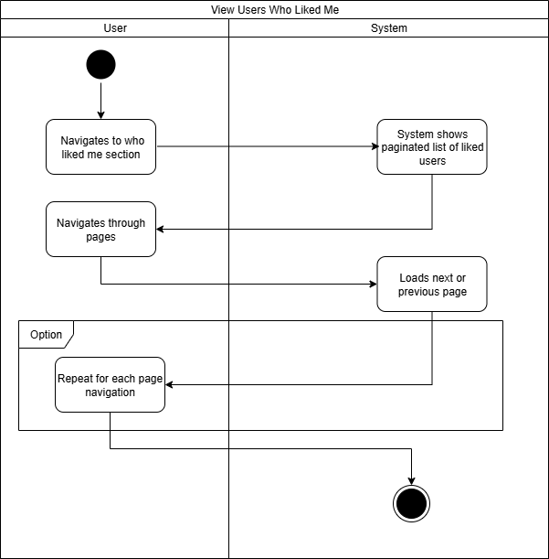

Figure 3.29: Activity Diagram for View Users Who Liked Me

### **3.3.2.5 Messaging Feature Module**

### 

Figure 3.29: Activity Diagram for Send Message

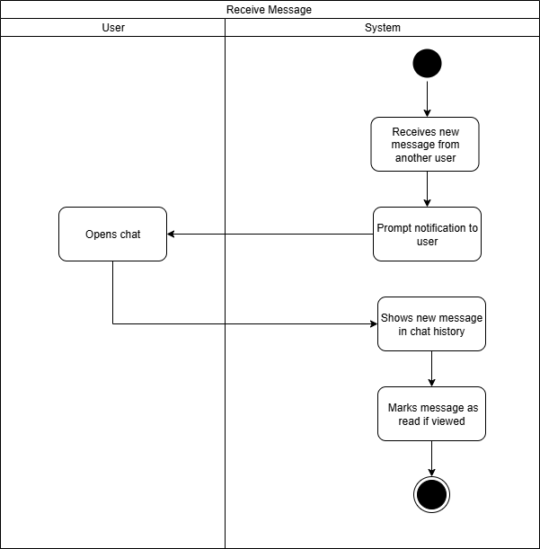

Figure 3.29: Activity Diagram for Receive Message

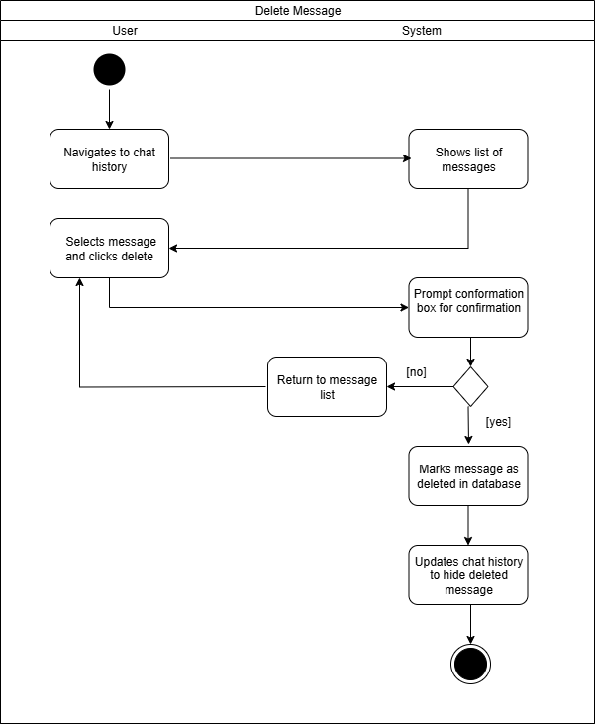

Figure 3.29: Activity Diagram for Delete Message

## 3.4 Functional and Non-Functional Requirement

### 3.4.1 Functional Requirement

Functional requirements form the cornerstone of the Lumé dating app, acting as a detailed blueprint that outlines the specific features and interactions the system must support. Much like an architect’s plan for designing a house, these requirements define the app’s capabilities, ensuring it meets user expectations for connecting, communicating, and managing profiles. They serve as a critical reference for validating that the app delivers value to users—such as enabling seamless user registration, messaging, or profile customization—and verifying that each implemented feature functions as intended. By clearly specifying what the system should do, functional requirements foster effective communication among stakeholders, including developers, designers, and project managers, ensuring a shared understanding of the app’s scope.

Moreover, well-defined functional requirements aid in project planning and risk management. By identifying the core functionalities—such as user account management, likes, messaging, and admin moderation—they highlight potential development challenges, such as ensuring secure authentication or handling real-time communication. This allows the development team to estimate the time, resources, and technical expertise needed, establishing a clear baseline for the project timeline and budget. Without this blueprint, development could become disorganized, leading to misaligned features or unmet user needs. Additionally, these requirements provide a foundation for future enhancements, such as adding new profile features or interaction options, ensuring consistency and maintainability by serving as a reference for iterative improvements.

### 3.4.1.1 Account Management Module

* FR 1: The system should allow users to register with a unique username, password, and role assignment, including a uniqueness check for the username.
* FR 2: The system should allow users to log in with username and password validation.

### 3.4.1.2 Administration Module

* FR 3: The system should display a list of users with their assigned roles.
* FR 4: The system should allow admins to open a modal dialog to edit user roles.
* FR 5: The system should allow admins to update user roles via the admin service, reflecting changes in the UI.
* FR 6: The system should allow admins to retrieve a list of photos pending approval.
* FR 7: The system should allow admins to approve or reject photos, updating the UI accordingly.

### 3.4.1.5 Users Management Module

* FR 8: The system should allow the current user to retrieve a paginated list of users with filtering by gender.
* FR 9: The system should allow the current user to retrieve detailed member information by username.
* FR 10: The system should allow the current user to update their profile information.
* FR 11: The system should allow the current user to add photos to their profile.
* FR 12: The system should allow the current user to set a photo as their main photo.
* FR 13: The system should allow the current user to delete photos from their profile.

### 3.4.1.3 Likes Features Module

* FR 14: The system should allow the current user to add a like to another user, preventing self-likes or duplicate likes.
* FR 15: The system should allow the current user to retrieve a paginated list of users they have liked.
* FR 16: The system should allow the current user to retrieve a paginated list of users who have liked them.

### 3.4.1.4 Messaging Features Module

* FR 17: The system should allow the current user to create and send a message to another user, preventing self-messaging.
* FR 18: The system should allow the current user to retrieve a paginated list of their sent and received messages.
* FR 19: The system should allow the current user to delete a message with authorization, using soft delete logic.

### 

### 3.4.2 Non-Functional Requirements

While functional requirements define what the Lumé dating app does, non-functional requirements (NFRs) specify how it performs, capturing the qualities that shape the user experience and system reliability. Extending the house-building analogy, if functional requirements are the blueprint for the app’s features, non-functional requirements represent the foundation and aesthetic qualities that make the app robust, appealing, and trustworthy. These requirements address critical aspects such as usability, availability, maintainability, and security, ensuring the app is intuitive, responsive, and secure for users seeking meaningful connections.

Non-functional requirements act as guiding principles for the app’s operational characteristics. For instance, they ensure the interface is user-friendly, allowing users to navigate effortlessly, or that the system remains available during peak usage to support uninterrupted interactions. They also guarantee that sensitive user data, like messages and photos, is protected against unauthorized access, fostering trust in the platform. Without these qualities, even a feature-rich dating app could fail to engage users if it is slow, prone to downtime, or difficult to use. By defining these emergent properties, non-functional requirements ensure the Lumé dating app not only meets functional expectations but also delivers a delightful and dependable experience, aligning with user goals and enhancing the platform’s success.

### 3.4.2.1 Usability

* NFR 1: The system should provide an intuitive interface, allowing users to access key features like messaging, liking other users, and updating profiles within three clicks or taps, ensuring easy navigation for a seamless user experience.
* NFR 2: The system should use a consistent and clear design with a well-organized layout, enabling users of all technical skill levels to navigate and use the app effortlessly.
* NFR 3: The system should deliver a responsive interface that adapts smoothly across devices, including desktops, tablets, and mobile phones, supporting a minimum screen resolution of 320x480 pixels.
* NFR 4: The system should present clear and user-friendly error messages without technical jargon, helping users understand and resolve issues quickly.

### 3.4.2.2 Availability

* NFR 5: The system should maintain 99.9% uptime, excluding planned maintenance, to ensure users can reliably access features like messaging and profile viewing at all times.
* NFR 6: The system should limit unplanned downtime to no more than 2 hours per month, using proactive monitoring to prevent outages and ensure consistent availability.
* NFR 7: The system should notify users at least 24 hours in advance of scheduled maintenance that may cause downtime, allowing them to plan accordingly.
* NFR 8: The system should recover from unexpected failures, such as server issues, within 5 minutes through automated recovery mechanisms.

### 3.4.2.3 Maintainability

* NFR 9: The system should be built with a modular structure, separating backend and frontend functionalities into independent components to simplify updates and minimize the impact of changes across the system.
* NFR 10: The system should follow standard coding practices with clear documentation, ensuring the codebase is readable and easy to maintain by developers.
* NFR 11: The system should allow new features, such as additional profile options or enhanced messaging capabilities, to be added with minimal changes, supporting future growth.
* NFR 12: The system should support automated testing to validate updates, reducing the risk of introducing errors during maintenance or feature additions.

### 3.4.2.4 Security

* NFR 13: The system should encrypt all sensitive user data, including personal details, messages, and photos, both during transmission and storage, using strong encryption standards to prevent unauthorized access.
* NFR 14: The system should securely hash user passwords using a robust hashing algorithm, ensuring passwords remain protected even in the event of a data breach.
* NFR 15: The system should enforce role-based access control, restricting administrative functions like user management and photo moderation to authorized users only.
* NFR 16: The system should automatically scan user-uploaded photos for inappropriate content before manual review, ensuring compliance with platform policies.
* NFR 17: The system should limit the rate of user actions, allowing no more than 100 requests per minute per user for non-admin tasks, to prevent abuse and protect system stability.
* NFR 18: The system should comply with data protection regulations (e.g., GDPR, CCPA), providing users with options to delete their data and ensuring secure data handling practices.

### 3.4.2.5 Additional System-Wide Requirements

* NFR 19: The system should respond to user actions, such as retrieving profiles or sending messages, within 2 seconds on average under normal conditions, ensuring a smooth experience.
* NFR 20: The system should scale to handle up to 10,000 concurrent users without performance issues, supporting peak usage during high-traffic periods.
* NFR 21: The system should be compatible with the latest two versions of major web browsers (e.g., Chrome, Firefox, Safari, Edge), ensuring broad accessibility.
* NFR 22: The system should support internationalization, allowing the interface to be translated into at least two additional languages (e.g., Spanish, French) with minimal changes.
* NFR 23: The system should ensure data integrity by maintaining consistent and reliable data operations for critical tasks like message deletion and photo management.

### 

## 3.5 Chapter Summary and Evaluation

Chapter 3 provides a detailed exploration of the methodology and requirement analysis for the Lumé dating app, emphasizing a user-centric approach to development. Through a comprehensive questionnaire targeting the youth in Southeast Asia and insights from a relationship expert, the chapter uncovers critical user needs and preferences, particularly regarding AI-driven features like intelligent matchmaking and emotion-aware communication. The requirement analysis employs UML diagrams, including use case and activity diagrams, to model user interactions and system workflows across modules such as account management, administration, user management, likes, and messaging. Functional requirements outline the app's core capabilities, ensuring it supports essential user actions like registration, profile management, and communication. Non-functional requirements address the app's performance, security, and usability, ensuring a reliable and engaging user experience. Together, these elements form a robust foundation for Lumé's development, aligning the app's features with user expectations and technical feasibility.

The methodology employed demonstrates a thorough and structured approach to understanding user needs and translating them into actionable requirements. The use of a questionnaire provides quantitative data on user demographics and preferences, with 47 responses offering valuable insights into the Southeast Asian youth market, particularly Malaysia. The interview with a relationship expert adds qualitative depth, ensuring a well-rounded perspective on user expectations, though its specific findings are not detailed in the chapter. The requirement analysis is meticulous, with detailed use case descriptions and activity diagrams that clearly define system interactions and workflows, providing clarity crucial for guiding development and ensuring stakeholder alignment. The functional requirements are comprehensive, covering essential features across various modules, while the non-functional requirements prioritize critical aspects like security and usability—key for a dating app handling sensitive user data, as evidenced by the survey's 87.2% high privacy concern rate.

Additionally, while the survey highlights strong user interest in AI features (e.g., 66% comfort with text analysis for tips), incorporating more explicit user feedback on their implementation could further align the app’s capabilities with expectations. The focus on a web-based initial launch, suggested by the survey’s privacy-over-features preference (78.7% willingness), is a practical constraint-driven choice given budget limitations, but it may limit early user reach compared to a mobile app. Overall, Chapter 3 effectively lays the groundwork for Lumé’s development, balancing user needs with technical considerations to create a promising, secure, and innovative dating platform tailored to its target demographic.

# References

SuperSurvey. (2025) 55+ Essential Dating App Survey Questions.<https://www.supersurvey.com/LPD-dating-app>

Orben & Przybylski. (2020) Dating Apps and Their Sociodemographic and Psychosocial Correlates: A Systematic Review.<https://www.mdpi.com/1660-4601/17/18/6600>

Pew Research Center. (2020) Online Dating Survey Topline.<https://www.pewresearch.org/internet/wp-content/uploads/sites/9/2020/02/PI_2020.02.06_Online-Dating_TOPLINE.pdf>

Coduto. (2025) Plenty of skepticism of AI in dating apps, especially among women, survey says.<https://www.bu.edu/com/articles/plenty-of-skepticism-of-ai-in-dating-apps-especially-among-women-survey-says/>

Lucidchart. (2025) UML Activity Diagram Guide.<https://www.lucidchart.com/pages/uml-activity-diagram>

ConceptDraw. (2025) Use Case Diagrams for Social Networking Site Examples.<https://www.conceptdraw.com/examples/use-case-diagrams-for-social-networking-site>

Visual Paradigm. (2025) What is a Use Case Diagram?<https://www.visual-paradigm.com/guide/uml-unified-modeling-language/what-is-use-case-diagram/>

Creately. (2025) Tinder Use Case Diagram Example.<https://creately.com/diagram/example/irx92xr42/tinder-use-case-classic>