<https://github.com/TingHsuanYang24>

**2-1. What is Git? Explain the workflow of Git when you push changes to a repository.**

Git is a distributed version control system which is capable of saving copies of a project with unique version numbers, and recording each change made from each version to the next.

Git Workflow of pushing changes to a repository:

1. Change directory to the location specified (a repository).
2. Make changes to file(s).
3. Stage: Move files to a “Staging Area” to be committed.
4. Commit: Commit the files.
5. Push: Send files to the repository in the name of a specified user with provided login information.

**2-2. What is Atom?**

Atom is an open-source text editor with interface development environment (IDE) capabilities.

**2-3. What is GitHub?**

GitHub is an online development platform that allows individuals and organizations to host and review code, manage projects, and build software.

**3. Example websites of web mapping.**

1) A World of Belonging on Airbnb <https://www.airbnb.com/map>

Credit: Airbnb

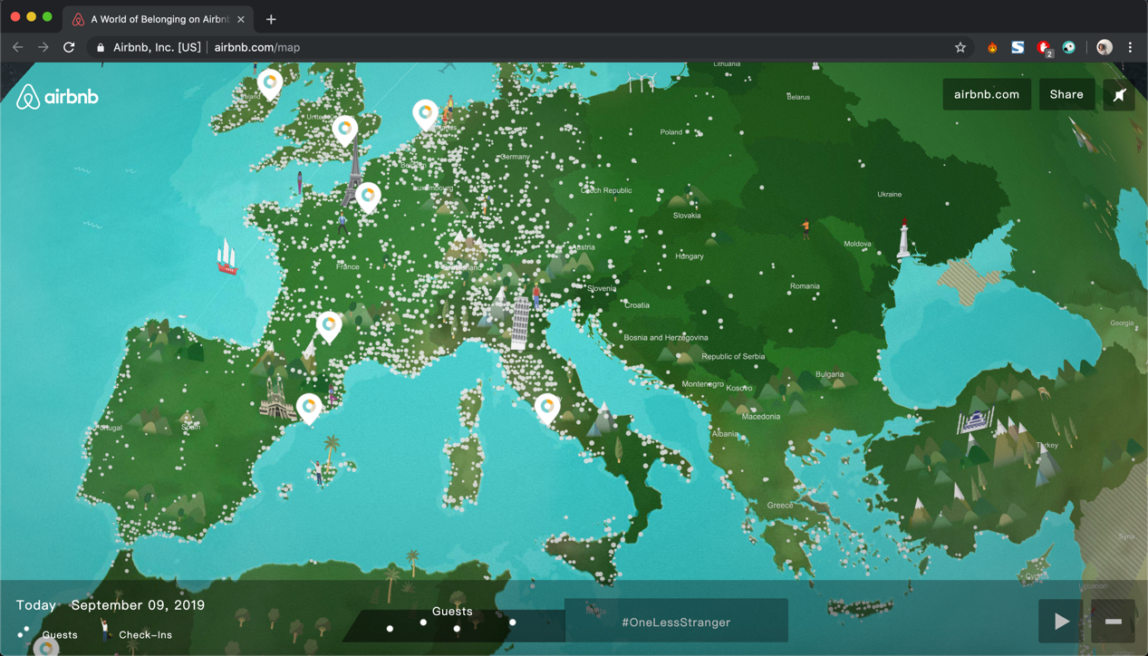

* **Primary purpose of the application:**

Provide a view of worldwide daily check-ins and stays of Airbnb, social posts with specific hashtag, and fun facts/trivia of some popular cities.

* **GIS functionality:**

Display location-based daily check-in and stay events, social posts and trivia on a map/earth by geocoding.

* **Target users:**

People interested in travel, finding accommodation with Airbnb, or exploring the current popular destinations on the map. And maybe people in love with adorable maps.

* **Comments in terms of the level of intuitiveness and suggestions for re-design:**
* Pan and zoom: It’s easy to pan the map or spin the earth, just like using google maps and most of the other web mapping applications. However, this map application only provides 2 zoom levels and the zooming can only be done by using the room in/out button at the bottom-right hand corner. (Zooming in can also be done by a double-click on the map). I think it would be better if the map can be zoomed by scrolling mouse wheel or pinching with two fingers.
* I would say that despite the adorable illustration, this map has very little to offer. I expect to obtain additional or more useful information from the map. For example, with more zoom levels, user can see a more detailed look of an interested area. Furthermore, when the user clicks on a cluster of dots representing an area defined by the creators, he/she can check on the featured or promoted listings and eventually be directed to a listing page to book a stay.

2) Inside Asia <https://www.insideasiatours.com/step-inside/>

Credit: Green Chameleon

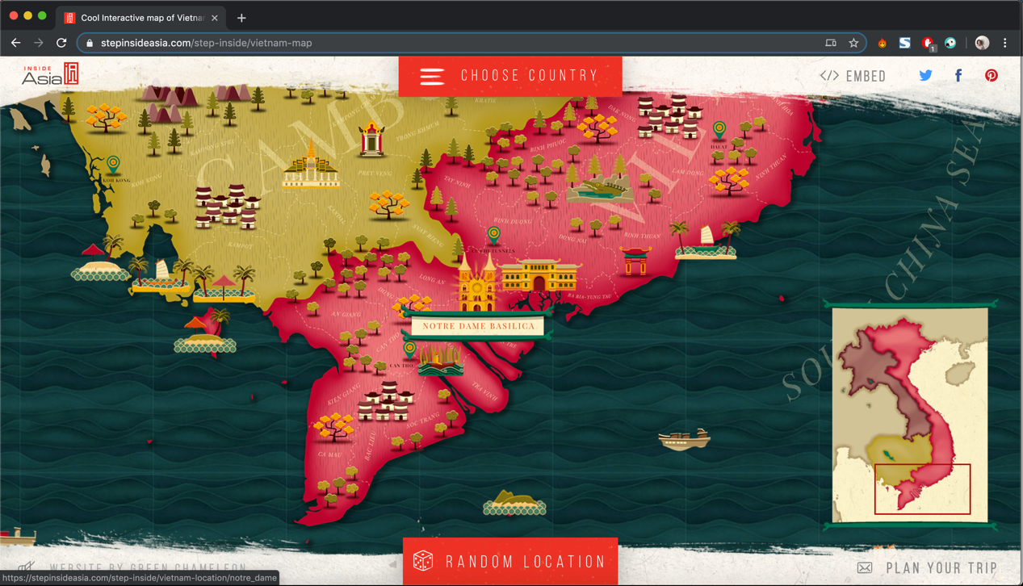

* **Primary purpose of the application:**

Provide an interactive map of tourist attractions in several Asia counties including Vietnam, Cambodia, Laos, and Myanmar.

* **GIS functionality:**

Display tourist attraction locations by geocoding and provide links to 360-degree virtual tour powered by Google.

* **Target users:**

Tourists interested in a trip to southeastern Asia.

* **Comments in terms of the level of intuitiveness and suggestions for re-design:**
* Pan and zoom: this map application doesn’t provide zooming, the users can only exploring the map by moving the cursor in different directions and the cursor react speed is a little bit too slow (or the cursor sensitivity is too weak).
* It’s indeed delightful to explore the details of the map illustration, but not intuitive enough for the users to distinguish between the icons representing attraction spots and the other decorative icons since there is no obvious visual hierarchy. The users can only find the spots by hovering the mouse over the icons to discover popped up tags. I think the figure-ground separation can be done better.
* I think it’s annoying that the website reloads a new page every time I click on a tag (open the the 360-degree virtual tour) and go back to the map view. It would be better if they can use a pop-up window to display the 360-degree virtual tour, like a quick view window offered by some of the eCommerce websites.