Multiple Choice Questions
Question 1
Consider following generalization / specialization.

Individual
sport
Discipline
Team sport

Discipline
nr

Name

Number
players
d
t
Suppose we represent this generalization / specialization by the following relational model:
Discipline (Disciplinenr, Name)
Individual sport (Disciplinenr) Disciplinenr refers to Disciplinenr in Discipline
Teamsport (Disciplinenr, Number players) Disciplinenr refers to Disciplinenr in Discipline
Consider the following 4 statements
- The relational model does not allow to enforce the completeness constraint; the disjointness constraint can be enforced.
- The relational model does not allow to enforce both the completeness constraint and the disjointness constraint.
- By dropping the relation ‘Discipline’ in the relational model, the completeness constraint can be enforced.
- The relational model allows the specialization to be partial.
Which of the following options is CORRECT?
- Statement 1 and 2 are both correct.
- Statement 1 and 4 are both incorrect.
- Only statement 1 is incorrect, the other statements are correct.
- Only statement 4 is incorrect, the other statements are correct.
Question 2
Consider the following EER model
Which statement is CORRECT?
- When mapping the EER relationship type IS_ENROLLED between COURSE and STUDENT to the relational model, a new relation needs to be introduced. The relation is identified by GRADE as its primary key.
- When mapping the EER relationship type INVOLVE between COURSE and ASSIGNMENT to the relational model, a new relation needs to be introduced. The 1..1 cardinalities of this relationship type cannot be enforced in the relational model.
- When mapping the EER relationship type PARTICIPATE between GROUP ASSIGNMENT and STUDENT to the relational model, a new relation needs to be introduced. The 4 cardinalities of this EER relationship type can be perfectly mapped to the relational model.
- The partial inheritance relationship between STUDENT and REPRESENTATIVE can be perfectly mapped to the relational model by the following two relations: STUDENT(StudentID, FirstName, LastName) and REPRESENTATIVE (S-StudentID, Email) whereby S-StudentID refers to StudentID in STUDENT.
Question 3
Consider the following ER model for a course administration.
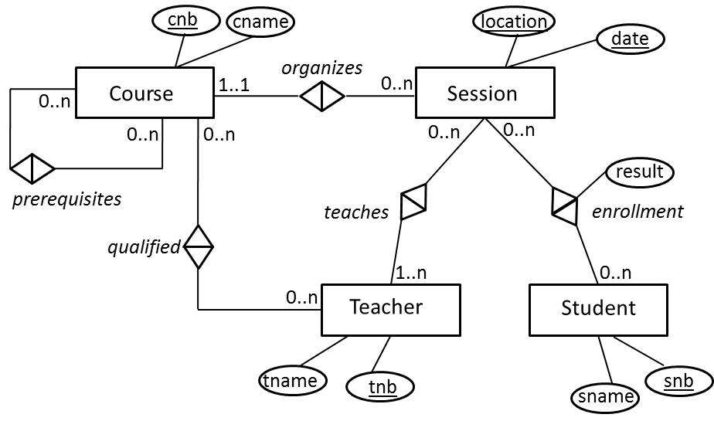

Which statement is NOT CORRECT?
- When mapping the ER relationship type teaches between Session and Teacher to the relational model, a new relation needs to be introduced. The 4 cardinalities of this ER relationship type can be perfectly mapped to the relational model.
- When mapping the ER relationship type organizes between Course and Session to the relational model, the primary key “cnb” of the Course relation will be included as a NOT NULL foreign key in the Session relation. The 4 cardinalities of this ER relationship type can be perfectly mapped to the relational model.
- When mapping the ER relationship type enrollment between Session and Student to the relational model, a new relation needs to be introduced. The 4 cardinalities of this ER relationship type can be perfectly mapped to the relational model.
- Both the ER and the relational model cannot enforce that a teacher can only teach sessions of courses for which he/she is qualified.
Question 4
Which of the following statements is CORRECT?
  - An EER relationship type always asks for the creation of a new corresponding relation R in the relational model.
  - A minimum cardinality of 1 in the EER model can never be enforced in the relational model.
  - In mapping an EER N:M relationship type to the relational model, we create a new relation R. Its primary key is the combination of the foreign keys referring to the primary keys of the relations corresponding to the participating entity types.
  - An EER aggregation cannot be mapped in a straightforward way to a relational model.
Question 5
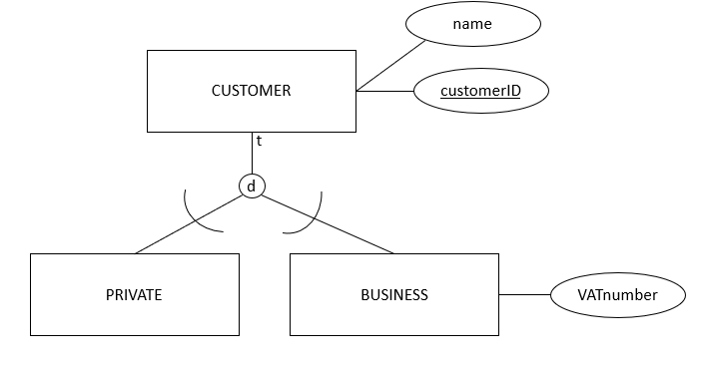
In mapping this EER specialization to a relational model, which of the following statements is CORRECT?
  - We can never enforce a total specialization in the relational model.
  - We can never enforce a disjoint specialization in the relational model.
  - Creating three relations Customers(customerID, name), Private(private-CID) and Business (business-CID, VATnumber) enforces both a total and disjoint specialization.
  - Creating two relations Private(customerID, name) and Business(customerID, name, VATnumber) enforces a total but not disjoint specialization.
Question 6
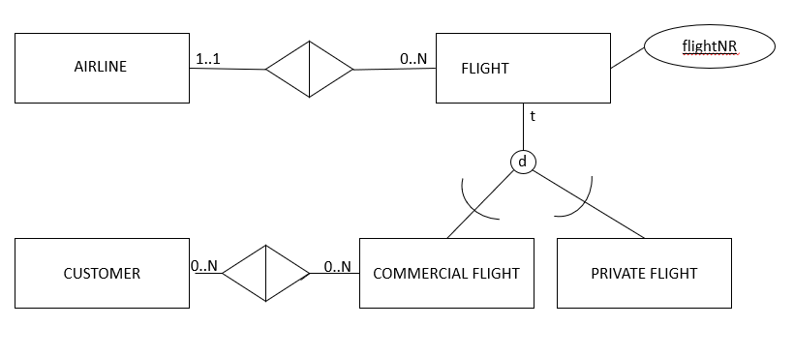
Which of the following statements is NOT CORRECT when mapping the above EER model to a relational model?
  - A new relation should be created to model the EER relationship type between customer and commercial flight.
  - A new relation should be created to model the EER relationship type between flight and airline.
  - The total EER specialization can be mapped to the relational model without loss of semantics.
  - The Airline’s primary key should be included as a NOT NULL foreign key in the relation ‘Flight’.
Question 7
Consider the following EER model
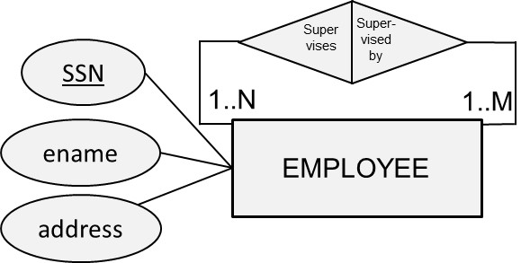
Which statement is CORRECT?
  - All 4 cardinalities can be perfectly mapped to the relational model.
  - Both minimum cardinalities cannot be successfully mapped to the relational model.
  - Both maximum cardinalities cannot be successfully mapped to the relational model.
  - The relational model cannot enforce that an employee can be supervised by M other employees.
Question 8
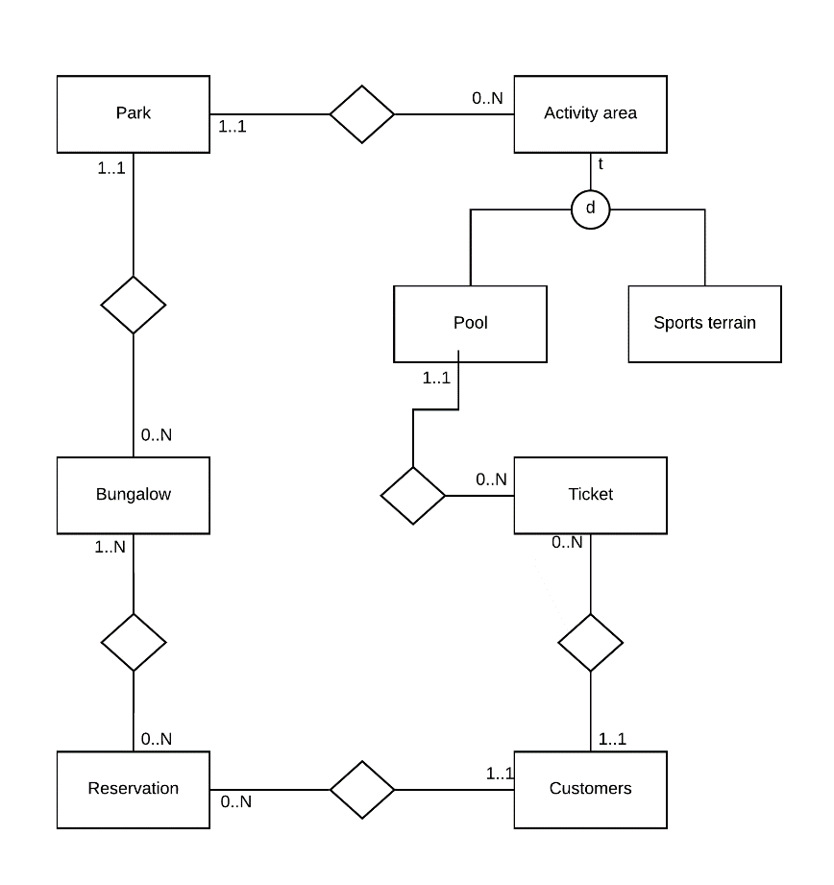
Which of following statements on mapping the above EER model to a relational model is CORRECT?
  - We cannot enforce all four cardinalities of the EER relationship type between ‘Park’ and ‘Activity area’.
  - We cannot enforce all four cardinalities of the EER relationship type between ‘Bungalow’ and ‘Reservation’.
  - The minimum cardinality of 1 at the side of ‘Customers’ in the EER relationship type between ‘Customers’ and ‘Ticket’ cannot be enforced.
  - We cannot enforce that the EER specialization is total in the relational model.
Question 9
Consider the following EER model

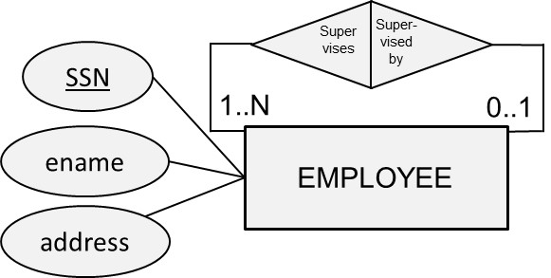
Which statement is CORRECT?
  - All 4 cardinalities can be perfectly mapped to the relational model.
  - The relational model cannot enforce that an employee supervises at least one other employee.
  - The relational model cannot enforce that an employee can be supervised by at most one other employee.
  - The relational model cannot enforce that an employee can supervise N other employees.
The way this would be mapped to the relational model is as follows:
EMPLOYEE(SSN, ename, address, SUPERVISOR-SSN)
SUPERVISOR-SSN is foreign key which refers to SSN of the EMPLOYEE relation. It can be NULL since the minimum cardinality is 0. Let’s consider some example tuples of the EMPLOYEE table:
SSN | Ename | Address | SUPERVISOR-SNN
100 | Bart Baesens | Naamsestraat 69, 3000 Leuven | 300
200 | Wouter Verbeke | Naamsestraat 69, 3000 Leuven | 300
300 | Wilfried Lemahieu | Naamsestraat 69, 3000 Leuven | 1000
1000 | Luc Sels | Naamsestraat 22, 3000, Leuven | NULL

Let’s now look at all 4 cardinalities. The minimum cardinality of 0 is enforced because of the NULL allowed constraint. Luc Sels for example is not supervised by anyone. The maximum cardinality of 1 is enforced because the relational model is normalised and does not allow multi valued attribute types according to the first normal form. The minimum cardinality of 1 (in the supervises direction) is not allowed since there are employees who don’t supervise anyone else such as Bart and Wouter. The maximum cardinality of N is perfectly enforced since there are employees such as Wilfried who supervise more than 1 employee. More specifically, Wilfried supervises both Bart and Wouter.
Question 10
Consider the following EER ternary relationship type

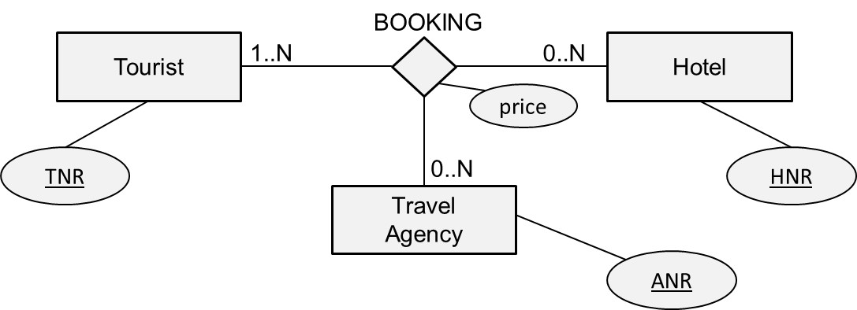
Which statement is CORRECT?
  - The minimum cardinality of 1 cannot be successfully mapped to the relational model.
  - All 6 cardinalities can be perfectly mapped to the relational model.
  - All maximum cardinalities of N cannot be successfully mapped to the relational model.
  - The corresponding relational model has 3 relations.
Question 11
Consider the following EER categorisation
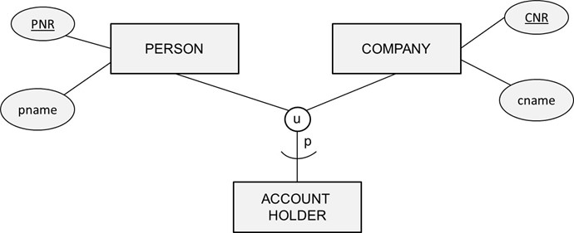
Suppose we map this to the relational model as follows:
PERSON(PNR, …, P-CustNo), P-CustNo refers to CustNo in ACCOUNT-HOLDER
COMPANY(CNR, …, C-CustNo), C-CustNo refers to CustNo in ACCOUNT-HOLDER
ACCOUNT-HOLDER(CustNo, …)
Which statement is CORRECT?
      - The categorisation can be perfectly mapped to the relational model.
      - The foreign keys P-CustNo and C-CustNo should be defined as NOT NULL.
      - We cannot guarantee that the tuples of the category relation are a subset of the union of the tuples of the superclasses.
      - The categorisation can also be modelled as a specialisation.

Open Questions
Question 1
Given the following EER model for an electricity market:
Map the model to a relational model representation. Discuss the possible loss of semantics. Clearly indicate the primary-foreign key relationships and specify NOT NULL declarations where necessary.
Answer:
Electricity_Producer(P-Name, Location)
Electricity_Reseller(Brand-Name, Nr-employees, Manager)
Sells(P-Name, Brand-Name)
P-Name: foreign key refers to P-Name in relation Electricity_Producer: NULL not allowed, on delete/update cascade
Brand-Name: foreign key refers to Brand-Name in relation Electricity_Reseller: NULL not allowed, on delete/update cascade
Local_Regulator(Province, Manager)
Customer(ID, Contract Type, Contract-With)
Contract-with: foreign key refers to Brand-Name in relation Electricity_Reseller: NULL not allowed, on delete/update cascade
Residential-Customer(R-C-ID, Household-size)
R-C-ID: foreign key refers to ID in relation Customer: NULL not allowed, on delete/update cascade
Business-Customer(B-C-ID, VAT-number)
B-C-ID: foreign key refers to ID in relation Customer: NULL not allowed, on delete/update cascade
Power-Plant(ID, MWH, Location, Regulated)
Regulated: foreign key refers to Province in relation Local_Regulator: NULL not allowed, on delete/update cascade
Owns(P-P-ID, Prod-Name)
P-P-ID: foreign key refers to ID in relation Power-Plant: NULL not allowed, on delete/update cascade
Prod-Name: foreign key refers to P-Name in relation Electricity_Producer: NULL not allowed, on delete/update cascade
Gas-Power-Plant(Gas-P-P-ID, Nr-pipelines)
Gas-P-P-ID: foreign key refers to ID in relation Power-Plant: NULL not allowed, on delete/update cascade
Wind-Power-Plant(Wind-P-P-ID, Nr-mills)
Wind-P-P-ID: foreign key refers to ID in relation Power-Plant: NULL not allowed, on delete/update cascade
Nuclear-Power-Plant(Nuclear-P-P-ID, Nr-reactors)
Nuclear-P-P-ID: foreign key
The following semantics were lost in the mapping:
• the disjointness of the specialization of Power Plant into Gas, Wind, and Nuclear cannot be enforced;
• the disjointness of the specialization of Customer into Residential and Business cannot be enforced;
• the minimum cardinality of 1 in the relationship type Owns between Electricity Producer and Power Plant cannot be enforced;
• the minimum cardinality of 1 in the relationship Sells between Electricity Producer and Electricity Reseller

Question 2
Given the following EER model for a driving school company:
Map the model to a relational model representation. Discuss the possible loss of semantics. Clearly indicate the primary-foreign key relationships and specify NOT NULL declarations where necessary.
Answer:
Examination_Centre(Location)
Examiner(Employee-ID, Work-Location)
Work-Location: foreign key refers to Location in relation Examination_Centre: NULL not allowed, on delete/update cascade
Exam_Driving_Route(Route-ID, Possible-in-Winter, Start-Location)
Start-Location: foreign key refers to Location in relation Examination_Centre: NULL not allowed, on delete/update cascade
Driving_License_Exam_Applicant(SSN, Name)
Exam_Opportunity(Exam-ID, Exam-Date, Route, Examiner, Applicant, Duration)
Route: foreign key refers to Route-ID in relation Exam_Driving_Route: NULL not allowed, on delete/update cascade
Examiner: foreign key refers to Employee-ID in relation Examiner: NULL not allowed, on delete/update cascade
Applicant: foreign key refers to SSN in relation Driving_License_Exam_Applicant: NULL not allowed, on delete/update cascade
Driving_School_Company(VAT-number, Name)
Car(ID, Brand, Year-of-Purchase, Owner)
Owner: foreign key refers to VAT-number in relation Driving_School_Company: NULL not allowed, on delete/update cascade
Driving_Instructors(Instructor-SSN, Name)
Trained_Official_Driving_Instructor(I-SSN, Employer)
I-SSN: foreign key refers to Instructor-SSN in relation Driving_Instructors: NULL not allowed, on delete/update cascade
Employer: foreign key refers to VAT-number in relation Driving_School_Company: NULL not allowed, on delete/update cascade
Family_Members(I-SSN)
I-SSN: foreign key refers to Instructor-SSN in relation Driving_Instructors: NULL not allowed, on delete/update cascade
Teaches(Student-SSN, Teacher-SSN)
Teacher-SSN: foreign key refers to Instructor-SSN in relation Driving_Instructors: NULL not allowed, on delete/update cascade
Student-SSN: foreign key refers to SSN in relation Driving_License_Exam_Applicant: NULL not allowed, on delete/update cascade

The following semantics were lost in the mapping:
• The specialization of driving instructors into trained official driving instructor and family members is perfectly mapped!
• We cannot enforce that the attribute type “Possible-in-Winter” should have a Boolean data type (i.e., true or false).
• We cannot enforce the maximum cardinality of 2 in the relationship type Teaches between Driving License Exam Applicant and Driving Instructors.
• We cannot enforce the minimum cardinality of 1 in the relationship Teaches between Driving License Exam Applicant and Driving Instructors.
• We cannot enforce that an examination center should have at least one examiner employed.
• We cannot enforce that an examination center should have at least one exam driving route.
• We cannot enforce that a driving school company should own at least one car.
• We cannot enforce that a driving school company should employ at least one trained official driving instructor.

