# Multiple Choice Questions

1. Which of these is part of the Query Processor in the DBMS Architecture?

1. DDL compiler
2. DML compiler
3. Transaction Manager
4. Security Manager

2. Which of these is NOT a part of the Storage Manager in the DBMS Architecture?

1. Connection Manager
2. Transaction Manager
3. Buffer Manager
4. Recovery Manager

3. Statement A: The DDL compiler compiles data definitions specified in DDL. It is possible that there is only 1 DDL with 3 instruction sets.

Statement B: The first step of the DDL compiler is to translate the DDL definitions.

Which statement(s) is/are CORRECT?

1. Only A
2. Only B
3. A and B
4. Neither A or B

4. Statement A: There is no query processor available in procedural DML.  
Statement B: With procedural DML, the DBMS determines the access path and navigational strategy to locate and modify the data specified in the query.

Which statement(s) is/are CORRECT?

1. Only A
2. Only B
3. A and B
4. Neither A or B

5. Evaluate the following statements:

1. Record-at-a-time DML means that the query gets recorded from the user at the time the user inputs the query and then gets processed.
2. Record-at-a-time DML means that navigating the database starts with positioning on one specific record and going from there onwards to other records.
3. Set-at-a-time DML means that the query gets set beforehand and then gets processed by the DBMS.
4. Set-at-a-time DML means that many records can be retrieved in one DML statement.

Which statements are CORRECT?

1. 1 and 3 are right
2. 2 and 3 are right
3. 1 and 4 are right
4. 2 and 4 are right

6. Statement A: The impedance mismatch problem can be solved by using middleware to map data structures between the DBMS and the DDL statements.

Statement B: An object-oriented host language such as Java combined with a document-oriented DBMS such as MongoDB does not require mapping objects to documents and vice versa.

Which statement(s) is/are CORRECT?

1. Only A
2. Only B
3. A and B
4. Neither A or B

7. Statement A: The Query Parser optimizes and simplifies a query and then passes it on to the Query Executor.

Statement B: In the DBMS architecture, the Storage Manager takes care of concurrency control.

Which statement(s) is/are CORRECT?

1. Only A
2. Only B
3. A and B
4. Neither A or B

8. Fill in the following sentences:

When during crash recovery, aborted transactions need to be undone, that is a task of the …A…

The part of the Storage manager that guarantees the ACID properties is the …B…

1. A: Lock manager, B: Recovery manager
2. A: Lock manager, B: Lock manager
3. A: Recovery manager, B: Buffer manager
4. A: Recovery manager, B: Transaction manager

9. CODASYL is an example of…

1. a Hierarchical DBMS
2. a Network DBMS
3. a Relational DBMS
4. an Object-Oriented DBMS

10. Which of the following DBMS types is NOT a classification based on a data model?

1. Hierarchical DBMS
2. Network DBMS
3. Cloud DBMS
4. Object-Relational DBMS

11. Statement A: In a Hierarchical DBMS, DML is declarative and set oriented with a query processor.

Statement B: In a relational DBMS, there is data independence between the logical and internal data model.

Which statement(s) is/are CORRECT?

* 1. Only A
  2. Only B
  3. A and B
  4. Neither A or B

12. If you want to use a DBMS architecture that can access multiple data sources itself and provides a uniform interface hiding the low-level details, the most appropriate DBMS would be a…

1. n-tier DBMS
2. Cloud DBMS
3. Client-Server DBMS
4. Federated DBMS

13. Statement A: An OLTP system is able to cope with real-time, simultaneous transactions which the database server is able to process in a huge volume.

Statement B: An OLAP system uses large amounts of operational data to run complex queries on and provide insights for tactical and strategical decision making.

Which statement(s) is/are correct?

1. Only A
2. Only B
3. A and B
4. Neither A or B

14. Statement A: Native XML DBMSs map the hierarchical structure of an XML document to a physical storage structure, because they are able to use the intrinsic structure of an XML document.

Statement B: XML-enabled DBMSs are able to store XML data in an integrated and transparent way, because they are able to use the intrinsic structure of an XML document.

Which statement(s) is/are correct?

1. Only A
2. Only B
3. A and B
4. Neither A or B

15. Which of the following statements about the ER model is CORRECT?

1. An entity represents a set of entity types with similar properties.
2. One of the strengths of the ER model is that temporal constraints can be modelled.
3. A weak entity type cannot have a key attribute type of its own. Therefore, a weak entity type borrows an attribute type of its owner entity type.
4. The ER model allows to enforce consistency across multiple relationship types.

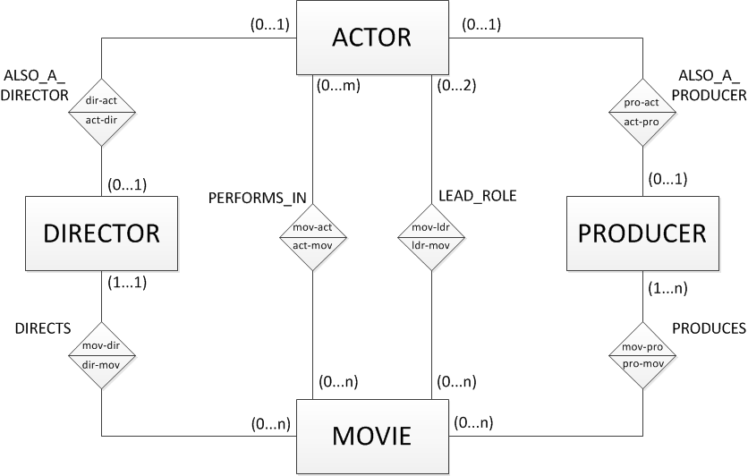

16. Given the ER model above, which of the following statements is CORRECT?

* 1. A movie always has as many lead actors as there actors in the movie.
  2. PRODUCER is an existence dependent entity type.
  3. A director of a movie can also act in the same movie.
  4. A movie can have multiple actors, producers and directors.

17. In the movie ER model above, we focus on the binary relationship ‘PRODUCES’. Suppose we add an attribute type that indicates the time that each producer spent on producing each movie called ‘WORKING HOURS’. Which of the following scenarios is possible?

* 1. We can migrate the attribute type ‘WORKING HOURS’ to the ‘MOVIE’ entity type.
  2. We can migrate the attribute type ‘WORKING HOURS’ to the ‘PRODUCER’ entity type.
  3. We can migrate the attribute type ‘WORKING HOURS’ to either one of the linked entity types.
  4. We can add the attribute type ‘WORKING HOURS’ to the relationship type PRODUCES.

1. Which statement is CORRECT?
   1. In case a ternary relationship type is represented as 3 binary relationship types, then semantics will get lost.
   2. A ternary relationship type can always be represented as 3 binary relationship types without loss of semantics.
   3. 3 binary relationship types between 3 entity types can always be replaced by 1 ternary relationship type between the 3 participating entity types.
   4. A ternary relationship type cannot have attribute types.
2. Which statement is CORRECT?
   1. A weak entity type can only have one attribute type.
   2. A weak entity type is always existence dependent.
   3. An existence dependent entity type is always a weak entity type.
   4. An existence dependent entity type always participates in a 1:1 relationship type.
3. Given the following ER model:

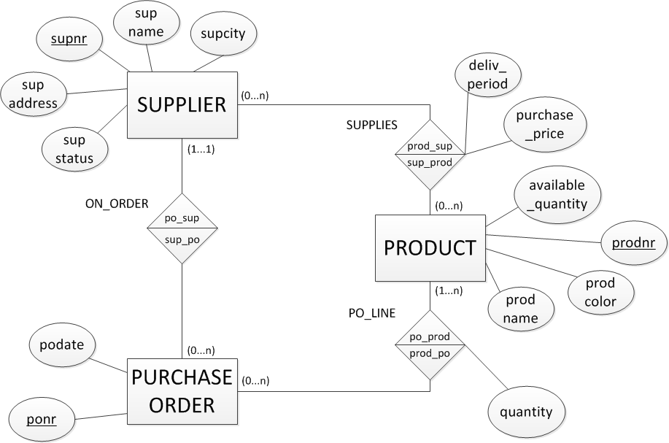

Which statement is NOT CORRECT?

1. The ER model does not enforce that a supplier can only have purchase orders outstanding for products he/she can actually supply.
2. The ER model has both weak and existence dependent entity types.
3. According to the ER model, a supplier cannot have more than 1 address.
4. According to the ER model, there can be suppliers than supply no products and have no purchase orders outstanding.

# Open Question

Make an ER model for company organizing courses as follows:

* For each course, the following data is recorded: coursenr, coursename. A course is uniquely identified by the coursenr.
* Some prerequisite knowledge may be required to follow a certain course. So one may have to follow one or more courses first, before one can be enrolled for a certain course. E.g., in order to enroll for the course “Advanced Microsoft Excel”, one must first follow “Basic Microsoft Excel”.
* Various sessions of a course can be organized, each on a specific date at a specific location. E.g., the course “Basic Microsoft Excel” can be organized in Bruges on January 8th, 2019, but also in Leuven on January 15th, 2019.
* For each lecturer, the following data is recorded: lecturernr, lecturername. A lecturer has a unique lecturernr.
* A lecturer can teach multiple sessions of courses. A session of a course can be taught by several lecturers.
* For each student, the following data is recorded: studentnr, studentname. A student has a unique studentnr.
* A student can be enrolled for more than one session. For each session his/her result is recorded.
* Evidently, multiple students can be enrolled for a specific session of a course.

Give some examples of semantics that cannot be enforced in the ER model.