新的label與僅有4個top數值。

驗證的話，先不要cross project，下面的方法是切成5個fold，先在相同的project中驗證。

java -jar RankLib-2.18.jar -train Chart/SBFL_chart.txt -ranker 1 -kcv 5 -kcvmd Chart_result/Chart_new_label/ -kcvmn rn -metric2t MAP -metric2T MAP -tvs 0.8 >> Chart_result/Chart_new_label/chart_RN_train.txt

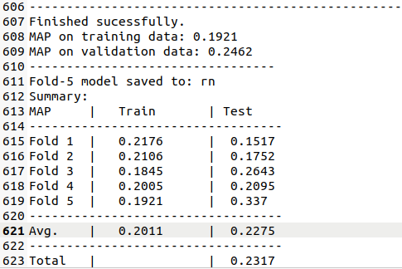

從這邊的整體結果來看很差。

不管，先互相驗證試試看。

首先拿Chart-26來看看

java -jar RankLib-2.18.jar -load Chart_result/Chart_new_label/f5.rn -rank Chart/SBFL_chart26_test.txt -indri Chart_result/Chart_test26/Chart_f5.rn_in_Chart26_result.txt

Chart-12，是F3沒有參與訓練的

java -jar RankLib-2.18.jar -load Chart_result/Chart_new_label/f3.rn -rank Chart/SBFL_chart12_test.txt -indri Chart_result/Chart_test12/Chart_f3.rn_in_Chart12_result.txt

test所有，用來看Chart12是否結果合理?

java -jar RankLib-2.18.jar -load Chart_result/Chart_new_label/f3.rn -rank Chart/SBFL_chart.txt -indri Chart_result/Chart_test/Chart_f3.rn_in_Chart_result.txt

從結果來看Chart-12的結果完全錯誤，沒任何用處，可能是因為這個label方法都是零點幾，造成模型沒辦法確認到底哪個結果是好的。

再跟老師討論?

真的想不到沒有APR的修復結果後當成label，作為訓練的其他方式。

或是將原本訓練資料**使用Top1、3、5、10以及是否生成patch這5個feature的結果。**的**是否生成Patch**這個改成計算的數值作為這個特徵。

.

直接試試看。

把剛剛的檔案名稱改成” old_chart分頁排名結果.xlsx”與” old_chart排名結果.xlsx”。

檔案名稱叫做**”SBFL_chart_calculate_as_feature.txt”**這個

java -jar RankLib-2.18.jar -train Chart/SBFL_chart_calculate_as_feature.txt -ranker 1 -kcv 5 -kcvmd Chart_result/Chart_calculate/ -kcvmn rn -metric2t MAP -metric2T MAP -tvs 0.8 >> Chart_result/Chart_calculate/chart_RN_train.txt

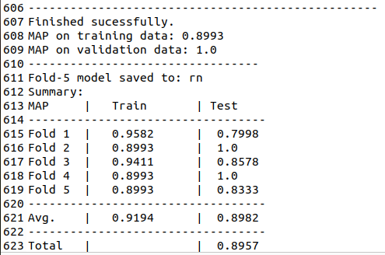

test所有，用來看Chart12、14是否結果是好的

java -jar RankLib-2.18.jar -load Chart_result/Chart_calculate/f3.rn -rank Chart/SBFL_chart_calculate_as_feature.txt -indri Chart_result/Chart_test/Chart_cal_f3.rn_in_Chart_result.txt

結果發現只是會單純的把好的APR排在前面而已，SBFL的好壞已經沒有任何影響了。

**驗證資料**

**(Chart應用於Chart)**

java -jar RankLib-2.18.jar -test Chart/SBFL_chart_calculate_as_feature.txt -metric2T MAP -idv Chart_output/chart_calculate_as_feature.map.txt

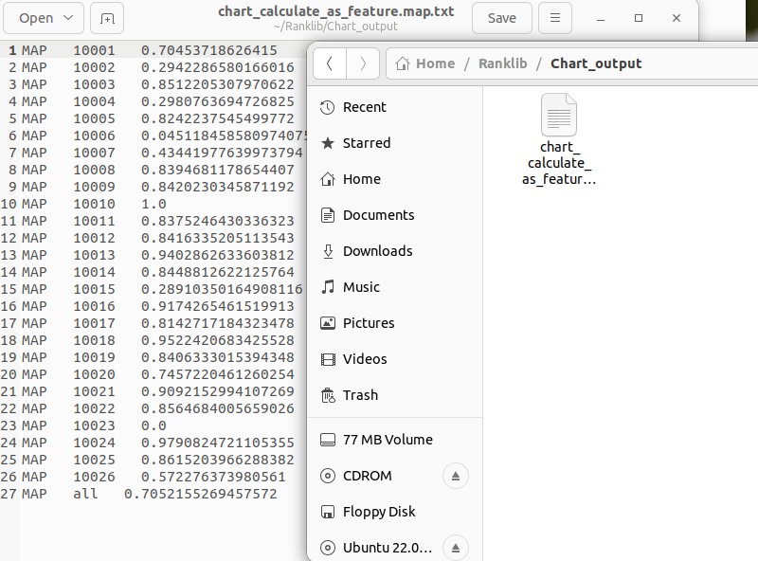

驗證結果

F1

java -jar RankLib-2.18.jar -load Chart_result/Chart_calculate/f1.rn -test Chart/SBFL_chart_calculate_as_feature.txt -metric2T MAP -idv Chart_output/chart_F1_calculate_as_feature_in_chart.map.txt

F2

java -jar RankLib-2.18.jar -load Chart_result/Chart_calculate/f2.rn -test Chart/SBFL_chart_calculate_as_feature.txt -metric2T MAP -idv Chart_output/chart_F2_calculate_as_feature_in_chart.map.txt

F3

java -jar RankLib-2.18.jar -load Chart_result/Chart_calculate/f3.rn -test Chart/SBFL_chart_calculate_as_feature.txt -metric2T MAP -idv Chart_output/chart_F3_calculate_as_feature_in_chart.map.txt

F4

java -jar RankLib-2.18.jar -load Chart_result/Chart_calculate/f4.rn -test Chart/SBFL_chart_calculate_as_feature.txt -metric2T MAP -idv Chart_output/chart_F4_calculate_as_feature_in_chart.map.txt

F5

java -jar RankLib-2.18.jar -load Chart_result/Chart_calculate/f5.rn -test Chart/SBFL_chart_calculate_as_feature.txt -metric2T MAP -idv Chart_output/chart_F5_calculate_as_feature_in_chart.map.txt

比較

java -cp RankLib-2.18.jar ciir.umass.edu.eval.Analyzer -all Chart_output/ -base chart_calculate_as_feature.map.txt > analysis.txt

**驗證資料**

**(Chart應用於Closure)**

java -jar RankLib-2.18.jar -test Closure/SBFL_closure_calculate_as_feature.txt -metric2T MAP -idv Chart_in_closure/closure_calculate_as_feature.map.txt

驗證結果

F1

java -jar RankLib-2.18.jar -load Chart_result/Chart_calculate/f1.rn -test Closure/SBFL_closure_calculate_as_feature.txt -metric2T MAP -idv Chart_in_closure/chart_F1_calculate_as_feature_in_closure.map.txt

F2

java -jar RankLib-2.18.jar -load Chart_result/Chart_calculate/f2.rn -test Closure/SBFL_closure_calculate_as_feature.txt -metric2T MAP -idv Chart_in_closure/chart_F2_calculate_as_feature_in_closure.map.txt

F3

java -jar RankLib-2.18.jar -load Chart_result/Chart_calculate/f3.rn -test Closure/SBFL_closure_calculate_as_feature.txt -metric2T MAP -idv Chart_in_closure/chart_F3_calculate_as_feature_in_closure.map.txt

F4

java -jar RankLib-2.18.jar -load Chart_result/Chart_calculate/f4.rn -test Closure/SBFL_closure_calculate_as_feature.txt -metric2T MAP -idv Chart_in_closure/chart_F4_calculate_as_feature_in_closure.map.txt

F5

java -jar RankLib-2.18.jar -load Chart_result/Chart_calculate/f5.rn -test Closure/SBFL_closure_calculate_as_feature.txt -metric2T MAP -idv Chart_in_closure/chart_F5_calculate_as_feature_in_closure.map.txt

比較

java -cp RankLib-2.18.jar ciir.umass.edu.eval.Analyzer -all Chart_in_closure/ -base closure_calculate_as_feature.map.txt > analysis.txt

**將模型Chart的出的F3應用於Closure**

java -jar RankLib-2.18.jar -load Chart_result/Chart_calculate/f3.rn -test Closure/SBFL_closure_calculate_as_feature.txt -metric2T MAP

詳細列出每一個pid中的每一個編號的預測分數。

java -jar RankLib-2.18.jar -load Chart_result/Chart_calculate/f3.rn -rank Closure/SBFL_closure_calculate_as_feature.txt -score Chart_F3_in_closure_Score.txt

java -jar RankLib-2.18.jar -load Chart_result/Chart_calculate/f3.rn -rank Closure/SBFL_closure_calculate_as_feature.txt -indri Closure_result/Chart_cal_f3.rn_in_Closure_result.txt

已經想不到任何在沒有APR結果下，來進一步預測哪種組合的好壞，因為我想了想都是需要APR的結果來預測。

但是這樣真的就感覺是單純的在統計結果了，不是用於組合的預測，想不到方法了。

可能將SBFL數值乘上與老師討論的數值，可能就會有差別嗎?

例如Chart-14

使用Dstar與TBar

這個數值就是使用Dstar在Chart-14使用得出的SBFL結果分數

而Tbar在Chart-14的統計分數是0.7767

兩個做相乘

有沒有可能就能分出SBFL的好壞