新增多個APR會使用的特徵，作為訓練資料。

**這是單純使用Top1、3、5、10以及是否生成patch這5個feature的結果。**

java -jar RankLib-2.18.jar -train Chart_new_feature/SBFL_chart_no_sus.txt -ranker 1 -kcv 5 -kcvmd Chart_result/Chart_no_sus/ -kcvmn rn -metric2t MAP -metric2T MAP -tvs 0.8 >> Chart_result/Chart_no_sus/chart_RN_train.txt

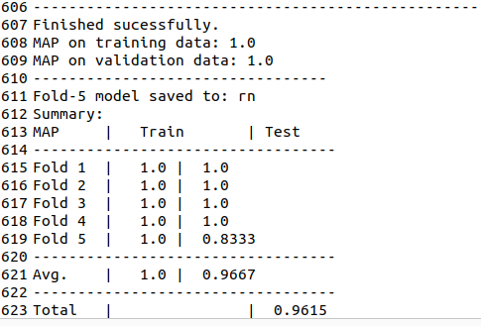

F1應用在closure上面看看。

java -jar RankLib-2.18.jar -load old_new_feature/Chart_result/Chart_no_sus/f1.rn -rank old_new_feature/Closure_new_feature/SBFL_closure_no_sus.txt -indri old_new_feature/Closure_result/2_Chart_no_sus_f1.rn_in_closure_result.txt

觀察closure-14

會先整理都是label為3的進行排名，其中的懷疑值是遞減的。

再來找lablel為2的，以此類推。

F3應用在closure上面看看。

java -jar RankLib-2.18.jar -load old_new_feature/Chart_result/Chart_no_sus/f3.rn -rank old_new_feature/Closure_new_feature/SBFL_closure_no_sus.txt -indri old_new_feature/Closure_result/3_Chart_no_sus_f3.rn_in_closure_result.txt

觀察closure-14

會先整理都是label為3的進行排名，其中的懷疑值是遞減的。

再來找lablel為2的，以此類推。

應用在Chart上，觀察12、14

java -jar RankLib-2.18.jar -load old_new_feature/Chart_result/Chart_no_sus/f3.rn -rank old_new_feature/Chart_new_feature/SBFL_chart_no_sus.txt -indri old_new_feature/Chart_result/Chart_no_sus_f3.rn_in_chart_result.txt

結果是同SBFL的情況下去排3、2、1、0

排完之後再排次之的SBFL情況。

**這是只有使用top資訊以及生成patch兩個patch的結果。**

java -jar RankLib-2.18.jar -train Chart_new_feature/SBFL_chart_one_top.txt -ranker 1 -kcv 5 -kcvmd Chart_result/Chart_one_top/ -kcvmn rn -metric2t MAP -metric2T MAP -tvs 0.8 >> Chart_result/Chart_one_top/chart_RN_train.txt

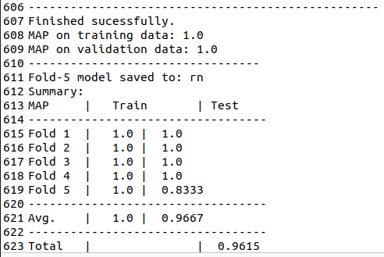

F1應用在closure上面看看。

java -jar RankLib-2.18.jar -load Chart_result/Chart_one_top/f1.rn -rank Closure_new_feature/SBFL_closure_one_top.txt -indri Closure_result/Chart_one_top_f1.rn_in_closure_result.txt

觀察closure-14

結果與預期的相符合。

驗證資料

java -jar RankLib-2.18.jar -test old_new_feature/Closure_new_feature/SBFL_closure_one_top.txt -metric2T MAP -idv old_new_feature/closure_output/closure_one_top.map.txt

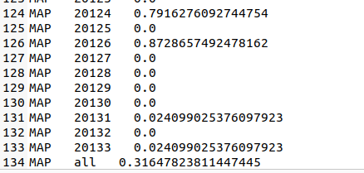

驗證結果

F1

java -jar RankLib-2.18.jar -load old_new_feature/Chart_result/Chart_one_top/f1.rn -test old_new_feature/Closure_new_feature/SBFL_closure_one_top.txt -metric2T MAP -idv old_new_feature/closure_output/chart_F1_one_top_in_closure.map.txt

F2

java -jar RankLib-2.18.jar -load old_new_feature/Chart_result/Chart_one_top/f2.rn -test old_new_feature/Closure_new_feature/SBFL_closure_one_top.txt -metric2T MAP -idv old_new_feature/closure_output/chart_F2_one_top_in_closure.map.txt

F3

java -jar RankLib-2.18.jar -load old_new_feature/Chart_result/Chart_one_top/f3.rn -test old_new_feature/Closure_new_feature/SBFL_closure_one_top.txt -metric2T MAP -idv old_new_feature/closure_output/chart_F3_one_top_in_closure.map.txt

F4

java -jar RankLib-2.18.jar -load old_new_feature/Chart_result/Chart_one_top/f4.rn -test old_new_feature/Closure_new_feature/SBFL_closure_one_top.txt -metric2T MAP -idv old_new_feature/closure_output/chart_F4_one_top_in_closure.map.txt

F5

java -jar RankLib-2.18.jar -load old_new_feature/Chart_result/Chart_one_top/f5.rn -test old_new_feature/Closure_new_feature/SBFL_closure_one_top.txt -metric2T MAP -idv old_new_feature/closure_output/chart_F5_one_top_in_closure.map.txt

比較

java -cp RankLib-2.18.jar ciir.umass.edu.eval.Analyzer -all old_new_feature/closure_output/ -base closure_one_top.map.txt > analysis.txt

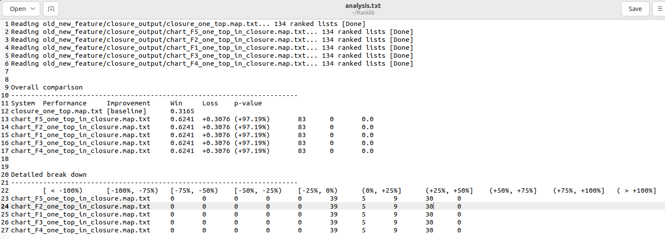

比起原始資料，performance從0.3提升到0.6，提升率是97%，有83個表現更好，0個表現更差。

下面的數字分別代表各自提升的數字。

**應用在Chart上，觀察12、14**

java -jar RankLib-2.18.jar -load old_new_feature/Chart_result/Chart_one_top/f3.rn -rank old_new_feature/Chart_new_feature/SBFL_chart_one_top.txt -indri old_new_feature/Chart_result/Chart_one_top_f3.rn_in_chart_result.txt

整理的excel是**”chart分頁排名結果_F3_one_top.xlsx”**

同label依照SBFL排序，再下一個label。

驗證資料

java -jar RankLib-2.18.jar -test old_new_feature/Chart_new_feature/SBFL_chart_one_top.txt -metric2T MAP -idv old_new_feature/chart_output/chart_one_top.map.txt

MAP

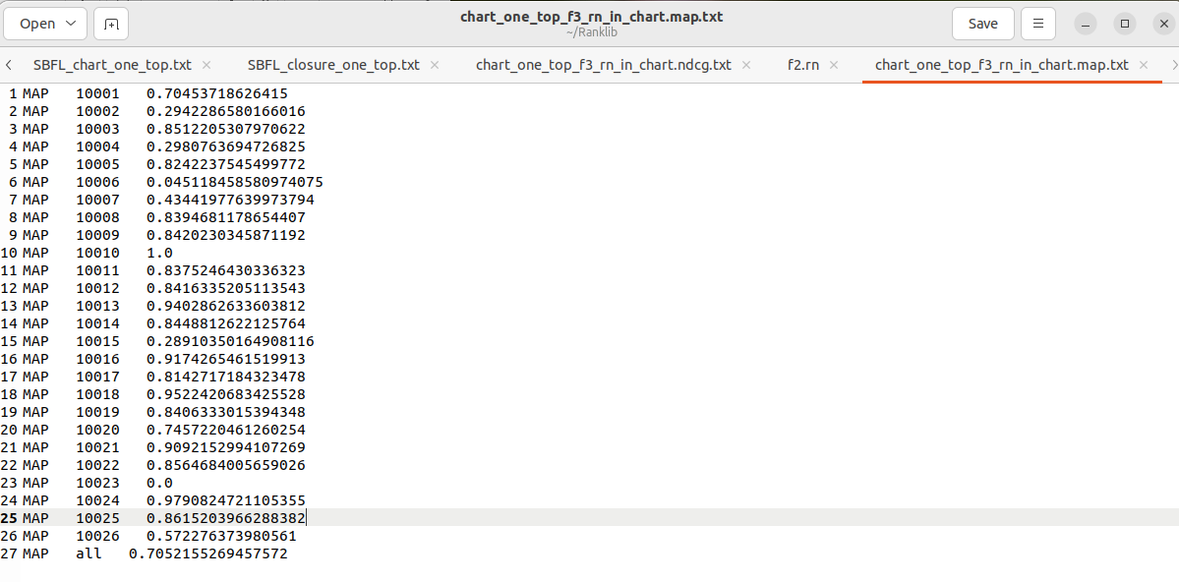

驗證結果

F1

java -jar RankLib-2.18.jar -load old_new_feature/Chart_result/Chart_one_top/f1.rn -test old_new_feature/Chart_new_feature/SBFL_chart_one_top.txt -metric2T MAP -idv old_new_feature/chart_output/chart_F1_one_top_in_chart.map.txt

F2

java -jar RankLib-2.18.jar -load old_new_feature/Chart_result/Chart_one_top/f2.rn -test old_new_feature/Chart_new_feature/SBFL_chart_one_top.txt -metric2T MAP -idv old_new_feature/chart_output/chart_F2_one_top_in_chart.map.txt

F3

java -jar RankLib-2.18.jar -load old_new_feature/Chart_result/Chart_one_top/f3.rn -test old_new_feature/Chart_new_feature/SBFL_chart_one_top.txt -metric2T MAP -idv old_new_feature/chart_output/chart_F3_one_top_in_chart.map.txt

F4

java -jar RankLib-2.18.jar -load old_new_feature/Chart_result/Chart_one_top/f4.rn -test old_new_feature/Chart_new_feature/SBFL_chart_one_top.txt -metric2T MAP -idv old_new_feature/chart_output/chart_F4_one_top_in_chart.map.txt

F5

java -jar RankLib-2.18.jar -load old_new_feature/Chart_result/Chart_one_top/f5.rn -test old_new_feature/Chart_new_feature/SBFL_chart_one_top.txt -metric2T MAP -idv old_new_feature/chart_output/chart_F5_one_top_in_chart.map.txt

比較

java -cp RankLib-2.18.jar ciir.umass.edu.eval.Analyzer -all old_new_feature/chart_output/ -base chart_one_top.map.txt > analysis.txt

**這是使用多個特徵的結果。**

java -jar RankLib-2.18.jar -train Chart_new_feature/SBFL_chart.txt -ranker 1 -kcv 5 -kcvmd Chart_result/Chart/ -kcvmn rn -metric2t MAP -metric2T MAP -tvs 0.8 >> Chart_result/Chart/chart_RN_train.txt

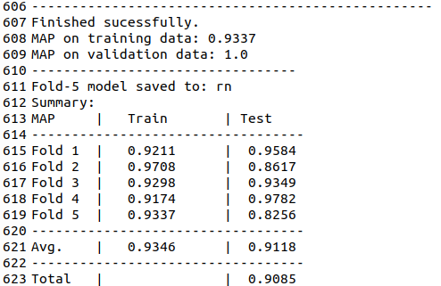

應用在closure上面看看。

java -jar RankLib-2.18.jar -load Chart_result/Chart/f1.rn -rank Closure_new_feature/SBFL_closure.txt -indri Closure_result/Chart_new_feature_f1.rn_in_closure_result.txt

比較像是針對APR技術有使用到的特徵做判斷，以此來統計那些特徵是對生成patch有幫助的。