**使用Chart**

Chart分成5個fold，用RankNet

java -jar RankLib-2.18.jar -train test/Chart_lr.txt -ranker 1 -kcv 5 -kcvmd test/Chart_result_rn/ -kcvmn rn -metric2t MAP -metric2T MAP -tts 0.8 >> test/Chart_result_rn/chart_RN_train.txt

測試Chart分成5個fold結果模型

java -jar RankLib_o.jar -load test/Chart_result_rn/f1.rn -rank test/Chart_lr.txt -score test/Chart_result_rn/f1_score.txt -norm zscore

java -jar RankLib-2.18.jar -load test/Chart_result_rn/f1.rn -rank test/Chart_lr.txt -score test/Chart_result_rn/f1_score_2.18.txt -norm zscore

我的執行結果。

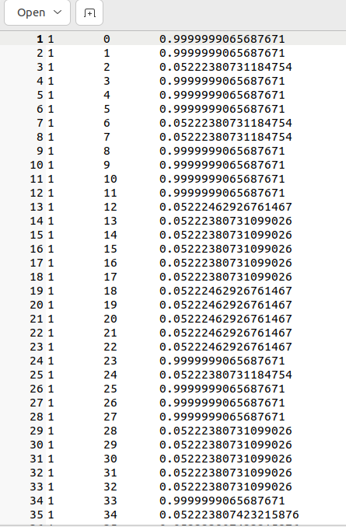

學長的結果

java -jar RankLib_o.jar -load test2/chart_rn/f1.txt -rank test/Chart_lr.txt -score test2/chart_rn/f1_score.txt -norm zscore

這邊用學長在NAS上存的模型測試看看

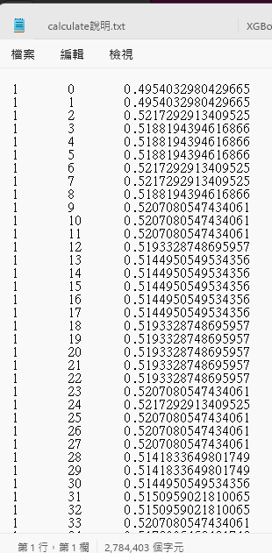

都差不多爛

**改用學長的參數配置。**

使用2.18的存在Chart_result_no_metric_set2資料夾

java -jar RankLib-2.18.jar -train test/Chart_lr.txt -ranker 1 -kcv 5 -tvs 0.1 -kcvmd test/Chart_result_no_metric_set/ -kcvmn rn >> test/Chart_result_no_metric_set/chart_RN_train.txt

使用_o的存在Chart_result_no_metric_set資料夾。

java -jar RankLib_o.jar -train test/Chart_lr.txt -ranker 1 -kcv 5 -tvs 0.1 -kcvmd test/Chart_result_no_metric_set/ -kcvmn rn >> test/Chart_result_no_metric_set/chart_RN_train.txt

結果都是很差的，不知道學長怎麼處理的。

**直接使用學長的10-fold結果測試模型比較**

java -jar RankLib-2.18.jar -test test/Chart_lr.txt -metric2T MAP -idv test2/Chart_rn_compare/Chart_lr.map.txt

F1

java -jar RankLib-2.18.jar -load test2/chart_rn/f1.txt -test test/Chart_lr.txt -metric2T MAP -idv test2/Chart_rn_compare/Chart_F1_in_chart.map.txt

F2

java -jar RankLib-2.18.jar -load test2/chart_rn/f2.txt -test test/Chart_lr.txt -metric2T MAP -idv test2/Chart_rn_compare/Chart_F2_in_chart.map.txt

F3

java -jar RankLib-2.18.jar -load test2/chart_rn/f3.txt -test test/Chart_lr.txt -metric2T MAP -idv test2/Chart_rn_compare/Chart_F3_in_chart.map.txt

F4

java -jar RankLib-2.18.jar -load test2/chart_rn/f4.txt -test test/Chart_lr.txt -metric2T MAP -idv test2/Chart_rn_compare/Chart_F4_in_chart.map.txt

F5

java -jar RankLib-2.18.jar -load test2/chart_rn/f5.txt -test test/Chart_lr.txt -metric2T MAP -idv test2/Chart_rn_compare/Chart_F5_in_chart.map.txt

F6

java -jar RankLib-2.18.jar -load test2/chart_rn/f6.txt -test test/Chart_lr.txt -metric2T MAP -idv test2/Chart_rn_compare/Chart_F6_in_chart.map.txt

F7

java -jar RankLib-2.18.jar -load test2/chart_rn/f7.txt -test test/Chart_lr.txt -metric2T MAP -idv test2/Chart_rn_compare/Chart_F7_in_chart.map.txt

F8

java -jar RankLib-2.18.jar -load test2/chart_rn/f8.txt -test test/Chart_lr.txt -metric2T MAP -idv test2/Chart_rn_compare/Chart_F8_in_chart.map.txt

F9

java -jar RankLib-2.18.jar -load test2/chart_rn/f9.txt -test test/Chart_lr.txt -metric2T MAP -idv test2/Chart_rn_compare/Chart_F9_in_chart.map.txt

F10

java -jar RankLib-2.18.jar -load test2/chart_rn/f10.txt -test test/Chart_lr.txt -metric2T MAP -idv test2/Chart_rn_compare/Chart_F10_in_chart.map.txt

比較

java -cp RankLib-2.18.jar ciir.umass.edu.eval.Analyzer -all test2/Chart_rn_compare/ -base Chart_lr.map.txt > analysis.txt

是有變化的，可能真的哪邊需要再修改，或是單純feature太少，可能把之前的不同APR特徵也放進來看看。

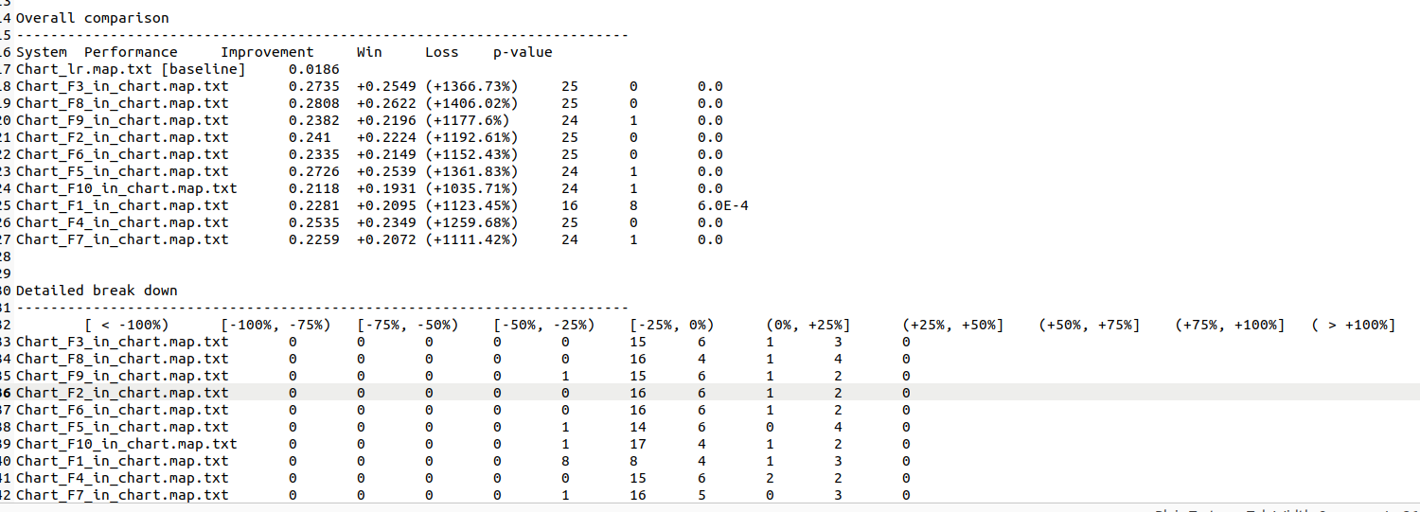

Time分成5個fold，用RankNet

java -jar RankLib-2.18.jar -train test/Time_lr.txt -ranker 1 -kcv 5 -kcvmd test/Time_result_rn/ -kcvmn rn -metric2t MAP -metric2T MAP -tts 0.8 >> test/Time_result_rn/time_RN_train.txt