LAB1 REPORT

B06901160 翁挺瑋

1.



2.

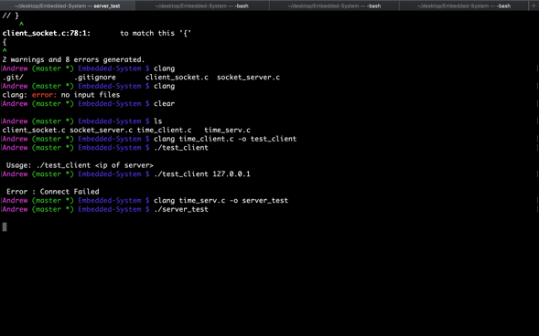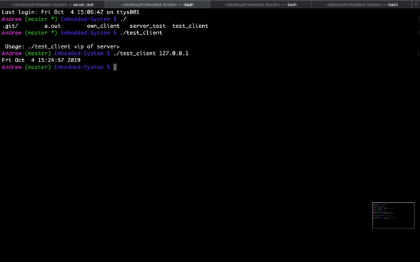

3. 

4. I have been using thread programming in Python server before, so that the server address would be cleared after a new launch.

5. System call : Used to debug by typing strace command

6.Socket programming: As attached. Yet the server I wrote does not receive data from client, I implemented the server client code from class material.

7. Make file used to compile multiple c files.