Lab4 Asynchronous Input and Output

B06901160 電機三 翁挺瑋

1. Blink with output = 1

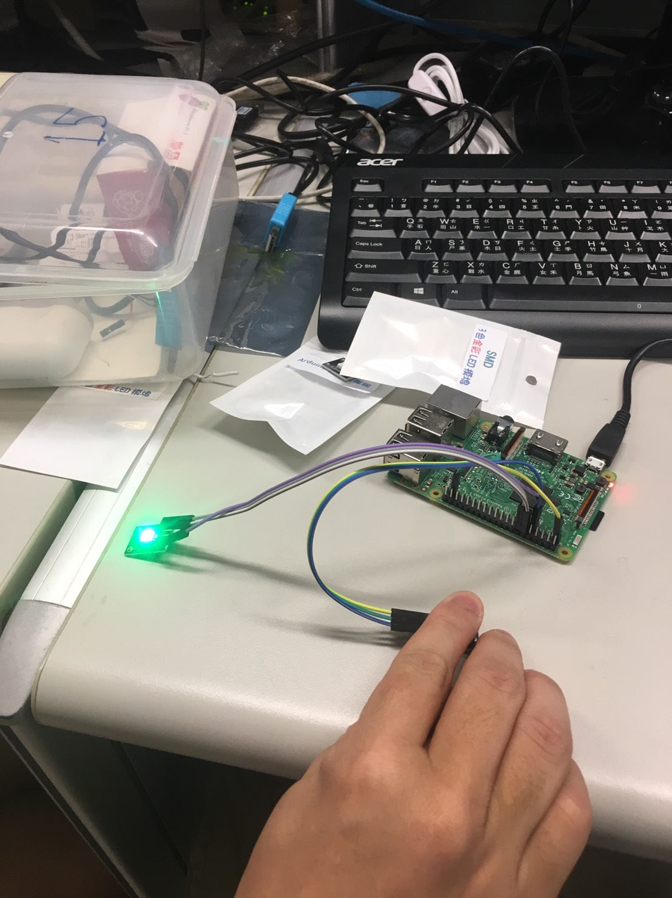

1. Dark with output = 0

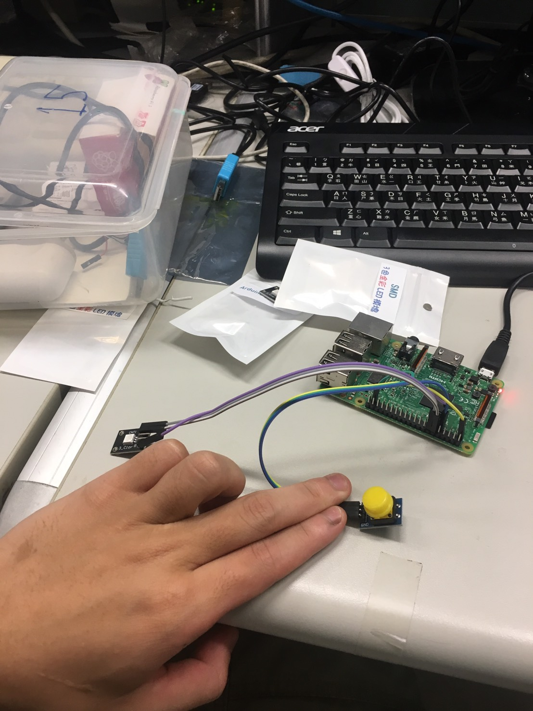

1. Discussion : We discovered that Pin 12 (GPIO 18) was seemingly occupied with clock. On our first try, only the button worked. After moving LED light to Pin 37, it worked as expected.
2. The code is attached in directory
3. Review questions
   * When does a circuit need pull up/down resistors? A: When we need to ensure the digital state goes to 1 or 0 respectively.
   * What does the C keyword volatile mean? A: It means that the keyword can be changed out size of the variable scope. In short "The value stored in this variable (memory location) might change without my code doing anything."
   * How do you implement wiringPiISR() if you are a wiringPI developer ? A: Use it for multi thread processing if there are a lot of GPIOs in use.