Lab6 Report

B06901160 電機三 翁挺瑋

## SimpleLInk SDK TI cc26x2

1. LED write value

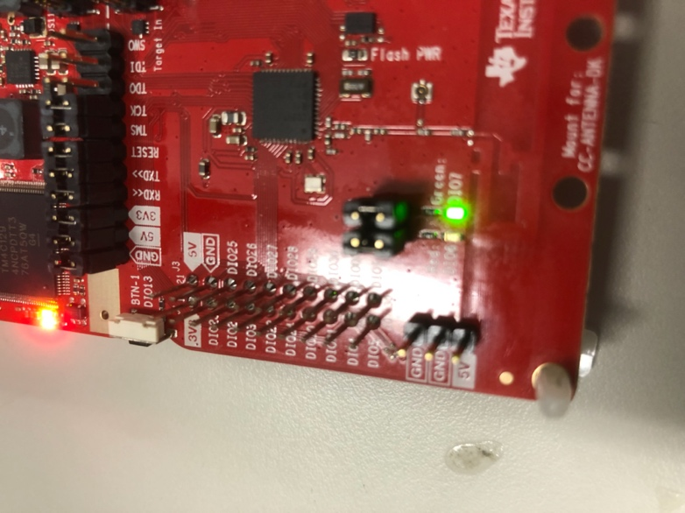

1. LED0 read

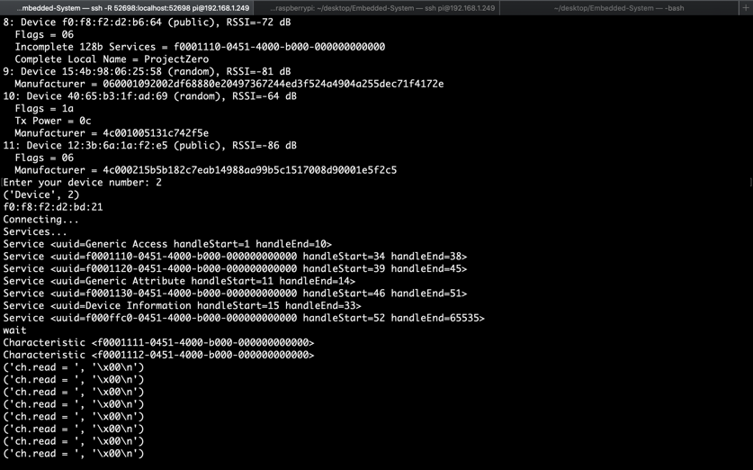

1. Button Service

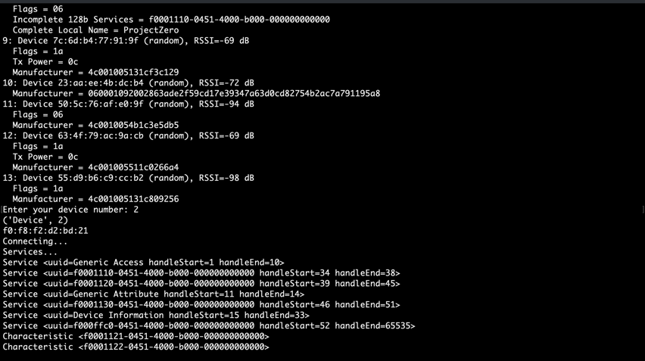

1. LED1 write

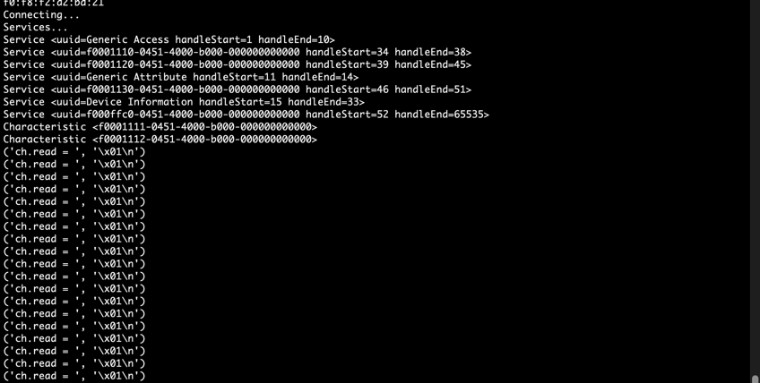

1. Button1 value

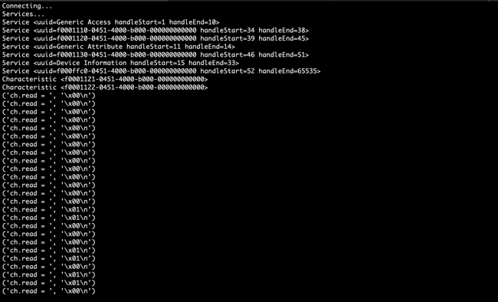

1. Student ID Service