**Q2**

Plotting training error vs. testing error 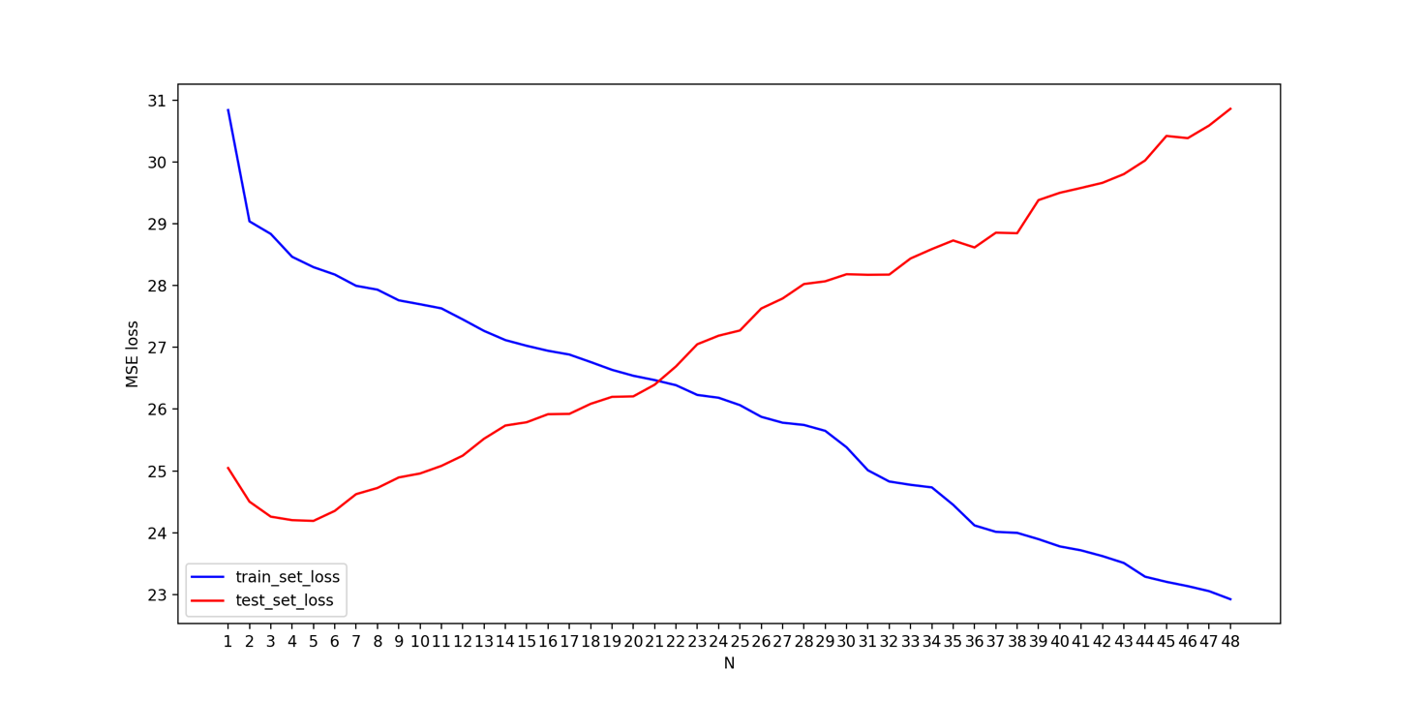

With training loss decreasing at a stable rate, yet testing loss increases perhaps due to overfitting.

**Q3**

Ex. Why do we need matrix inversion in linear regression. Can you proceed without it?

A: