# B06901160 電機二 翁挺瑋 HW6

1.

.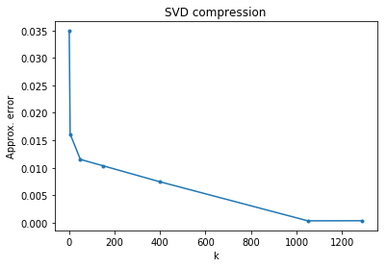

2. Analyze the rank of R channel of the provided image and explain how you analyze.

Perform SVD for k=1 ...

rank = 1

Perform SVD for k=5 ...

rank = 5

Perform SVD for k=50 ...

rank = 50

Perform SVD for k=150 ...

rank = 150

Perform SVD for k=400 ...

rank = 400

Perform SVD for k=1050 ...

rank = 1050

Perform SVD for k=1289 ...

rank = 1066

We calculate the rank using numpy.linalg.matrix_rank(imArr_compressed[:,:,1]) when (ch == 1) which means channel Green. For the rank of k = 1299, since some sigma are zero, thus the rank is smaller than k.

3.

|  |  |  |
| --- | --- | --- |
| 1 | 2 | 3 |
|  |  |  |
| 4 | 5 | ∑ 1-5 |
|  |  |  |