Z Transform

B06901160 電機二 翁挺瑋

(a)-(f) plots

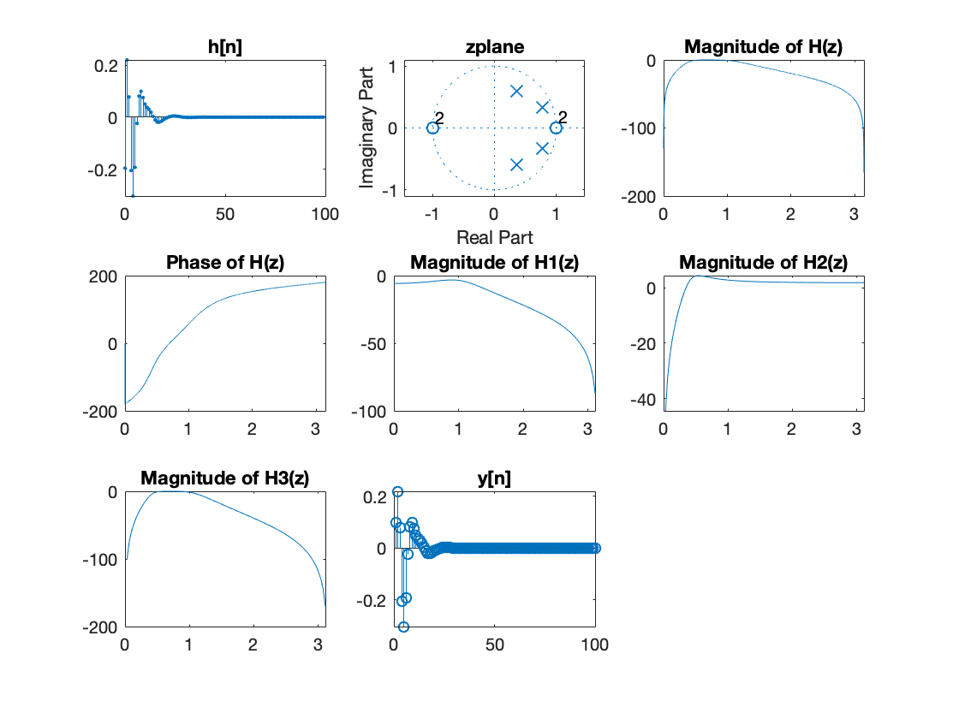

1. ROC = exterior to the 0.8380 circle
2. H(z) = H1(z)H2(z) = $(\frac{0.0976+0.1952z^{-1}+0.0976z^{-2}}{1-0.715z^{-1}+0.4746094z^{-2}})(\frac{1-2z^{-1}+z^{-2}}{1-1.5372z^{-1}+0.7021684z^{-2}})$
3. Since H(z) is the cascade of H1,H2, it is same with ©
4. Y[n] equals the result in (a) since the z transform of Dirac delta function is 1.