MATLAB2 B06901160 翁挺瑋
a.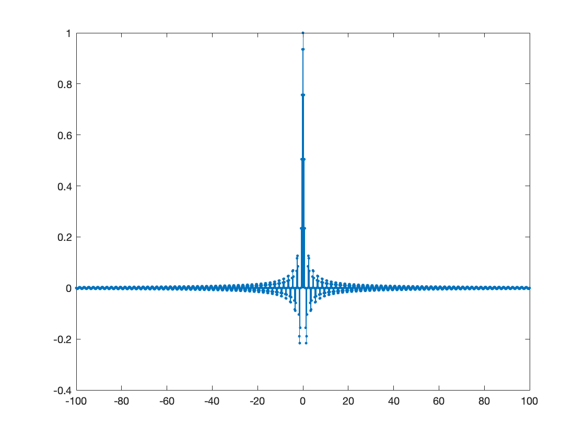
This is the discrete sinc function.
b.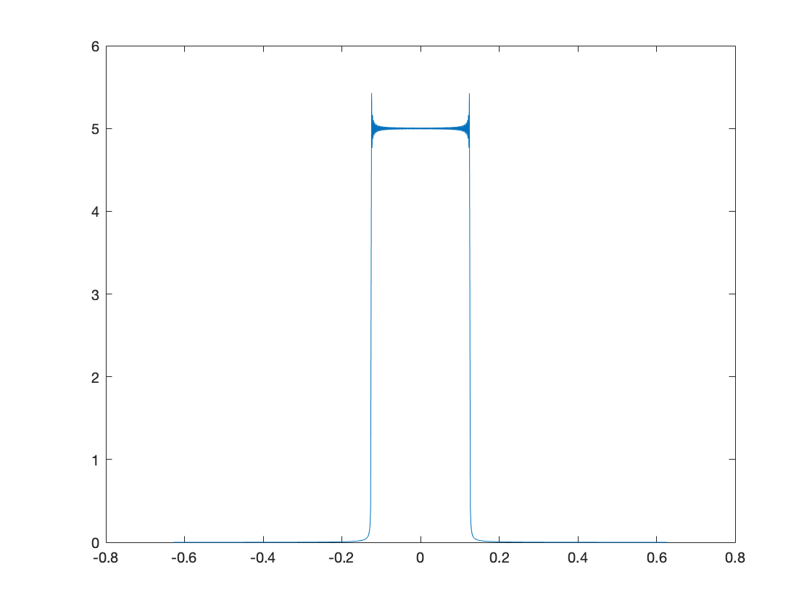
After Fourier transform, a sinc function indeed becomes a rectangular pulse.
c.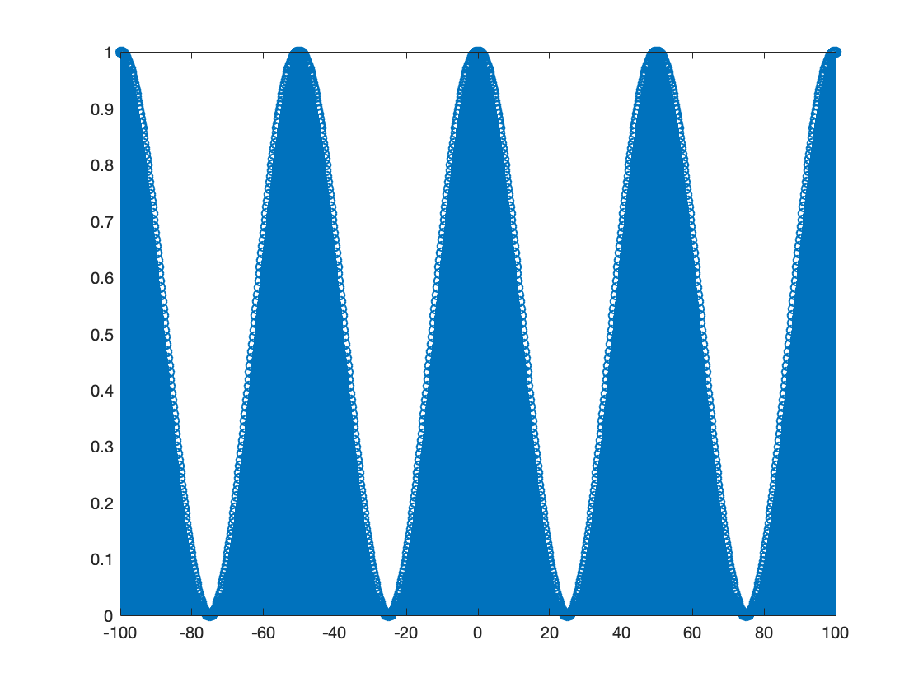
Since this is cosine squared, there are no negative values on the y axis.
d.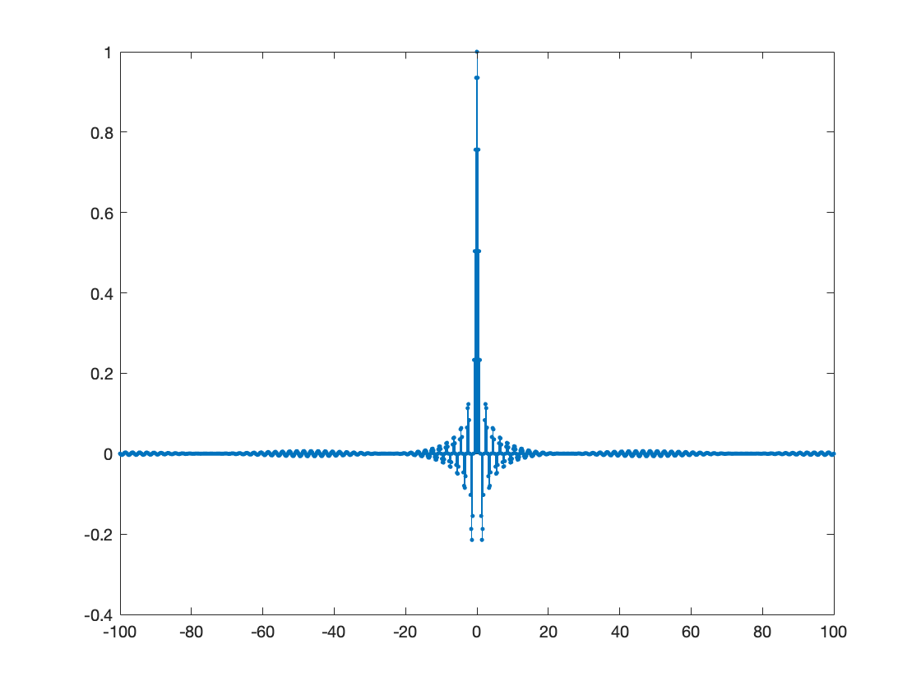
y(t) is a sinc function.
e.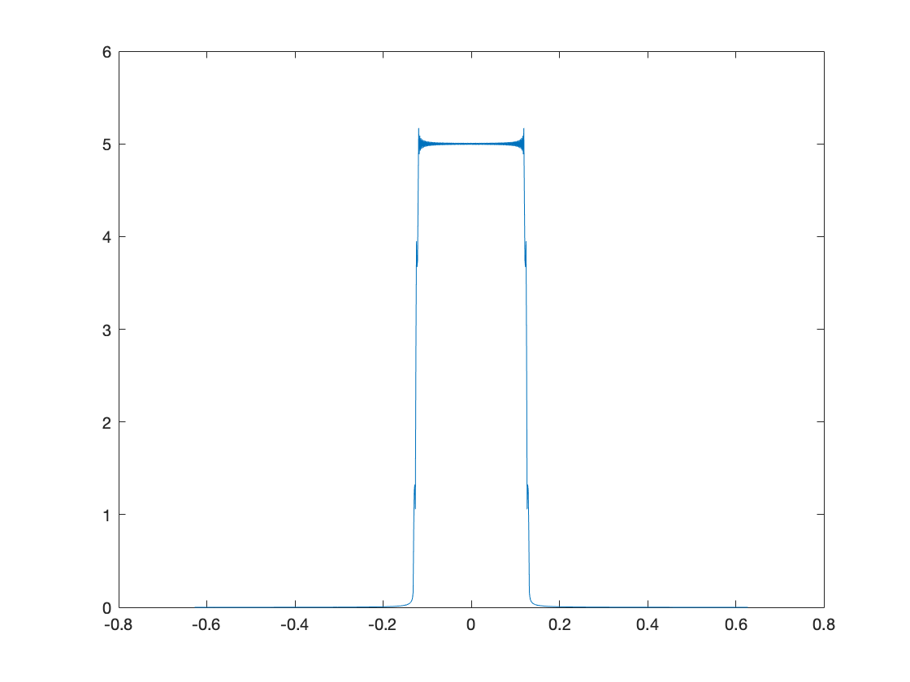
A sinc function becomes a rectangular pulse after Fourier transform.

