B06901160 電機二 翁挺瑋
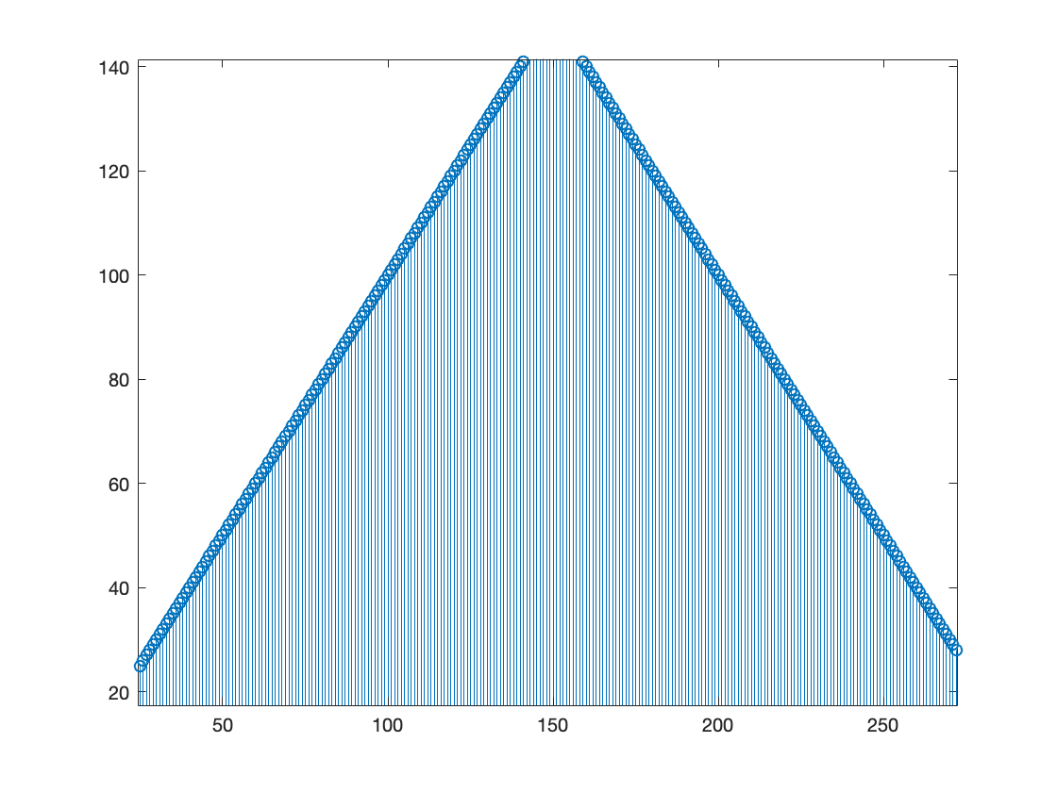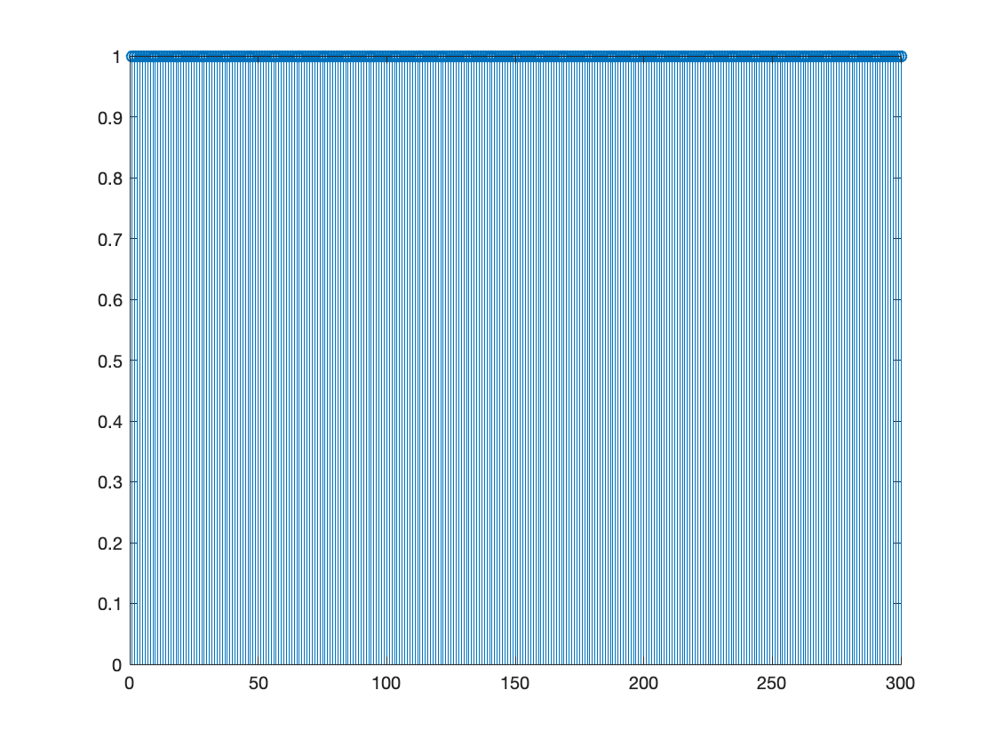
- X1 (a) X2
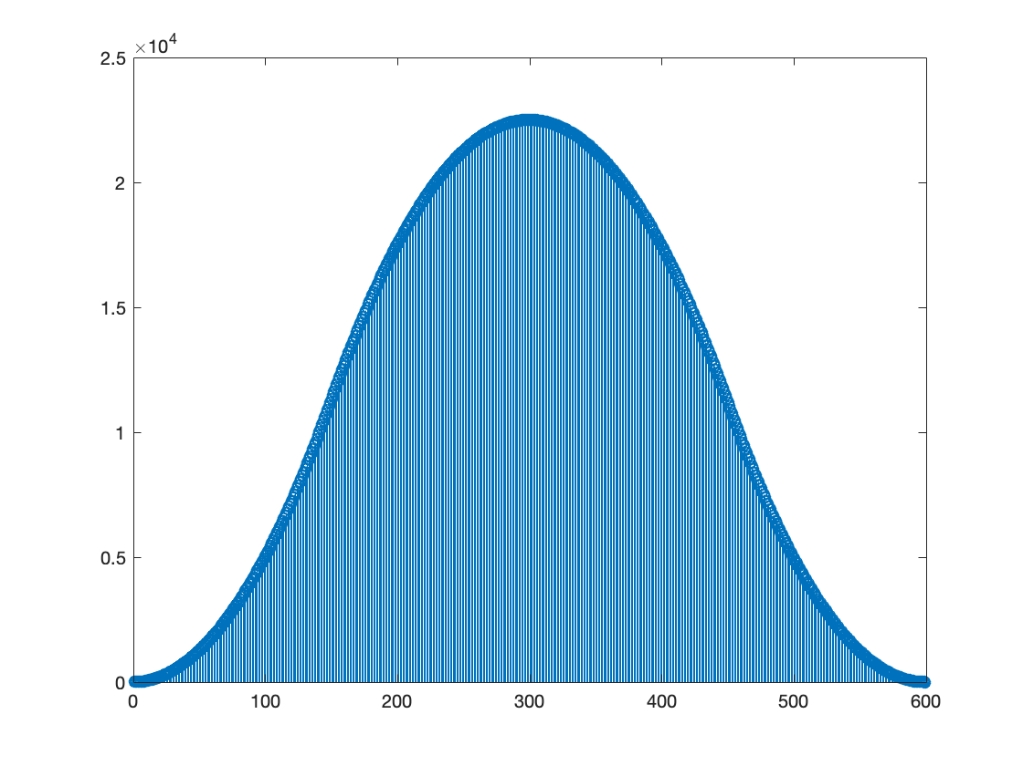
(b)

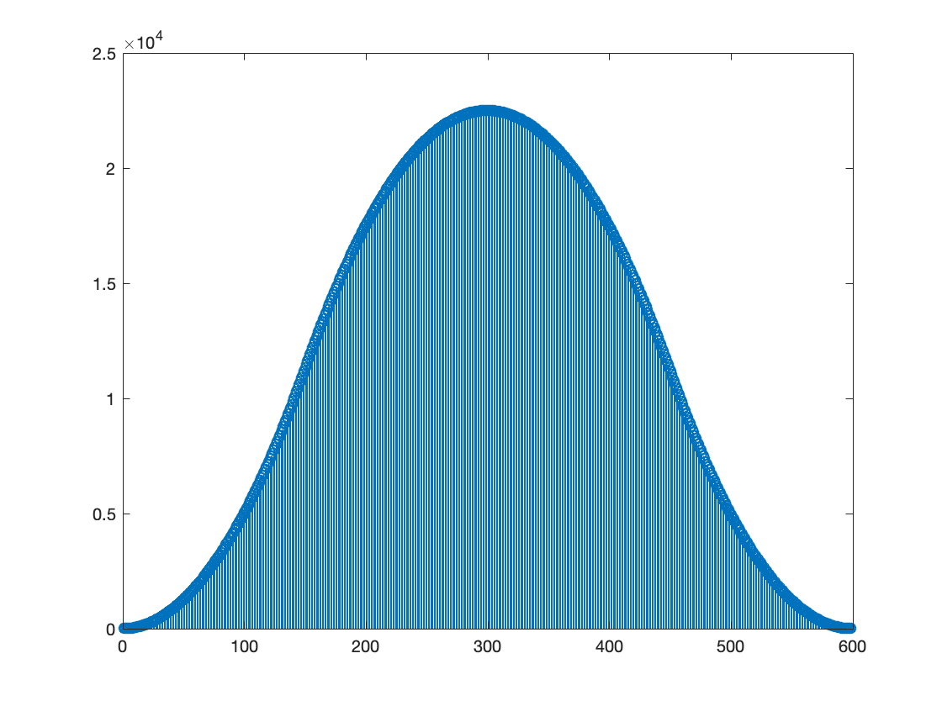
(c)

- And (c) are plots of X1 * X2, which means zero values at 0 and 600 and peak at 300.
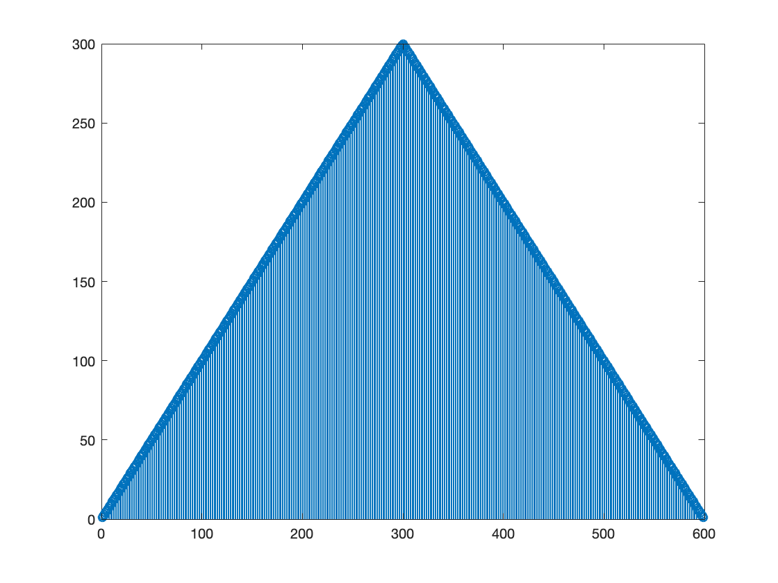
(d)
(d) is the convolution of two identical rectangular functions, so it becomes a symmetric trangle.

