AngryBird Report

**- F74046250 李昱廷 -**

|  |
| --- |
| GameItem |
| + g_body: b2Body *  # g_pixmap: QGraphicsPixmapItem  # g_size: QSizeF  # g_world: b2World *  # g_worldsize, g_windowsize: QSizeF |
| + GameItem(b2World *world);  + ~GameItem(): virtual  + setGlobalSize(QSizeF worldsize, QSizeF windowsize): void  + paint(): void |

一、UML :

|  |
| --- |
| Bg |
| + Bg(int x, int y, QPixmap pixmap, b2World *world, QGraphicsScene *scene); |

|  |
| --- |
| Pig |
| + Pig(float x, float y, float radius, QTimer *timer, QPixmap pixmap, b2World *world, QGraphicsScene *scene) |

|  |
| --- |
| Barrier |
| + Barrier(b2World *world);  + ~Barrier();  + create_reg(float x, float y, float w, float h, QTimer *timer, QPixmap pixmap, b2World *world, QGraphicsScene *scene) |

|  |
| --- |
| Shooter |
| + Shooter(int x, int y, QPixmap pixmap, b2World *world, QGraphicsScene *scene);  + waiting(Bird *bird): void |

|  |
| --- |
| Land |
| + Land(float x, float y, float w, float h, QPixmap pixmap, b2World *world, QGraphicsScene *scene) |

|  |
| --- |
| bird |
| + Bird(float x, float y, float radius, QTimer *timer, QPixmap pixmap, b2World *world, QGraphicsScene *scene);  + ~Bird(): virtual  + setLinearVelocity(b2Vec2 velocity): void  + SpecialEffect(): virtual void |
| + flying: bool |

|  |
| --- |
| Thirdbird |
| + Thirdbird(float x, float y, float radius, QTimer *timer, QPixmap pixmap, b2World *world, QGraphicsScene *scene)  + SpecialEffect(): virtual void |

|  |
| --- |
| Secondbird |
| + Secondbird(float x, float y, float radius, QTimer *timer, QPixmap pixmap, b2World *world, QGraphicsScene *scene)  + SpecialEffect(): virtual void |

|  |
| --- |
| Firstbird |
| + Firstbird(float x, float y, float radius, QTimer *timer, QPixmap pixmap, b2World *world, QGraphicsScene *scene)  + SpecialEffect(): virtual void |

|  |
| --- |
| MainWindow |
| - Ui::ui: MainWindow *  - scene: QGraphicsScene *  - world: b2World *  - land: Land *  - barrier: Barrier *  - shooter: Shooter *  - bird: Bird *  - firstbird: Firstbird *  - secondbird: Secondbird *  - thirdbird: Thirdbird *  - bg: Bg *  - itemList: QList<GameItem *>  - PigList: QList<Pig *>  - Blist: QList<Barrier *>  - Shooterlist: QList<Shooter *>  - Birdlist: QList<Bird *>  - timer: QTimer  - timer1: QTimer *  - start: QPoint  - end: QPoint  - birdkind: int  - num: int  - a: int |

|  |
| --- |
| + MainWindow(QWidget *parent): explicit  + ~MainWindow();  + showEvent(QShowEvent *): void  + eventFilter(QObject *,QEvent  *event): void  + closeEvent(QCloseEvent *): void  - tick(): void  - QUITSLOT(): void  - next(): void  - slot(): void  - WinLose(): void  - on_pushButton_clicked(): void  - on_pushButton_2_clicked(): void  - thing() |

二、遊戲介紹

1. 遊戲畫面: 1600 * 900

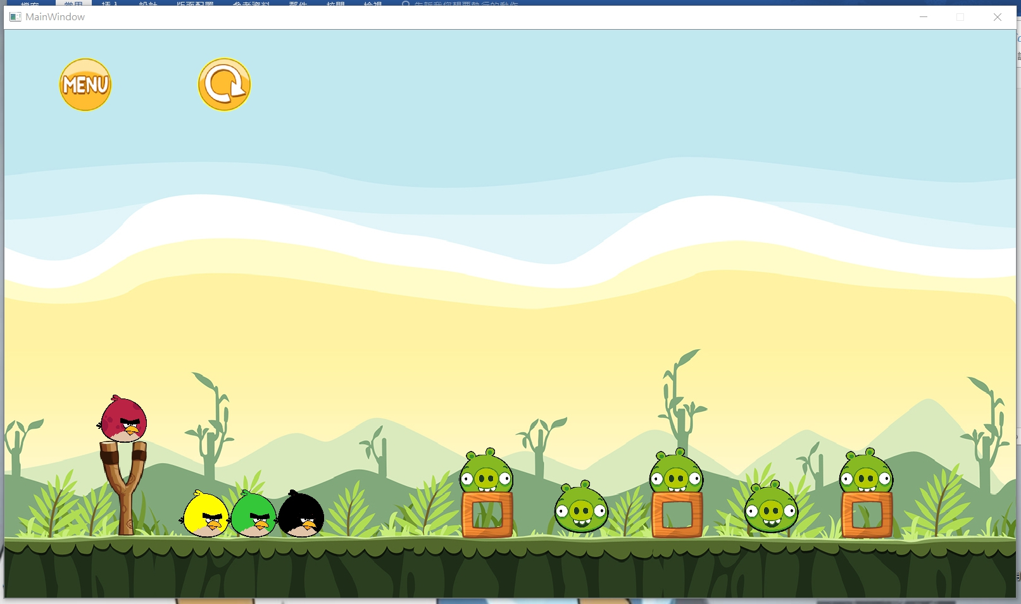

2. 遊戲按鈕:

a. MENU鍵: 離開遊戲

b. RESTART鍵: 重新開始遊戲

3. 鳥的功能:

a. 黃色鳥鳥: 飛行中按一下鍵速度會變成10倍

b. 綠色鳥鳥: 飛行中按一下鍵會迴轉

c. 黑色鳥鳥: 飛行中按一下鍵會垂直向下撞擊