Optional 2 process:

Step1:

Create a new account for google cloud

Step2:

Go to google cloud shell

Step3:

Open the terminal console

Step4:Authorize

Step5:

gcloud config list project



Step6:Enable apis

gcloud services enable compute.googleapis.com         \  
                       containerregistry.googleapis.com  \  
                       aiplatform.googleapis.com  \  
                       cloudbuild.googleapis.com \  
                       cloudfunctions.googleapis.com

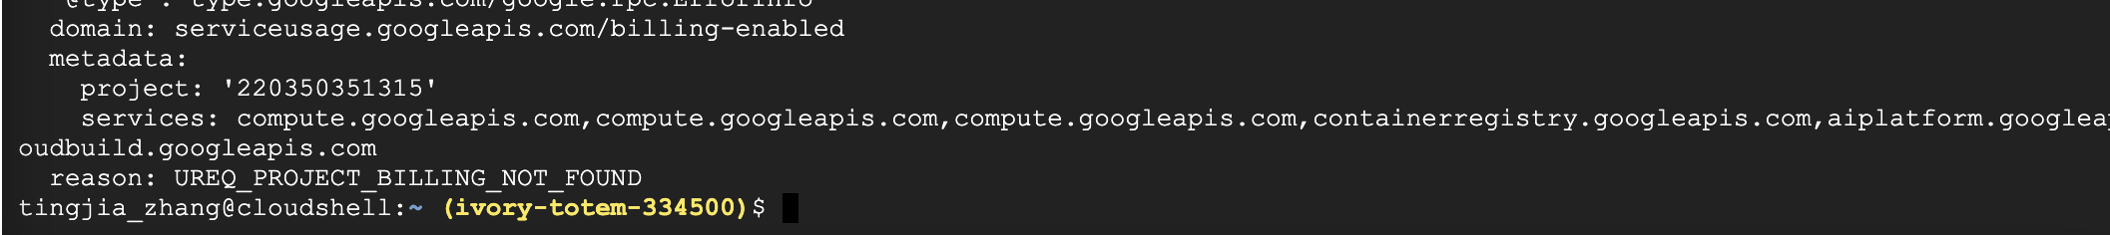

Step7:

Create a Cloud Storage Bucket

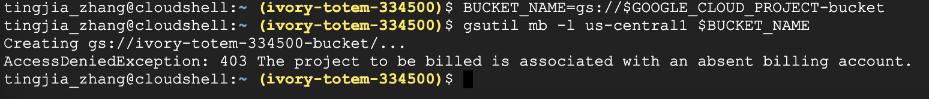

## Step8: Create a Vertex AI Workbench instance

Step9: Create python notebooks

Step10: import library

USER_FLAG = "--user"

!pip3 install {USER_FLAG} google-cloud-aiplatform==1.7.0 --upgrade  
!pip3 install {USER_FLAG} kfp==1.8.9 google-cloud-pipeline-components==0.2.0

import os  
  
if not os.getenv("IS_TESTING"):  
    # Automatically restart kernel after installs  
    import IPython  
  
    app = IPython.Application.instance()  
    app.kernel.do_shutdown(True)

## Step11: Set your project ID and bucket

import os  
PROJECT_ID = ""  
  
# Get your Google Cloud project ID from gcloud  
if not os.getenv("IS_TESTING"):  
    shell_output=!gcloud config list --format 'value(core.project)' 2>/dev/null  
    PROJECT_ID = shell_output[0]  
    print("Project ID: ", PROJECT_ID)

if PROJECT_ID == "" or PROJECT_ID is None:  
    PROJECT_ID = "your-project-id"  # @param {type:"string"}

BUCKET_NAME="gs://" + PROJECT_ID + "-bucket"

## Step12: Creating your first pipeline

## Step13: Creating an end-to-end ML pipeline

## Step14:clean up