

**嵌入式系统实验报告**

**综合实验1——自行车位置记录**

**综合实验2——多功能户外小助手**

**学院** 电子与信息学院

**专业** 信息工程（电类联合班）

**学生姓名**  马廷俊

**指导教师** 崔寅鸣 李磊

**提交日期**2015年 6月7日



**嵌入式系统实验报告**

**综合实验1——自行车位置记录**

**学院** 电子与信息学院

**专业** 信息工程（电类联合班）

**学生姓名**  马廷俊

**指导教师** 崔寅鸣 李磊

**提交日期**2015年 6月7日

## 一、实验目的

平常我们下课后经常把自行车随手一停在某个地方，结果下午上课或者第二天起床就忘了自己把自行车停哪了，于是需要花费很多时间去回忆那时候的动作，如果彻底忘记了就只能一辆一辆地去找，更加费时费力。于是我们开发了这样一款软件，在停自行车时从自行车上面的GSM和GPS模块发送当前的经纬度坐标到手机上，或者直接在手机上记录当前的位置，下次就可以直接从手机中找到自行车的位置，然后根据内嵌的百度地图和街景实时定位到自行车的位置。

## 二、实验内容

接受并读取SMS功能，获取GPS坐标，联网，嵌入百度地图和街景等。

## 三、实验原理

接受以短信形式发至手机的模块位置信息并读取到应用中，利用GPS传感器获得当前GPS信息并显示，将GPS信息传递到百度的API并获取地图和街景

## 四、实验步骤

主菜单布局：

<RelativeLayout xmlns:android=*"http://schemas.android.com/apk/res/android"*

xmlns:tools=*"http://schemas.android.com/tools"*

android:layout_width=*"match_parent"*

android:layout_height=*"match_parent"*

tools:context=*"${relativePackage}.${activityClass}"* >

<ImageView

android:id=*"@+id/biaoti"*

android:layout_width=*"match_parent"*

android:layout_height=*"120dp"*

android:layout_alignParentLeft=*"true"*

android:layout_alignParentTop=*"true"*

android:src=*"@drawable/biaoti"*

android:scaleType=*"fitStart"*

android:background=*"#00000000"*/>

<ImageButton

android:id=*"@+id/ezmode"*

android:layout_width=*"240dp"*

android:layout_height=*"64dp"*

android:layout_below=*"@+id/biaoti"*

android:layout_centerHorizontal=*"true"*

android:layout_marginTop=*"14dp"*

android:background=*"@drawable/ezmode"*

android:scaleType=*"fitStart"*

/>

<ImageButton

android:id=*"@+id/exmode"*

android:layout_width=*"240dp"*

android:layout_height=*"64dp"*

android:layout_alignLeft=*"@+id/ezmode"*

android:layout_below=*"@+id/ezmode"*

android:layout_marginTop=*"25dp"*

android:src=*"@drawable/exmod"*

android:scaleType=*"fitStart"*

android:background=*"#00000000"* />

<ImageButton

android:id=*"@+id/instruction"*

android:layout_width=*"240dp"*

android:layout_height=*"64dp"*

android:layout_alignLeft=*"@+id/exmode"*

android:layout_below=*"@+id/exmode"*

android:layout_marginTop=*"25dp"*

android:src=*"@drawable/instruction"*

android:scaleType=*"fitStart"*

android:background=*"#00000000"*/>

<ImageButton

android:id=*"@+id/exit"*

android:layout_width=*"240dp"*

android:layout_height=*"64dp"*

android:layout_alignLeft=*"@+id/instruction"*

android:layout_below=*"@+id/instruction"*

android:layout_marginTop=*"25dp"*

android:src=*"@drawable/exit"*

android:scaleType=*"fitStart"*

android:background=*"#00000000"*/>

</RelativeLayout>

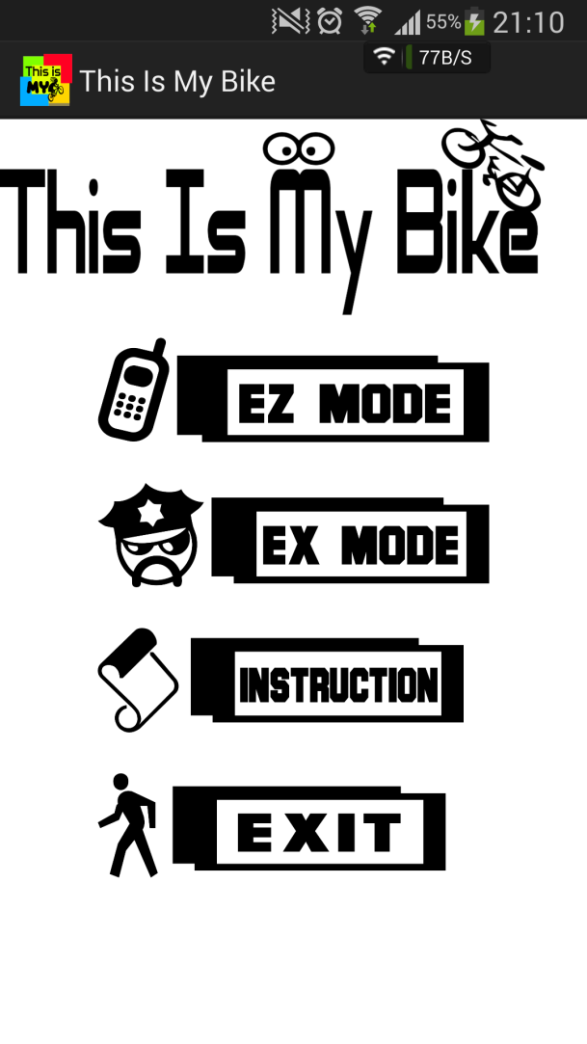

EX MODE菜单布局：

<?xml version=*"1.0"* encoding=*"utf-8"*?>

<RelativeLayout xmlns:android=*"http://schemas.android.com/apk/res/android"*

android:layout_width=*"match_parent"*

android:layout_height=*"match_parent"* >

<ImageButton

android:id=*"@+id/backtoez"*

android:layout_width=*"200dp"*

android:layout_height=*"45dp"*

android:layout_alignParentBottom=*"true"*

android:layout_centerHorizontal=*"true"*

android:layout_marginBottom=*"110dp"*

android:background=*"#00000000"*

android:scaleType=*"fitStart"*

android:src=*"@drawable/backtoezmod"* />

<ImageButton

android:id=*"@+id/opengps"*

android:layout_width=*"200dp"*

android:layout_height=*"45dp"*

android:layout_alignLeft=*"@+id/backtoez"*

android:layout_centerVertical=*"true"*

android:background=*"#00000000"*

android:scaleType=*"fitStart"*

android:src=*"@drawable/opengps"* />

<TextView

android:id=*"@+id/refresh"*

android:layout_width=*"wrap_content"*

android:layout_height=*"wrap_content"*

android:layout_alignParentTop=*"true"*

android:layout_centerHorizontal=*"true"*

android:layout_marginTop=*"68dp"*

android:text=*"当前无车载GPS的信息！"*

android:textSize=*"24sp"* />

</RelativeLayout>

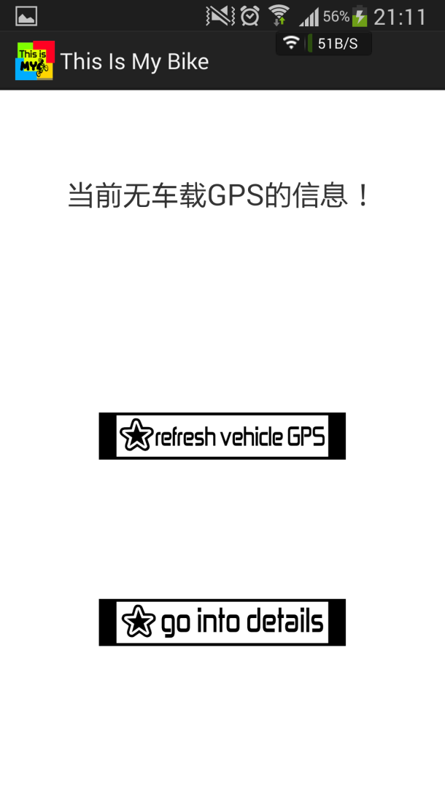

EZ MODE菜单布局：

<?xml version=*"1.0"* encoding=*"utf-8"*?>

<RelativeLayout xmlns:android=*"http://schemas.android.com/apk/res/android"*

android:layout_width=*"match_parent"*

android:layout_height=*"match_parent"* >

<ImageView

android:id=*"@+id/mybike"*

android:layout_width=*"120dp"*

android:layout_height=*"45dp"*

android:layout_alignParentRight=*"true"*

android:layout_alignTop=*"@+id/mylocation"*

android:layout_marginRight=*"23dp"*

android:src=*"@drawable/mybike"*

android:scaleType=*"fitStart"*

android:background=*"#00000000"*/>

<ImageView

android:id=*"@+id/mylocation"*

android:layout_width=*"120dp"*

android:layout_height=*"45dp"*

android:layout_alignParentLeft=*"true"*

android:layout_alignParentTop=*"true"*

android:layout_marginLeft=*"20dp"*

android:src=*"@drawable/mylocation"*

android:scaleType=*"fitStart"*

android:background=*"#00000000"*/>

<TextView

android:id=*"@+id/mylocationtext"*

android:layout_width=*"130dp"*

android:layout_height=*"150dp"*

android:layout_alignLeft=*"@+id/mylocation"*

android:layout_below=*"@+id/mylocation"*

android:text=*"Latitude :\nunknown\nLontitude :\nunknown\nAddress :\nunknown"* />

<TextView

android:id=*"@+id/mybiketext"*

android:layout_width=*"130dp"*

android:layout_height=*"150dp"*

android:layout_alignLeft=*"@+id/mybike"*

android:layout_below=*"@+id/mybike"*

android:text=*"Latitude :\nunknown\nLontitude :\nunknown\nAddress :\nunknown"* />

<ImageView

android:id=*"@+id/distance"*

android:layout_width=*"110dp"*

android:layout_height=*"50dp"*

android:layout_alignLeft=*"@+id/mylocationtext"*

android:layout_below=*"@+id/mylocationtext"*

android:src=*"@drawable/distance"*

android:scaleType=*"fitStart"*

android:background=*"#00000000"*/>

<TextView

android:id=*"@+id/distancetext"*

android:layout_width=*"200dp"*

android:layout_height=*"80dp"*

android:layout_alignTop=*"@+id/distance"*

android:layout_toRightOf=*"@+id/mylocationtext"*

android:text=*"100.00m"*

android:textSize=*"20sp"* />

<ImageButton

android:id=*"@+id/storemybike"*

android:layout_width=*"200dp"*

android:layout_height=*"45dp"*

android:layout_below=*"@+id/distancetext"*

android:layout_centerHorizontal=*"true"*

android:scaleType=*"fitStart"*

android:src=*"@drawable/storemybike"*

android:background=*"#00000000"*/>

<ImageButton

android:id=*"@+id/surroundingview"*

android:layout_width=*"200dp"*

android:layout_height=*"45dp"*

android:layout_alignLeft=*"@+id/openthemap"*

android:layout_below=*"@+id/openthemap"*

android:layout_marginTop=*"15dp"*

android:scaleType=*"fitStart"*

android:src=*"@drawable/surroundingview"*

android:background=*"#00000000"*/>

<ImageButton

android:id=*"@+id/openthemap"*

android:layout_width=*"200dp"*

android:layout_height=*"45dp"*

android:layout_alignLeft=*"@+id/storemybike"*

android:layout_below=*"@+id/storemybike"*

android:layout_marginTop=*"15dp"*

android:scaleType=*"fitStart"*

android:src=*"@drawable/openthemap"*

android:background=*"#00000000"*/>

</RelativeLayout>

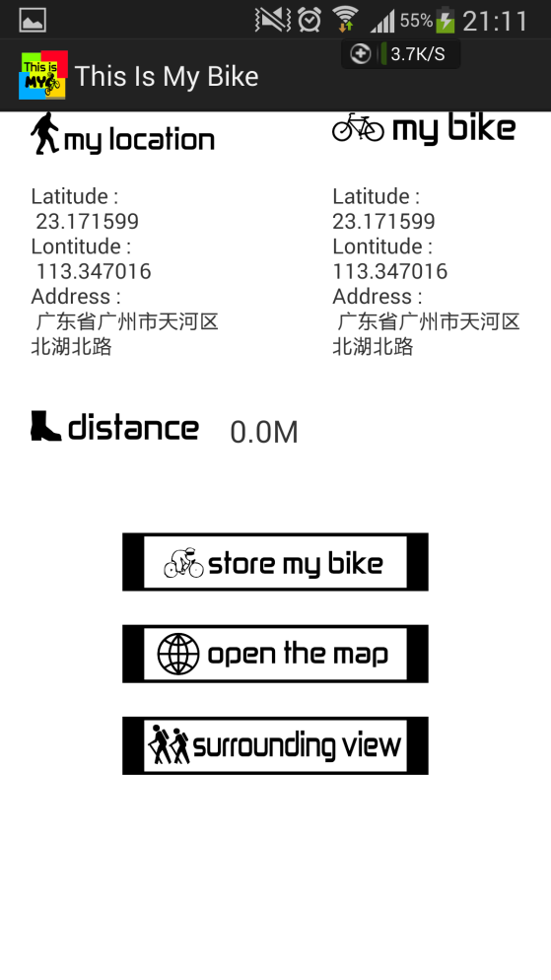

Instruction界面布局：

<?xml version=*"1.0"* encoding=*"utf-8"*?>

<RelativeLayout xmlns:android=*"http://schemas.android.com/apk/res/android"*

android:layout_width=*"match_parent"*

android:layout_height=*"match_parent"* >

<TextView

android:id=*"@+id/shuoming"*

android:layout_width=*"wrap_content"*

android:layout_height=*"wrap_content"*

android:layout_alignParentTop=*"true"*

android:layout_centerHorizontal=*"true"*

android:layout_marginTop=*"42dp"*

android:textSize=*"24sp"*

android:text=*"app名称：This is my bike （这是我的单车）\n作者：林霖 马廷俊 徐松斌 黄培裕\nDemoApplication.java\nOpenmap.java\nSurroundingview,java\n参考了百度地图SDK的部分代码\n\nSMSBroadcastReceiver.java\n参考了一片关于读取实时短信的博客"* />

</RelativeLayout>

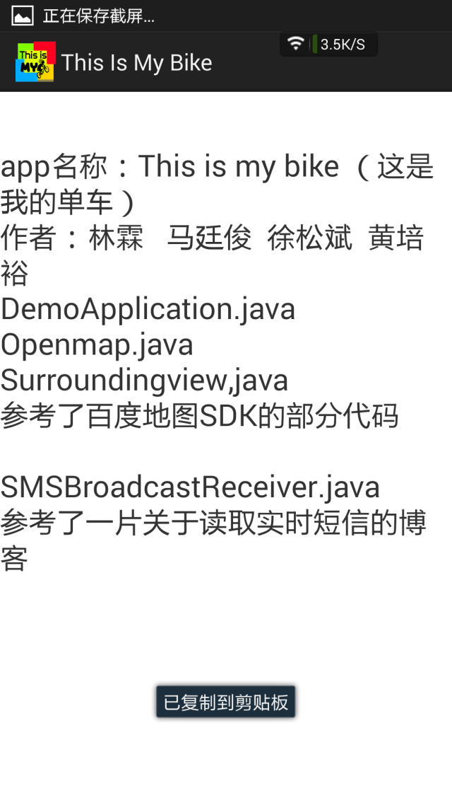

1. **程序说明**
2. 获取GPS坐标

package com.example.thisismybike;

//dingweiSDK

import android.R.string;

import android.app.Activity;

import android.os.Bundle;

import android.os.Handler;

import android.os.Message;

import com.example.thisismybike.R;

import com.baidu.location.BDLocation;

import com.baidu.location.BDLocationListener;

import com.baidu.location.LocationClient;

import com.baidu.location.LocationClientOption;

import com.baidu.location.BDNotifyListener;//假如用到位置提醒功能，需要import该类

//如果使用地理围栏功能，需要import如下类

import com.baidu.location.BDGeofence;

import com.baidu.location.BDLocationStatusCodes;

import com.baidu.location.GeofenceClient;

import com.baidu.location.GeofenceClient.OnAddBDGeofencesResultListener;

import com.baidu.location.GeofenceClient.OnGeofenceTriggerListener;

import com.baidu.location.GeofenceClient.OnRemoveBDGeofencesResultListener;

import com.baidu.location.LocationClientOption.LocationMode;

import android.app.Application;

import android.app.Service;

import android.content.Intent;

import android.content.SharedPreferences;

import android.content.SharedPreferences.Editor;

import android.os.Vibrator;

import android.util.Log;

import android.view.KeyEvent;

import android.view.View;

import android.view.View.OnClickListener;

import android.widget.Button;

import android.widget.CheckBox;

import android.widget.ImageButton;

import android.widget.TextView;

import com.baidu.location.BDLocation;

import com.baidu.location.BDLocationListener;

import com.baidu.location.GeofenceClient;

import com.baidu.location.LocationClient;

import com.baidu.mapapi.SDKInitializer;

import com.baidu.mapapi.model.LatLng;

import com.baidu.mapapi.utils.DistanceUtil;

public class Messagemenu extends Activity{

//private Handler handler;

private TextView locationInfoTextView = null;

private LocationClient locationClient = null;

private static final int UPDATE_TIME = 1050;

public double bikelatitude=23.171723;

public double bikelongitude=113.347231;

public double mylatitude=0;

public double mylongitude=0;

public String bikeplacename=null;

public LatLng myPoint;

public LatLng bikePoint;

public TextView DISTANCE;

@Override

protected void onCreate(Bundle savedInstanceState) {

super.onCreate(savedInstanceState);

setContentView(R.layout.message_menu);

SDKInitializer.initialize(getApplicationContext());

locationInfoTextView = (TextView) this.findViewById(R.id.mylocationtext);

SharedPreferences sp=getSharedPreferences("jingwei", MODE_PRIVATE);

String lonstr=sp.getString("bikelongitude", "113.350338");

String latstr=sp.getString("bikelatitude", "23.167386");

String bikeaddr=sp.getString("bikeaddr", "unknown");

bikePoint = new LatLng(Double.valueOf(latstr), Double.valueOf(lonstr));

TextView bikelocation=(TextView)findViewById(R.id.mybiketext);

bikelocation.setText("Latitude :\n"+latstr+"\nLontitude :\n"+lonstr+"\nAddress :\n "+bikeaddr);

//SDKInitializer.initialize(this);

locationClient = new LocationClient(this);

//设置定位条件

LocationClientOption option = new LocationClientOption();

option.setOpenGps(true); //是否打开GPS

option.setLocationMode(LocationMode.Hight_Accuracy);

option.setCoorType("bd09ll"); //设置返回值的坐标类型。

option.setProdName("LocationDemo"); //设置产品线名称。强烈建议您使用自定义的产品线名称，方便我们以后为您提供更高效准确的定位服务。

option.setScanSpan(UPDATE_TIME); //设置定时定位的时间间隔。单位毫秒

option.setIsNeedAddress(true);

option.setNeedDeviceDirect(true);

locationClient.setLocOption(option);

final ImageButton streetviewbutton=(ImageButton)findViewById(R.id.surroundingview);

streetviewbutton.setOnClickListener(new OnClickListener() {

@Override

public void onClick(View arg0) {

// TODO Auto-generated method stub

// streetviewbutton.setBackgroundResource(R.drawable.surroundingview2);

Intent intent =new Intent(Messagemenu.this,Surroundingview.class);

startActivity(intent);

finish();

}

});

final ImageButton openmapbutton=(ImageButton)findViewById(R.id.openthemap);

openmapbutton.setOnClickListener(new OnClickListener() {

@Override

public void onClick(View arg0) {

// TODO Auto-generated method stub

//openmapbutton.setBackgroundResource(R.drawable.opengps2);

Intent intent =new Intent(Messagemenu.this,Openmap.class);

startActivity(intent);

finish();

}

});

//注册位置监听器

locationClient.registerLocationListener(new BDLocationListener() {

@Override

public void onReceiveLocation(final BDLocation location) {

// TODO Auto-generated method stub

if (location == null) {

return;

}

mylatitude=location.getLatitude();

mylongitude=location.getLongitude();

myPoint = new LatLng(mylatitude, mylongitude);

//mylatitude=(int)(location.getLatitude()*1000000);

//mylongitude=(int)(location.getLongitude()*1000000);

final ImageButton storemybike=(ImageButton)findViewById(R.id.storemybike);

storemybike.setOnClickListener(new OnClickListener() {

@Override

public void onClick(View arg0) {

// TODO Auto-generated method stub

// storemybike.setBackgroundResource(R.drawable.storemybike2);

// storemybike.setBackgroundResource(R.drawable.storemybike);

bikelatitude=location.getLatitude();

bikelongitude=location.getLongitude();

bikePoint = new LatLng(bikelatitude, bikelongitude);

bikeplacename=location.getAddrStr();

DISTANCE=(TextView)findViewById(R.id.distancetext);

double distance1 = DistanceUtil.getDistance(myPoint, bikePoint);

DISTANCE.setText(distance1+"M");

SharedPreferences sp=getSharedPreferences("jingwei", MODE_PRIVATE);

Editor loceditor=sp.edit();

loceditor.putString("bikelatitude", String.valueOf(bikelatitude));

loceditor.putString("bikelongitude", String.valueOf(bikelongitude));

loceditor.putString("bikeaddr", bikeplacename);

loceditor.commit();

TextView bikelocation=(TextView)findViewById(R.id.mybiketext);

bikelocation.setText("Latitude :\n"+bikelatitude+"\nLontitude :\n"+bikelongitude+"\nAddress :\n "+bikeplacename);

}

});

StringBuffer sb = new StringBuffer(256);

sb.append("Latitude :\n ");

sb.append(location.getLatitude());

sb.append("\nLontitude :\n ");

sb.append(location.getLongitude());

sb.append("\nAddress :\n ");

sb.append(location.getAddrStr());

locationInfoTextView.setText(sb.toString());

DISTANCE=(TextView)findViewById(R.id.distancetext);

double distance1 = DistanceUtil.getDistance(myPoint, bikePoint);

DISTANCE.setText(distance1+"M");

}

});

locationClient.start();

//myPoint = new LatLng(mylatitude, mylongitude);

//bikePoint = new LatLng(bikelatitude, bikelongitude);

/* double distance1 = DistanceUtil.getDistance(myPoint, bikePoint);

DISTANCE=(TextView)findViewById(R.id.distancetext);

DISTANCE.setText(distance1+"M");

Thread threadgetdistance=new Thread(this);

threadgetdistance.start();

handler=new Handler(){

@Override

public void handleMessage(Message msg){

//DISTANCE=(TextView)findViewById(R.id.distancetext);

DISTANCE.setText(msg.getData().getDouble("D")+"M");

super.handleMessage(msg);

}

};

}

@Override

public void run() {

// TODO Auto-generated method stub

while(!Thread.currentThread().isInterrupted()){

Message m=handler.obtainMessage();

Bundle bundle=new Bundle();

bundle.putDouble("D", DistanceUtil.getDistance(myPoint, bikePoint));

m.setData(bundle);

handler.sendMessage(m);

try{Thread.sleep(500);}catch(InterruptedException e){e.printStackTrace();}

}*/

}

@Override

public boolean onKeyDown(int keyCode, KeyEvent event) {

if (keyCode == KeyEvent.KEYCODE_BACK && event.getRepeatCount() == 0) {

Intent intent=new Intent(Messagemenu.this,MainActivity.class);

startActivity(intent);

finish();

return true;

} else

return super.onKeyDown(keyCode, event);

}

}

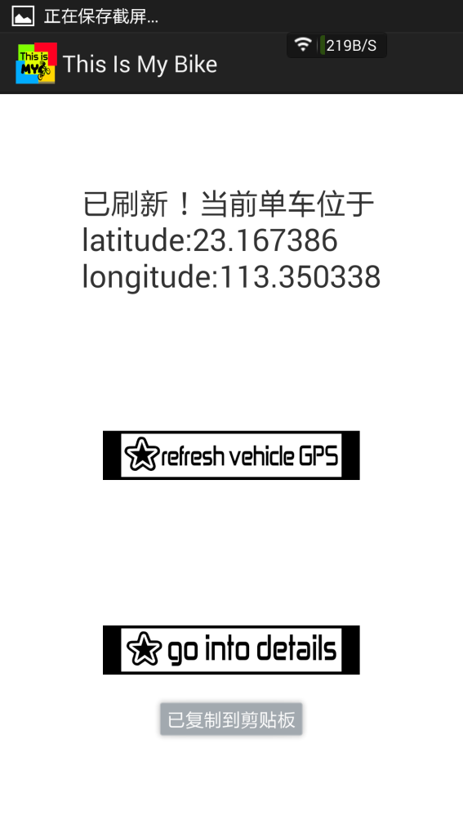

1. 调用百度地图

package com.example.thisismybike;

import android.app.Activity;

import android.content.Intent;

import android.content.SharedPreferences;

import android.os.Bundle;

import android.view.KeyEvent;

import android.view.View;

import android.view.View.OnClickListener;

import android.widget.Button;

import android.widget.RadioGroup;

import android.widget.RadioGroup.OnCheckedChangeListener;

import com.baidu.location.BDLocation;

import com.baidu.location.BDLocationListener;

import com.baidu.location.LocationClient;

import com.baidu.location.LocationClientOption;

import com.baidu.mapapi.map.BaiduMap;

import com.baidu.mapapi.map.BitmapDescriptor;

import com.baidu.mapapi.map.BitmapDescriptorFactory;

import com.baidu.mapapi.map.MapStatusUpdate;

import com.baidu.mapapi.map.MapStatusUpdateFactory;

import com.baidu.mapapi.map.MapView;

import com.baidu.mapapi.map.MarkerOptions;

import com.baidu.mapapi.map.MyLocationConfiguration;

import com.baidu.mapapi.map.MyLocationConfiguration.LocationMode;

import com.baidu.mapapi.map.MyLocationData;

import com.baidu.mapapi.map.OverlayOptions;

import com.baidu.mapapi.model.LatLng;

import com.baidu.mapapi.overlayutil.PoiOverlay;

import com.baidu.mapapi.search.core.PoiInfo;

import com.baidu.mapapi.search.poi.PoiDetailSearchOption;

import com.baidu.mapapi.search.poi.PoiNearbySearchOption;

import com.baidu.mapapi.search.poi.PoiSearch;

/**

* 此demo用来展示如何结合定位SDK实现定位，并使用MyLocationOverlay绘制定位位置 同时展示如何使用自定义图标绘制并点击时弹出泡泡

*

*/

public class Openmap extends Activity {

// 定位相关

LocationClient mLocClient;

public MyLocationListenner myListener = new MyLocationListenner();

private LocationMode mCurrentMode;

BitmapDescriptor mCurrentMarker;

MapView mMapView;

BaiduMap mBaiduMap;

// UI相关

boolean isFirstLoc = true;// 是否首次定位

private PoiSearch mPoiSearch = null;

@Override

public void onCreate(Bundle savedInstanceState) {

super.onCreate(savedInstanceState);

setContentView(R.layout.mymap);

mCurrentMarker = null;

mCurrentMode = LocationMode.COMPASS;

// 地图初始化

mMapView = (MapView) findViewById(R.id.bmapView);

mBaiduMap = mMapView.getMap();

mBaiduMap

.setMyLocationConfigeration(new MyLocationConfiguration(

mCurrentMode, true, mCurrentMarker));

// 开启定位图层

mBaiduMap.setMyLocationEnabled(true);

// 定位初始化

mLocClient = new LocationClient(this);

mLocClient.registerLocationListener(myListener);

LocationClientOption option = new LocationClientOption();

option.setOpenGps(true);// 打开gps

option.setCoorType("bd09ll"); // 设置坐标类型

option.setScanSpan(1000);

option.setNeedDeviceDirect(true);

mLocClient.setLocOption(option);

mLocClient.start();

//定义bikeMaker坐标点

SharedPreferences sp=getSharedPreferences("jingwei", MODE_PRIVATE);

String lonstr=sp.getString("bikelongitude", "113.350338");

String latstr=sp.getString("bikelatitude", "23.167386");

LatLng point = new LatLng(Double.valueOf(latstr), Double.valueOf(lonstr));

//构建Marker图标

BitmapDescriptor bitmap = BitmapDescriptorFactory

.fromResource(R.drawable.icon_bike);

//构建MarkerOption，用于在地图上添加Marker

OverlayOptions overlaybike = new MarkerOptions()

.position(point)

.icon(bitmap);

//在地图上添加Marker，并显示

mBaiduMap.addOverlay(overlaybike);

//POI nearby bike

/*mPoiSearch.searchNearby(new PoiNearbySearchOption().radius(5000).keyword("自行车维修").location(point));

PoiOverlay overlay = new MyPoiOverlay(mBaiduMap);

mBaiduMap.setOnMarkerClickListener(overlay);

overlay.setData();

overlay.addToMap();

overlay.zoomToSpan();*/

}

/**

* 定位SDK监听函数

*/

public class MyLocationListenner implements BDLocationListener {

@Override

public void onReceiveLocation(BDLocation location) {

// map view 销毁后不在处理新接收的位置

if (location == null || mMapView == null)

return;

MyLocationData locData = new MyLocationData.Builder()

.accuracy(location.getRadius())

// 此处设置开发者获取到的方向信息，顺时针0-360

.direction(location.getDirection()).latitude(location.getLatitude())

.longitude(location.getLongitude()).build();

mBaiduMap.setMyLocationData(locData);

if (isFirstLoc) {

isFirstLoc = false;

LatLng ll = new LatLng(location.getLatitude(),

location.getLongitude());

MapStatusUpdate u = MapStatusUpdateFactory.newLatLng(ll);

mBaiduMap.animateMapStatus(u);

}

}

public void onReceivePoi(BDLocation poiLocation) {

}

}

//POI new class

private class MyPoiOverlay extends PoiOverlay {

public MyPoiOverlay(BaiduMap baiduMap) {

super(baiduMap);

}

@Override

public boolean onPoiClick(int index) {

super.onPoiClick(index);

PoiInfo poi = getPoiResult().getAllPoi().get(index);

// if (poi.hasCaterDetails) {

mPoiSearch.searchPoiDetail((new PoiDetailSearchOption())

.poiUid(poi.uid));

// }

return true;

}

}

@Override

protected void onPause() {

mMapView.onPause();

super.onPause();

}

@Override

protected void onResume() {

mMapView.onResume();

super.onResume();

}

@Override

protected void onDestroy() {

// 退出时销毁定位

mLocClient.stop();

// 关闭定位图层

mBaiduMap.setMyLocationEnabled(false);

mMapView.onDestroy();

mMapView = null;

super.onDestroy();

}

@Override

public boolean onKeyDown(int keyCode, KeyEvent event) {

if (keyCode == KeyEvent.KEYCODE_BACK && event.getRepeatCount() == 0) {

Intent intent=new Intent(Openmap.this,Messagemenu.class);

startActivity(intent);

finish();

return true;

} else

return super.onKeyDown(keyCode, event);

}

}

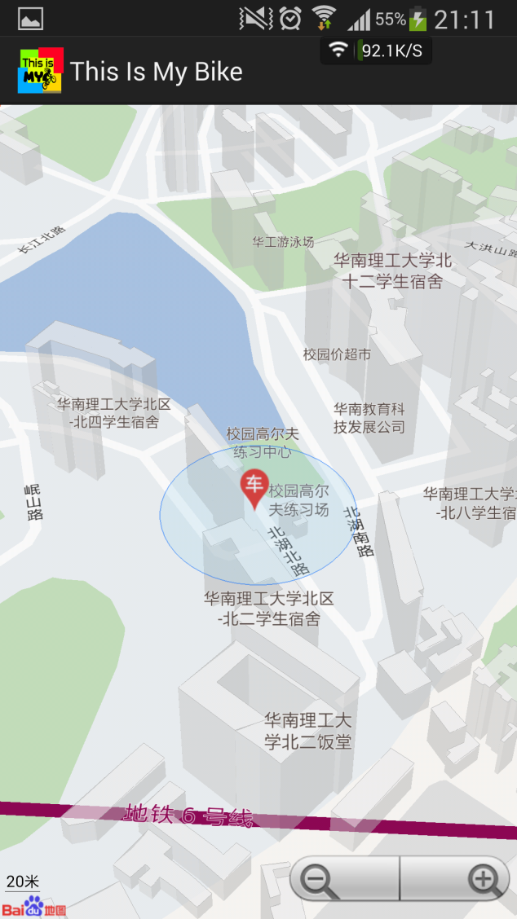

（3）调用百度街景

package com.example.thisismybike;

import android.R.string;

import android.app.Activity;

import android.content.Intent;

import android.content.SharedPreferences;

import android.os.Bundle;

import android.view.KeyEvent;

import com.baidu.lbsapi.panoramaview.*;

import com.baidu.lbsapi.BMapManager;

import com.baidu.mapapi.SDKInitializer;

import com.baidu.pplatform.comapi.basestruct.GeoPoint;

public class Surroundingview extends Activity implements PanoramaViewListener {

private PanoramaView mPanoView;

@Override

public void onCreate(Bundle savedInstanceState){

super.onCreate(savedInstanceState);

SDKInitializer.initialize(getApplicationContext());

DemoApplication app = (DemoApplication) this.getApplication();

if (app.mBMapManager == null) {

app.mBMapManager = new BMapManager(app);

app.mBMapManager.init(new DemoApplication.MyGeneralListener());

}

setContentView(R.layout.streetview);

mPanoView = (PanoramaView) findViewById(R.id.panorama);

mPanoView.setPanoramaImageLevel(5);

//mPanoView.setPanoramaViewListener(this);

SharedPreferences sp=getSharedPreferences("jingwei", MODE_PRIVATE);

String lonstr=sp.getString("bikelongitude", "113.350338");

String latstr=sp.getString("bikelatitude", "23.167386");

mPanoView.setPanorama(Double.valueOf(lonstr),Double.valueOf(latstr));

}

@Override

protected void onPause() {

super.onPause();

mPanoView.onPause();

}

@Override

protected void onResume() {

super.onResume();

mPanoView.onResume();

}

@Override

protected void onDestroy() {

mPanoView.destroy();

super.onDestroy();

}

@Override

public void onLoadPanoramBegin() {

// TODO Auto-generated method stub

}

@Override

public void onLoadPanoramaDesc() {

// TODO Auto-generated method stub

}

@Override

public void onLoadPanoramaEnd() {

// TODO Auto-generated method stub

}

@Override

public void onLoadPanoramaError() {

// TODO Auto-generated method stub

}

@Override

public boolean onKeyDown(int keyCode, KeyEvent event) {

if (keyCode == KeyEvent.KEYCODE_BACK && event.getRepeatCount() == 0) {

Intent intent=new Intent(Surroundingview.this,Messagemenu.class);

startActivity(intent);

finish();

return true;

} else

return super.onKeyDown(keyCode, event);

}

}

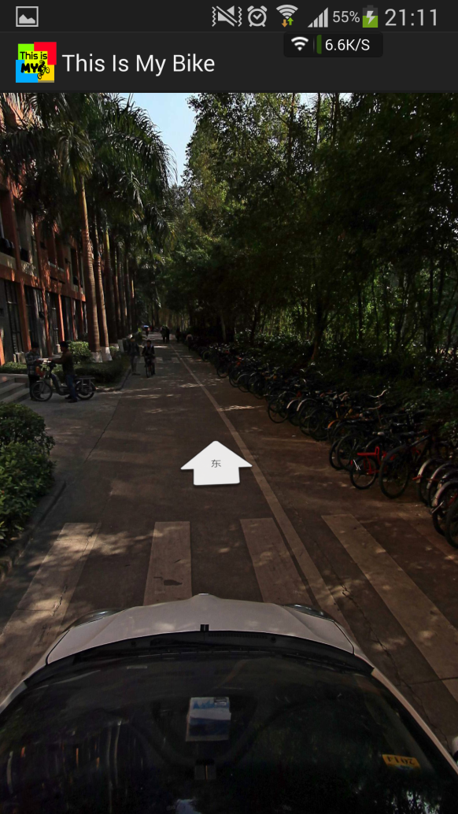

（4）接收SMS并读取其中GPS坐标

package com.example.thisismybike;

import android.app.Activity;

import android.content.BroadcastReceiver;

import android.content.Context;

import android.content.Intent;

import android.content.SharedPreferences;

import android.content.SharedPreferences.Editor;

import android.os.Bundle;

import android.telephony.SmsMessage;

import android.widget.TextView;

public class SMSBroadcastReceiver extends BroadcastReceiver {

private static final String ACTION = "android.provider.Telephony.SMS_RECEIVED";

@Override

public void onReceive(Context context, Intent intent) {

if (intent.getAction().equals(ACTION)) {

StringBuffer SMSAddress = new StringBuffer();

StringBuffer SMSContent = new StringBuffer();

Bundle bundle = intent.getExtras();

if (bundle != null) {

Object[] pdusObjects = (Object[]) bundle.get("pdus");

SmsMessage[] messages = new SmsMessage[pdusObjects.length];

for (int i = 0; i < pdusObjects.length; i++) {

messages[i] = SmsMessage

.createFromPdu((byte[]) pdusObjects[i]);

}

for (SmsMessage message : messages) {

SMSAddress.append(message.getDisplayOriginatingAddress());

SMSContent.append(message.getDisplayMessageBody());

{

String [] temp = null;

String SMStemp=String.valueOf(SMSContent);

temp = SMStemp.split(",");

String lat=temp[0];

String lon=temp[1];

SharedPreferences sp= context.getSharedPreferences("jingwei",Activity.MODE_PRIVATE);

Editor loceditor=sp.edit();

loceditor.putString("bikelatitude2", lat);

loceditor.putString("bikelongitude2", lon);

loceditor.commit();

}

}

}

}

}

}

**六、其他代码注释**

**MainActivity.java:**

package com.example.thisismybike;

import android.app.Activity;

import android.content.Intent;

import android.os.Bundle;

import android.view.Menu;

import android.view.MenuItem;

import android.view.View;

import android.view.View.OnClickListener;

import android.widget.ImageButton;

import com.example.thisismybike.R;

public class MainActivity extends Activity {

@Override

protected void onCreate(Bundle savedInstanceState) {

super.onCreate(savedInstanceState);

setContentView(R.layout.activity_main);

final ImageButton ezmode=(ImageButton)findViewById(R.id.ezmode);

ezmode.setOnClickListener(new OnClickListener() {

@Override

public void onClick(View arg0) {

// TODO Auto-generated method stub

//ezmode.setBackgroundResource(R.drawable.ezmode2);

Intent intent =new Intent(MainActivity.this,Messagemenu.class);

startActivity(intent);

finish();

}

});

final ImageButton exmod=(ImageButton)findViewById(R.id.exmode);

exmod.setOnClickListener(new OnClickListener() {

@Override

public void onClick(View arg0) {

// TODO Auto-generated method stub

//exmod.setBackgroundResource(R.drawable.exmod2);

Intent intent =new Intent(MainActivity.this,Exmod.class);

startActivity(intent);

finish();

}

});

final ImageButton exit=(ImageButton)findViewById(R.id.exit);

exit.setOnClickListener(new OnClickListener() {

@Override

public void onClick(View arg0) {

// TODO Auto-generated method stub

// exmod.setBackgroundResource(R.drawable.exit2);

finish();

}

});

final ImageButton instru=(ImageButton)findViewById(R.id.instruction);

instru.setOnClickListener(new OnClickListener() {

@Override

public void onClick(View arg0) {

// TODO Auto-generated method stub

Intent intent =new Intent(MainActivity.this,Instruction.class);

startActivity(intent);

finish();

}

});

}

}

**EX MODE.java**

package com.example.thisismybike;

import android.app.Activity;

import android.os.Bundle;

import com.example.thisismybike.R;

import android.content.Intent;

import android.content.SharedPreferences;

import android.content.SharedPreferences.Editor;

import android.view.KeyEvent;

import android.view.View;

import android.view.View.OnClickListener;

import android.widget.ImageButton;

import android.widget.TextView;

public class Exmod extends Activity {

@Override

protected void onCreate(Bundle savedInstanceState) {

super.onCreate(savedInstanceState);

setContentView(R.layout.exmod_menu);

final ImageButton back2ez=(ImageButton)findViewById(R.id.backtoez);

back2ez.setOnClickListener(new OnClickListener() {

@Override

public void onClick(View arg0) {

// TODO Auto-generated method stub

//back2ez.setBackgroundResource(R.drawable.backtoezmod2);

Intent intent =new Intent(Exmod.this,Messagemenu.class);

startActivity(intent);

finish();

}

});

final ImageButton opengps=(ImageButton)findViewById(R.id.opengps);

opengps.setOnClickListener(new OnClickListener() {

@Override

public void onClick(View arg0) {

// TODO Auto-generated method stub

// opengps.setBackgroundResource(R.drawable.opengps2);

// opengps.setBackgroundResource(R.drawable.opengps);

SharedPreferences sp=getSharedPreferences("jingwei", MODE_PRIVATE);

String lonstr=sp.getString("bikelongitude2", "113.350338");

String latstr=sp.getString("bikelatitude2", "23.167386");

String bikeaddr=sp.getString("bikeaddr", "unknown");

Editor loceditor=sp.edit();

loceditor.putString("bikelatitude",latstr);

loceditor.putString("bikelongitude", lonstr);

loceditor.putString("bikeaddr", bikeaddr);

loceditor.commit();

TextView refreshtext=(TextView)findViewById(R.id.refresh);

refreshtext.setText("已刷新！当前单车位于\n"+"latitude:"+latstr+"\nlongitude:"+lonstr);

}

});

}

@Override

public boolean onKeyDown(int keyCode, KeyEvent event) {

if (keyCode == KeyEvent.KEYCODE_BACK && event.getRepeatCount() == 0) {

Intent intent=new Intent(Exmod.this,MainActivity.class);

startActivity(intent);

finish();

return true;

} else

return super.onKeyDown(keyCode, event);

}

}

**Instruction.java**

package com.example.thisismybike;

import android.app.Activity;

import android.content.Intent;

import android.os.Bundle;

import android.view.KeyEvent;

public class Instruction extends Activity {

@Override

protected void onCreate(Bundle savedInstanceState) {

// TODO Auto-generated method stub

super.onCreate(savedInstanceState);

setContentView(R.layout.instructionmenu);

}

@Override

public boolean onKeyDown(int keyCode, KeyEvent event) {

if (keyCode == KeyEvent.KEYCODE_BACK && event.getRepeatCount() == 0) {

Intent intent=new Intent(Instruction.this,MainActivity.class);

startActivity(intent);

finish();

return true;

} else

return super.onKeyDown(keyCode, event);

}

}

1. **心得体会**

这次实验是嵌入式系统课程的最后一次实验，所以我们花了两周的时间小组合作搞了一个APP用以验收。这个APP不仅结合了我们之前的最基础的布局，即按键和不同菜单间的跳转；以及利用传感器，不过这次不再是加速度传感器了而是GPS传感器，其调用方法大致相同。我们还新增了读取SMS的内容以及引入百度地图API的东西，最后整体运行良好，经过实测也符合预期。

总体来说，嵌入式课程给了我很多知识，我感觉收获最多的是在安卓开发这一部分，因为这些也是现在比较热门的技术，因而也让我从几乎没有基础开始渐渐掌握一些语句到最后可以看懂程序，然后自己写一些简单的程序等等。同时，我也会在安卓开发上在进一步学习，掌握更多内容。



**嵌入式系统实验报告**

**综合实验2——多功能户外小助手**

**学院** 电子与信息学院

**专业** 信息工程（电类联合班）

**学生姓名**  马廷俊

**指导教师** 崔寅鸣 李磊

**提交日期**2015年 6月7日

## 实验目的

在户外有时候我们需要一些实用的小工具，例如在迷失方向的时候我们需要一个指南针，在黑暗中我们需要一个手电筒，再加上一个常用的能够报时计时的多功能闹钟，在安卓手机上用一个app整合并实现上述功能，这就是我们做这个大作业的初衷。

## 实验内容

综合以前的实验所学习到的知识，在android系统实现一个实用的应用程序，该程序包含了指南针、水平仪、手电筒、多功能时钟四个小程序，分别实现了四个不同的功能。

**三、实验步骤**

主菜单布局：我们没有用安卓adk提供的原始的button，而是自己编写了一个FButton，使界面更加美观

public class MainActivity extends Activity {

private FButton btn_compass ;

private FButton btn_gradienter;

private FButton btn_light;

private FButton btn_clock;

private FButton btn_about;

@Override

protected void onCreate(Bundle savedInstanceState) {

super.onCreate(savedInstanceState);

setContentView(R.layout.fragment_main);

btn_compass = (FButton)findViewById(R.id.button_compass);

btn_compass.setOnClickListener(new View.OnClickListener() {

@Override

public void onClick(View arg0) {

gotopage(Compass.class);

}

});

btn_gradienter = (FButton)findViewById(R.id.button_gradienter);

btn_gradienter.setOnClickListener(new View.OnClickListener() {

@Override

public void onClick(View arg0) {

gotopage(Gradienter.class);

}

});

btn_light = (FButton)findViewById(R.id.button_light);

btn_light.setOnClickListener(new View.OnClickListener() {

@Override

public void onClick(View arg0) {

startActivity(new Intent(MainActivity.this, Superllight.class) );

}

});

btn_clock = (FButton)findViewById(R.id.button_timer);

btn_clock.setOnClickListener(new View.OnClickListener() {

@Override

public void onClick(View arg0) {

startActivity(new Intent(MainActivity.this, ClockMain.class) );

}

});

btn_about = (FButton)findViewById(R.id.button_map);

btn_about.setOnClickListener(new View.OnClickListener() {

@Override

public void onClick(View arg0) {

gotopage(About.class);

}

});

}

private void gotopage(Class<?> goalpage){

startActivity(new Intent(MainActivity.this, goalpage) );

finish();

}

}

效果：

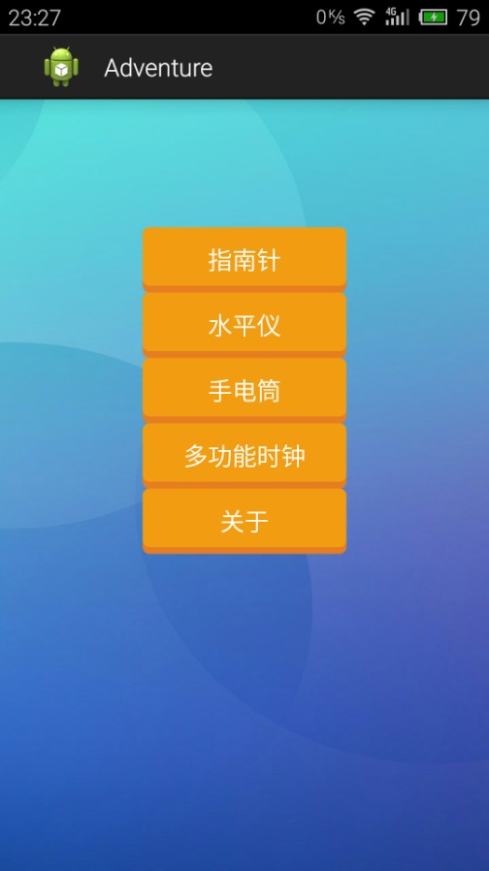

组员信息页面：

public class About extends Activity {

private FButton btn_back;

@Override

protected void onCreate(Bundle savedInstanceState) {

super.onCreate(savedInstanceState);

setContentView(R.layout.about);

btn_back = (FButton)findViewById(R.id.back_from_about);

btn_back.setOnClickListener(new View.OnClickListener() {

@Override

public void onClick(View arg0) {

gotopage(MainActivity.class);

}

});

}

private void gotopage(Class<?> goalpage){

startActivity(new Intent(About.this, goalpage) );

finish();

}

}

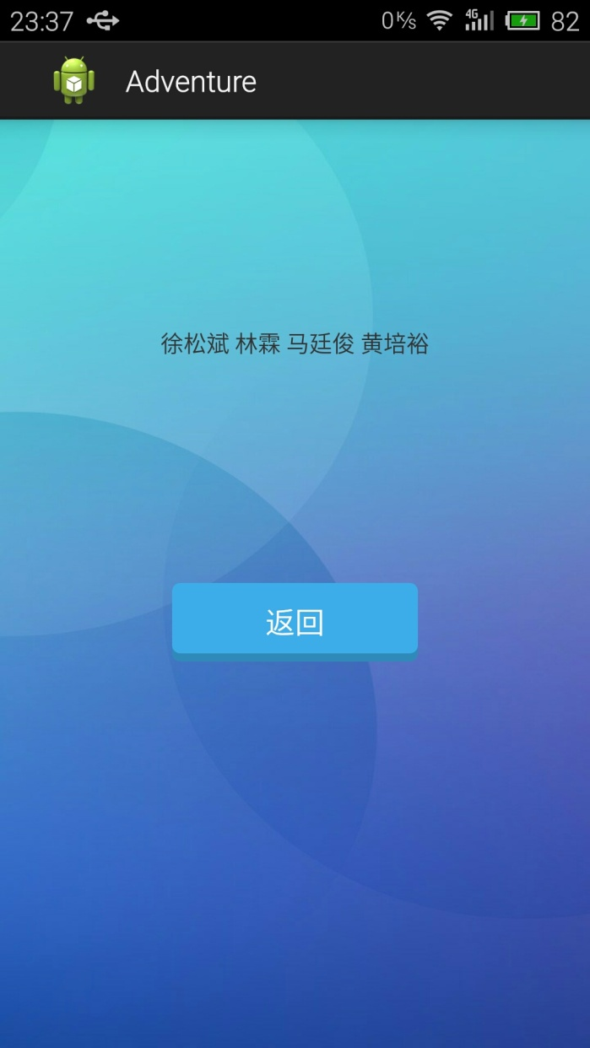

多功能时钟界面

public class ClockMain extends Activity {

@Override

protected void onCreate(Bundle savedInstanceState) {

super.onCreate(savedInstanceState);

setContentView(R.layout.clock_main);

tabHost = (TabHost) findViewById(android.R.id.tabhost);

tabHost.setup();

tabHost.addTab(tabHost.newTabSpec("tabTime").setIndicator("鏃堕挓").setContent(R.id.tabTime));

tabHost.addTab(tabHost.newTabSpec("tabAlarm").setIndicator("闂归挓").setContent(R.id.tabAlarm));

tabHost.addTab(tabHost.newTabSpec("tabTimer").setIndicator("鍊掕鏃?).setContent(R.id.tabTimer));

tabHost.addTab(tabHost.newTabSpec("tabStopWatch").setIndicator("绉掕〃").setContent(R.id.tabStopWatch));

stopWatchView = (StopWatchView) findViewById(R.id.tabStopWatch);

}

@Override

protected void onDestroy() {

stopWatchView.onDestory();

super.onDestroy();

}

private StopWatchView stopWatchView;

private TabHost tabHost;

}

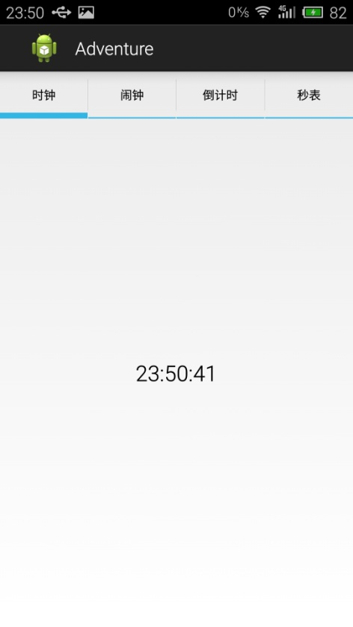

**四、程序说明**

1. 指南针

public class Compass extends Activity

implements SensorEventListener

{

private FButton btn_back = null;

ImageView znzImage; //定义显示指南针图片

float currentDegree = 0f; //记录指南针转过的角度

//定义Sensor管理器

SensorManager mSensorManager;

@Override

protected void onCreate(Bundle savedInstanceState) {

super.onCreate(savedInstanceState);

setContentView(R.layout.compass);

znzImage = (ImageView)findViewById(R.id.znzImage);

mSensorManager = (SensorManager)getSystemService(SENSOR_SERVICE);

btn_back = (FButton)findViewById(R.id.back_from_compass);

btn_back.setOnClickListener(new View.OnClickListener() {

@Override

public void onClick(View arg0) {

gotopage(MainActivity.class);

}

});

}

@Override

protected void onResume() {

// TODO Auto-generated method stub

super.onResume();

//为系统的方向传感器注册监听器

mSensorManager.registerListener(this,

mSensorManager.getDefaultSensor(Sensor.TYPE_ORIENTATION),

SensorManager.SENSOR_DELAY_GAME);

}

@Override

protected void onPause() {

//取消注册

mSensorManager.unregisterListener(this);

super.onPause();

}

@Override

protected void onStop() {

//取消注册

mSensorManager.unregisterListener(this);

super.onStop();

}

@Override

public void onSensorChanged(SensorEvent event)

{

//获取触发event的传感器类型

int sensorType = event.sensor.getType();

switch(sensorType)

{

case Sensor.TYPE_ORIENTATION:

//获取绕z轴转过的角度

float degree = event.values[0];

//创建旋转动画（反向旋转degree角度）

RotateAnimation ra = new RotateAnimation(currentDegree,

-degree,Animation.RELATIVE_TO_SELF,0.5f,

Animation.RELATIVE_TO_SELF,0.5f);

//设置动画的持续时间

ra.setDuration(200);

//运行动画

znzImage.startAnimation(ra);

currentDegree = -degree;

break;

}

}

@Override

public void onAccuracyChanged(Sensor sensor,int accuracy)

{

}

private void gotopage(Class<?> goalpage){

startActivity(new Intent(Compass.this, goalpage) );

finish();

}

}

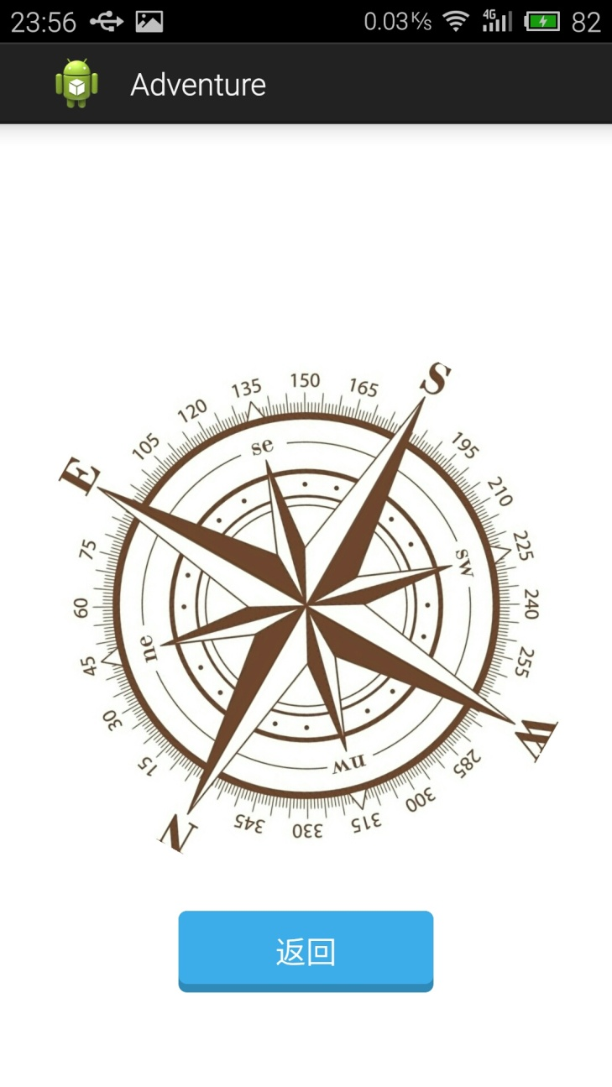

1. 水平仪

public class Gradienter extends Activity implements SensorEventListener

{

// 定义水平仪的仪表盘

MyView show;

// // 定义真机的Sensor管理器

SensorManager mSensorManager;

// 定义模拟器的Sensor管理器

TextView textView1;

TextView textView2;

private int width = 0;

private int height = 0;

private FButton back = null;

@Override

public void onCreate(Bundle savedInstanceState)

{

super.onCreate(savedInstanceState);

// 使屏幕不显示标题栏(必须要在setContentView方法执行前执行)

this.requestWindowFeature(Window.FEATURE_NO_TITLE);

// 隐藏状态栏，使内容全屏显示(必须要在setContentView方法执行前执行)

this.getWindow().setFlags(WindowManager.LayoutParams.FLAG_FULLSCREEN,

WindowManager.LayoutParams.FLAG_FULLSCREEN);

setContentView(R.layout.gradienter);

// 获取水平仪的主组件

show = (MyView) findViewById(R.id.show);

// 获取真机的传感器管理服务

mSensorManager = (SensorManager)getSystemService(SENSOR_SERVICE);

back = (FButton)findViewById(R.id.back_from_gradienter);

back.setOnClickListener(new View.OnClickListener() {

@Override

public void onClick(View arg0) {

gotopage(MainActivity.class);

}

});

}

@Override

public void onResume()

{

super.onResume();

// 为系统的方向传感器注册监听器

mSensorManager.registerListener( this,

mSensorManager.getDefaultSensor(Sensor.TYPE_ACCELEROMETER),

SensorManager.SENSOR_DELAY_UI);

}

@Override

protected void onPause()

{

// 取消注册

mSensorManager.unregisterListener(this);

super.onPause();

}

@Override

protected void onStop()

{

// 取消注册

mSensorManager.unregisterListener(this);

super.onStop();

}

@Override

public void onAccuracyChanged(Sensor sensor, int accuracy)

{

}

@Override

public void onSensorChanged(SensorEvent event)

{

float[] values = event.values;

// // 真机上获取触发event的传感器类型

int sensorType = event.sensor.getType();

// 模拟器上获取触发event的传感器类型

//textView1.setText(Float.toString(values[1]));

switch (sensorType)

{

case Sensor.TYPE_ACCELEROMETER:

// 获取与Y轴的夹角

float xAccess = values[0];

// 获取与Z轴的夹角

float yAccess = values[1];

// 获取与X轴的夹角

float zAccess = values[2];

textView2=(TextView)findViewById(R.id.state);

// 判断手机方向

if (xAccess>=9.0)

{

textView2.setText("侧垂");

}

else if (yAccess>=9.0)

{

textView2.setText("正垂");

}

else if (zAccess>=9.0)

{

textView2.setText("俯水平");

}

else if (xAccess<=-9.0)

{

textView2.setText("反侧垂");

}

else if (yAccess<=-9.0)

{

textView2.setText("反正垂");

}

else if (zAccess<=-9.0)

{

textView2.setText("仰水平");

}

// 气泡位于中间时（水平仪完全水平），气泡的X、Y座标

int x_max = (show.back.getWidth() - show.bubble.getWidth()) / 2;

int y_max= (show.back.getHeight() - show.bubble.getHeight()) / 2;

//int x = (int) (-x_max*xAccess/9.8f)+show.back.getWidth()/2;

//int y = (int) (y_max*yAccess/9.8f)+show.back.getHeight()/2;

WindowManager wm = (WindowManager) getBaseContext().getSystemService(Context.WINDOW_SERVICE);

width = wm.getDefaultDisplay().getWidth();

height = wm.getDefaultDisplay().getHeight();

int x = (int) (x_max*xAccess/9.8f)+width/2;

int y = (int) (-y_max*yAccess/9.8f)+height/2;

// 如果计算出来的X、Y座标还位于水平仪的仪表盘内，更新水平仪的气泡座标

if (isContain(x, y))

{

show.bubbleX = x-show.bubble.getWidth() / 2 ;

show.bubbleY = y-show.bubble.getHeight() / 2;

}

// 通知系统重回MyView组件

show.postInvalidate();

break;

}

}

// // 计算x、y点的气泡是否处于水平仪的仪表盘内

// private boolean isContain(int x, int y)

// {

// // 计算气泡的圆心座标X、Y

// int bubbleCx = x + show.bubble.getWidth() / 2;

// int bubbleCy = y + show.bubble.getWidth() / 2;

// // 计算水平仪仪表盘的圆心座标X、Y

// int backCx = show.back.getWidth() / 2;

// int backCy = show.back.getWidth() / 2;

// // 计算气泡的圆心与水平仪仪表盘的圆心之间的距离。

// double distance = Math.sqrt((bubbleCx - backCx) * (bubbleCx - backCx)

// + (bubbleCy - backCy) * (bubbleCy - backCy));

// // 若两个圆心的距离小于它们的半径差，即可认为处于该点的气泡依然位于仪表盘内

// if (distance < (show.back.getWidth() - show.bubble.getWidth()) / 2)

// {

// return true;

// }

// else

// {

// return false;

// }

// }

// 计算x、y点的气泡是否处于水平仪的仪表盘内

private boolean isContain(int x, int y)

{

WindowManager wm = (WindowManager) getBaseContext().getSystemService(Context.WINDOW_SERVICE);

width = wm.getDefaultDisplay().getWidth();

height = wm.getDefaultDisplay().getHeight();

// 计算气泡的圆心座标X、Y

int bubbleCx = x + show.bubble.getWidth() / 2;

int bubbleCy = y + show.bubble.getWidth() / 2;

// 计算水平仪仪表盘的圆心座标X、Y

int backCx = width / 2;

int backCy = height / 2;

// 计算气泡的圆心与水平仪仪表盘的圆心之间的距离。

double distance = Math.sqrt((bubbleCx - backCx) * (bubbleCx - backCx)

+ (bubbleCy - backCy) * (bubbleCy - backCy));

// 若两个圆心的距离小于它们的半径差，即可认为处于该点的气泡依然位于仪表盘内

if (distance < (show.back.getWidth() - show.bubble.getWidth()) / 2)

{

return true;

}

else

{

return false;

}

}

private void gotopage(Class<?> goalpage){

startActivity(new Intent(Gradienter.this, goalpage) );

finish();

}

}

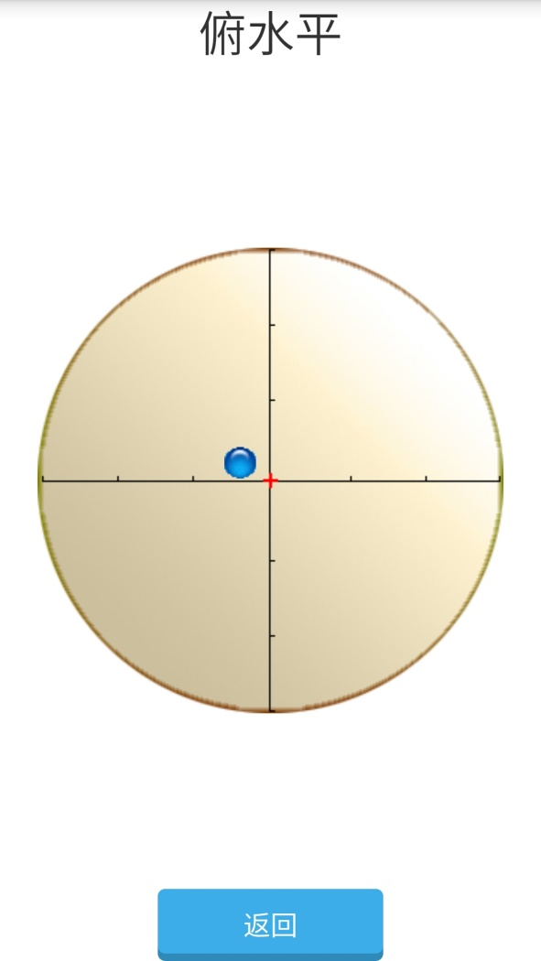

1. 手电筒

public class Flashlight extends BaseActivity {

@Override

protected void onCreate(Bundle savedInstanceState) {

super.onCreate(savedInstanceState);

mImageViewFlashlight.setTag(false);

Point point = new Point();

getWindowManager().getDefaultDisplay().getSize(point);

LayoutParams laParams = (LayoutParams) mImageViewFlashlightController

.getLayoutParams();

laParams.height = point.y * 3 / 4;

laParams.width = point.x / 3;

mImageViewFlashlightController.setLayoutParams(laParams);

}

public void onClick_Flashlight(View view) {

if (!getPackageManager().hasSystemFeature(

PackageManager.FEATURE_CAMERA_FLASH)) {

Toast.makeText(this, "当前设备没有闪光灯", Toast.LENGTH_LONG).show();

return;

}

if (((Boolean) mImageViewFlashlight.getTag()) == false) {

openFlashlight();

} else {

closeFlashlight();

}

}

// 打开闪光灯

protected void openFlashlight() {

TransitionDrawable drawable = (TransitionDrawable) mImageViewFlashlight

.getDrawable();

drawable.startTransition(200);

mImageViewFlashlight.setTag(true);

try {

mCamera = Camera.open();

int textureId = 0;

mCamera.setPreviewTexture(new SurfaceTexture(textureId));

mCamera.startPreview();

mParameters = mCamera.getParameters();

mParameters.setFlashMode(mParameters.FLASH_MODE_TORCH);

mCamera.setParameters(mParameters);

} catch (Exception e) {

// TODO: handle exception

}

}

// 关闭闪光灯

protected void closeFlashlight() {

TransitionDrawable drawable = (TransitionDrawable) mImageViewFlashlight

.getDrawable();

if (((Boolean) mImageViewFlashlight.getTag())) {

drawable.reverseTransition(200);

mImageViewFlashlight.setTag(false);

if (mCamera != null) {

mParameters = mCamera.getParameters();

mParameters.setFlashMode(Parameters.FLASH_MODE_OFF);

mCamera.setParameters(mParameters);

mCamera.stopPreview();

mCamera.release();

mCamera = null;

}

}

}

@Override

public void onPause()

{

super.onPause();

closeFlashlight();

}

}

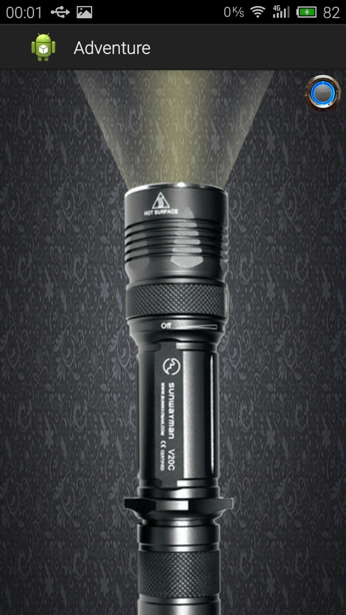

1. 多功能时钟

显示时间

public class TimeView extends LinearLayout {

public TimeView(Context context, AttributeSet attrs, int defStyle) {

super(context, attrs, defStyle);

}

public TimeView(Context context, AttributeSet attrs) {

super(context, attrs);

}

public TimeView(Context context) {

super(context);

}

@Override

protected void onFinishInflate() {

super.onFinishInflate();

tvTime = (TextView) findViewById(R.id.tvTime);

tvTime.setText("Hello");

timerHandler.sendEmptyMessage(0);

}

@Override

protected void onVisibilityChanged(View changedView, int visibility) {

super.onVisibilityChanged(changedView, visibility);

if (visibility==View.VISIBLE) {

timerHandler.sendEmptyMessage(0);

}else{

timerHandler.removeMessages(0);

}

}

private void refreshTime(){

Calendar c = Calendar.getInstance();

tvTime.setText(String.format("%d:%d:%d", c.get(Calendar.HOUR_OF_DAY),c.get(Calendar.MINUTE),c.get(Calendar.SECOND)));

}

private Handler timerHandler = new Handler(){

public void handleMessage(android.os.Message msg) {

refreshTime();

if (getVisibility()==View.VISIBLE) {

timerHandler.sendEmptyMessageDelayed(0, 1000);

}

};

};

private TextView tvTime;

}

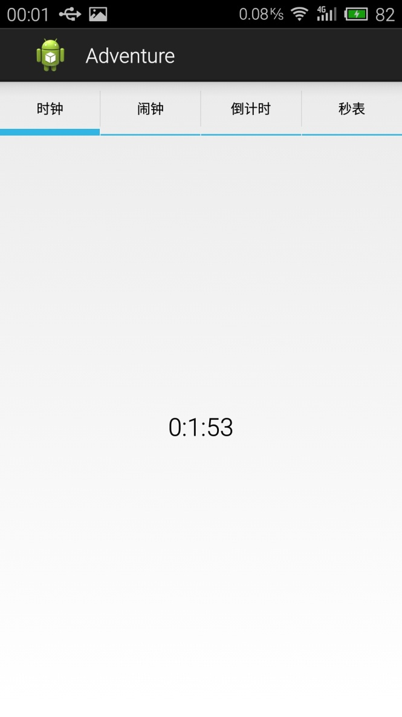

闹钟

public class AlarmView extends LinearLayout {

// public AlarmView(Context context, AttributeSet attrs, int defStyle) {

// super(context, attrs, defStyle);

// // TODO Auto-generated constructor stub

// }

public AlarmView(Context context, AttributeSet attrs) {

super(context, attrs);

init();

}

public AlarmView(Context context) {

super(context);

init();

}

private void init(){

alarmManager = (AlarmManager) getContext().getSystemService(Context.ALARM_SERVICE);

}

@Override

protected void onFinishInflate() {

super.onFinishInflate();

btnAddAlarm = (Button) findViewById(R.id.btnAddAlarm);

lvAlarmList = (ListView) findViewById(R.id.lvAlarmList);

adapter = new ArrayAdapter<AlarmView.AlarmData>(getContext(), android.R.layout.simple_list_item_1);

lvAlarmList.setAdapter(adapter);

readSavedAlarmList();

btnAddAlarm.setOnClickListener(new View.OnClickListener() {

@Override

public void onClick(View v) {

addAlarm();

}

});

lvAlarmList.setOnItemLongClickListener(new AdapterView.OnItemLongClickListener() {

@Override

public boolean onItemLongClick(AdapterView<?> parent, View view,

final int position, long id) {

new AlertDialog.Builder(getContext()).setTitle("鎿嶄綔閫夐」").setItems(new CharSequence[]{"閸掔娀娅?}, new DialogInterface.OnClickListener() {

@Override

public void onClick(DialogInterface dialog, int which) {

switch (which) {

case 0:

deleteAlarm(position);

break;

default:

break;

}

}

}).setNegativeButton("鍙栨秷", null).show();

return true;

}

});

}

private void deleteAlarm(int position){

AlarmData ad = adapter.getItem(position);

adapter.remove(ad);

saveAlarmList();

alarmManager.cancel(PendingIntent.getBroadcast(getContext(), ad.getId(), new Intent(getContext(), AlarmReceiver.class), 0));

}

private void addAlarm(){

//TODO

Calendar c = Calendar.getInstance();

new TimePickerDialog(getContext(), new TimePickerDialog.OnTimeSetListener() {

@Override

public void onTimeSet(TimePicker view, int hourOfDay, int minute) {

Calendar calendar = Calendar.getInstance();

calendar.set(Calendar.HOUR_OF_DAY, hourOfDay);

calendar.set(Calendar.MINUTE, minute);

calendar.set(Calendar.SECOND, 0);

calendar.set(Calendar.MILLISECOND, 0);

Calendar currentTime = Calendar.getInstance();

if (calendar.getTimeInMillis()<=currentTime.getTimeInMillis()) {

calendar.setTimeInMillis(calendar.getTimeInMillis()+24*60*60*1000);

}

AlarmData ad = new AlarmData(calendar.getTimeInMillis());

adapter.add(ad);

alarmManager.setRepeating(AlarmManager.RTC_WAKEUP,

ad.getTime(),

5*60*1000,

PendingIntent.getBroadcast(getContext(), ad.getId(), new Intent(getContext(), AlarmReceiver.class), 0));

saveAlarmList();

}

}, c.get(Calendar.HOUR_OF_DAY), c.get(Calendar.MINUTE), true).show();

}

private void saveAlarmList(){

Editor editor = getContext().getSharedPreferences(AlarmView.class.getName(), Context.MODE_PRIVATE).edit();

StringBuffer sb = new StringBuffer();

for (int i = 0; i < adapter.getCount(); i++) {

sb.append(adapter.getItem(i).getTime()).append(",");

}

if (sb.length()>1) {

String content = sb.toString().substring(0, sb.length()-1);

editor.putString(KEY_ALARM_LIST, content);

System.out.println(content);

}else{

editor.putString(KEY_ALARM_LIST, null);

}

editor.commit();

}

private void readSavedAlarmList(){

SharedPreferences sp = getContext().getSharedPreferences(AlarmView.class.getName(), Context.MODE_PRIVATE);

String content = sp.getString(KEY_ALARM_LIST, null);

if (content!=null) {

String[] timeStrings = content.split(",");

for (String string : timeStrings) {

adapter.add(new AlarmData(Long.parseLong(string)));

}

}

}

private Button btnAddAlarm;

private ListView lvAlarmList;

private static final String KEY_ALARM_LIST = "alarmList";

private ArrayAdapter<AlarmData> adapter;

private AlarmManager alarmManager;

private static class AlarmData{

public AlarmData(long time) {

this.time = time;

date = Calendar.getInstance();

date.setTimeInMillis(time);

timeLabel = String.format("%d鏈?d鏃?%d:%d",

date.get(Calendar.MONTH)+1,

date.get(Calendar.DAY_OF_MONTH),

date.get(Calendar.HOUR_OF_DAY),

date.get(Calendar.MINUTE));

}

public long getTime() {

return time;

}

public String getTimeLabel() {

return timeLabel;

}

@Override

public String toString() {

return getTimeLabel();

}

public int getId(){

return (int)(getTime()/1000/60);

}

private String timeLabel="";

private long time = 0;

private Calendar date;

}

}

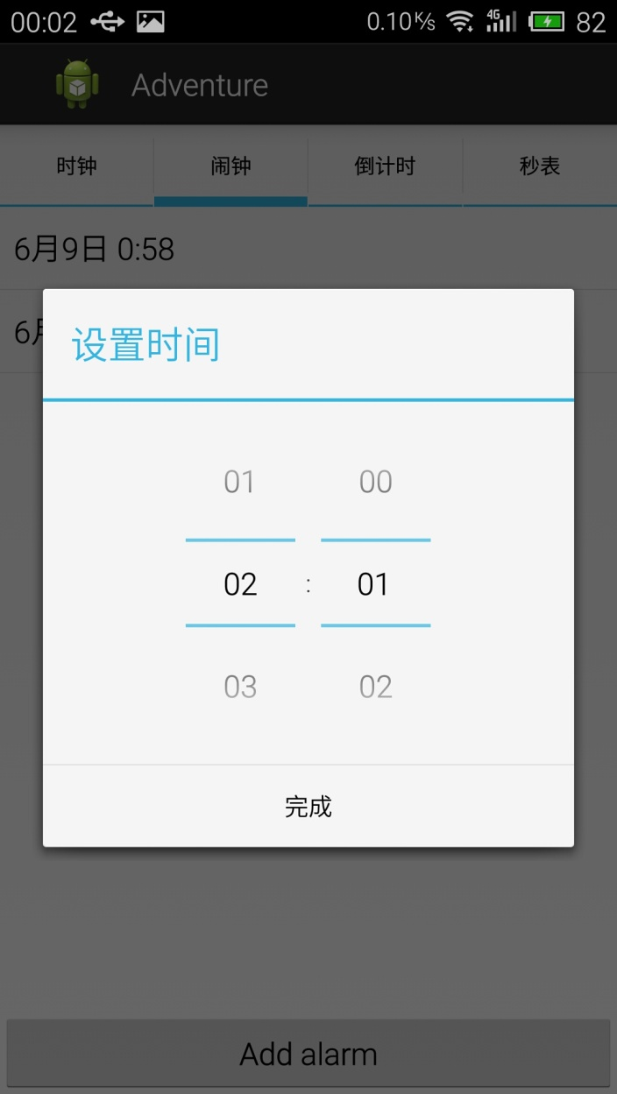

秒表

public class StopWatchView extends LinearLayout {

public StopWatchView(Context context, AttributeSet attrs) {

super(context, attrs);

}

@Override

protected void onFinishInflate() {

super.onFinishInflate();

tvHour = (TextView) findViewById(R.id.timeHour);

tvHour.setText("0");

tvMin = (TextView) findViewById(R.id.timeMin);

tvMin.setText("0");

tvSec = (TextView) findViewById(R.id.timeSec);

tvSec.setText("0");

tvMSec = (TextView) findViewById(R.id.timeMSec);

tvMSec.setText("0");

btnLap = (Button) findViewById(R.id.btnSWLap);

btnLap.setOnClickListener(new View.OnClickListener() {

@Override

public void onClick(View v) {

adapter.insert(String.format("%d:%d:%d.%d", tenMSecs/100/60/60,tenMSecs/100/60%60,tenMSecs/100%60,tenMSecs%100), 0);

}

});

btnPause = (Button) findViewById(R.id.btnSWPause);

btnPause.setOnClickListener(new View.OnClickListener() {

@Override

public void onClick(View v) {

stopTimer();

btnPause.setVisibility(View.GONE);

btnResume.setVisibility(View.VISIBLE);

btnLap.setVisibility(View.GONE);

btnReset.setVisibility(View.VISIBLE);

}

});

btnReset = (Button) findViewById(R.id.btnSWReset);

btnReset.setOnClickListener(new View.OnClickListener() {

@Override

public void onClick(View v) {

stopTimer();

tenMSecs = 0;

adapter.clear();

btnLap.setVisibility(View.GONE);

btnPause.setVisibility(View.GONE);

btnReset.setVisibility(View.GONE);

btnResume.setVisibility(View.GONE);

btnStart.setVisibility(View.VISIBLE);

}

});

btnResume = (Button) findViewById(R.id.btnSWResume);

btnResume.setOnClickListener(new View.OnClickListener() {

@Override

public void onClick(View v) {

startTimer();

btnResume.setVisibility(View.GONE);

btnPause.setVisibility(View.VISIBLE);

btnReset.setVisibility(View.GONE);

btnLap.setVisibility(View.VISIBLE);

}

});

btnStart = (Button) findViewById(R.id.btnSWStart);

btnStart.setOnClickListener(new View.OnClickListener() {

@Override

public void onClick(View v) {

startTimer();

btnStart.setVisibility(View.GONE);

btnPause.setVisibility(View.VISIBLE);

btnLap.setVisibility(View.VISIBLE);

}

});

btnLap.setVisibility(View.GONE);

btnPause.setVisibility(View.GONE);

btnReset.setVisibility(View.GONE);

btnResume.setVisibility(View.GONE);

lvTimeList=(ListView) findViewById(R.id.lvWatchTimeList);

adapter = new ArrayAdapter<String>(getContext(), android.R.layout.simple_list_item_1);

lvTimeList.setAdapter(adapter);

showTimeTask = new TimerTask() {

@Override

public void run() {

hander.sendEmptyMessage(MSG_WHAT_SHOW_TIME);

}

};

timer.schedule(showTimeTask, 200, 200);

}

private void startTimer(){

if (timerTask==null) {

timerTask = new TimerTask() {

@Override

public void run() {

tenMSecs++;

}

};

timer.schedule(timerTask, 10, 10);

}

}

private void stopTimer(){

if (timerTask!=null) {

timerTask.cancel();

timerTask=null;

}

}

private int tenMSecs = 0;

private Timer timer = new Timer();

private TimerTask timerTask = null;

private TimerTask showTimeTask = null;

private TextView tvHour,tvMin,tvSec,tvMSec;

private Button btnStart,btnResume,btnReset,btnPause,btnLap;

private ListView lvTimeList;

private ArrayAdapter<String> adapter;

private Handler hander = new Handler(){

public void handleMessage(android.os.Message msg) {

switch (msg.what) {

case MSG_WHAT_SHOW_TIME:

tvHour.setText(tenMSecs/100/60/60+"");

tvMin.setText(tenMSecs/100/60%60+"");

tvSec.setText(tenMSecs/100%60+"");

tvMSec.setText(tenMSecs%100+"");

break;

default:

break;

}

};

};

private static final int MSG_WHAT_SHOW_TIME = 1;

public void onDestory() {

timer.cancel();

}

}

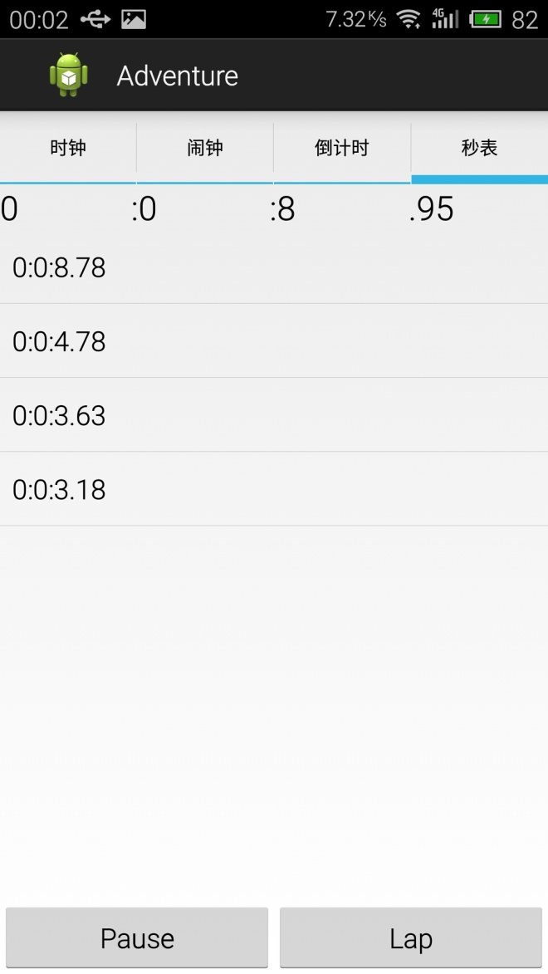

**五、心得体会**

这个实验算是一个各种小功能集合的一个程序，也差不多算是之前所做的一些包括各种传感器综合在一起的应用程序。功能不算特别创新，因为这个APP只是我们在做完第一个应用后再综合起来做成的一个程序。

总体来说，嵌入式课程给了我很多知识，我感觉收获最多的是在安卓开发这一部分，因为这些也是现在比较热门的技术，因而也让我从几乎没有基础开始渐渐掌握一些语句到最后可以看懂程序，然后自己写一些简单的程序等等。同时，我也会在安卓开发上在进一步学习，掌握更多内容。