**E8.9**

a & b. From the result of summary, we can see that here are 8 terminal nodes in the tree, and the misclassification error rate is 0.1636.

c. The root is split into nodes using the variable **Loyal CH**, which was also the most important variable for the model in the summary. Choose 2) in the plot below to see the result : If a customer scored **Loyal CH ≥ 0.5036** , they will be predicted to be in the class **CH**, which shows we expect them to buy Citrus Hill instead of Minute Maid.

d. Develop the plot(tree), and we’ll get the plot below, which shows the same results as the output above. If we have information about a specific customer, we can use the plot to predict which brand of orange juice will they buy. For example, if a customer has a Loyal CH of <0.0356415, then he/she have a high possibility to buy MM instead of CH.

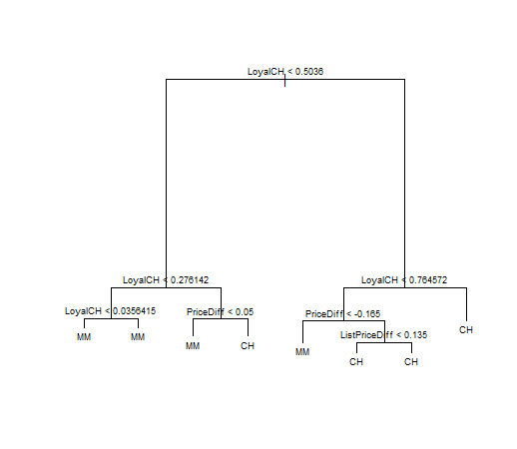

e. From the result below, we can see that the test error rate = (7+36)/(7+36+159+68) = 0.1592593.

f. Because the tree with 8 and 6 terminal nodes results in only 166 cross-validation errors, which is the minimal, so it’s the optimal size chosen by cv.tree.

g. & h. The plot below shows that the tree with 6-8 nodes has the lowset cross-validation errors rate, and this is the same result as f.

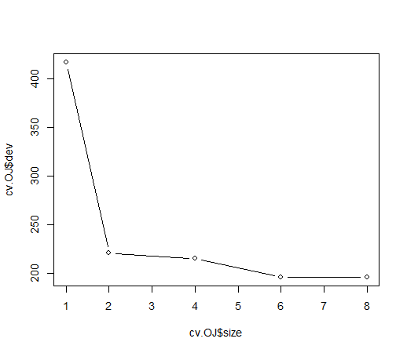

i. Produce a pruned tree corresponding to the optimal tree size : 6 nodes , then we can develop the plot below.

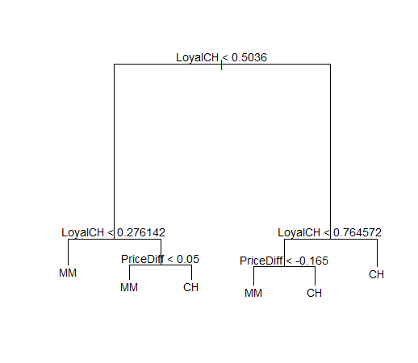

j. The training error rate is still 0.1636 when we use the tree of 6 nodes.

k. The testing error rate is still (7+36)/(7+36+159+68) = 0.1592593.But it produced a way more interpretable tree.

**E8.10**

c. The required plot is shown below.

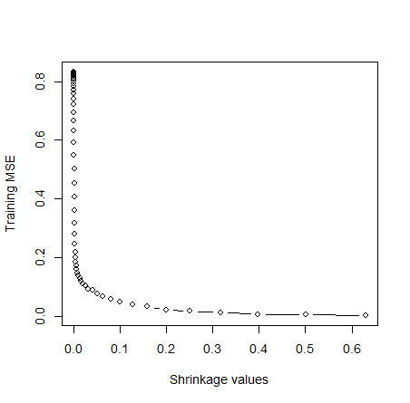

d. The required plot is shown below.

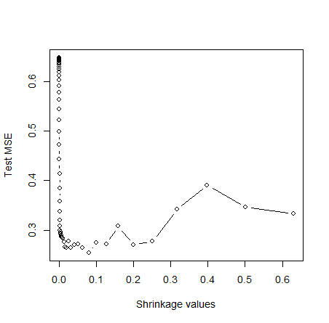

e. Using lm and glm to fit and predict , which is fit 1 and fit 2 respectively. And developing the MSE as below, the MSE of lm is 0.4917959, and the MSE of glm is 0.4570283. Then comparing both of them to the MSE of boosting, which is shown in the plot in d., we can see that the MSE of boosting is **lower** than that of lm as well as glm.

f. From the result below, we can see that“**CAtBat**” is by far the most important variable.

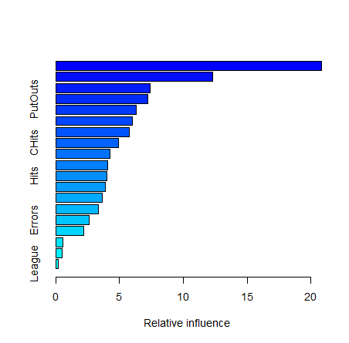

g. The MSE of bagging is 0.2299324, which is slightly lower than the test MSE of boosting.

