**The****Electromagnetic Environment for** **High Voltage Transmission Line**

**Abstract**

High Voltage transmission plays a significant role in enabling the efficient allocation of power, which is one of the preconditions of the fast development of Chinese economy. However, the high voltage in the transmission lines also generates electromagnetic field around them, which might influence people’s health and the function of devices nearby.

This paper mainly describes the electromagnetic environment around the transmission line. First, several factors related with the intensity of the electric field and magnetic field is mentioned. Second, some ways to minimize the influence of electromagnetic field are also introduced according to the factors. In addition, several cases are conductive to proving the validity of these ways.

**Keywords**

Electromagnetic Environment, High Voltage Transmission, electric field, magnetic field

**Introduction**

To achieve the optimal allocation of energy resources in our country despite the unbalanced electricity demand and energy distribution, it is imperative to promote the construction of UHV power grid, which can enhance the sustainable development of electric energy and relieve the environmental pollution. However, with the increasing awareness of health and environmental protection, the electromagnetic pollution of UHV transmission has attracted public attention and concern. The research on the Electromagnetic Environment is relatively rare, which cannot meet people’s demand for thorough research on its environmental influence. Thus, this paper focuses on the electromagnetic environment around the high voltage transmission line.

Several methods are mentioned in this paper, including charge simulation method, the Biot-Savart law analytical method, etc. Omitted to ensure the scientific readability and popularization in this essay, some detailed calculations can be found in the references on the last page. Since some people worry about the electromagnetic pollution of China’s high voltage transmission. This essay will focus on the evaluation of the electromagnetic environment, provide a clear outline of high voltage transmission and clear up the misunderstanding of high voltage transmission.

This paper first analyzes the electric field on high voltage transmission line, which mainly focuses on several factors related with the intensity of electric field. Due to the limitation of the space, this paper only focuses on two factors---the height and the layout of the transmission line. Then it comes to the magnetic field part, which also focuses on factors related with the intensity on magnetic field.

1. **The Analysis of power frequency electric field of EHV transmission line**

Because of the need to reduce the power loss during the transformation, the voltage on the transformation line has reached a certain high level. When the voltage is higher than 1000kV, it is generally called ultra-high voltage, or UHV. When the ultra-high voltage transmission line works, the charge on the wire will generate power frequency electric field in space. Several factors decide the electric field intensity, such as the height of the transmission line, transmission line layout, etc. During the construction of transmission line, optimizing the layout of the cable can profoundly reduce the influence of electric field and magnetic field, which can minimize the influence of the transmission line to the people and machine in the vicinity.

**1.1** **the Influence of height on power frequency** **electric field**

In order to analyze the influence of height on the electric field generated by the electric field, we assume that the transmission lines are infinitely long and parallel to the ground, which can be considered as a good conductor. Under the assumption, we can use Charge Simulation Method to calculate the equivalent charge on the transmission line. And the electric field intensity in any point in the space can be calculated in according to the superposition principle after we get the equivalent effective charge per unit length. The detailed calculation is based on Zhang Kexin’s essay “The research on electromagnetic environment of EHV transmission line (2009)”.

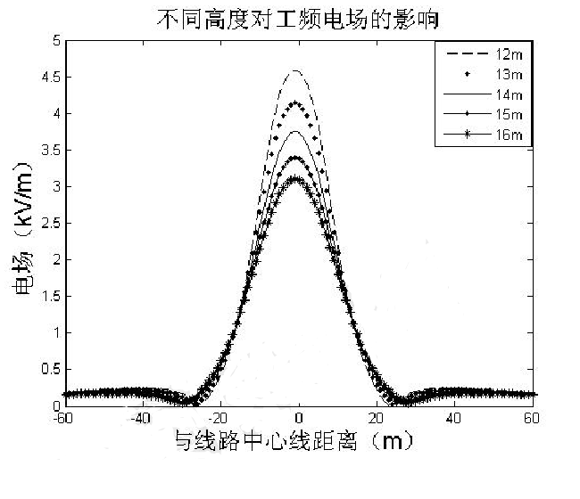Basing on the calculation, we can judge the influence of height of the transmission line on the electric field intensity on the ground. The graph below clearly shows it. The electric field intensity on the ground decreases with the increase of conductor ground height. This relationship can be used to reduce the effect of transmission line to the ground. The diagram below shows the highest electric field strength of different height. According to China's demand for maximum electric field intensity of transmission lines in residential areas, the highest intensity of electric field should be no larger than 4kV/m, which shows that the height of transmission line should larger than 14 m. During the construction process, however, we should consider the droop of the transmission line due to gravity, which means that we should rise the height of the transmission line even higher.

Figure 1: the Influence of height on power frequency electric field

Table1: the highest electric field strength of different height

|  |  |  |  |  |  |
| --- | --- | --- | --- | --- | --- |
| Height(m) | 12 | 13 | 14 | 15 | 16 |
| electric field intensity(kV/m) | 4.589 | 4.136 | 3.725 | 3.383 | 3.091 |

**1.2 the influence of Transmission line layout on the** **electric field**

Basing on the research and practice, different transmission line layout can lead to different electric field. According to Xu Yang from College of Electrical Engineering, Beijing Jiaotong University, when the lines are put in vertical way, the distribution of field intensity will reach a peak. The horizontal layout, however, leads to the biggest coverage area of high-intensity electric field. If the three-phase lines are arranged in the inverted triangle form, both the maximum of electric field and the coverage area will be reduced to the greatest extent. Xu’s theory is proved by the present form of transmission towers.

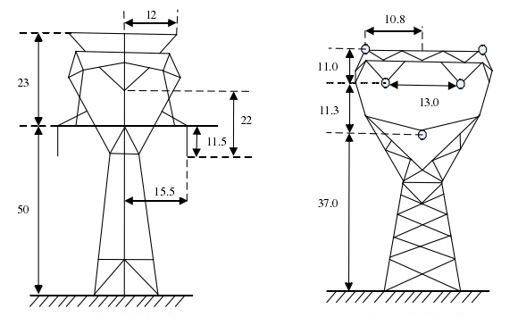In accord with the different transmission line layout, there are different kinds of transmission tower, such as cup-type tower, Compact tower, etc. In the cup-type tower, the

Figure 2 Cup-typetower(left) and Compact tower(right)

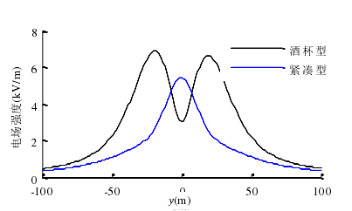three-phase line are arranged in the triangle form, while in the compact tower, it is in the inverted triangle form. Basing on the same calculation as Xu does,Chen Bodong found that the electric field intensity around the cup-type tower is higher than that of the compact tower, which is shown in his essay “Numerical Simulation Study of the Electromagnetic Environment

Figure 3 the electric field intensity aroundcup-type towercompact tower

for Ultra High Voltage Transmission Line”. In the power construction, the compact tower can not only reduce the width of the power line corridor, but also can reduce the electric field intensity around the line, which is both environmental friendly and economical. However, compact tower cannot meet the radio interference 58dB limit requirement when used above 2500m, according to Huang Daochun’s essay “the study on electromagnetic environment of UHV AC transmission line”. Comparing with it, cup-type tower can generally meet several kinds of the electromagnetic environment requirement in high altitude area, which can make up the defects of compact tower. The influence of terrain also should be taken into consideration while choosing the type of transmission tower. One of the cases showing the influence of terrain and weather is the 1000kV Transmission lines from Jindong to Jingmen, which generally use the cup-type tower while passing through mountainous and hilly areas, while the cathead tower is a better choice in the plain area.

**2. The Analysis of power frequency** **magnetic field of UHV transmission line**

When the transmission line is working, magnetic field is generated around the line by the current. Several factors determine the intensity of magnetic field, such as the height of the transmission line, Transmission line layout, etc. In relate with the analysis above about the electric field, we also focus on the layout and the height of the transmission line.

* 1. **The influence of** **transmission line layout on** **magnetic field**

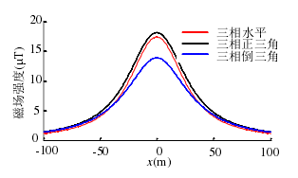The magnetic field produced by the current in each phase transmission line can be directly obtained by the ampere loop theorem, and the magnetic field strength around the line can be obtained by superimposed the magnetic field generated by all the line. In Chen Bodong’s paper “Numerical Simulation Study of the Electromagnetic Environment for Ultra High Voltage Transmission Line”, the influence of mirror current is considered, and the magnetic field intensity is calculated by mirror image method. Unlike the calculation of electric field, the calculation of magnetic field takes the droop of the transmission line into consideration, which means the line cannot be considered as horizontal line. The calculation shows the influence of transmission line layout. The inverted triangle arrangement minimizes the magnetic induction intensity, and the maximum magnetic induction intensity appears below the line, which is shown in figure 4. Basing on this figure, the inverted triangle arrangement should be taken into consideration in the power construction. Likewise, different transmission line layout is accord with the different types of tower to meet the demand to put the line in different layout. The result is shown at the picture above, which shows clearly that Compact tower is has lower intensity of magnetic field than that of Cup-type tower. It can also reflect the superiority of Compact tower. 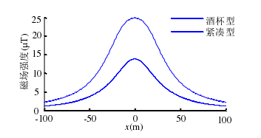

Figure 4 the relationship between magnetic field intensity and transmission line layout

Table 2Maximum magnetic field under different type of tower

Figure 4 the 2-dimensional magnetic field distribution of Cup-type tower(upper) and Compact tower(lower)

|  |  |  |  |
| --- | --- | --- | --- |
| Type of tower | 2-D | 3-D | deviation |
| Cup-type tower | 25.64 | 24.68 | 3% |
| Compact tower | 13.83 | 13.95 | 0.8% |

* 1. **The influence of the transmission line height on magnetic field**

The height of transmission line can influence the magnetic field, which is similar with electric field. In Zhang Kexin’s paper, he used Biot Savart law to calculate the power frequency magnetic field at any point around wire with the ideology of calculus. Any wire in which current flow is equivalent to a large number of tiny straight current conducting wires. The magnetic field of any point around the transmission line can be considered as a vector, which is the combination of all the tiny equivalent wires. The detailed calculation is in his paper “The research on electromagnetic environment of EHV transmission line (2009)”

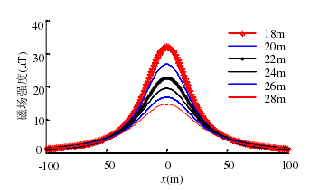

Figure 5 the magnetic field intensity in different transmission line height

The result is clearly shown in figure 5, which suggests that we can reduce the intensity of magnetic fields on the ground via increasing the height of the transmission line. When the height reaches a certain value, the magnetic field attenuation is slow, but in a certain height span, the magnetic field near the ground can be effectively reduced by changing the wire height. The result inspires us that in some extent we can raise the height to reduce the intensity of magnetic fields on the ground. If we need to decrease it to a further extent, other methods should be used. However, according to the ICNIRP rule, the limit of magnetic field public exposure is $100μ T$, which is higher than the data in figure 5 in a large degree. Consequently, when it comes to the influence of electromagnetic field generated by transmission line on human health, only the electric field should be taken into consideration.

**3.0 conclusion**

The electromagnetic environment is related with the height of the lines, the layout of the transmission line, the distances between different lines and so on, which can be minimized by using several methods. The method includes rising the height of the transmission line, choosing the ideal transmission tower, etc. Basically, the electromagnetic environment of Chinese is 1000kV UHV AC transmission line is environmental-friendly.

Despite the fact that compacted tower have better performance in electromagnetic environment than the cup-type tower, the cup-type tower can meet all kinds of demand for electromagnetic environment regardless of the altitude of the area. However, the line corridor width of cup-type tower is larger than that of compacted tower. Thus the compacted tower has advantage over cup-type tower in the matter of height and Line corridor width. The disadvantage of compacted tower is also clear--- cannot meet the radio interference 58dB limit requirement when used above 2500m, which is just a small defect that cannot cover its advantage. We can use it in low-altitude area to make full use of its economic efficiency. We can choose the ideal type of tower basing on the situation we meet to make the best use of the advantages of each tower.

**Reference**

1. The research on electromagnetic environment of EHV transmission line 张可心 硕士位论文
2. 高电压输电线路工频电磁环境 许杨等 电力学报
3. 1000 k V 特高压输电线路的电磁环境 邵方殷等 电网技术
4. Study on electromagnetic environment of UHV AC Transmission Lines 黄道春 The 8th International Power Engineering Conference (IPEC 2007)
5. 特高压输电线路电磁环境数值模拟研究 陈博栋 硕士学位论文
6. 特高压交流输电线路电磁环境研究 王晓燕 博士学位论文