# 2018 MCM

**Problem B: How Many Languages?**

**Background**: There are currently about 6,900 languages spoken on Earth. About half the world’s population claim one of the following ten languages (in order of most speakers) as a native language: Mandarin (incl. Standard Chinese), Spanish, English, Hindi, Arabic, Bengali, Portuguese, Russian, Punjabi, and Japanese. However, much of the world’s population also speaks a second language. When considering total numbers of speakers of a particular language (native speakers plus second or third, etc. language speakers), the languages and their order change from the native language list provided. The total number of speakers of a language may increase or decrease over time because of a variety of influences to include, but not limited to, the language(s) used and/or promoted by the government in a country, the language(s) used in schools, social pressures, migration and assimilation of cultural groups, and immigration and emigration with countries that speak other languages. Moreover, in our globalized, interconnected world there are additional factors that allow languages that are geographically distant to interact. These factors include international business relations, increased global tourism, the use of electronic communication and social media, and the use of technology to assist in quick and easy language translation.

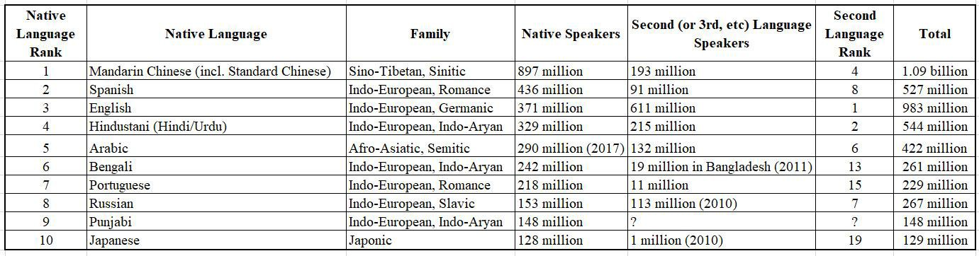

Retrieved from <https://en.wikipedia.org/wiki/List_of_languages_by_total_number_of_speakers>on January 17, 2018.

**Problem:** A large multinational service company, with offices in New York City in the United States and Shanghai in China, is continuing to expand to become truly international. This company is investigating opening additional international offices and desires to have the employees of each office speak both in English and one or more additional languages. The Chief Operating Officer of the company has hired your team to investigate trends of global languages and location options for new offices.

## Part I:

1. Consider the influences and factors described in the background paragraph above, as well as other factors your group may identify. Based on projected trends, and some or all of these influences and factors, model the distribution of various language speakers over time.
2. Use your model to predict what will happen to the numbers of native speakers and total language speakers in the next 50 years. Do you predict that any of the languages in the current top-ten lists (either native speakers or total speakers) will be replaced by another language? Explain.
3. Given the global population and human migration patterns predicted for the next 50 years, do the geographic distributions of these languages change over this same period of time? If so, describe the change.

## Part II:

1. Based on your modeling from **Part I**, and assuming your client company wants to open six new international offices, where might you locate these offices and what languages would be spoken in the offices? Would your recommendations be different in the short term versus the long term? Explain your choices.
2. Considering the changing nature of global communications, and in an effort to save your client company resources, might you suggest that the company open less than six international offices? Indicate what additional information you would need and describe how you would analyze this option in order to advise your client.

## Part III:

Write a 1-2 page memo to the Chief Operating Officer of the service company summarizing your results and recommendations.

**Note:** In your analysis, ignore unpredictable or high-impact, low probability events such as asteroid collisions that would cause a catastrophic jump in evolutionary trends over time, and possibly render all languages extinct.

Your submission should consist of:

* One-page Summary Sheet,
* Two-page memo,
* Your solution of no more than 20 pages, for a maximum of 23 pages with your summary and memo.
* Note: Reference list and any appendices do not count toward the 23-page limit and should appear after your completed solution.

## Attachments:

List of Languages by Total Numbers of Speakers

## References:

Lane, J. (2017). *The 10 Most Spoken Languages in the World.* Babbel Magazine. Retrieved from <https://www.babbel.com/en/magazine/the-10-most-spoken-languages-in-the-world>

Noack, R. and Gamio, L. (April 23, 2015). *The World’s Languages in 7 Maps and Charts.* The Washington Post. Retrieved from [https://www.washingtonpost.com/news/worldviews/wp/2015/04/23/the-worlds-languages-in-7-maps-](https://www.washingtonpost.com/news/worldviews/wp/2015/04/23/the-worlds-languages-in-7-maps-and-charts/?utm_term=.a993dc2a15cb) [and-charts/?utm_term=.a993dc2a15cb](https://www.washingtonpost.com/news/worldviews/wp/2015/04/23/the-worlds-languages-in-7-maps-and-charts/?utm_term=.a993dc2a15cb)

List of Languages by Total Numbers of Speakers <https://en.wikipedia.org/wiki/List_of_languages_by_total_number_of_speakers>

2018年MCM

问题B：多少种语言？

背景：目前地球上约有6,900种语言。普通话（包括标准中文），西班牙文，英文，印度文，阿拉伯文，孟加拉文，葡萄牙文，俄文，旁遮普文和日文，大约有一半的世界人口是以下十种语言之一。但是，全世界的许多人口也会说第二种语言。在考虑特定语言（母语人士，第二或第三等语言使用者）的总发言人数时，语言及其顺序会从所提供的母语列表中变化。一种语言的说话人总数可能随着时间的推移而增加或减少，原因是各种影响包括但不限于一国政府使用和/或推广的语言，语言，用于学校，社会压力，文化团体的移民和同化，以及与讲其他语言的国家的移民和移民。而且，在我们这个全球化的，相互联系的世界里，还有另外的因素让地理上遥远的语言能够互动。这些因素包括国际商业关系，增加的全球旅游业，电子通讯和社交媒体的使用，以及利用技术来协助快速和简单的语言翻译。

于2018年1月17日从https://en.wikipedia.org/wiki/List_of_languages_by_total_number_of_speakers取得。

问题：一家在美国纽约市和中国上海设有办事处的大型跨国服务公司正在不断拓展成为真正的国际化。该公司正在调查开设更多的国际办事处，并希望每个办事处的员工都能用英语和一种或多种其他语言讲话。该公司的首席运营官已经聘请了你的团队来调查全球语言的发展趋势以及新办公室的位置选择。

第一部分：

A.考虑上述背景段落中描述的影响和因素，以及您的小组可能识别的其他因素。根据预测的趋势，以及这些影响和因素中的一些或全部，随着时间的推移，模​​拟各种说话人的分布。

B.用你的模型来预测未来50年母语人士和说话人总数会发生什么变化。您是否预测当前十大名单中的任何一种语言（母语人士或总讲话人）将被另一种语言所取代？说明。

C.鉴于未来50年预测的全球人口和人口迁移模式，这些语言的地理分布是否在同一时期发生变化？如果是这样，请描述这个变化。

第二部分：

答：根据第一部分的建模，假设您的客户公司想要开设六个新的国际办事处，您可以在哪里找到这些办事处，并在办事处使用哪种语言？你的建议在短期和长期上会有所不同吗？解释你的选择。

B.考虑到全球通讯性质的不断变化，为了挽救您的客户公司资源，您是否可以建议公司开设少于六个国际办事处？指出您需要哪些附加信息，并描述如何分析此选项以便为您的客户提供建议。

第三部分：

向服务公司的首席运营官写一份1-2页的备忘录，总结你的结果和建议。

注意：在您的分析中，忽略不可预测的或高影响的低概率事件，如小行星碰撞，随着时间的推移会导致演化趋势发生灾难性的跳跃，并可能导致所有语言消失。

您的提交应该包括：

•单页汇总表，

•两页备忘录，

•您的解决方案不超过20页，最多23页，包括摘要和备忘录。

•注意：参考列表和任何附录不计入23页限制，应在完成解决方案后出现。

附件：

发言人总数的语言清单

参考文献：

Lane，J。（2017）。世界上10种最常用的语言。 Babbel杂志。取自https://www.babbel.com/zh/magazine/the-10-most-spoken-languages-in-the-world

Noack，R.和Gamio，L.（2015年4月23日）。 7个地图和图表中的世界语言。华盛顿邮报。取自https://www.washingtonpost.com/news/worldviews/wp/2015/04/23/the-worlds-languages-in-7-maps- and-charts /？utm_term = .a993dc2a15cb

演讲人总数的语言名单https://en.wikipedia.org/wiki/List_of_languages_by_total_number_of_speakers

发言人总数的语言清单。从...获得

2018年1月17日的https://en.wikipedia.org/wiki/List_of_languages_by_total_number_of_speakers。

民族志（2017年第20版）

以下26种语言被列为在2017年edi总共有5000万或以上的演讲者