Github URL: <https://github.com/Tingwei-hub/GIT_PA02.git>

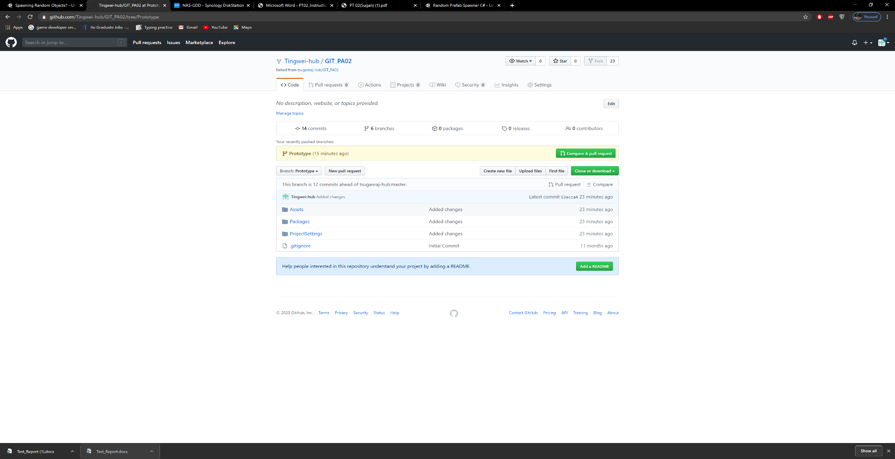

|  |  |  |  |  |  |  |
| --- | --- | --- | --- | --- | --- | --- |
| **Test Case ID** | **Description** | **Input** | **Expected Result** | **Actual Result** | **Pass/Fail** | **Remarks** |
| 1 | Player collision with obstacle | Nil | Minus health | Minus health | Pass | Nil |
| 2 | Player avoids obstacle | Nil | +1 score | +1 score | Pass | Nil |
| 3 | Player runs out of health | Nil | Go to game over scene | Go to game over scene | Pass | Nil |
| 4 | Game over scene to sample scene | Click on restart | Restarts scene | Restarts scene | Pass | Nil |
| 5 |  |  |  |  |  |  |
| 6 |  |  |  |  |  |  |
| 7 |  |  |  |  |  |  |
| 8 |  |  |  |  |  |  |
| 9 |  |  |  |  |  |  |
| 10 |  |  |  |  |  |  |

