**Assignment 3 from Tingyu ZHENG**

**Problem introduction:**

Murder mystery game has become an important way for young people to socialize and have fun these days. In my free time, I also like to ask my friends to play murder mystery games, but I encounter some difficulties when I try to find proper scripts and venues. There is no platform that gathers all relative information. People need to look for information, generally incomplete and inconsistent, on different platforms, combine and compare it manually, which is a waste of time. At the same time, it is difficult for individuals to communicate with other players or to see posts of genuine experience other than advertisements.

Therefore, I want to build a website that can integrate information about venues and scripts to meet the needs of murder mystery games players in different scenarios. They can find important details such as venue location, time availability and information of scripts on one website, so that they can quickly browse for scripts and time options of a proper venue as well as find out a venue that can provide the service of a specific script that interests them. Meanwhile, I want to build an online community for individual enthusiasts to communicate with each other, share experience, and meet with strangers.

**Interviews:**

**Interview Questions:**

1.When organizing a murder mystery game with friends, you will first determine the venue or first determine the script?

**Venue first**:

2. Which websites or information sources will you rely on to obtain concert related information?

3. What information would you click on from this website or app to view? Can you show me?

4. How do you find out about a venue in the determined location?

5. Do you check the comments of the venues? Where will you inquire?

6. How do you check the number of people required and time availability of the scripts of the venue?

7. Do you look up introductions to plays and reviews? Where would you look up?

**Script first**:

2. Which websites or information sources will you rely on to obtain concert related information?

3. What information would you click on from this website or app to view? Can you show me?

4. How do you find out about a script you wanted to play? Or, through which way do you find out about a script that interests you?

5. Do you look up reviews, introductions, etc. of plays? Where do you check?

6. How do you find out about a venue that has that play? Do you look up its reviews?

7. How do you determine the venue location and available times?

8. Is the navigation bar/information shown clear enough?

9. Is the function of each part clear enough? What part could be improved and how?

10. What content should be added?

11. Is this information resource helpful if you are going to plan a murder mystery game?

1. 在开展剧本杀活动时，你会先确定场馆，先确定剧本？

**先确定场馆：**

2. 你通常通过哪些网站、软件等信息来源来获得相关信息？

3. 你会从这个网站或软件点击什么地方查看什么信息？

4. 你如何查到一个地点合适的场馆？

5. 你是否会查询场馆的评价？你会在哪里查询？

6. 你如何查询场馆中人数和时间合适的剧本？

7. 你是否会查询剧本的介绍以及评价？你会在哪里查询？

**先确定剧本：**

2. 你通常通过哪些网站、软件等信息来源来获得相关信息？

3. 你会从这个网站或软件点击什么地方查看什么信息？

4. 你如何查到一个想要玩的剧本？或者，你是通过哪种途径了解到想玩的剧本？

5. 你是否会查询剧本的评价、简介等？你会在哪里查询？

6. 你如何查到一个拥有该剧本的场馆？是否会查询它的评价？

7. 你如何确定场馆地点和可选时间？

8. 软件/页面提供的信息是否足够清晰有效？

9. 每个部分的功能是否足够清晰？哪一部分可以改进，如何改进？

10. 你觉得应该增加哪些内容？

11. 如果你要确定一次剧本杀活动，这个网站/软件有帮助吗？

**Interview Videos & responses:**

See the attached files.

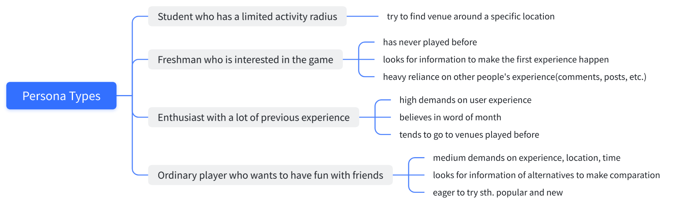**Persona Types:**

**Persona Type Picked: Ordinary players who want to have fun with friends.**

I chose this persona type because ordinary players occupy the majority of murder mystery game players. People use this game as a social event and use it to gather friends or make new friends. It is an important way of entertainment for ordinary people outside of work or study life and because of its long duration and medium-high cost, people usually don’t play it too often. Penny is one of the ordinary players who fulfil economic conditions to do it in her spare time, have some experiences related to murder mystery game, interested in it, have tendency to organize and play it again but won't play it too often like fans. She is like any one of us.

**Customer Journey Map**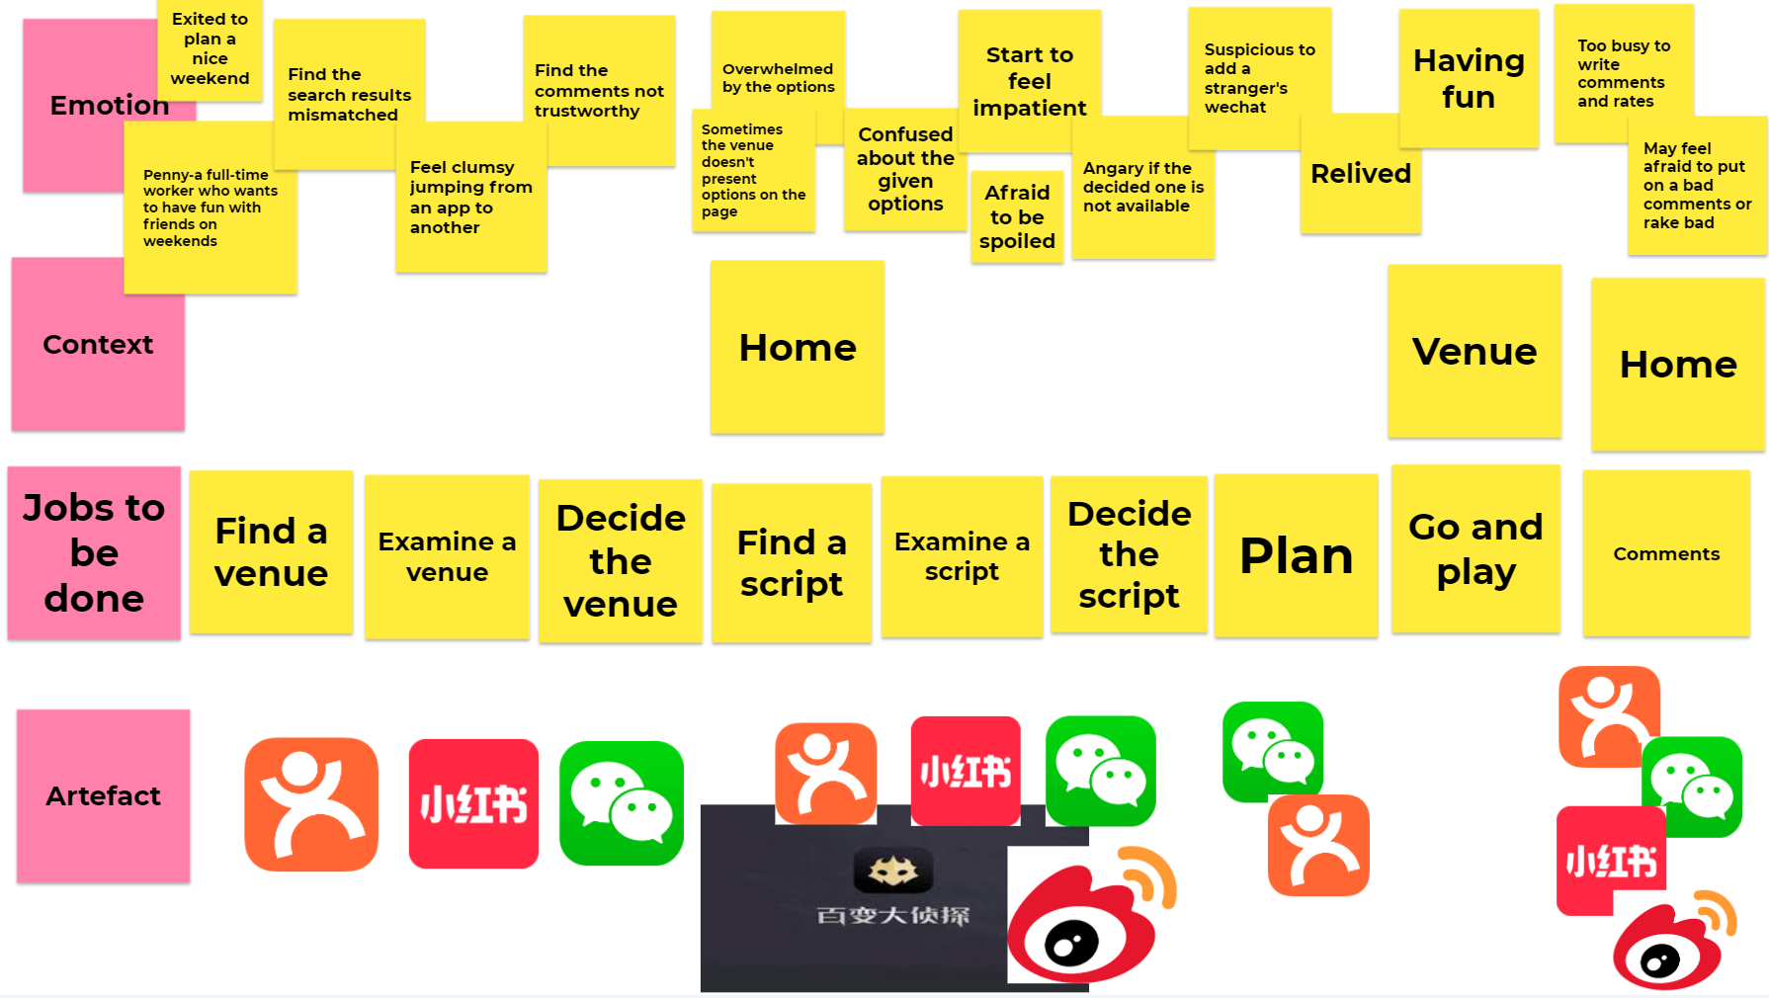

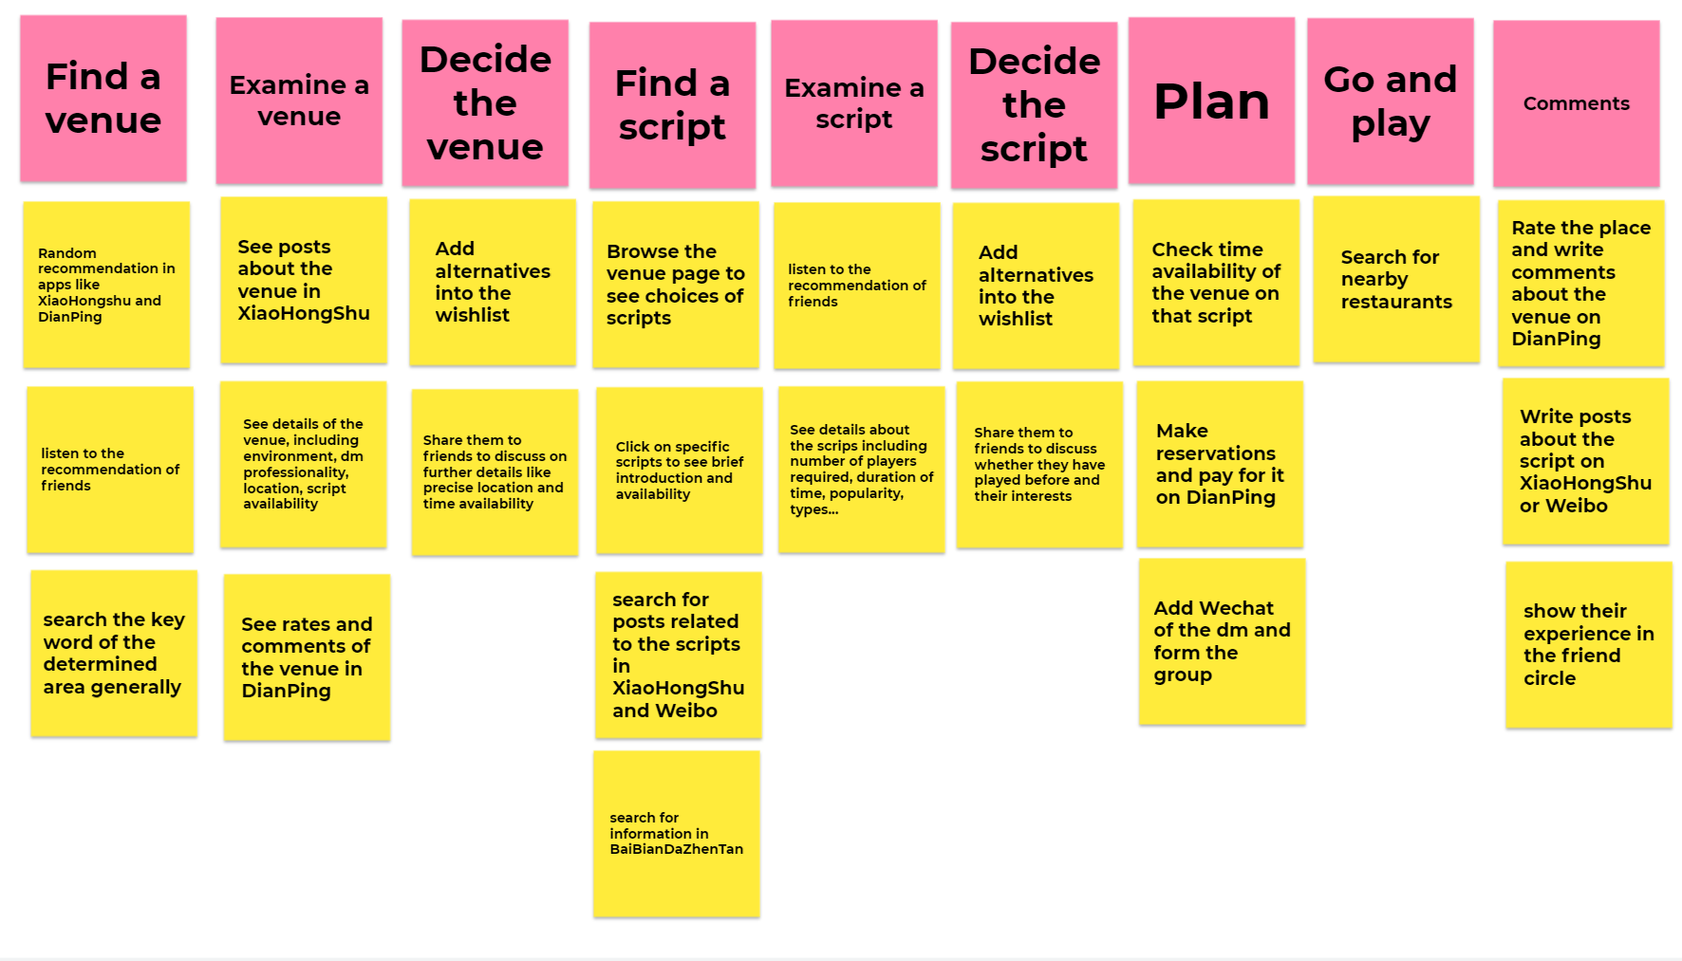**Story Map**

|  |  |  |  |  |  |
| --- | --- | --- | --- | --- | --- |
| **Functional** | **Overall Venue Information** | **Detailed Venue Information** | **Script Information** | **Planification and Confirmation** | **Comments** |
| **Content** | *Location:*  1.Is it within the area required?  2.Is it easy for everyone to go? How far is the distance? | *Location:*  1.Detailed location  2.Possible ways of getting there | *Attributes:*  1.Scripts type  2.Number of players required  3.Scripts introduction  4.Duration of time | *Economics:*  1.Cost  2.Payment methods | 1.Which platform to put on comments?  2.Is it safe to write bad comments? |
| *Service:*  1.Does it have lots of scripts?  2. Does it provide many time options? | *Service:*  1.Details of scripts provided  2.Details of time availability | *References:*  1.Players' comments on the scripts  2.Does it up-to-date or popular? | *Others:*  1.Availability  2.Contact with the venue |
| *Others：*  1.Is the environment good for the gathering?  2.Is it popular on social media? | *Others:*  1.Comments about the chosen venue  2. Professionality of dm to lead the game |

**Problem Statement**

How might we make a full-time worker who wants to plan a murder mystery game with friends on weekend (who) address the problem of collecting information, generally considered as incomplete and ingenuine, on different platforms (what) so that she/he can save time and have a better murder mystery game experience (why)?

**Card sorting**

**Participants' Test:**

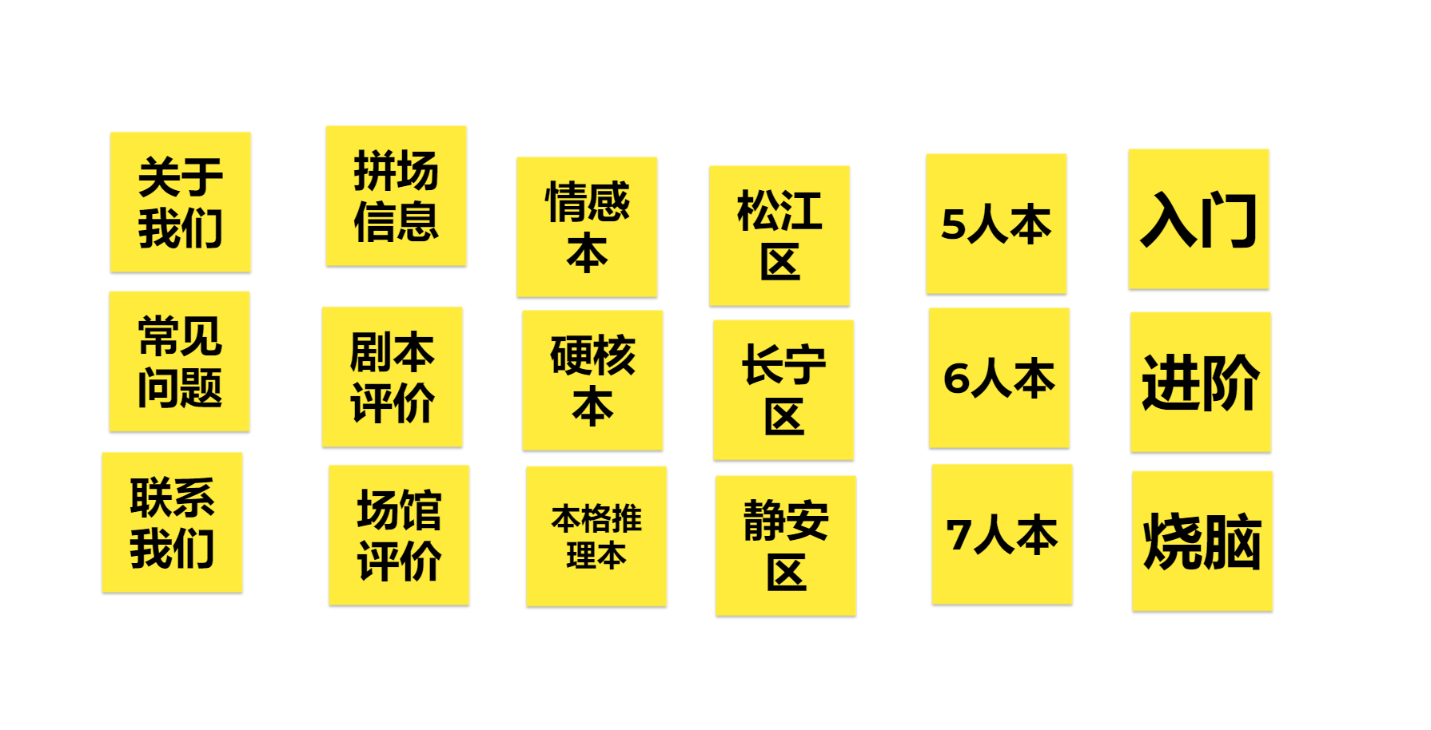

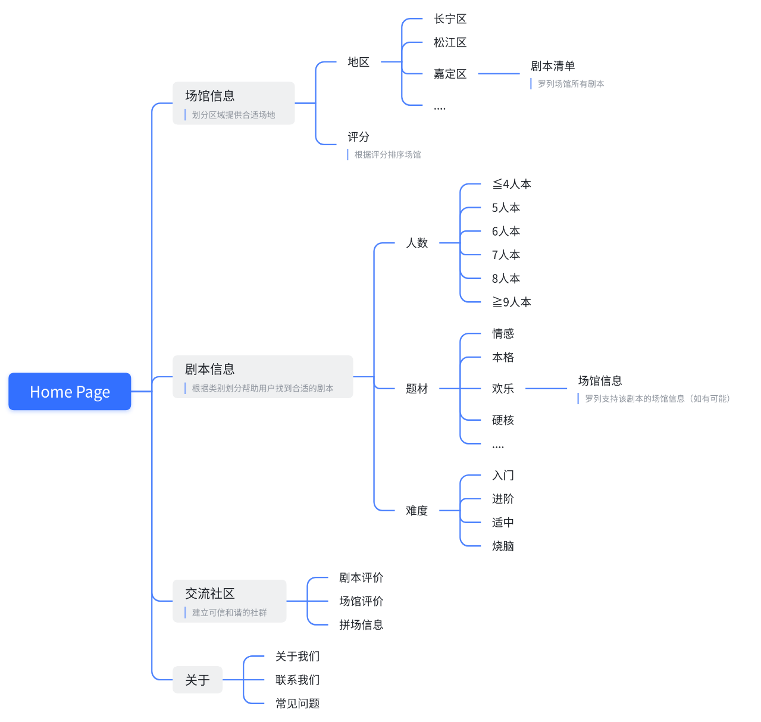**Organized result:**

**Positioning Map**

