**21522683 – Phan Trọng Tính – Bài tập CSDL nâng cao**

* 8 Bài tập trong slide

Câu 1:

Câu 2:

Câu 3:

Câu 4:

Câu 5:

* Các câu trong 2 đề thi:A notebook with writing on it

  Description automatically generatedA notebook with writing on it

  Description automatically generated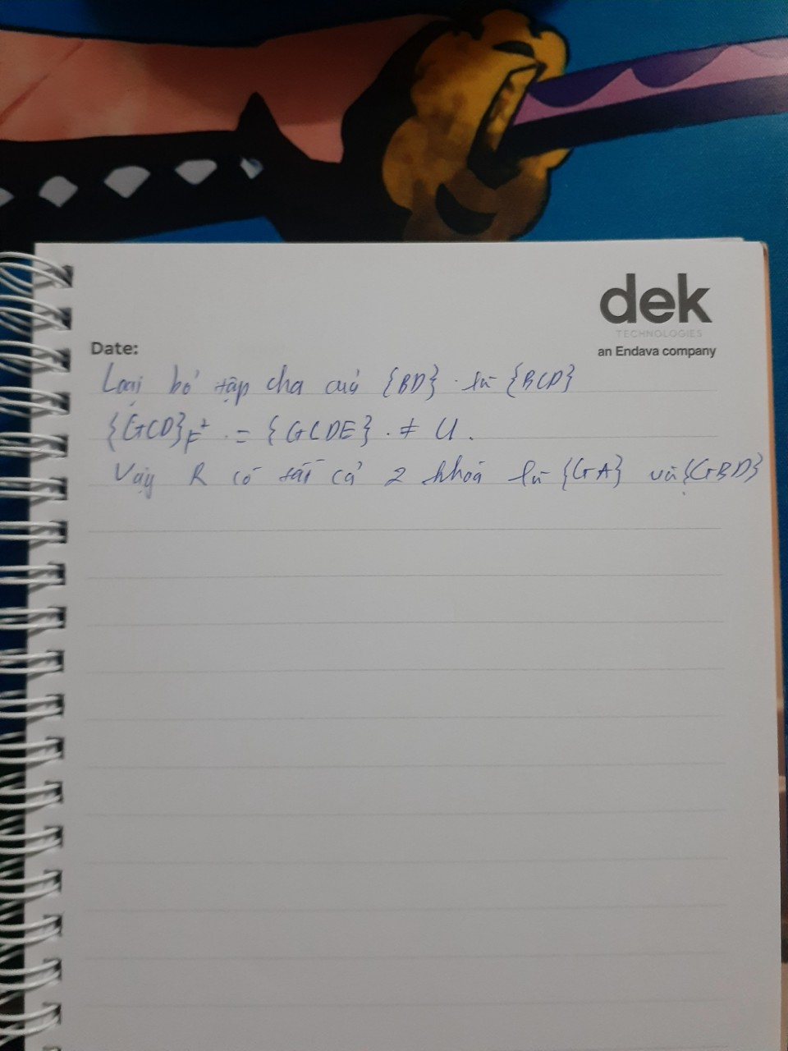A notebook with writing on it

  Description automatically generatedA hand holding a notebook with writing on it

  Description automatically generatedA hand holding a notebook with writing on it

  Description automatically generated