**Phan Trọng Tính – 21522683 - BÀI TẬP 4**

* Đề HK1 2020 – 2021:

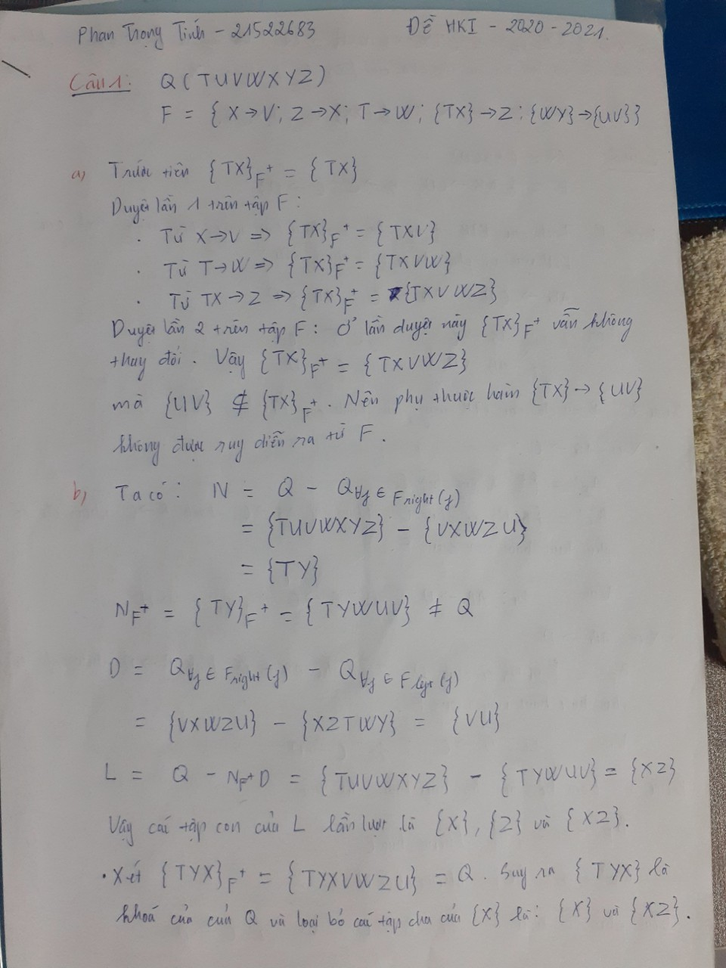

* Đề HK2 2022 – 2023:

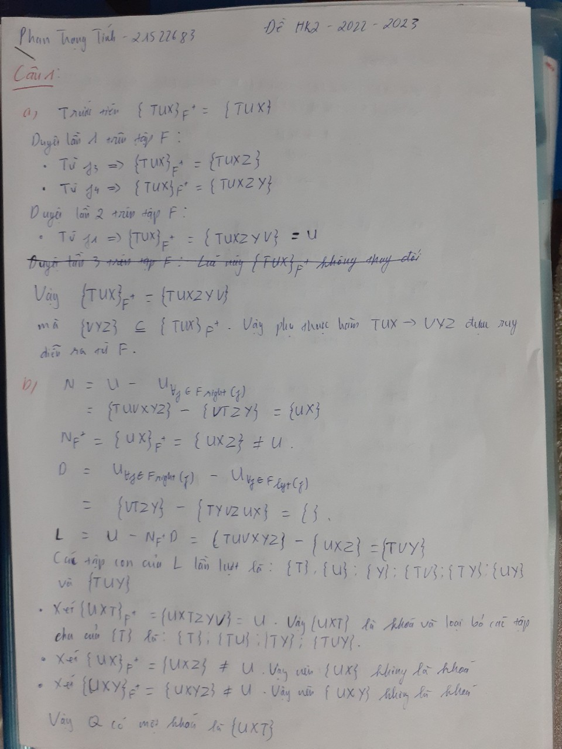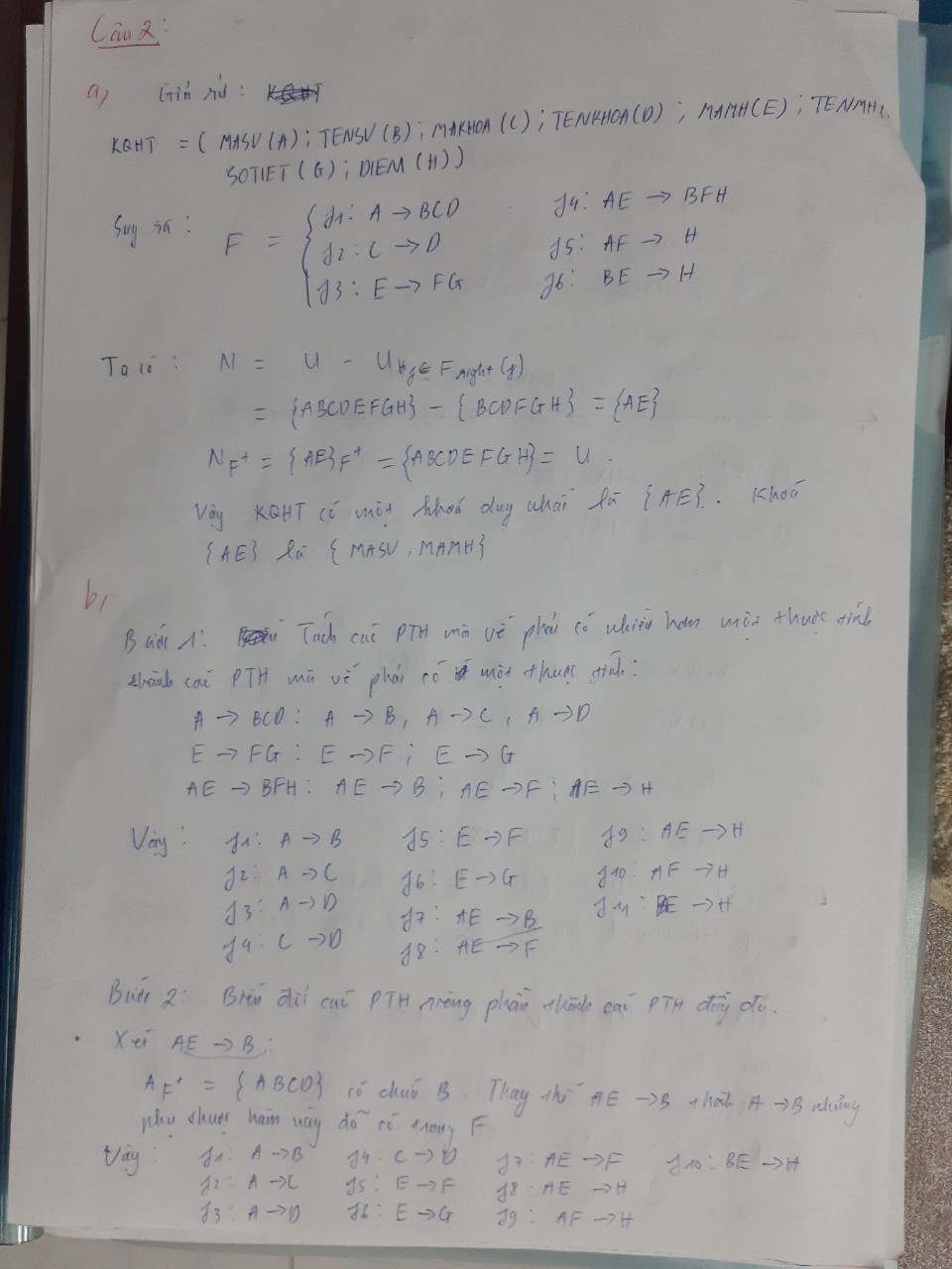

* Đề HK2 2021 – 2022:

