***MagicWater***

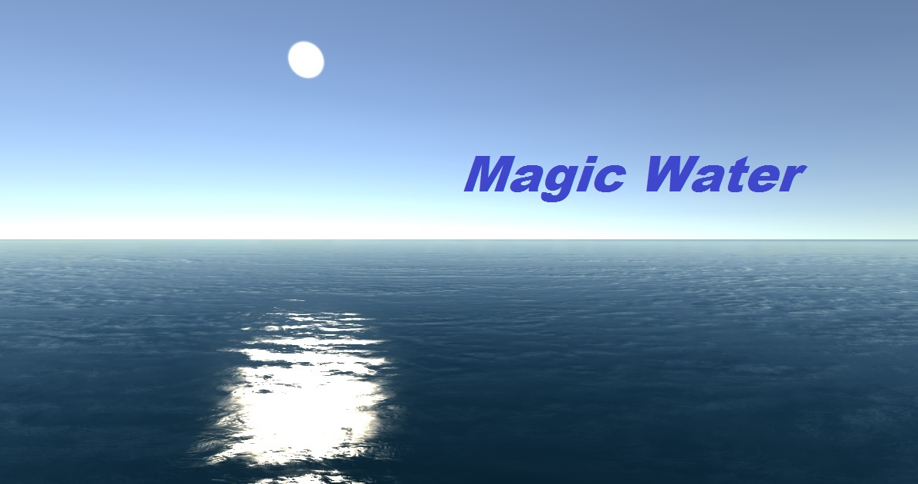

**How to use MagicWater :**

1. Open New Project.

2. Import the MagicWater plugin .

3. You will get MagicWater in Assets.

4. MagicWater contains :

a) Docs

b) ExampleScenes

c) Prefabs

5. Docs contain the documentation.

6. ExampleScenes contain some example scenes.

7. Prefabs contain MagicWater prefab.

8. Drag MagicWater prefab to Hierarchy.

9. Select MagicWater object in Hierarchy.

10. Look at inspector of MagicWater object.

11. Go to Water(script) in inspector.

12. Assign scene camera to MainCamera.

13. Assign Directional Light to SunLight.

14. Set properties of MagicWater as per your requirements and Play.

15. Use can see example scene also in example scene folder of MagicWater.

Note : For every MagicWater instance in hierarchy, MainCamera and SunLight must be assigned

**How To Use Layers on game objects :**

After adding MagicWater in the scene, three layers will be automatically created :

1. WaterReflNRefrObjects

2. WaterReflObjects

3. WaterRefrObjects

These layers categorise any game object which we want to add in scene based on reflection and refraction of that game object in the water.

***WaterReflNRefrObjects*** layer should be applied on the gameobjects which produce both reflection and refraction on water.

***WaterReflObjects*** layer should be applied on the gameobjects which produce only reflection on water.

***WaterRefrObjects*** layer should be applied on the gameobjects which produce only refraction on water.

**How To Use Features of MagicWater :**

**1. Ocean :**

This check box will define whether water is ocean(never ending water) or water on defined areas. If we uncheck this box, then water will be defined by MagicWater Plane and we can change it by scaling, rotating, positioning in transform section.

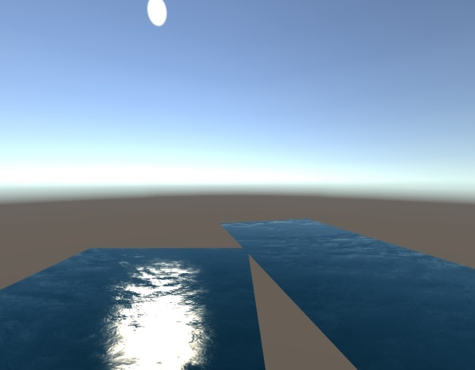

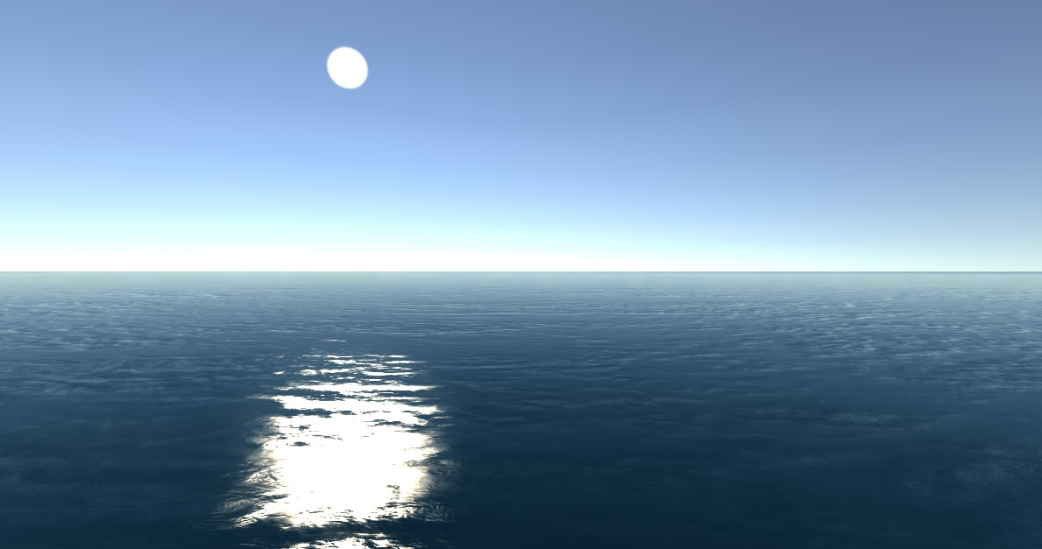

**2. Sun Light :**

We have to assign Directional light on SunLight field. After assigning, sun will be reflected in water and it will change when we change the directional light of the scene.

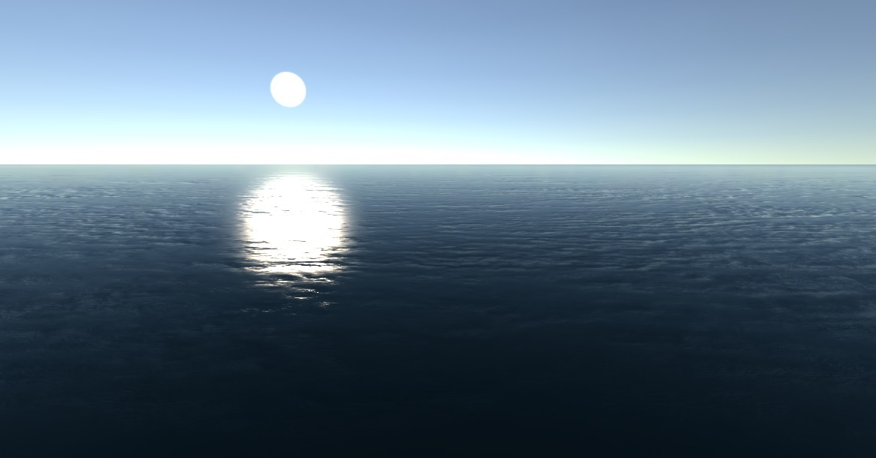

**3. Sun Color :**

This is the reflected color of the sun on the water. We can change the color by unchecking the DefaultSunColor box and choosing sun color in color picker.

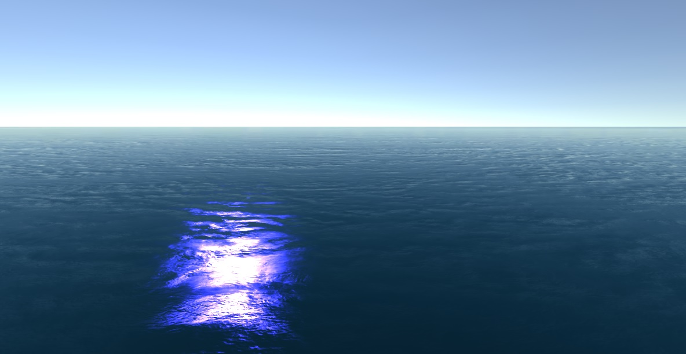

**4. Water Color :**

This is the color of the water. We can change the color by unchecking the DefaultWaterColor box and choosing Water Color in color picker.

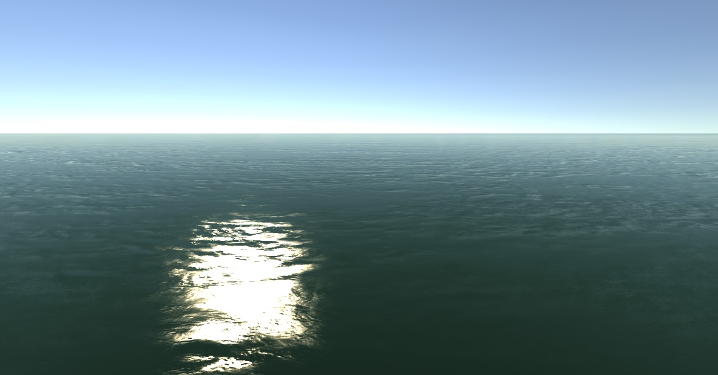

**5. ShadowReceive :**

This checkbox defines whether we want shadow effects of objects on water or not.

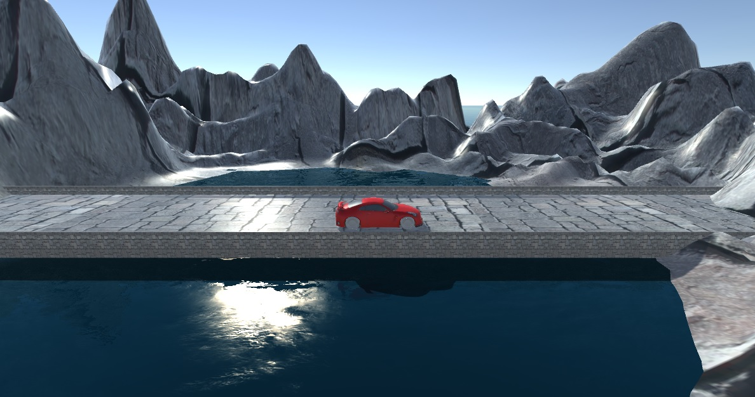

**6. ObjectReflection :**

This checkbox defines whether we want reflection effects of objects on water or not.

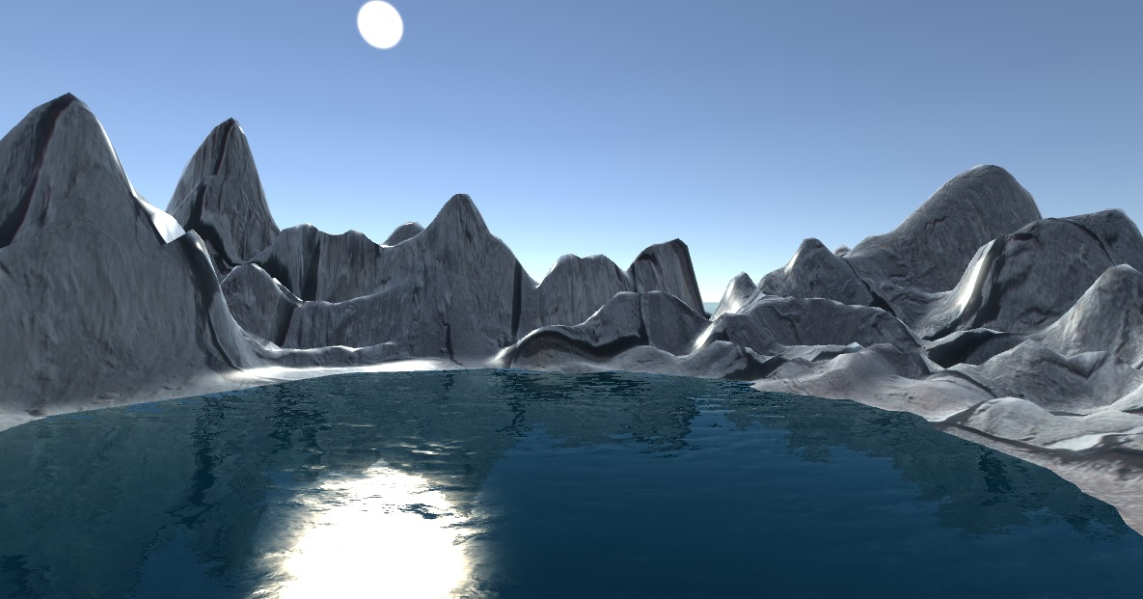

**7. ObjectRefraction :**

This checkbox defines whether we want refraction effects of objects on water or not.

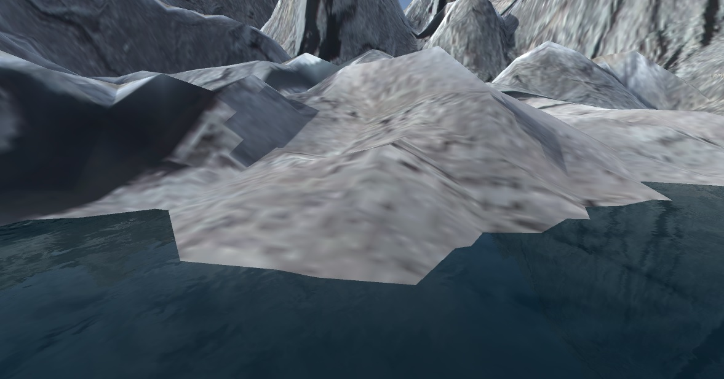

**8. EnvironmentReflection :**

This checkbox defines whether we want reflection effects of sky on water or not. DefaultSkyReflection results in reflection of default sky of unity.

CustomSkyColor allow us to choose sky color for reflection on water.

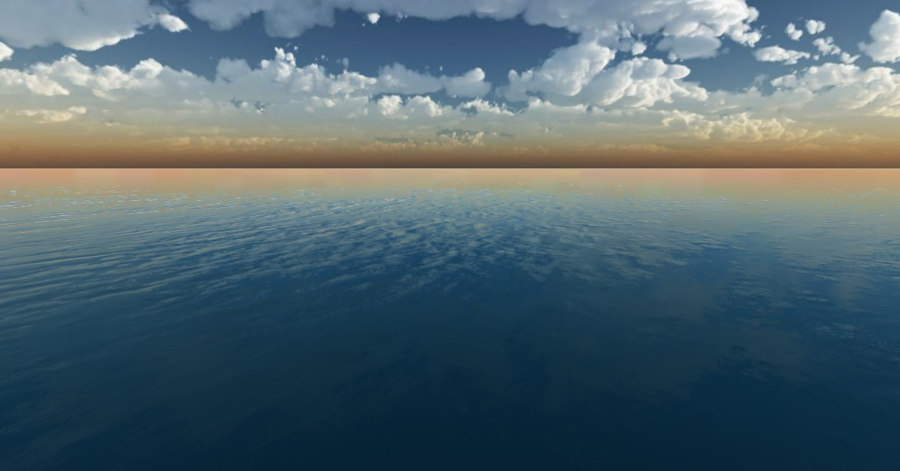

**NOTE :** While using refraction , if you have selected MagicWater in hierarchy, then some time objects under water which are refracting starts flickering. But this flickering does not happen when you click any other game object in hierarchy or in final Build :)