Level 0
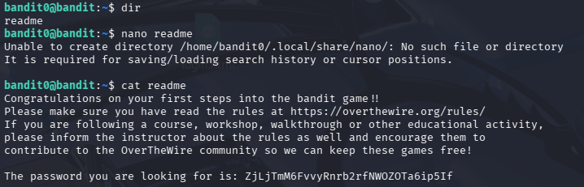

Level 1
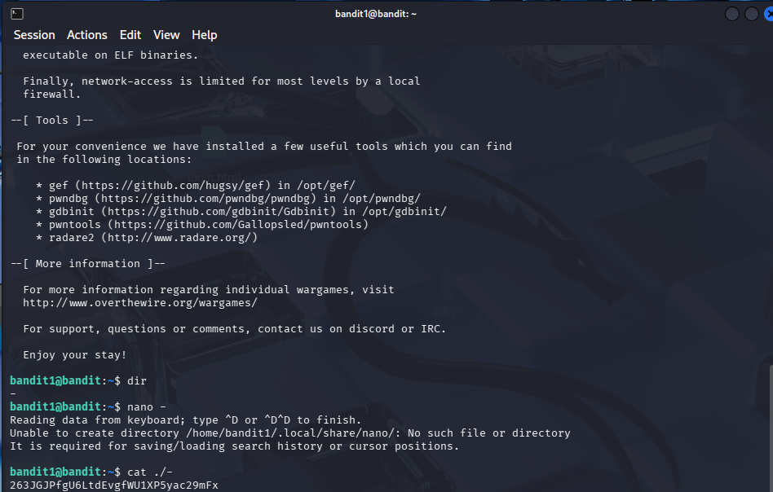
Level 2
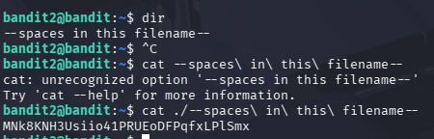

Level 3
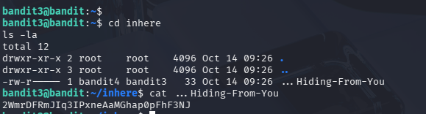

Level 4

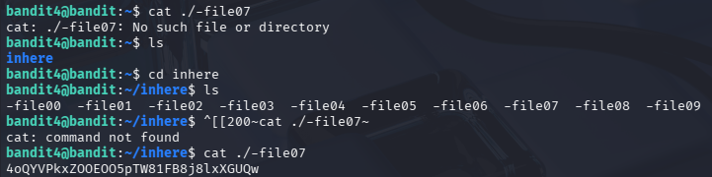

Level 5
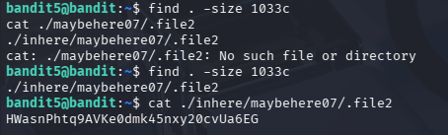

Level 6


Level 7

Level 8
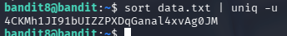

Level 9
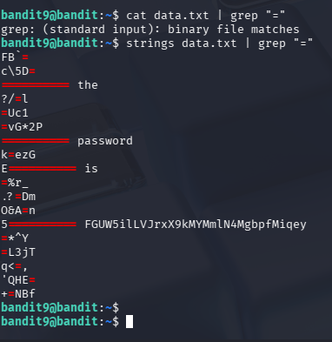

Level 10

Level 11

