**AuE 8220 - Autonomy: Mobility and Manipulation**

**Homework 3: Interpolation, Inverse Kinematics**

**Authors:** Tanmay Samak, Chinmay Samak, Riccardo Setti, Olamide Akinyele

**NOTE:** For running standalone GUIs, navigate to HW03\Submission\GUI\GUI Executable and run Problem_1_GUI.exe (OR) Problem_2_GUI.exe

**Problem 1:**

**GUI:** Run HW03\Submission\GUI\GUI Executable\Problem_1_GUI.exe for standalone execution. Refer HW03\Submission\GUI\GUI Source\Problem_1_GUI.m for source code and HW03\Submission\GUI\GUI Build for built packages.

**Results:** For each of the four cases, we plot the orientation of the intermediate frames at t= [0:2:10] secs on the same graph; note that the initial and final frames overlap exactly in each case (as expected) but the intermediate frames slightly vary based on the interpolation scheme used.

|  |  |
| --- | --- |
|  |  |
| 1-A | 1-B |
|  |  |
| 1-C | 1-D |

Animation MP4 files are located in HW03\Submission\Results\Problem 1 directory

***1-A***

**Concept:** We linearly interpolate individual angles (relative ZYZ) and then compute rotation matrix for each of the interpolated angles.

**Code:** AuE8220_AMM_HW03_F22.m lines 9-56

**GUI:** Click on Solve Problem 1-A button to generate results

***1-B***

**Concept:** We first convert Rzyz relative Euler angle representation to Rxyz (roll, pitch, yaw) absolute/fixed angle representation:

We then choose only one (positive) set of absolute XYZ angles and linearly interpolate them. Finally, we compute rotation matrix for each of the interpolated angles.

**Code:** AuE8220_AMM_HW03_F22.m lines 57-124

**GUI:** Click on Solve Problem 1-B button to generate results

***1-C***

**Concept:** We first compute and convert the initial and final rotation matrices to homogenous transformation matrices using the r2t() function, and then interpolate between them using the trinterp() function, wherein the rotation is interpolated using quaternion spherical linear interpolation (slerp). Since this is different than interpolating the Euler angles, we get slightly different plots for 1-A and 1-C.

**Code:** AuE8220_AMM_HW03_F22.m lines 125-157

**GUI:** Click on Solve Problem 1-C button to generate results

***1-D***

**Concept:** We first compute and convert the initial and final rotation matrices to RPY representation using the tr2rpy() function, and then interpolate between them using the trinterp() function, wherein the rotation is interpolated using quaternion spherical linear interpolation (slerp). Since this is different than interpolating the Euler angles, we get slightly different plots for 1-B and 1-D.

**Code:** AuE8220_AMM_HW03_F22.m lines 158-195

**GUI:** Click on Solve Problem 1-D button to generate results

**Problem 2:**

**GUI:** Run HW03\Submission\GUI\GUI Executable\Problem_2_GUI.exe for standalone execution. Refer HW03\Submission\GUI\GUI Source\Problem_2_GUI.m for source code and HW03\Submission\GUI\GUI Build for built packages.

**Results:** First, for all interpolation schemes, we plot task space variables: (i) x vs. t; (ii) y vs. t; and (iii) y vs. x

|  |  |  |
| --- | --- | --- |
|  |  |  |
| x vs. t | y vs. t | y vs. x |

Similarly, for all interpolation schemes, we also plot joint space variables: (iv) vs. t; and (v) vs. t

|  |  |
| --- | --- |
|  |  |
| vs. t | vs. t |

Animation MP4 files are located in HW03\Submission\Results\Problem 2 directory

***2-A***

**Concept:** We perform cubic polynomial interpolation for Cartesian coordinates:

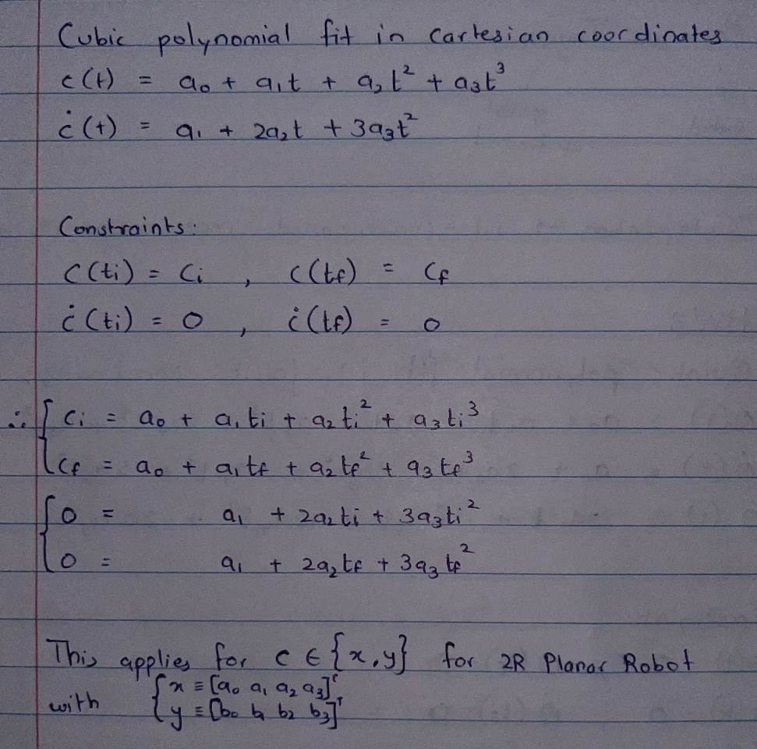

We convert the above equations into matrix representation, and interpolate x and y coordinates individually. Finally, we compute elbow-down inverse-kinematics of 2R planar robot (using geometric approach) for each of the interpolated coordinates.

**Code:** AuE8220_AMM_HW03_F22.m lines 196-245; 346-430

**GUI:** Click on Solve Problem 2-A button to generate results

***2-B***

**Concept:** We perform quintic polynomial interpolation for joint coordinates:

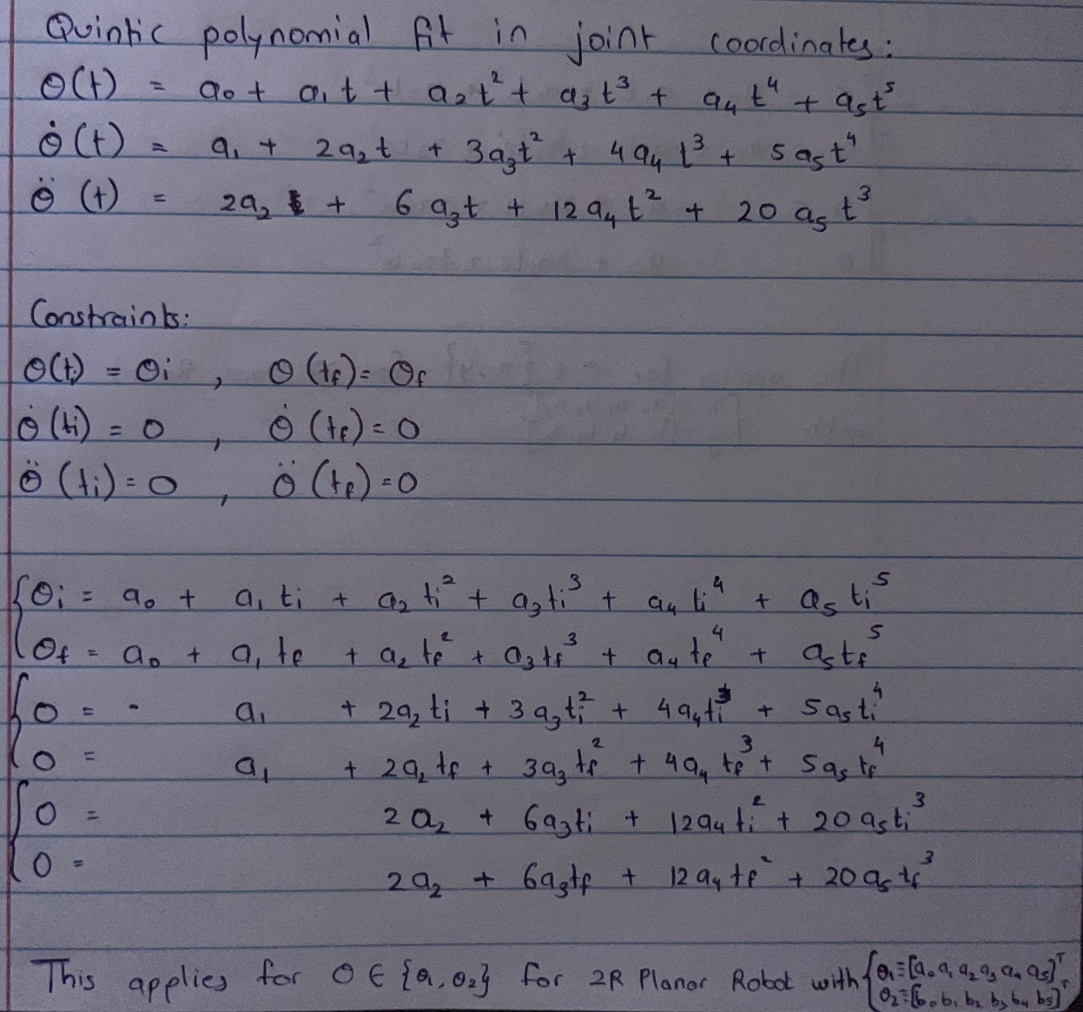

We convert the above equations into matrix representation, and interpolate and individually. Finally, we compute forward-kinematics of 2R planar robot (using geometric approach) for each of the interpolated coordinates.

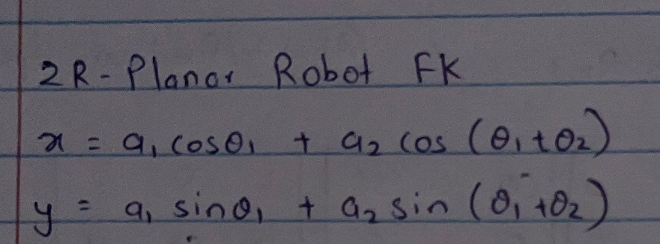

**Code:** AuE8220_AMM_HW03_F22.m lines 246-302; 346-430

**GUI:** Click on Solve Problem 2-B button to generate results

***2-C***

**Concept:** We perform quintic polynomial interpolation between the Cartesian coordinates using the tpoly() function. **Note:** Peter Corke’s Robotics Toolbox does not support cubic polynomial interpolation. This causes a slight difference between plots for 2-A and 2-C, since 2-A uses cubic polynomial interpolation which is less smooth than the quintic polynomial interpolation used in 2-C.

Finally, we compute elbow-down inverse-kinematics of 2R planar robot using the ikine() function for each of the interpolated coordinates. **Note:** since the ikine() function uses numerical approach, we cannot guarantee a particular configuration (elbow-up/down), hence we initialize the joint parameters to the geometrical elbow-down ones calculated in 2-A, to force the solver to solve for elbow-down configuration only.

**Code:** AuE8220_AMM_HW03_F22.m lines 303-324; 346-430

**GUI:** Click on Solve Problem 2-C button to generate results

***2-D***

**Concept:** We perform quintic polynomial interpolation between the joint coordinates using the jtraj() function. **Note:** there is no visible difference between plots for 2-B and 2-D, since both of these solutions use quintic polynomial interpolation.

Finally, we compute forward-kinematics of 2R planar robot using the fkine() function for each of the interpolated coordinates.

**Code:** AuE8220_AMM_HW03_F22.m lines 325-345; 346-430

**GUI:** Click on Solve Problem 2-D button to generate results