

实 验（实训）报 告

项 目 名 称 实验七
所属课程名称 操作系统
项 目 类 型 实验
实验(实训)日期

班 级 22软件2
学 号 220110900316
姓 名 罗奕麟
指导教师

浙江财经大学教务处制
一、【目的及要求】
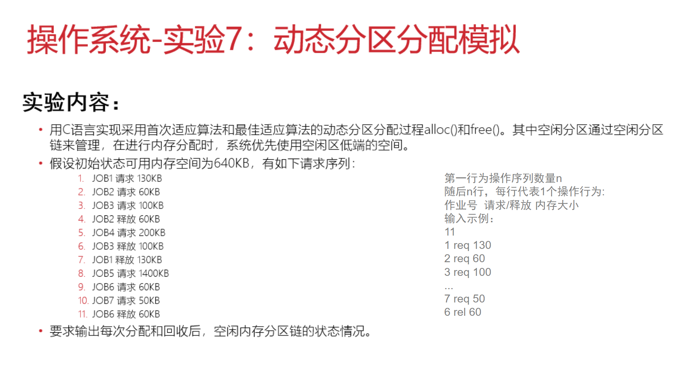

- 实验（实训）内容：

#实验过程
#include <stdio.h>
#include <stdlib.h>
#include <string.h>
// 内存分区节点结构
typedef struct Node {
int start; // 分区起始位置
int size; // 分区大小
int allocated; // 是否已分配(0:空闲, 1:已分配)
char job[10]; // 作业名称
struct Node* next;
} Node;

// 创建新节点
Node* createNode(int start, int size) {
Node* node = (Node*)malloc(sizeof(Node));
node->start = start;
node->size = size;
node->allocated = 0;
node->job[0] = '\0';
node->next = NULL;
return node;
}

// 打印内存分配情况
void printMemory(Node* head) {
Node* current = head;
printf("\n当前内存分配情况：\n");
while (current != NULL) {
if (current->allocated) {
printf("[%d-%d] %s 已分配 %dKB\n",
current->start,
current->start + current->size - 1,
current->job,
current->size);
} else {
printf("[%d-%d] 空闲 %dKB\n",
current->start,
current->start + current->size - 1,
current->size);
}
current = current->next;
}
printf("\n");
}

// 首次适应算法
Node* firstFit(Node* head, int size, char* jobName) {
Node* current = head;
while (current != NULL) {
if (!current->allocated && current->size >= size) {
// 如果找到足够大的空闲分区
if (current->size > size) {
// 分割分区
Node* newNode = createNode(current->start + size, current->size - size);
newNode->next = current->next;
current->next = newNode;
current->size = size;
}
current->allocated = 1;
strcpy(current->job, jobName);
return current;
}
current = current->next;
}
return NULL;
}

// 最佳适应算法
Node* bestFit(Node* head, int size, char* jobName) {
Node* current = head;
Node* bestNode = NULL;
int minDiff = 999999;

// 找到最小合适分区
while (current != NULL) {
if (!current->allocated && current->size >= size) {
int diff = current->size - size;
if (diff < minDiff) {
minDiff = diff;
bestNode = current;
}
}
current = current->next;
}

if (bestNode != NULL) {
if (bestNode->size > size) {
// 分割分区
Node* newNode = createNode(bestNode->start + size, bestNode->size - size);
newNode->next = bestNode->next;
bestNode->next = newNode;
bestNode->size = size;
}
bestNode->allocated = 1;
strcpy(bestNode->job, jobName);
return bestNode;
}
return NULL;
}

// 释放内存
void releaseMemory(Node* head, char* jobName) {
Node* current = head;
Node* prev = NULL;

while (current != NULL) {
if (current->allocated && strcmp(current->job, jobName) == 0) {
current->allocated = 0;
current->job[0] = '\0';

// 合并相邻空闲分区
if (prev != NULL && !prev->allocated) {
prev->size += current->size;
prev->next = current->next;
free(current);
current = prev;
}

if (current->next != NULL && !current->next->allocated) {
current->size += current->next->size;
Node* temp = current->next;
current->next = temp->next;
free(temp);
}
return;
}
prev = current;
current = current->next;
}
}

int main() {
// 初始化内存空间（640KB）
Node* memory = createNode(0, 640);
int n, jobId, size;
char op[4], jobName[10];

printf("请输入操作数量: ");
scanf("%d", &n);

printf("请输入操作序列(格式: 作业号 req/rel 大小):\n");
for (int i = 0; i < n; i++) {
scanf("%d %s %d", &jobId, op, &size);
sprintf(jobName, "JOB%d", jobId);

if (strcmp(op, "req") == 0) {
// 使用最佳适应算法
if (bestFit(memory, size, jobName) != NULL) {
printf("%s 申请 %dKB 成功\n", jobName, size);
} else {
printf("%s 申请 %dKB 失败\n", jobName, size);
}
} else if (strcmp(op, "rel") == 0) {
releaseMemory(memory, jobName);
printf("%s 释放内存\n", jobName);
}

printMemory(memory);
}

return 0;
}
#结果与分析
