## Burning Tool Prepare

1. Download win32diskimageer tool

<https://sourceforge.net/projects/win32diskimager/files/latest/download>

1. unzip the following file



## compile u-boot

1. cd [source tree]/u-boot
2. make rk3288_secure_defconfig
3. make -j4

after compile it will have a uboot file which named rk3288_loader_v1.05.233.bin

## 3. compile kernel

1. cd [source tree]/kernel
2. make ARCH=arm rockchip_defconfig
3. **for Tinker board :**

make ARCH=arm rk3288-miniarm.img

## 4. compile Android

1. cd [source tree]
2. source build/envsetup.sh
3. lunch rk3288-userdebug
4. make -j8
5. ./mkimage.sh

## 5. copy the generated image from step 2, 3, 4 to the specific folder

1. cd [source tree]/RKTools/linux/Linux_Pack_Firmware/rockdev
2. ./collectImages.sh && ./mkupdate.sh

After the step 5.B, it will generate a file which named update.img and located at [source tree]/RKTools/linux/Linux_Pack_Firmware/rockdev/update.img

## 6. change format of the update.img

1. open the SpiImageTools.exe and load the update.img as the following

After step 2, it will generate data.bin which is located at the same folder as the SpiImageTools.exe

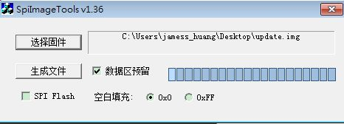

Step 2

Step 1

1. use the Win32diskImager.exe tool to burn the data.bin into sdcard, then you can boot the Tinker Board with sdcard.