

Project 1
Healthcare
March 2021
Authors: Stephan, Jiyoon, Hans, Frank
Table of Contents
Introduction 3
I. The Pipeline 4
Data sources and collection methods 4
Data cleaning and preprocessing techniques used 4
Feature selection and engineering 4
II. Exploratory data Analysis 5
Summary statistics and visualizations 5
Correlation analysis and feature importance ranking 7
Multicollinearity check 8
Feature Specific Analysis 9
IV. Model selection and evaluation 10
Description of candidate models and algorithms considered 10
Model evaluation metrics and criteria used 10
Model performance and results 10
V. User Interface 11
Integration 11
CLI 11
VI. Discussion and Conclusion 12
Key take aways and recommendations 12
Ethics 12
References 13
Appendix 14

Introduction

Machine learning and AI has great potential to increase accuracy in medical diagnosis and increase efficiency in medical processes. Medical Centre Randstad wants to hold a pilot to see if they can use the data they gathered from their patients to, based on their lifestyle, predict how old someone will get. On top of that they want to give tailored advice that can help increase a patients lifespan.
This project will have the following goals:
- Gathering of the data
- Transforming the data so its suitable for modeling
- Finding out the correlation between lifestyle and genetics affects lifespan
- Presenting the findings and a working application that can predict lifespan

I. The Pipeline

The pipeline chosen for this project consists of two parts. The first part generates the data and the second fits the regression for use in the end-user interface.

Part I: Data Model

The main philosophy behind our pipeline is versatility. At the start of the project, it was unclear to us what dataset we would be using. Three options had been presented to us for the data acquisition:

- Pull from a rest API.
- Pull from an SQLite database.
- Read from a .csv file

At the start of the project there was some confusion amongst our team whether we ought to build for a static or a dynamic dataset. In an early stage of the project, we made the design choice to start building a pipeline that could import from the three sources. Because we were unsure if the supplied data would be static or dynamic, we made the choice to automate the generation of different datasets prior to the EDA conclusions what dataset to use for the final version.

The data models that made it to the next stage have an enumerated name structure df1 to df5.
For use in the next stage of the project the data model generated its output in .csv and stores it in an SQLite.db

Data analyses determined that df4 would be the model we’d be using for the final regression model. The other models are currently commented out to reduce system load and clutter.

Part II: Regression Model

The versatile design philosophy was at the forefront for our design of the regression file. The EDA made it clear to us that the path ahead led to a linear regression model. We started to craft our regression model with versatile data path in and out. For input the standard is currently set to df4 from SQLite. Import from .csv is currently commented out. With a simple filename change in the model we can use the model to run regression on our other df’s.

Our regression model’s output is versatile as well it is both stored in a python pickle format (.pkl) as in an SQLite database. Allowing for the diverse life expectancy interfaces our group is proud to present.

Data sources and collection methods
- Pull from a rest API.
- Pull from an SQLite database.
- Read from .csv file

Data cleaning and preprocessing techniques used
- There were very few NaNs, dropping them would not have a significant effect on results
- Duplicates were dropped (there were no duplicates)
- Few negative values that are invalid, also dropped
- Strange characters converted tot NaNs and dropped
- Outliers are possible good values in general, so we left them for further analysis

Feature selection and engineering
Mass (kg)
Maybe worthwhile to divide into separate groups and training of the model can be done based on these groups.

BMI (mass / length²)
seems interesting to add, based on the results for mass.
  - Categories and subcategories as defined by the World Health Organization seem interesting to add. Grouping on these categories give the possibility to try clustering and look for better results per category. A regression per category is interesting but out of scope, because lack of time.

Once you have worked out you BMI score, use the table below to determine your BMI rating. The rating is the same for males and females. The table shows the World Health Organization BMI classification system.
classification | BMI (kg/m2) | sub-classification |  | BMI (kg/m2)
underweight | < 18.50 | severe thinness |  | < 16.00
underweight | < 18.50 | moderate thinness |  | 16.00 - 16.99
underweight | < 18.50 | mild thinness |  | 17.00 - 18.49
normal range | 18.5 - 24.99 | normal |  | 18.5 - 24.99
overweight | ≥ 25.00 | pre-obese |  | 25.00 - 29.99
overweight | ≥ 25.00 | Obese  (≥ 30.00) | obese class I | 30.00 - 34.99
overweight | ≥ 25.00 | Obese  (≥ 30.00) | obese class II | 35.00 - 39.99
overweight | ≥ 25.00 | Obese  (≥ 30.00) | obese class II | ≥ 40.00
source: World Health Organization

Datasets
We defined different sets to test for best results, when fitting the model:

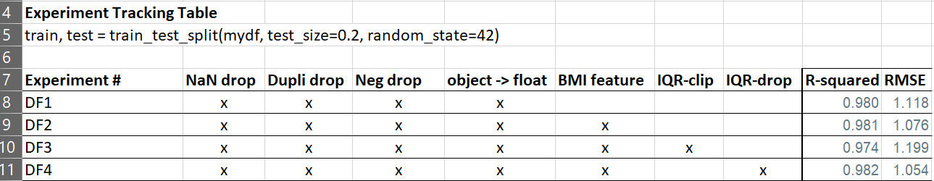
Source: _Experiment_Tracking_Management.xlsx

IRQ method is used to clip and drop outliers.

II. Exploratory data Analysis
Source: EDA_Pipeline.ipynb

Summary statistics and visualizations
 | genetic | length | mass | exercise | smoking | alcohol | lifespan | sugar
count | 3977.00 | 3977.00 | 3977.00 | 3977.00 | 3977.00 | 3977.00 | 3977.00 | 3977.00
mean | 82.04 | 184.05 | 91.71 | 2.40 | 9.78 | 2.27 | 79.99 | 6.48
std | 7.09 | 12.52 | 25.25 | 1.17 | 6.91 | 1.80 | 7.45 | 2.71
min | 64.00 | 154.00 | 50.00 | 0.10 | 0.00 | 0.00 | 59.70 | 0.70
25% | 77.60 | 175.00 | 71.30 | 1.50 | 3.30 | 0.60 | 75.00 | 4.40
50% | 81.70 | 184.00 | 89.00 | 2.20 | 9.50 | 1.70 | 79.60 | 6.30
75% | 86.50 | 193.00 | 110.00 | 3.20 | 15.80 | 4.00 | 84.90 | 8.40
max | 100.30 | 214.00 | 163.60 | 5.50 | 22.20 | 6.00 | 100.40 | 13.80

From this table:
- we expect some outliers in mass
- smoking and alcohol with 0 values are discrete

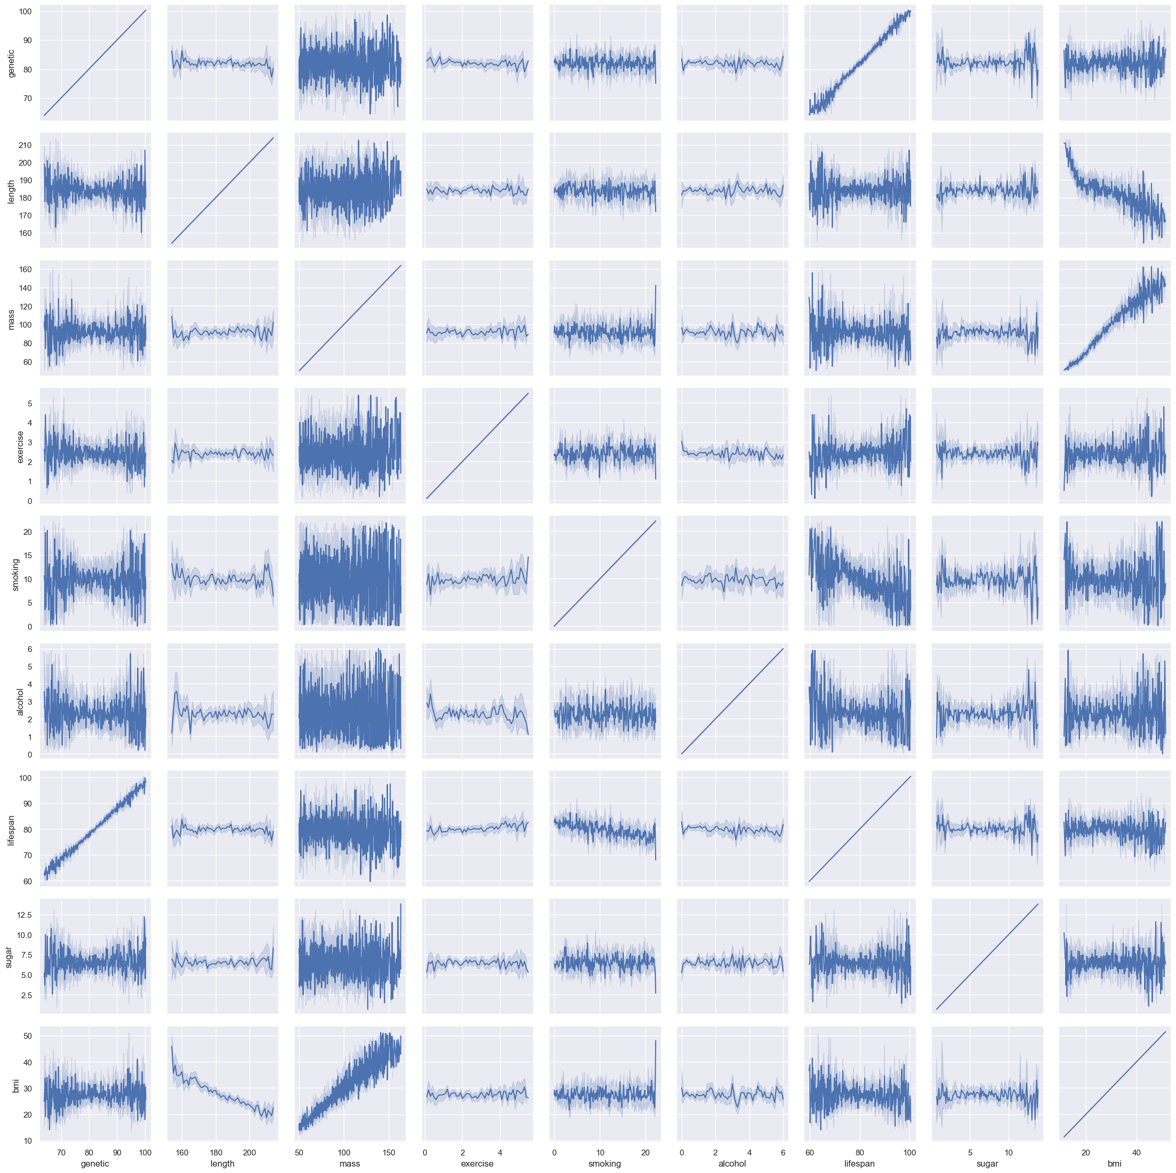
When we plot each possible feature combination we see:
- a negative correlation between smoking, alcohol with lifespan
- a positive correlation between exercise and genetic (strong linear) with lifespan

Correlation analysis and feature importance ranking

When we calculate the correlation coefficient between features (but remember correlation != causation) we see the following:
- genetic seems to be the most correlated with lifespan
- runners up are smoking (-), exercise(+) and alcohol (-)
- other values seems to have less, but negative impact on the lifespan

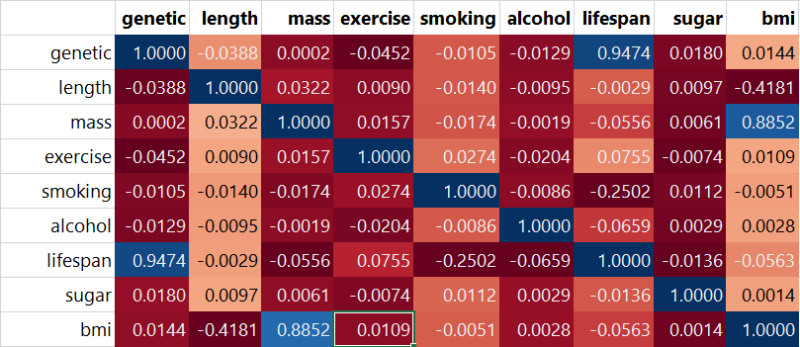
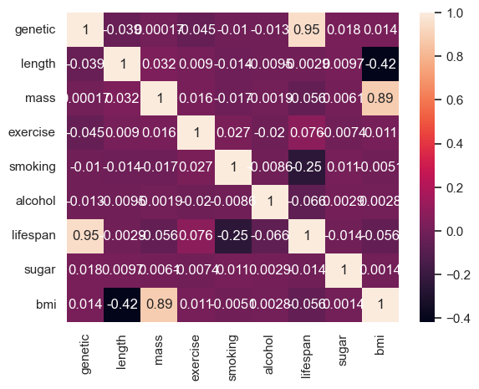

Multicollinearity check

In statistics, multicollinearity (also collinearity) is a phenomenon in which one predictor variable in a multiple regression model can be linearly predicted from the others with a substantial degree of accuracy. In this situation, the coefficient estimates of the multiple regression may change erratically in response to small changes in the model or the data
From the correlation matrix we check the top 3 correlated features (apart from lifespan)
Exercise – genetic | -0.045
Exercise – smoking | 0.027
Exercise - alcohol | -0,020
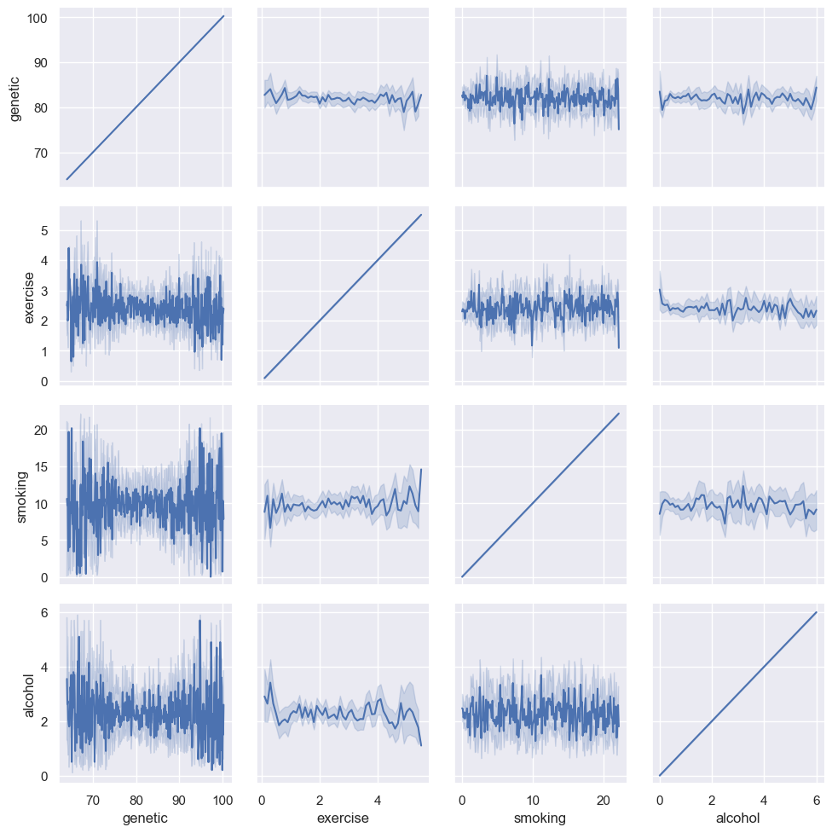

We apply the function stats.pearonr which also performs a significance test with the null hypothesis that there is no significant correlation between exercise and e.g. smoking.

When the p-value is:

- < 0.05 we reject the null hypothesis and the correlation is statistically significant.
- > 0.05 we fail to reject the null hypothesis and the correlation is not statistically significant.

smoking corr: 0.0274
smoking p-val: 0.0837
alcohol corr: -0.0204
alcohol p-val: 0.1978
genetic corr: -0.0452
genetic p-val: 0.0044

Based on the results: we reject smoking and alcohol as statistically significant correlated to exercise, however genetic is significantly correlated to exercise, so lets graph their relation:
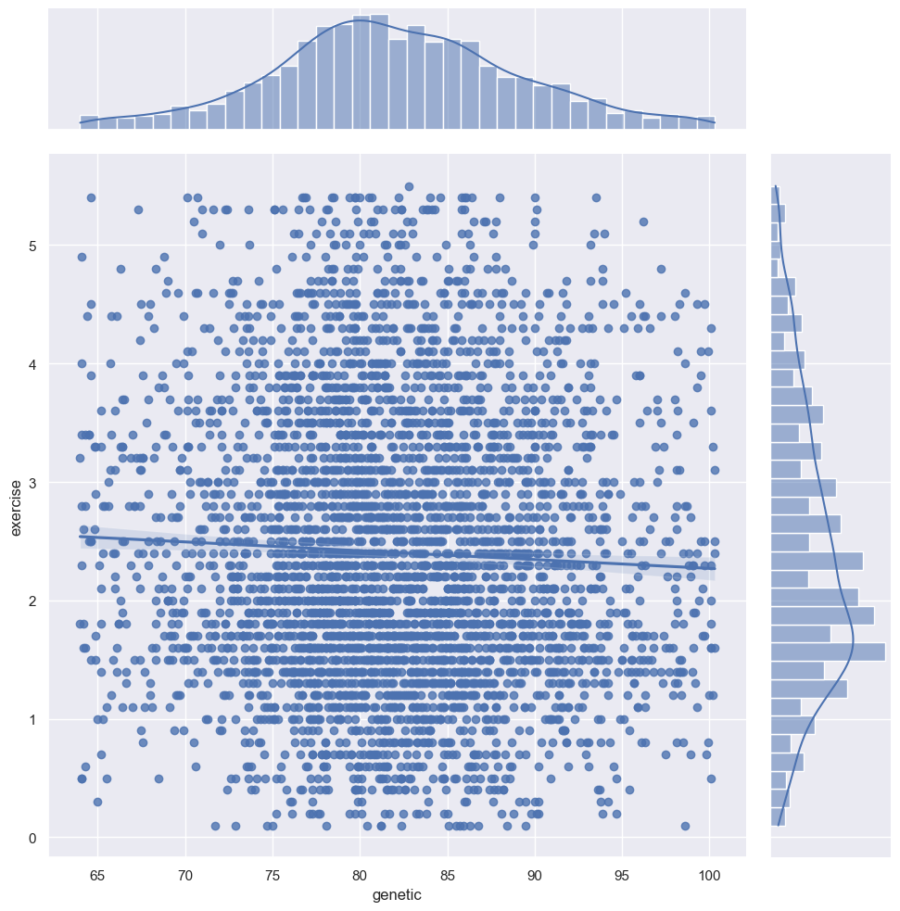
There is a lightly negative linear correlation between genetic and exercise, for the sake of this analysis we continue with the assumption that there is a negative linear correlation.

Greedy elimination:
If genetic and exercise are correlated then the feature with the lowest correlation to lifespan is eliminated in this case exercise with 0.076 will be removed (genetic = 0.95)
Lets quantify the difference in linear regression accuracy (with and without ‘exercise’)
coefficient of determination(R²) with exercise: 0.9792571387182405
RMSE: 1.085065117096135
coefficient of determination(R²)without exercise: 0.963087002111707
RMSE: 1.4474751925341771
Deleting the slightly correlated exercise reduced accuracy of the model therefore we conclude it improves the model and decide to keep exercise despite being multi-correlated
"The fact that some or all predictor variables are correlated among themselves does not, in general, inhibit our ability to obtain a good fit nor does it tend to affect inferences about mean responses or predictions of new observations."
Applied Linear Statistical Models, p289, 4th Edition

Feature Analysis
Impact of BMI:
Earlier on we decided to add BMI as a feature and now we can measure how it affects the accuracy in our linear regression model:
Without BMI (R²): 0.9789841911416836
With BMI (R²): 0.9792571387182405
This comes down to a 0.027% increase, its not a lot but since the model is already very accurate we decided to keep BMI because it has been researched extensively and we can use that knowledge (e.g. categories) to optimize our model in the future.
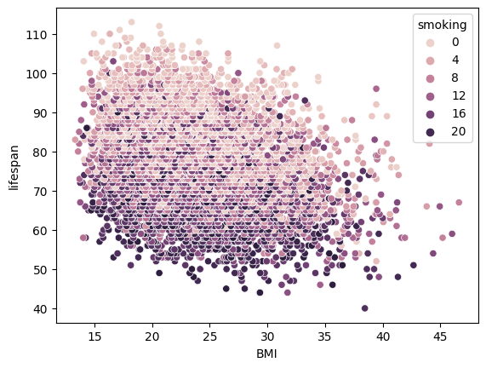

Feature transformation:
sources: exercise_feature_transformations.ipynb, Mass_Sqrt_Transformation_Norm.ipynb
Algorithms like Linear Regression, Logistic Regression, KNN or Neural Nets can be highly affected by distribution and scale of the input features. Transforming these could lead to better results.
Regarding feature scaling and linear regression:
Consider the model:
y=β0+β1×1+β2×2+…+ϵy=β0+β1×1+β2×2+…+ϵ.
The least squares estimator of β1,β2,…β1,β2,… are not affected by shifting. The reason is that these are the slopes of the fitting surface — how much the surface changes if you change x1,x2,…x1,x2,… one unit. This does not depend on location. The scaling doesn’t affect the estimators of the other slopes. Thus, scaling simply corresponds to scaling the corresponding slopes.
To conclude, technically, feature scaling does not make a difference in the regression, but it might give us some practical benefits and in further feature engineering steps.
https://www.atoti.io/articles/when-to-perform-a-feature-scaling/

Continuing with only transformations:
We use the python library fitter (https://fitter.readthedocs.io) to quickly find the current best fit by comparing the features to the most common distributions:
f = Fitter(feature, distributions=['norm','uniform','t','pearson3','loguniform', 'lognorm','chi2'])

Feature | Distribution
Lifespan | Normal
Genetic | Normal
Exercise | Normal
Smoking | Uniform (with outliers near 0)
Alcohol | Log-norm (but with 2 peaks)
Mass | Chi-squared
Sugar | Chi-Squared

A chi-squared distribution constructed by squaring a single standard normal distribution is said to have 1 degree of freedom
https://en.wikipedia.org/wiki/Chi-squared_distribution
Lets transform mass from a Chi2 distribution to a Normal distribution by applying the square root and quantify the effect on the accuracy of our linear regression model:
Before transformation:
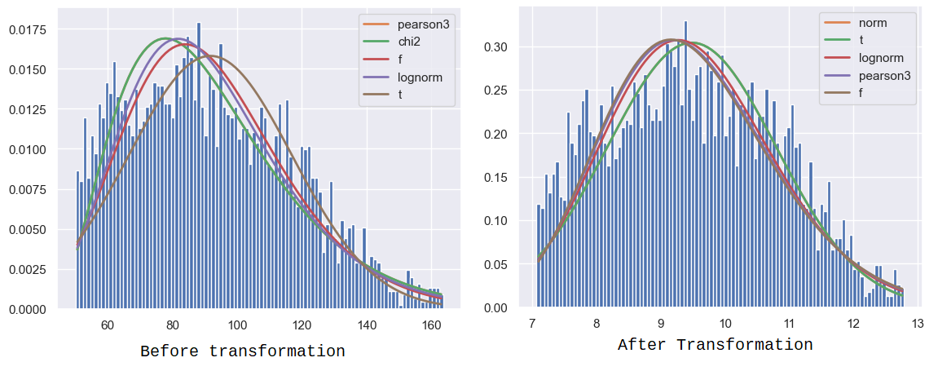
Taking the square root of gives us a (more) normally distributed mass ✅
The effect on our regression model is as follows:
Rsquared: 0.9826184086652832 an improvement of: 0.05 % compared to DF4
RMSE: 0.9826184086652832

A minor improvement, but not big enough to change from DF4 as data for our model.

IV. Model selection and evaluation

Description of candidate models and algorithms considered

Algorithms: we considered k-means, randomforestregressor and linear regression

Random Forest Regressor
The dataset contains some features which are categorical variables and some which are continuous, Since Decision Trees are used for both regression and classification problems it might produce a better result:

rng_forest_regr = RandomForestRegressor(n_estimators=300)
rng_forest_regr.fit(X,y)

coefficient of determination(R²): 0.9758901067146091

Conclusion: random forest decision tree does not produce a better result, so we stick with linear regression.

Model evaluation metrics and criteria used
We use the following metrics
R²
In regression, the R² coefficient of determination is a statistical measure of how well the regression predictions approximate the real data points.
RMSE
The root-mean-square error (RMSE) is a frequently used measure of the differences between values (sample or population values) predicted by a model and the values observed.
Train-test-split seed:
train_test_split(df, test_size=0.2, random_state=42)

Model performance and results
_Experiment_Tracking_Management.xlsx
In the end df4 has the best results.
A df6 where we used the root square of mass gives a little better result, but because of the minimal improvement and lack of time df4 is used for the pipeline.

V. User Interface

Integration

CLI

VI. Discussion and Conclusion

Key take aways and recommendations

Lifespan was heavily

Ethics

References

Appendix

