**Force Field**

**Explorer**

**A Graphical User Interface to TINKER**

**Version 5.0 February 2009**

**Table of Contents**

**Introduction** 4

**Current Release** 4

**Future Plans** 4

**Installation** 5

• **Linux** 5

• **Macintosh OS X** 5

• **Microsoft Windows** 5

**Description of Force Field Explorer Components** 7

➢ **Molecular Tree** 7

➢ **3D Graphics and Global Axis** 8

➢ **Keyword Editor** 9

➢ **Modeling Commands** 10

➢ **Logs** 11

**Description of Force Field Explorer Menus** 13

➢ **File** 13

◻ Open 13

◻ Save As 13

◻ Close 13

◻ Close All 13

◻ Download from PDB 13

◻ Load Restart Data 13

◻ Load Induced Data 13

◻ Exit 13

➢ **Selection** 13

◻ Select All 14

◻ Restrict to Selections 14

◻ Highlight Selections 14

◻ Set Selection Color 14

◻ Label Selected Atoms 14

◻ Label Selected Residues 14

◻ Set Label Font Size 14

◻ Set Label Font Color 14

➢ **Display** 14

◻ Wireframe 15

◻ Tube 15

◻ Spacefill 15

◻ Ball & Stick 15

◻ Invisible 15

◻ RMIN 15

◻ Fill 15

◻ Points 15

◻ Lines 15

◻ Preferences – Radius 15

◻ Preferences – Wireframe Thickness 15

◻ Preferences – Detail 15

➢ **Color** 15

◻ Monochrome 15

◻ CPK 15

◻ Residue 15

◻ Structure 16

◻ Polymer 16

◻ Partial Charge 16

◻ Vector Magnitude 16

◻ User Color 16

◻ Apply User Color to Selections 16

◻ Set User Color 16

➢ **Options** 16

◻ Active System 16

◻ Drag 16

◻ Reset Global Zoom 17

◻ Reset Global Translation 17

◻ Reset Global Rotation 17

◻ Reset Global View 17

◻ Toggle Hydrogens 17

◻ Full Screen 17

◻ Set Background Color 17

➢ **Picking** 17

◻ Graphics Picking 17

◻ Set Graphics Picking Color 18

➢ **Trajectory** 18

◻ Oscillate 18

◻ Frame 18

◻ Speed 18

◻ Skip 18

◻ Play 18

◻ Stop 18

◻ Step Forward 18

◻ Step Back 19

◻ Reset 19

➢ **Simulation** 19

◻ Release Job 19

◻ Connect to Local Job 19

◻ Connect to Remote Job 19

◻ Set Remote Job Address 19

➢ **Export** 19

◻ Capture Graphics 19

◻ PNG 19

◻ JPEG 19

➢ **Window** 20

◻ Reset Panes 20

◻ Show Tree 20

◻ Show Tool Bar 20

◻ Show Global Axes 20

◻ Show Console 20

◻ Java Metal Look & Feel 20

◻ Windows/Macintosh/Motif Look & Feel 20

➢ **Help** 20

◻ About 20

**Acknowledgments** 21

**Reporting Bugs** 21

**Introduction**

Force Field Explorer is a graphical user interface to the TINKER suite of molecular modeling tools. The goal is to create a robust environment for computational chemistry and molecular engineering applications. Current features include:

* Setup and real-time visualization of modeling routines, including local/global optimizations, sampling methods, superposition etc.
* Basic 3D molecular visualization (wireframe, spacefilling, ball & stick, etc) with special features for force field specific parameters such as Lennard-Jones radii and partial charge magnitudes.
* A comprehensive editor for TINKER keyword files, which contain parameters that control modeling algorithms.
* TINKER trajectory playback.

**Current Release**

This is the third release of Force Field Explorer, which is being labeled v. 5.0 and dated February 2009 to mirror the TINKER version it is compatible with. Dependencies, listed below, are now included in self-extracting installers for Linux, Mac OSX and Microsoft Windows.

1. TINKER version 5.0
2. Java Runtime Environment (JRE) 1.4.X (1.4.2 preferred).
3. Java3D 1.3.X (1.3.1 preferred).

Major improvements over the 2nd release include:

* Self-Extracting Installers for Linux, Mac OSX (requires Panther 10.3) and Microsoft Windows. These distributions include TINKER binaries, source code, documentation, and example files. A JRE and Java3D libraries are included with the Linux and Windows installers. Mac OSX Panther 10.3 already includes a JRE, however Java3D must be obtained from the OSX website.
* An intuitive, consistent selection mechanism.
* Improved keyword and modeling panels.
* Support for TINKER internal coordinate, restart and induced dipole file formats, plus loading of Protein Databank files directly from the PDB or from disk. Conversion of PDB files to TINKER format (with automatic atom typing for many biomolecules) is also supported.

**Future Plans**

The most important Force Field Explorer development goal is to add molecular editing features. We hope to soon target JRE 1.5 "Tiger", and Java3D 1.4. Java3D has just been open sourced by Sun, which has the potential to spur improvements to the API. Other goals include a few more visualization methods and support for other file types.

**Installation**

TINKER and Force Field Explorer are now being distributed within self-extracting installers for Linux, Macintosh OSX (Panther 10.3 and above) and Microsoft Windows. Included are binary TINKER executables, source code, example/test files, documentation and the Java environment needed by Force Field Explorer This is a private JRE that will not affect any other JREs that may be installed system wide. The exception is Mac OSX, where only a single System wide JRE is allowed.

    For each platform, a launch script/exe located in the top level installation directory named “ffe” will launch Force Field Explorer.

    On some platforms, double clicking the ffe.jar file in the “tinker/jar” directory will also launch Force Field Explorer. In this case, your system JRE will be invoked instead of the private JRE in the install kit. This is fine, as long as your system JRE is a 1.4.2 version that includes Java3D 1.3.1 extensions.

* **Linux**

After downloading the installer, execute it from a shell window. A script to run Force Field Explorer is located in the top level installation directory, which defaults to “/opt/TINKER”. In this case, TINKER binaries would be located in the “opt/TINKER/bin” directory. Any choice for installation directory is fine.

* **Macintosh OS X**

As mentioned above, Force Field Explorer only runs on Panther version 10.3 or later after installing the Macintosh Java3D implementation. It can be downloaded from the Macintosh OS X website:

<http://www.apple.com/downloads/macosx/apple/java3dandjavaadvancedimagingupdate.html>

After installing Java3D, download “TINKER_macosx_4_2.sit”, and double click the file to un-stuff it. Then double click the “Install TINKER and Force Field Explorer” icon to finish the installation. A script to run Force Field Explorer is located in top level TINKER directory while TINKER binaries are located in the “TINKER/bin” directory.

* **Microsoft Windows**

After downloading the installer, double click to start installation. Force Field Explorer can then be launched from an icon or the Start Menu.

**Description of Force Field Explorer Components**

* **Molecular Tree**

The Molecular Tree is a structural hierarchy of each system, used for navigating and making selections. When Force Field Explorer opens a structure file, it attempts to groups atoms into protein/nucleic acid macromolecules and their constituent residues. It also groups ions, water and hetero molecules together. This is done even in the absence of a TINKER sequence file. When a display or color command is chosen, all currently selected groups of atoms are affected.

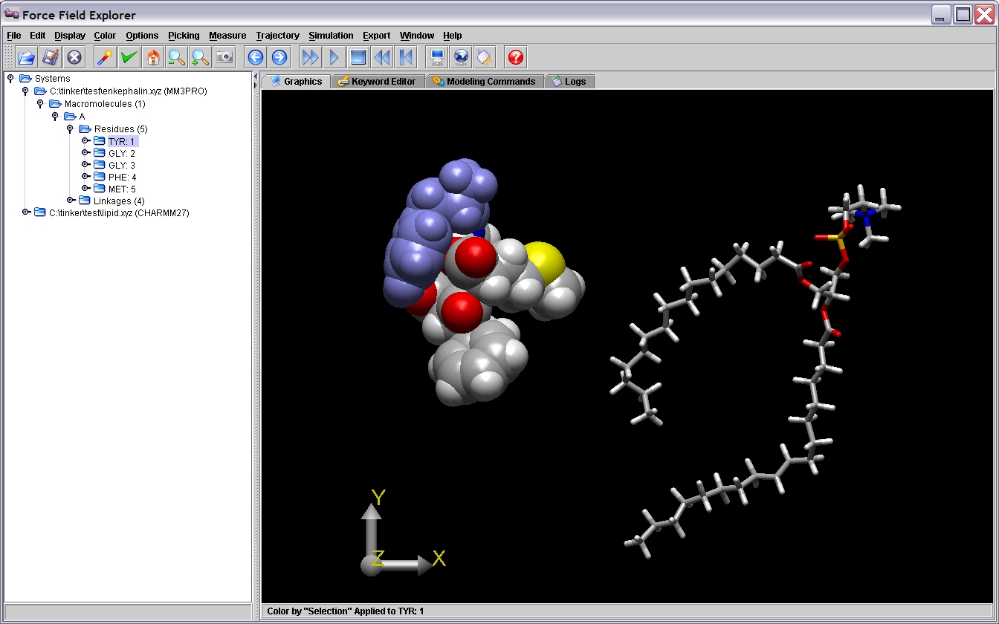

Figure . The first residue of enkephalin has been selected in the Tree view and is highlighted blue in the graphics window.

* **3D Graphics and Global Axis**

Left-clicking the Global Axis, then dragging performs a rotation about the origin of the entire scene. This is useful for manual docking of two systems. For example, after positioning each system individually in the X-Y plane by dragging them with the mouse, a rotation about the Y-axis allows orientation in the Y-Z plane. Right-clicking the Global Axis, then dragging performs a translation of the entire scene.

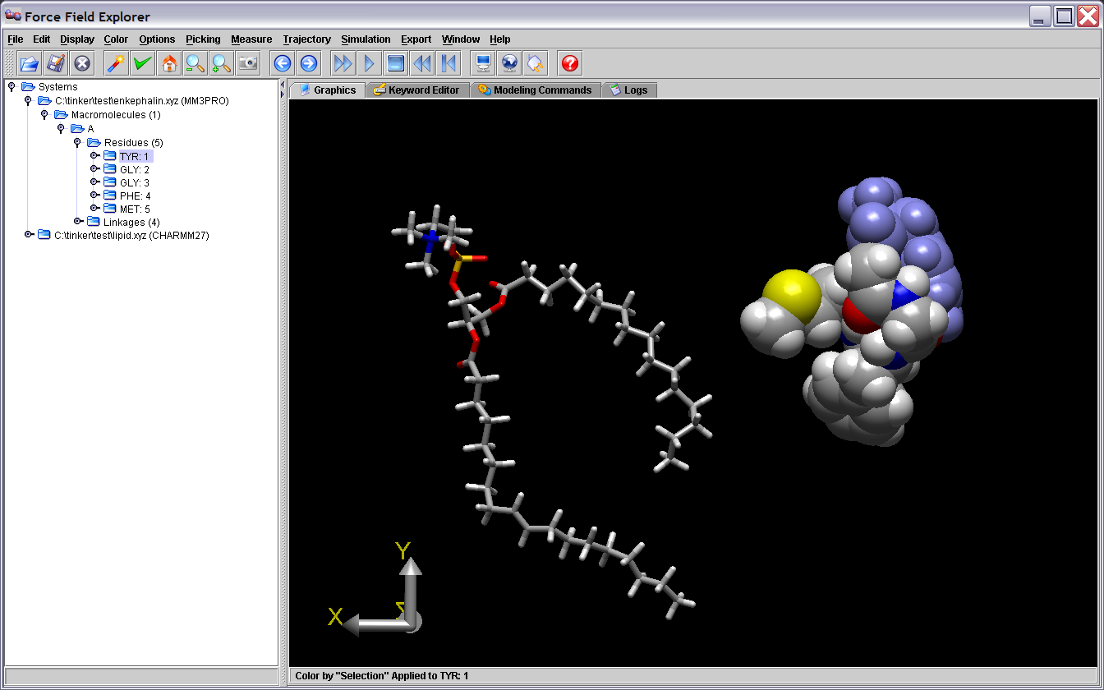

Figure . Dragging the Graphics Axis causes the entire scene to rotate about the global origin. The scene above has been rotated 180 degrees around the Y-axis.

* **Keyword Editor**

The Keyword Editor allows modification of keyword files that control various aspects of TINKER calculations. If a Modeling Command is executed on a system, the corresponding Keyword File is automatically saved. Modifications can also be saved at any time using one of the save buttons. Any text or keywords that Force Field Explorer does not recognize are considered “Comments” and are appended to the end of saved key files. As an example, the enkephalin keyword control file is shown below.

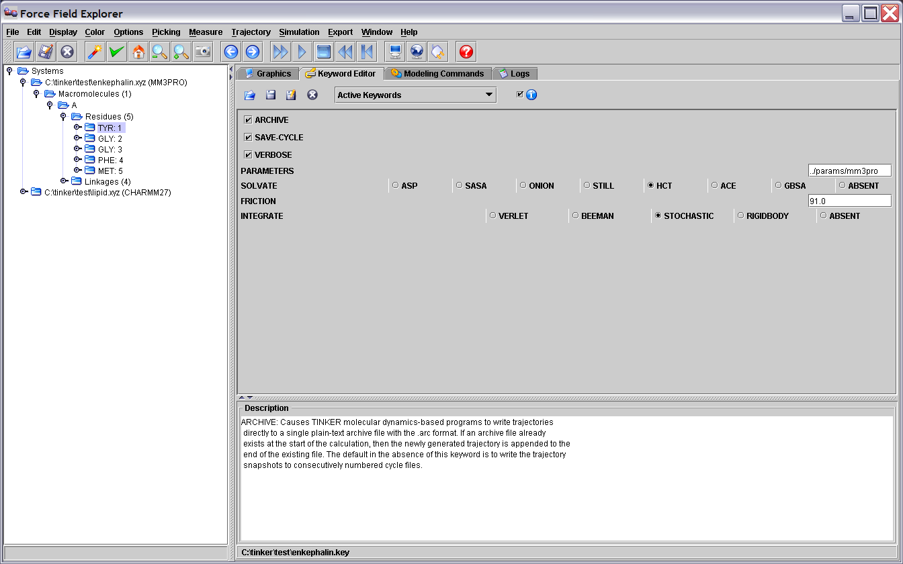

Figure . The Keyword Editor is displaying the enkephalin keyword file.

* **Modeling Commands**

The Modeling Commands panel of Force Field Explorer allows launching of most of the TINKER programs. After selecting a routine and configuring its modifying arguments, selecting the “play” button starts the job running. If TINKER will modify the coordinates of the system, Force Field Explorer will automatically connect to the routine and show progress interactively. If the routine completes before Force Field Explorer is exited, the textual results in the log file are loaded into the Logs panel. If Force Field Explorer exits while one or more routines are running, they continue in the background unless explicitly killed by the user. For example, the “Optimize” command has been selected for enkephalin (Figure 4).

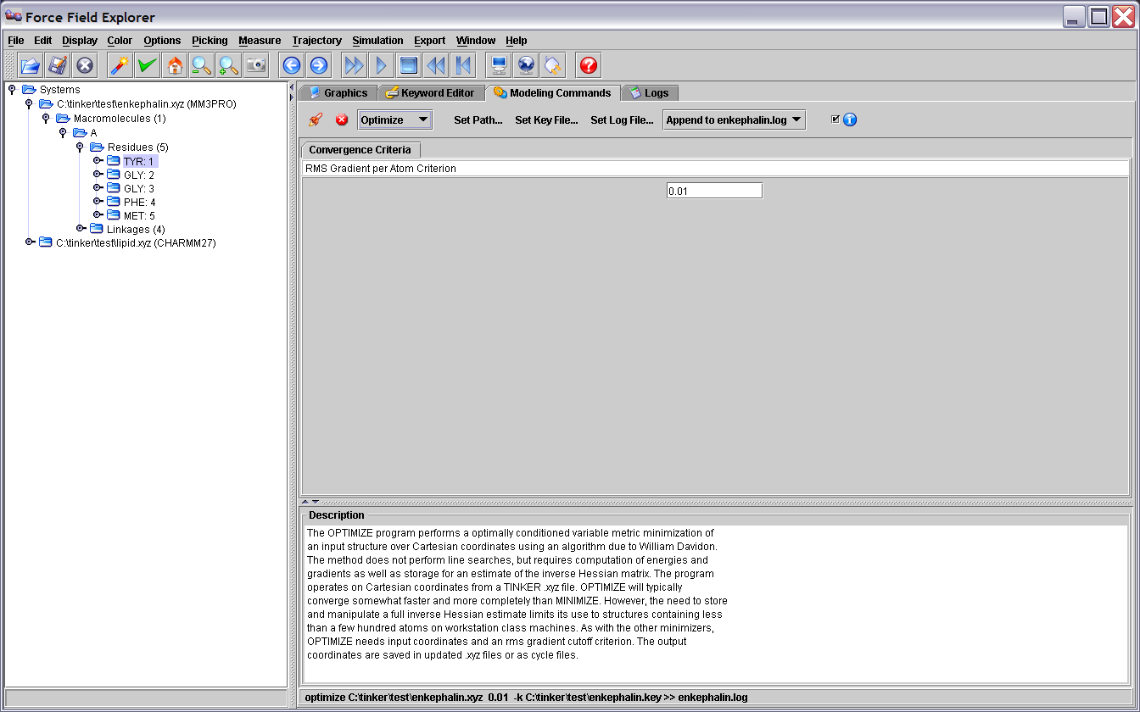

Figure . The OPTIMIZE routine has been selected in the Modeling Commands panel and will execute on the active system, in this case enkephalin.

* **Logs**

The Logs panel is a simple text editor where output logged from TINKER routines is automatically loaded. It can also be used to edit any text file, for example TINKER coordinate or keyword files.

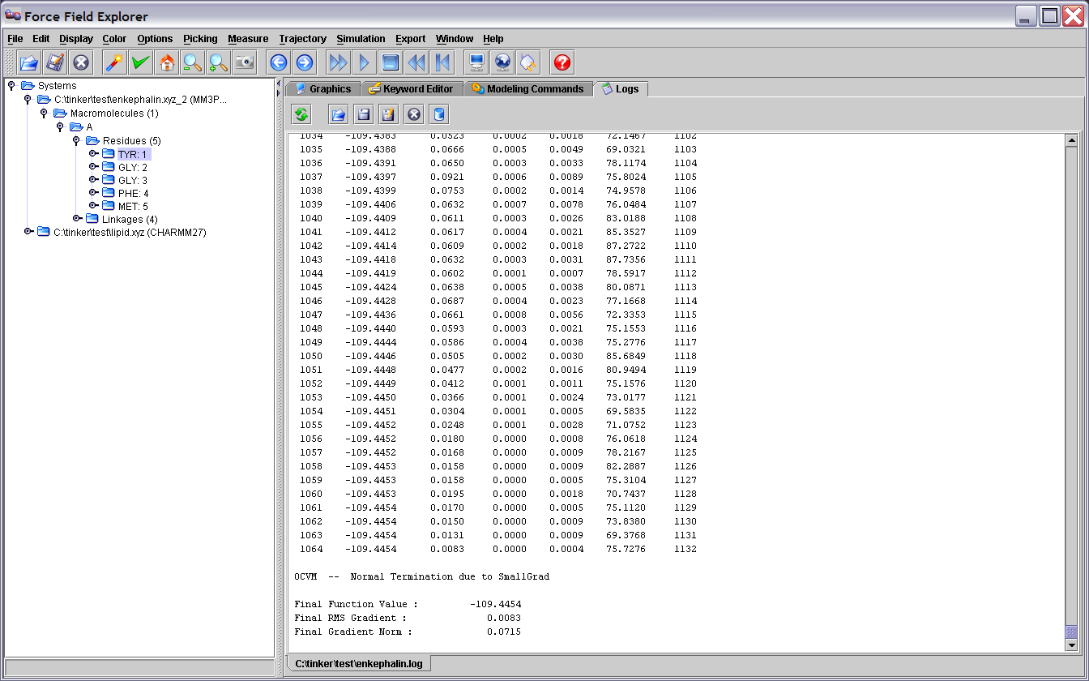

Figure . The Log panel shows output logged from a TINKER Optimize command on enkephalin.

If a modeling command changes the coordinates of an open structure, the final structure generated is re-loaded onto the open structure used to initiate the command.

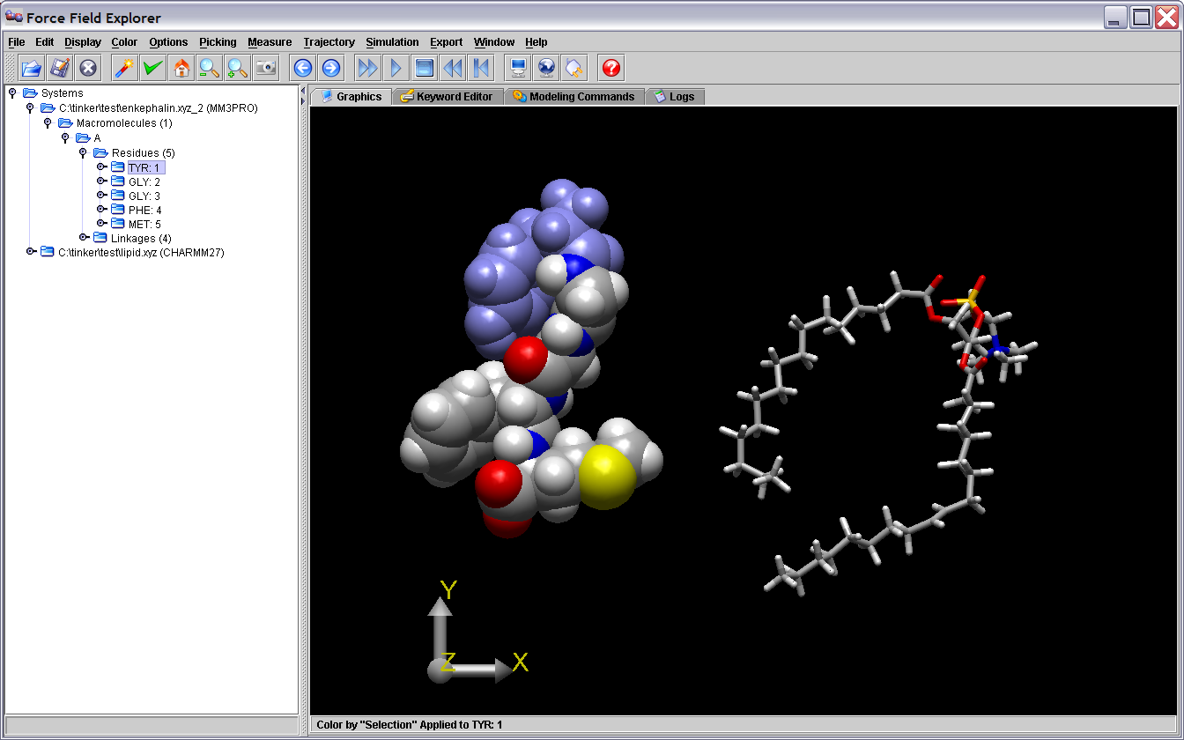

Figure . The coordinates for the local minima of enkephalin (enkephalin.xyz_2) were loaded onto the open structure (enkephalin.xyz) used to launch the TINKER optimize command.

**Description of Force Field Explorer Menus**

* **File**

Force Field Explorer currently reads TINKER coordinate files (*.xyz, *.int), restart files (*.dyn), archive files (*.arc), induced dipole files (*u) and Protein Databank files (*.pdb). However, file writing has only been implemented for TINKER Cartesian coordinate files.

* + Open

An attempt is made to open the selected file. Currently, TINKER coordinate files, Archive files, and Protein Databank files are recognized.

* + Save As

Saves the active file under a different name. (This command is currently only supported for Cartesian coordinate TINKER files)

* + Close

Close the active file.

* + Close All

Close all open files.

* + Download from PDB

Entering a valid 4 character accession will download the corresponding PDB file, save it to the current Force Field Explorer working directory, then open it.

* + Load Restart Data

TINKER Restart files (*.dyn) contain atomic positions, velocities and two sets of accelerations (current and previous step), but no connectivity information. Loading a Restart file on top of an open TINKER coordinate file allows visualization of velocities and accelerations.

* + Load Induced Data

TINKER Induced Dipole files (*.*u) contain induced dipole vectors. They are produced during a molecular dynamics routine using the TINKER “save-induced” keyword. Loading an Induced Dipole file on top of an open TINKER coordinate file allows visualization of induced dipoles.

* + Exit

Exit shuts Force Field Explorer down, saving user preferences.

* **Selection**

The set of nodes currently selected are highlighted in the Molecular Tree. If the shift key his pressed while clicking on two nodes, all nodes in between are selected. Alternatively, by holding down the control key while clicking on a node, either in the Tree or Graphics window, the selection state of a node can be toggled. To use Graphics based picking, the Graphics Picking checkbox under the Picking menu must be checked.

* + Select All

All open systems are selected.

* + Restrict to Selections

Nodes that are not selected are made invisible.

* + Highlight Selections

Selected nodes are highlighted in the Graphics window.

* + Set Selection Color

Choose the color for selected atoms.

* + Label Selected Atoms

Selected atoms are labeled by number and description.

* + Label Selected Residues

Selected residues are labeled by their respective three letter identifiers.

* + Set Label Font Size

The default label size is 12 point.

* + Set Label Font Color

The default font color is white.

* **Display**

We have intentionally maintained a simple, but elegant rendering mechanism. The Force Field Explorer data structure is self-rendering, meaning that each object “knows how to draw itself”. Rendering commands are “Top-Down”, meaning that commands filter down through the molecular tree, with each node responding and/or passing commands to its children. This paradigm positions Force Field Explorer to easily scale up to multi-level molecular engineering/nanotechnology modeling projects. What we want to avoid is a rendering/data architecture built upon “an array of atoms”. In our opinion, “an array of atoms” infrastructure can not achieve our molecular engineering design goals. While a graphics change is being rendered, one additional graphics command will be cached. Other commands are ignored while the 3D view catches up. Changes are applied to all selected nodes in the Molecular Tree View.

* + Wireframe
  + Tube

Slow for large systems (more than a few thousand atoms).

* + Spacefill
  + Ball & Stick

Slow for large systems (more than a few thousand atoms).

* + Invisible
  + RMIN

Similar to Spacefill, but the sphere radii are set to the Lennard-Jones minima for the given atom.

* + Fill

Fill rendered polygons.

* + Points

Render only vertices.

* + Lines

Render edges between vertices.

* + Preferences – Radius

A scale factor applied to all rendered spheres and cylinders.

* + Preferences – Wireframe Thickness

This specifies the thickness of wireframe representations in pixels.

* + Preferences – Detail

Changes the number of vertices used in creating spheres and cylinders. More vertices (a higher number on the slider) create a smoother appearance, but slower rotations.

* **Color**
  + Monochrome

Black & White rendering.

* + CPK

Atom based colors.

* + Residue

Color based on amino/nucleic acid.

* + Structure

Color based on secondary structure specified in PDB files.

* + Polymer

A different color is assigned to each polymer.

* + Partial Charge

Coloring is based on partial charges that correspond to atom types specified in TINKER coordinate files.

* + Vector Magnitude

Coloring is based on vector magnitude, where the vector may represent velocity, acceleration, induced dipole or force depending on user choice.

* + User Color

Arbitrary colors can be assigned to selected atoms by choosing the “Apply User Color to Selections” menu item. The “User Color” can then be selected to invoke this scheme.

* + Apply User Color to Selections

See Above.

* + Set User Color

Specify the color to use when selecting the “Apply User Color to Selections” option.

* **Options**
  + Active System

Coordinate controls for the active system.

* + - Reset Rotation

Removes any rotations applied to the active system.

* + - Reset Translation

Removes any translation applied to the active system.

* + - Reset Rotation and Translation

Removes any rotation/translation applied to the active system.

* + - Rotate About Center of Mass

Specifies the active system should be rotated about its center of mass.

* + - Reset About Pick

Specifies the active system should be rotated about the node selected by graphics picking.

* + Drag

Specify which system is controlled by mouse clicking/dragging within the Graphics window.

* + - Active System

Regardless of mouse position, the Active system is controlled.

* + - System Below Mouse

To move a system, it must be picked by clicking over it with the mouse.

* + Reset Global Zoom

Reset the global zoom that has been applied to the entire scene.

* + Reset Global Translation

Remove any global translation that has been applied to the entire scene.

* + Reset Global Rotation

Remove any global rotation that has been applied to the entire scene.

* + Reset Global View

Remove any global rotation and translation, then reset the global zoom.

* + Toggle Hydrogens

Show/Hide hydrogen atoms.

* + Full Screen

Make the graphics window fill the entire screen.

* + Set Background Color

Change the color of the graphics window background. This is useful for switching to a white background before capturing images that might be printed.

* **Picking**

Graphics picking can be used to select nodes anywhere in the structural hierarchy. By holding the control key while picking, the selection state of the picked node is toggled between selected/not selected. However, holding the shift button down while picking currently has no effect.

* + Graphics Picking

Selecting this checkbox turns on Graphics Picking.

* + - Atom

Individual atoms will be picked.

* + - Bond

A Bond will be picked, with consecutive clicks cycling through all Bonds made by the picked atom.

* + - Angle

An Angle will be picked, with consecutive clicks cycling through all Angles made by the picked atom.

* + - Dihedral

A Dihedral will be picked, with consecutive clicks cycling through all Dihedrals made by the picked atom.

* + - Residue
    - Polymer
    - Molecule
    - System
    - Measure Distance

After selecting two atoms the distance between them will be reported in the Force Field Explorer console.

* + - Measure Angle

After selecting three atoms the angle formed between them will be reported in the Force Field Explorer console.

* + - Measure Dihedral

After selecting four atoms the dihedral formed between them will be reported in the Force Field Explorer console.

* + Set Graphics Picking Color

Picked nodes will be highlighted in the color selected using this control.

* **Trajectory**

TINKER trajectories are stored in Archive files (*.arc), which are simply a concatenation of coordinate files (*.xyz, *.int).

* + Oscillate

When the end of a trajectory is reached, it is played in the reverse direction instead of restarting at the beginning.

* + Frame

Advance to an arbitrary frame of the active trajectory.

* + Speed

Choose a frame rate for trajectory playback. If 20 frames per second is entered, for example, a delay of 50 msec between coordinate changes is enforced. Therefore, the actual frame rate will be slower than what is specified if rendering for the system is slow.

* + Skip

Instead of displaying every frame during trajectory playback, only every nth frame will be rendered.

* + Play

Play the active trajectory.

* + Stop

Stop the active trajectory.

* + Step Forward

Advance the active trajectory one frame.

* + Step Back

Rewind the active trajectory one frame.

* + Reset

Return the active trajectory to the first frame.

* **Simulation**

TINKER sampling and optimization methods are configured to start a server that listens for Force Field Explorer clients. Once a client – server connection is made, simulation information can be sent between TINKER and Force Field Explorer. Multiple Force Field Explorer clients can connect to the same TINKER simulation.

* + Release Job

If Force Field Explorer is connected to a TINKER simulation, the connection will be closed.

* + Connect to Local Job

Force Field Explorer will attempt to connect to a TINKER simulation executing on the current computer.

* + Connect to Remote Job

Force Field Explorer will attempt to connect to a TINKER simulation executing on a remote computer.

* + Set Remote Job Address

Specify the IP address of the remote computer where a TINKER simulation is executing. No domain name server is used, so the address should be of the form: XXX.XXX.XXX.XXX

* **Export**

Currently, Force Field Explorer can save screenshots uses JPEG and PNG formats. More formats will be supported when we target Java 1.5 (this release targets Java 1.4.2). In most cases, PNG gives better image quality when using Force Field Explorer than JPEG, probably because the default JPEG configuration we are using chooses small image size over preservation of detail.

* + Capture Graphics

Capture the Graphics window to an image file.

* + PNG

Use the PNG image format.

* + JPEG

Use the JPEG image format.

* **Window**

Force Field Explorer components can be customized to some extent to suit user preferences. Many user configurable choices are saved between sessions.

* + Reset Panes

This resets the slider between the Molecular Tree and Graphics Windows to the default position. The Graphics window is a heavy weight component (so hardware graphics acceleration can be used), while most Force Field Explorer components are light weight “Swing” components. Unfortunately, this effect prevents the user from dragging the slider and shrinking the Graphics window.

* + Show Tree

Show/Hide the Tree view.

* + Show Tool Bar

Show/Hide the Tool Bar.

* + Show Global Axes

Show/Hide the Global Axes. The Global Axes are used both as a visual cue and to affect global rotations and translations.

* + Show Console

Show the command line Console.

* + Java Metal Look & Feel

This is the default appearance and should be consistent across platforms.

* + Windows/Macintosh/Motif Look & Feel

This appearance should cause Force Field Explorer to more closely resemble the native platform.

* **Help**
  + About

This displays the TINKER logo and contact information.

**Acknowledgments**

Most of the work on Force Field Explorer has been done by me, Michael Schnieders, a 4th year graduate student with Jay Ponder. My undergraduate training was primarily in biochemistry and computer science. As a graduate student my focus has shifted to computational chemistry/molecular biology and statistical mechanics.

A significant contribution to Force Field Explorer was made by Zhiguang "Frank" Gao over the summer of 2002. The Force Field Explorer logo was provided by Pengyu Ren and shows an optimized AMEOBA gas phase water dimer. Special thanks go out to Alan Grossfield for offering many helpful suggestions. We would also like to thank Eric Reiss for making available his modified version of some Java3D Behaviors and Pat Niemeyer for his work in developing the BeanShell scripting framework. Needless to say, this tool (and the fun of creating it) exists due to the support of Jay Ponder.

**Reporting Bugs**

I apologize for any bugs that remain in Force Field Explorer. TINKER is known for its robustness and clean code, and my goal is to achieve similar standards. Should you happen to perform some command that causes a Java stack trace to be dumped to the console, please copy the output and forward it to ponder@dasher.wustl.edu. Poor video card drivers can sometimes result in unpredictable Force Field Explorer behavior. If this should happen, try to find the latest drivers for your platform/video card combination.