**IR Transmitter Communication**

An IR beacon is already being used in the track, and the students may have some experience with the sensors, depending on how they choose to approach the payload. An alternative to RF for communicating the bin number would be through pulses from an IR transmitter. This would require the students to learn how to interpret the data from the beacon, without interfacing with complex RF chips. It requires an understanding of timing, encoding, and error correction, and has many creative solutions.

The design consists of an IR transmitter at the pedestal and receiver on a hovercraft operating at 36kHz. This frequency was chosen so the data transmission does not conflict with the constant beacon signal, which would be operating from the pedestal at 56kHz. The transmitter sends a start pulse, followed by a series of pulses. The number of pulses would correspond to a target bin number. After the data is transmitted there would be a 1 second wait period before transmitting the start pulse again. The speed is chosen to be human readable, which would allow for easy debugging.

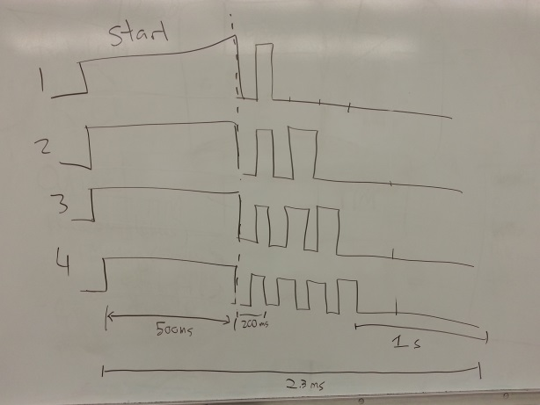

**Signal Specs**

This design teaches some fundamentals of wireless data transmission in an easy to understand way that the teams would be able to implement themselves. The focus of this solution moves away from code in complex libraries that students would use without understanding and towards creative data processing solutions.

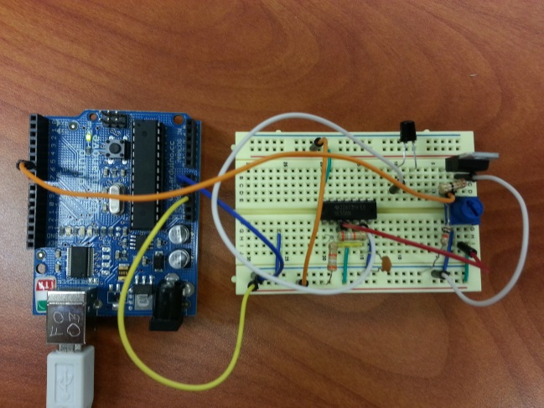 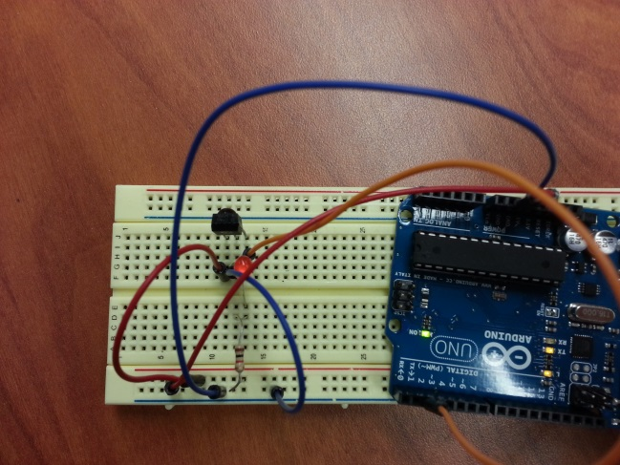

**Transmitter/Encoder Receiver/decoder**