PRG521 Summitive

* Laikin Barnard 6955 *

2021

Contents

Question 1: 2

Screen shots: 3

Code: 5

# Question 6:

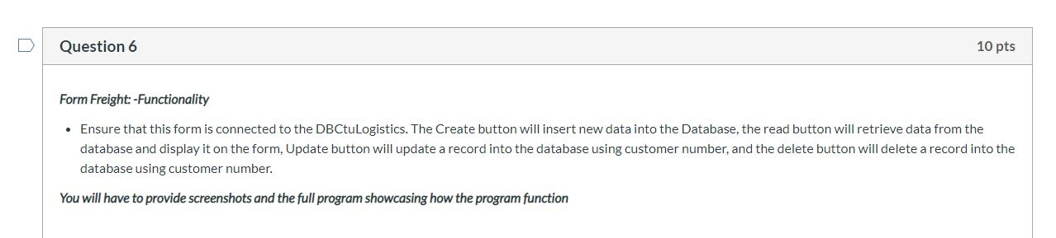

## Screen shots:

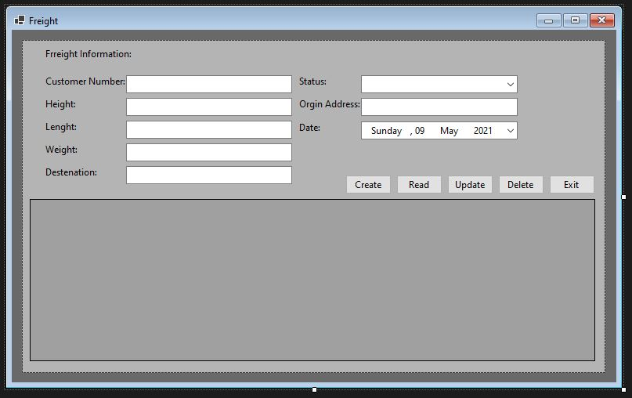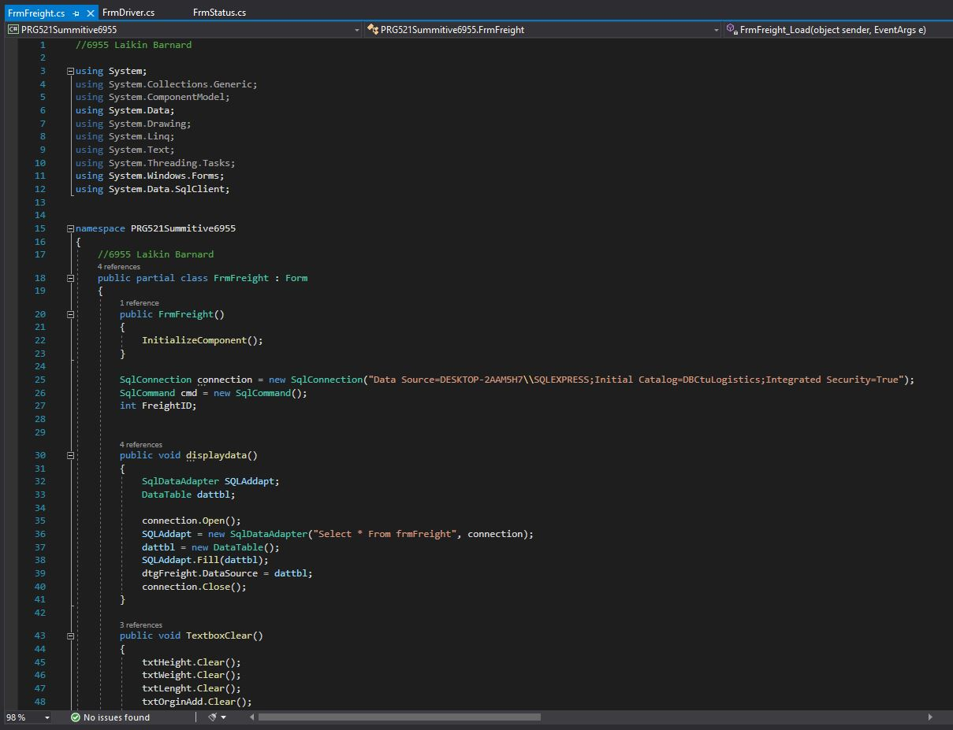

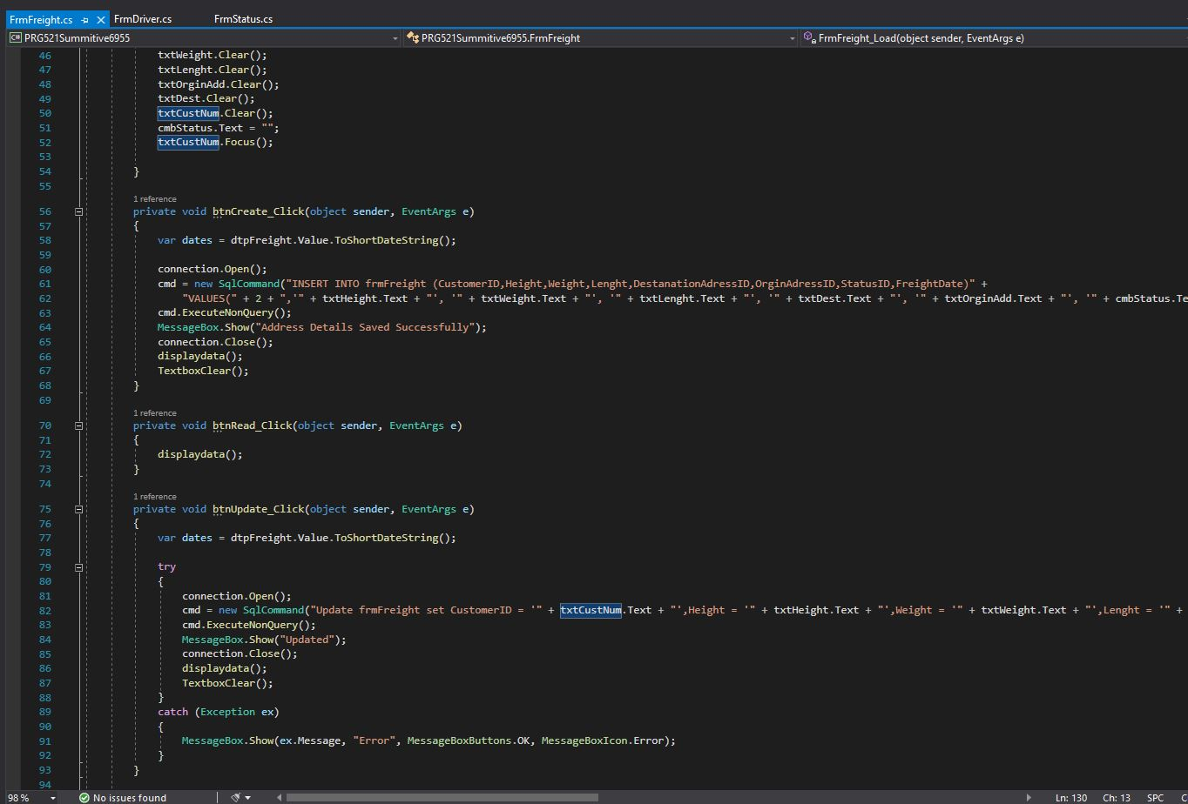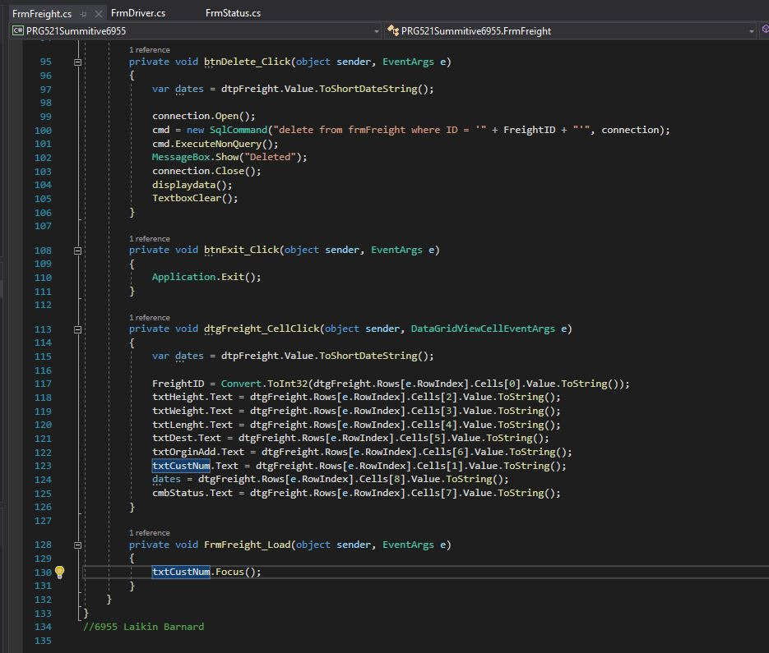

## Code:

//6955 Laikin Barnard

using System;

using System.Collections.Generic;

using System.ComponentModel;

using System.Data;

using System.Drawing;

using System.Linq;

using System.Text;

using System.Threading.Tasks;

using System.Windows.Forms;

using System.Data.SqlClient;

namespace PRG521Summitive6955

{

//6955 Laikin Barnard

public partial class FrmFreight : Form

{

public FrmFreight()

{

InitializeComponent();

}

SqlConnection connection = new SqlConnection("Data Source=DESKTOP-2AAM5H7\\SQLEXPRESS;Initial Catalog=DBCtuLogistics;Integrated Security=True");

SqlCommand cmd = new SqlCommand();

int FreightID;

public void displaydata()

{

SqlDataAdapter SQLAddapt;

DataTable dattbl;

connection.Open();

SQLAddapt = new SqlDataAdapter("Select * From frmFreight", connection);

dattbl = new DataTable();

SQLAddapt.Fill(dattbl);

dtgFreight.DataSource = dattbl;

connection.Close();

}

public void TextboxClear()

{

txtHeight.Clear();

txtWeight.Clear();

txtLenght.Clear();

txtOrginAdd.Clear();

txtDest.Clear();

txtCustNum.Clear();

cmbStatus.Text = "";

txtCustNum.Focus();

}

private void btnCreate_Click(object sender, EventArgs e)

{

var dates = dtpFreight.Value.ToShortDateString();

connection.Open();

cmd = new SqlCommand("INSERT INTO frmFreight (CustomerID,Height,Weight,Lenght,DestanationAdressID,OrginAdressID,StatusID,FreightDate)" +

"VALUES(" + 2 + ",'" + txtHeight.Text + "', '" + txtWeight.Text + "', '" + txtLenght.Text + "', '" + txtDest.Text + "', '" + txtOrginAdd.Text + "', '" + cmbStatus.Text + "', '" + dates + "')", connection);

cmd.ExecuteNonQuery();

MessageBox.Show("Address Details Saved Successfully");

connection.Close();

displaydata();

TextboxClear();

}

private void btnRead_Click(object sender, EventArgs e)

{

displaydata();

}

private void btnUpdate_Click(object sender, EventArgs e)

{

var dates = dtpFreight.Value.ToShortDateString();

try

{

connection.Open();

cmd = new SqlCommand("Update frmFreight set CustomerID = '" + txtCustNum.Text + "',Height = '" + txtHeight.Text + "',Weight = '" + txtWeight.Text + "',Lenght = '" + txtLenght.Text + "',DestanationAdressID = '" + txtDest.Text + "',OrginAdressID = '" + txtOrginAdd.Text + "',StatusID = '" + cmbStatus.Text + "',FreightDate = '" + dates + "' where ID = '" + FreightID + "'", connection);

cmd.ExecuteNonQuery();

MessageBox.Show("Updated");

connection.Close();

displaydata();

TextboxClear();

}

catch (Exception ex)

{

MessageBox.Show(ex.Message, "Error", MessageBoxButtons.OK, MessageBoxIcon.Error);

}

}

private void btnDelete_Click(object sender, EventArgs e)

{

var dates = dtpFreight.Value.ToShortDateString();

connection.Open();

cmd = new SqlCommand("delete from frmFreight where ID = '" + FreightID + "'", connection);

cmd.ExecuteNonQuery();

MessageBox.Show("Deleted");

connection.Close();

displaydata();

TextboxClear();

}

private void btnExit_Click(object sender, EventArgs e)

{

Application.Exit();

}

private void dtgFreight_CellClick(object sender, DataGridViewCellEventArgs e)

{

var dates = dtpFreight.Value.ToShortDateString();

FreightID = Convert.ToInt32(dtgFreight.Rows[e.RowIndex].Cells[0].Value.ToString());

txtHeight.Text = dtgFreight.Rows[e.RowIndex].Cells[2].Value.ToString();

txtWeight.Text = dtgFreight.Rows[e.RowIndex].Cells[3].Value.ToString();

txtLenght.Text = dtgFreight.Rows[e.RowIndex].Cells[4].Value.ToString();

txtDest.Text = dtgFreight.Rows[e.RowIndex].Cells[5].Value.ToString();

txtOrginAdd.Text = dtgFreight.Rows[e.RowIndex].Cells[6].Value.ToString();

txtCustNum.Text = dtgFreight.Rows[e.RowIndex].Cells[1].Value.ToString();

dates = dtgFreight.Rows[e.RowIndex].Cells[8].Value.ToString();

cmbStatus.Text = dtgFreight.Rows[e.RowIndex].Cells[7].Value.ToString();

}

private void FrmFreight_Load(object sender, EventArgs e)

{

txtCustNum.Focus();

}

}

}

//6955 Laikin Barnard

Results:

