PRG521 Summitive

* Laikin Barnard 6955 *

2021

Contents

Question 4: 2

Screen shots: 3

Code: 5

Results: 8

# Question 4:

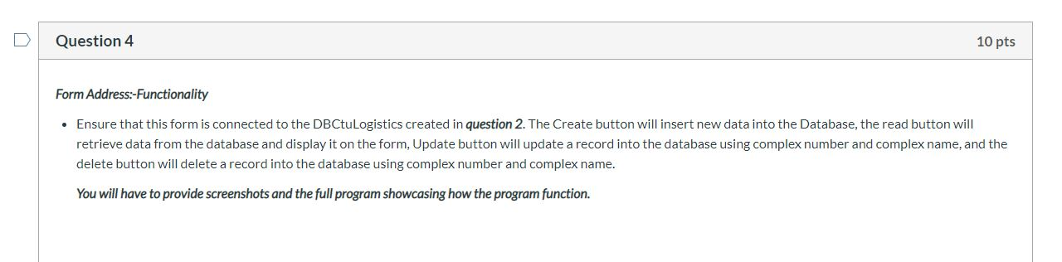

## Screen shots:

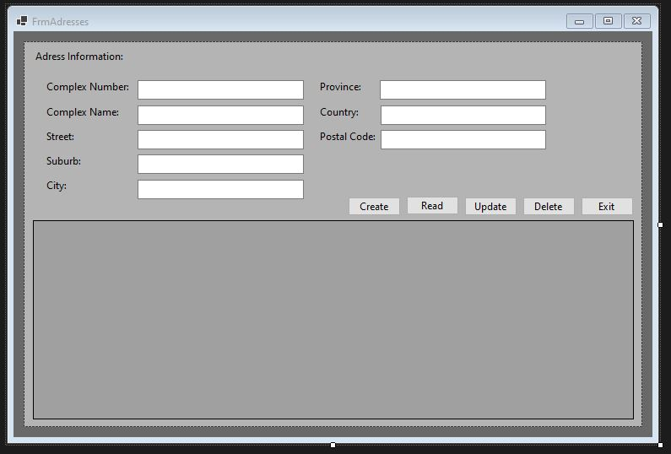

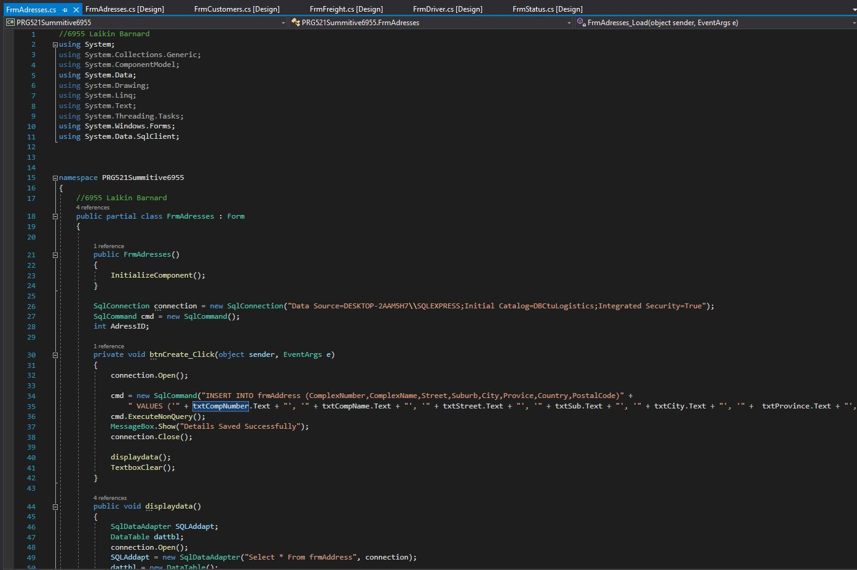

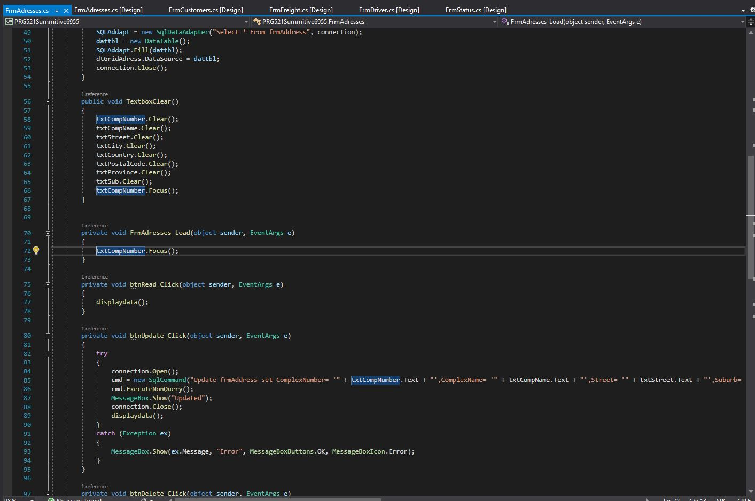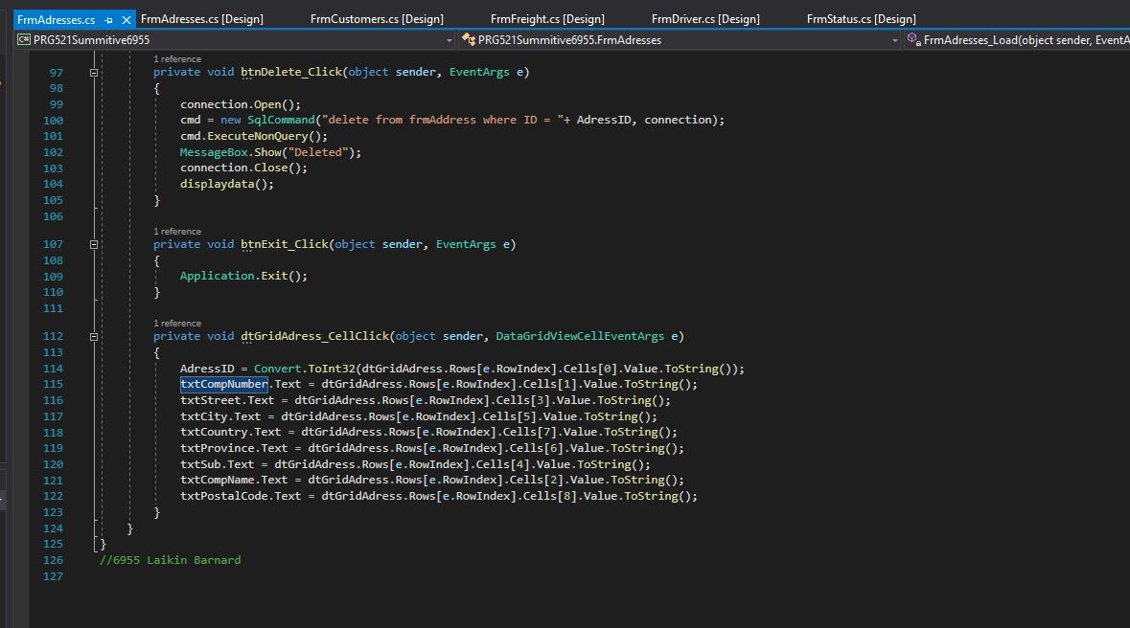

## Code:

//6955 Laikin Barnard

using System;

using System.Collections.Generic;

using System.ComponentModel;

using System.Data;

using System.Drawing;

using System.Linq;

using System.Text;

using System.Threading.Tasks;

using System.Windows.Forms;

using System.Data.SqlClient;

namespace PRG521Summitive6955

{

//6955 Laikin Barnard

public partial class FrmAdresses : Form

{

public FrmAdresses()

{

InitializeComponent();

}

SqlConnection connection = new SqlConnection("Data Source=DESKTOP-2AAM5H7\\SQLEXPRESS;Initial Catalog=DBCtuLogistics;Integrated Security=True");

SqlCommand cmd = new SqlCommand();

int AdressID;

private void btnCreate_Click(object sender, EventArgs e)

{

connection.Open();

cmd = new SqlCommand("INSERT INTO frmAddress (ComplexNumber,ComplexName,Street,Suburb,City,Provice,Country,PostalCode)" +

" VALUES ('" + txtCompNumber.Text + "', '" + txtCompName.Text + "', '" + txtStreet.Text + "', '" + txtSub.Text + "', '" + txtCity.Text + "', '" + txtProvince.Text + "', '" + txtCountry.Text + "', " + txtPostalCode.Text + ")", connection);

cmd.ExecuteNonQuery();

MessageBox.Show("Details Saved Successfully");

connection.Close();

displaydata();

TextboxClear();

}

public void displaydata()

{

SqlDataAdapter SQLAddapt;

DataTable dattbl;

connection.Open();

SQLAddapt = new SqlDataAdapter("Select * From frmAddress", connection);

dattbl = new DataTable();

SQLAddapt.Fill(dattbl);

dtGridAdress.DataSource = dattbl;

connection.Close();

}

public void TextboxClear()

{

txtCompNumber.Clear();

txtCompName.Clear();

txtStreet.Clear();

txtCity.Clear();

txtCountry.Clear();

txtPostalCode.Clear();

txtProvince.Clear();

txtSub.Clear();

txtCompNumber.Focus();

}

private void FrmAdresses_Load(object sender, EventArgs e)

{

txtCompNumber.Focus();

}

private void btnRead_Click(object sender, EventArgs e)

{

displaydata();

}

private void btnUpdate_Click(object sender, EventArgs e)

{

try

{

connection.Open();

cmd = new SqlCommand("Update frmAddress set ComplexNumber= '" + txtCompNumber.Text + "',ComplexName= '" + txtCompName.Text + "',Street= '" + txtStreet.Text + "',Suburb= '" + txtSub.Text + "',City= '" + txtCity.Text + "',Provice= '" + txtProvince.Text + "',Country= '" + txtCountry.Text + "',PostalCode= '" + txtPostalCode.Text + "' where ID = '" + AdressID + "'", connection);

cmd.ExecuteNonQuery();

MessageBox.Show("Updated");

connection.Close();

displaydata();

}

catch (Exception ex)

{

MessageBox.Show(ex.Message, "Error", MessageBoxButtons.OK, MessageBoxIcon.Error);

}

}

private void btnDelete_Click(object sender, EventArgs e)

{

connection.Open();

cmd = new SqlCommand("delete from frmAddress where ID = "+ AdressID, connection);

cmd.ExecuteNonQuery();

MessageBox.Show("Deleted");

connection.Close();

displaydata();

}

private void btnExit_Click(object sender, EventArgs e)

{

Application.Exit();

}

private void dtGridAdress_CellClick(object sender, DataGridViewCellEventArgs e)

{

AdressID = Convert.ToInt32(dtGridAdress.Rows[e.RowIndex].Cells[0].Value.ToString());

txtCompNumber.Text = dtGridAdress.Rows[e.RowIndex].Cells[1].Value.ToString();

txtStreet.Text = dtGridAdress.Rows[e.RowIndex].Cells[3].Value.ToString();

txtCity.Text = dtGridAdress.Rows[e.RowIndex].Cells[5].Value.ToString();

txtCountry.Text = dtGridAdress.Rows[e.RowIndex].Cells[7].Value.ToString();

txtProvince.Text = dtGridAdress.Rows[e.RowIndex].Cells[6].Value.ToString();

txtSub.Text = dtGridAdress.Rows[e.RowIndex].Cells[4].Value.ToString();

txtCompName.Text = dtGridAdress.Rows[e.RowIndex].Cells[2].Value.ToString();

txtPostalCode.Text = dtGridAdress.Rows[e.RowIndex].Cells[8].Value.ToString();

}

}

}

//6955 Laikin Barnard

## Results:

