Laikin Barnard FA1

Contents

QUESTION 19: 2

TestSearchReplace Class 2

ReplaceSubString Class 2

RESULTS: 2

CODE: 3

# QUESTION 19:

## TestSearchReplace Class

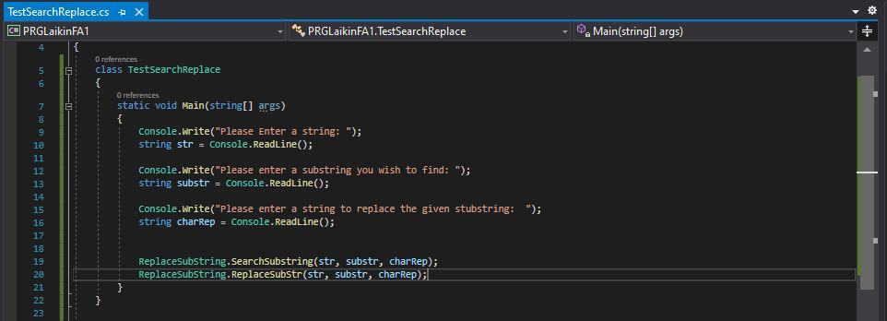

## ReplaceSubString Class

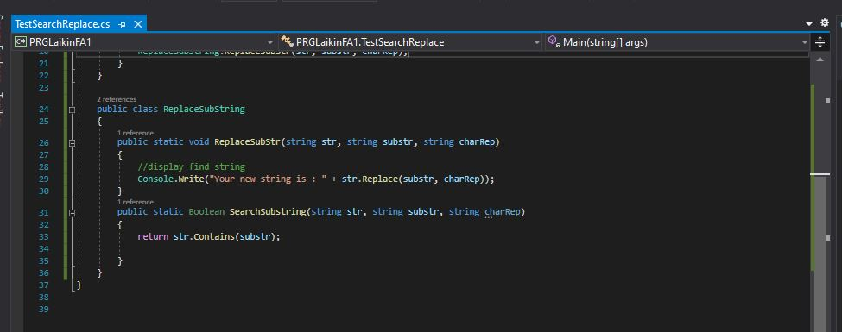

## RESULTS:

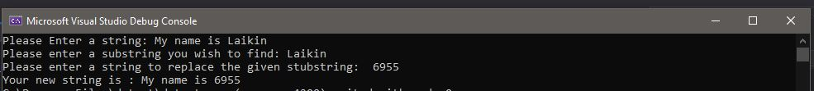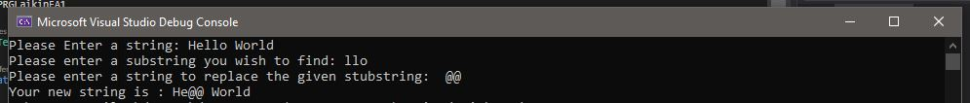

## CODE:

namespace PRGLaikinFA1

{

class TestSearchReplace

{

static void Main(string[] args)

{

Console.Write("Please Enter a string: ");

string str = Console.ReadLine();

Console.Write("Please enter a substring you wish to find: ");

string substr = Console.ReadLine();

Console.Write("Please enter a string to replace the given stubstring: ");

string charRep = Console.ReadLine();

ReplaceSubString.SearchSubstring(str, substr, charRep);

ReplaceSubString.ReplaceSubStr(str, substr, charRep);

}

}

public class ReplaceSubString

{

public static void ReplaceSubStr(string str, string substr, string charRep)

{

//display find string

Console.Write("Your new string is : " + str.Replace(substr, charRep));

}

public static Boolean SearchSubstring(string str, string substr, string charRep)

{

return str.Contains(substr);

}

}

}