WEB Technologies 2(Back end)

Final Project

“Online Library”

SE-2323

Students: Kydyrbek M., Zhumaseitov M., Yernazarov A.

**Online Library**

**Overview**

The **Online Library** is a web application built with **Node.js**, **Express.js**, and **MongoDB**. It allows users to register, log in, and manage their profiles. Admins can add, update, and delete books, while users can add books to their profiles. The application uses **EJS** for server-side rendering and **MongoDB Atlas** for data storage.

**Features**

* **User Authentication**:
  + Register new users with email, password, and role (user or admin).
  + Log in with email and password.
  + Logout functionality.
* **Role-Based Access Control**:
  + **Admins** can add, update, and delete books.
  + **Users** can add books to their profiles.
* **Book Management**:
  + Admins can perform CRUD operations on the book collection.
  + Users can view the book collection and add books to their profiles.
* **Responsive Design**:
  + Clean and modern user interface with responsive styling.

**Technologies Used**

* **Backend**:
  + Node.js
  + Express.js
  + MongoDB (with Mongoose)
* **Frontend**:
  + EJS (Embedded JavaScript templates)
  + CSS (for styling)
* **Authentication**:
  + Express-session (for session management)
  + bcrypt (for password hashing)
* **Deployment**:
  + MongoDB Atlas (for cloud database)
  + Render(for deployment web server)

**Project Structure**

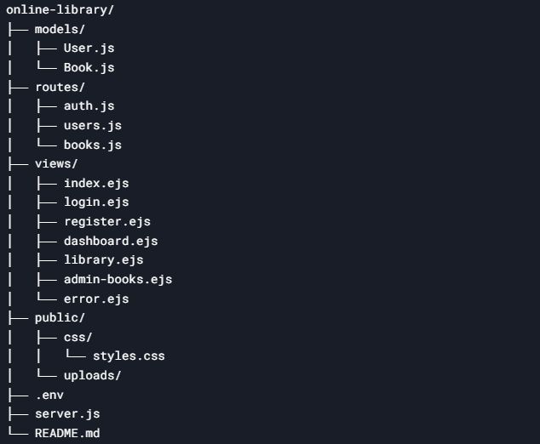

**Setup Instructions**

**1. Clone the Repository**

git clone https://github.com/Tinkerinio/web2.git

cd web2

**2. Install Dependencies**

npm install

**3. Start the Server**

**node server.js**

**Division of work**

1. Alsalim:

Connection with MongoDB atlas

Working with backend(routes)

Creating collections(models in vscode)

2. Miras:

Frontend(working with ejs files)

Connecting files with each other

3. Magzhan:

Backend(server.js, express.js)

Connection routes between project files

Home Page:

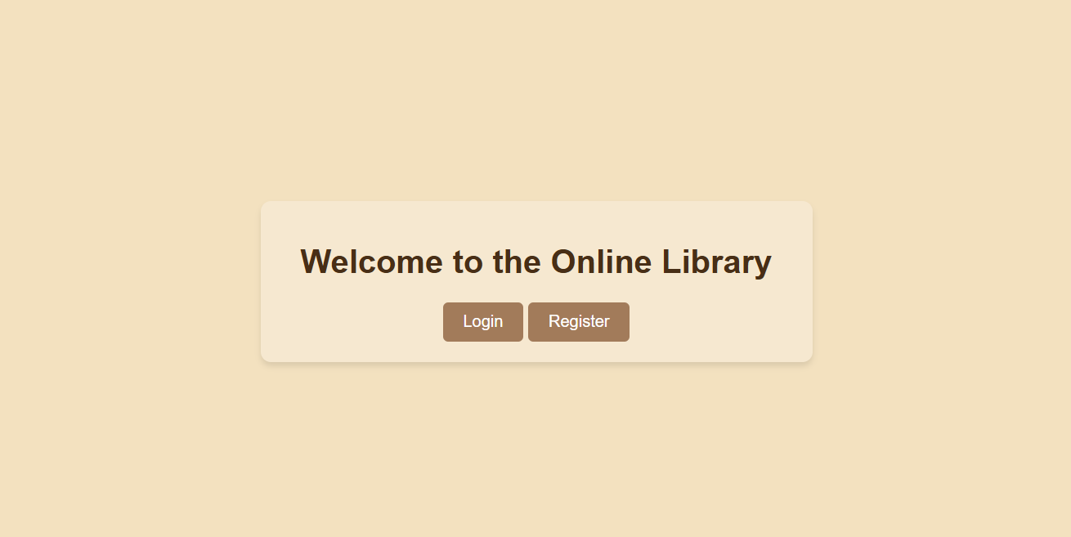

Registration:

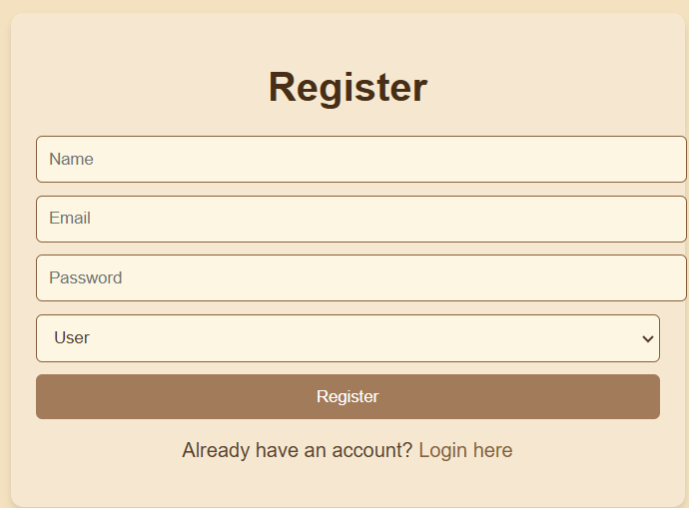

Login:

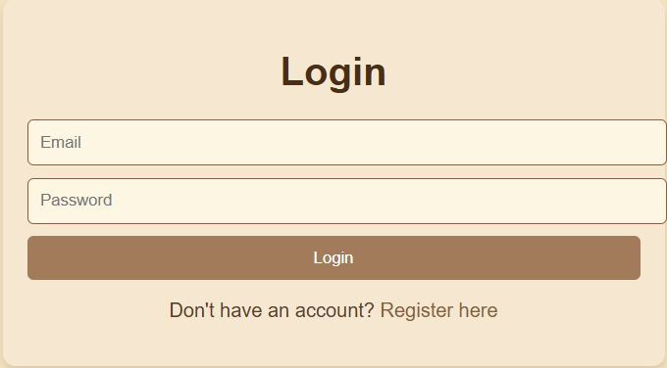

Dashboard:

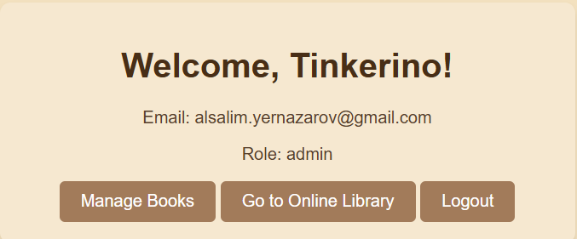

Admin-books:

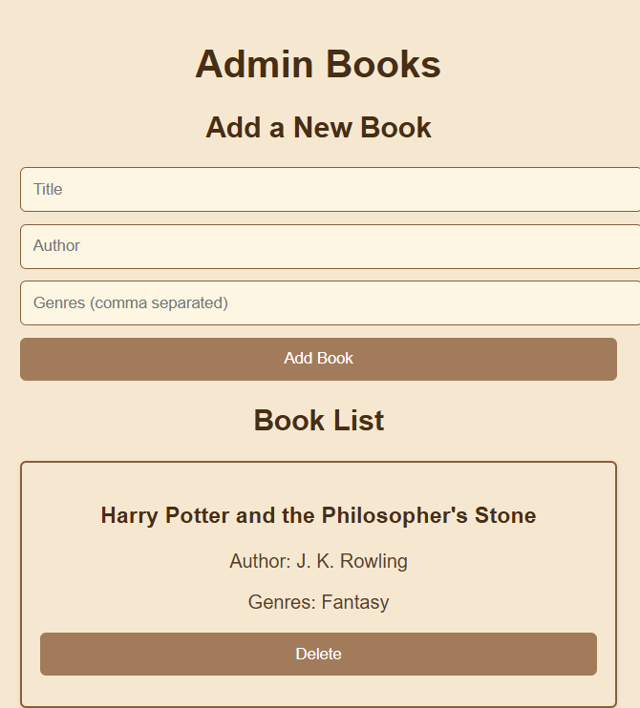

Library:

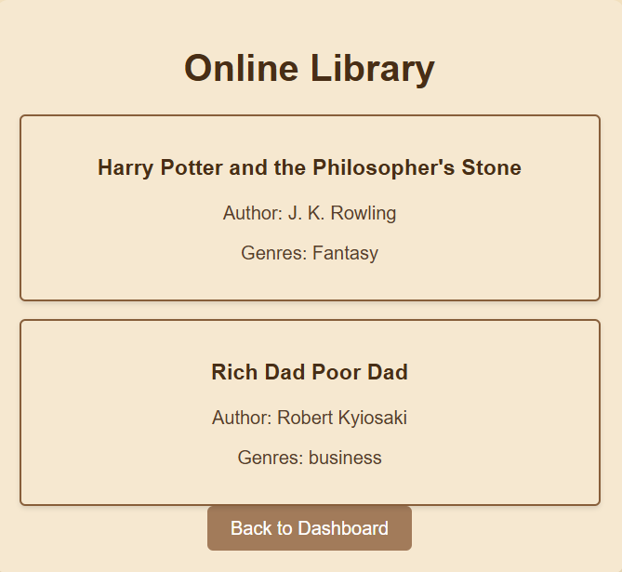

**Contact**

For any questions or feedback, please contact:

* **Email**: alsalim.yernazarov@gmail.com
* **GitHub**: Tinkerinio